Distributed Authorization In Enterprise Applications
CSE590 Research Paper

Author: Jason Hogg
Student No: 0641054
Version: 1.0

Table of Contents

1 Introduction 3
2 Authentication and Authorization in Distributed Applications 3
3 XrML Licenses and Distributed Authorization 5
3.1 XrML Licenses 6
3.2 XrML Based Authorization 7
3.2.1 Rights 7
3.2.2 Resources 7
3.2.3 Conditions 8
3.3 License Issuance – Security Authorization Service 8
3.3.1 The WS-Trust Security Token Service 8
3.3.2 Using XrML to support Federated Security Scenarios 9
3.3.1 Using XrML to support Constrained Delegation within a Banking Scenario 10
4 Conclusion 14
Bibliography 14

Introduction
Traditionally, enterprise application security has focused on authentication and authorization in order to determine who a particular user is and what their rights are within a particular application. Authentication was typically achieved using a user id and password, and authorization is performed using either Role based security whereby a particular user’s rights are determined by their presence within a logical group managed by an administrator, or potentially discretionary access control whereby a particular’s users ability to access an object such as a file is determined by an Access Control List (ACL) a model in which the owner of the object grants rights to other users as to their rights of access.

While in the past this may have been sufficient for individual applications or resources with small groups of users, enterprise applications are now required to integrate with other applications and also conform to regulations that stipulate requirements for access control and auditing. Furthermore, due to mergers and expansion across geographic boundaries integration may occur across security boundaries within an organization (eg – across different Kerberos realms) or in business to business applications across organizational boundaries.

Changing business requirements have also lead to the need for more advanced capabilities for authenticating users – through the use of centralized user directories, smart cards, biometric devices and two factor authentication techniques. Similarly, the resources being protected are changing from isolated files and databases to resources with complex and dynamic intellectual property rights possibly including confidential mission-critical information – leading to the requirement for more sophisticated capabilities for specifying and enforcing authorization rules.

As the techniques for authenticating users using protocols such as Kerberos or X.509 certificates are quite well known and have been discussed extensively in class I have chosen to focus on the topic of authorization within distributed applications. In particular concentrating on a rights expression language called the Extensible Rights Markup Language (XrML) which is an XML language for specifying authorization rules related to the use and distribution of resources including digital content and Web services.

Authentication and Authorization in Distributed Applications
In addition to security boundaries within an organization and across organizations new business models have emerged around the ownership and distribution of assets. For some organizations such as Barnes & Nobles these business models have introduced new competitors completely reshaped their industry – and for others such as Blockbuster the transition is only just beginning.

The challenge of determining who is actually authorized to access digital content such as digital music, digital videos and of course Web services is a large problem. Requirements may include:
- Time restrictions – the ability to grant a user access to a resource for a particular duration.
- Usage restrictions – limiting access to a resource to a particular user or group of users – such as the person who paid to watch a DVD or online video.
- Subscription models – allowing users to subscribe to a resource perhaps with usage limitations. For example allowing a consumer to perform stock quote look ups via a web service called from within Microsoft Money.
- Quality of service – support for different quality levels depending on factors such as fees.
- Geographical restrictions – restricting access to certain resources based on regulations within different countries, or perhaps different pricing models are required for taxation reasons
- Delegation – allowing a subject with access to a resource to transfer their rights of access to another user either on a temporary or permanent basis
- Software execution – restricting access by a user to a resource that is located on a particular machine.
- Web service access – restricting access to a web service by any one of the conditions above but also requiring that advanced data entitlement requirements are enforced prior to access to the service’s functionality. Examples include user spending limits, transfer limits, credential validity etc.

In order to keep the scope of this paper manageable I have chosen to focus on requirements pertaining to a distributed enterprise application rather requirements specific to digital media. On the surface a distributed application can look simple. Figure 1 illustrates a deceptively simple banking application calling a Web service which in turn accesses information from a database.

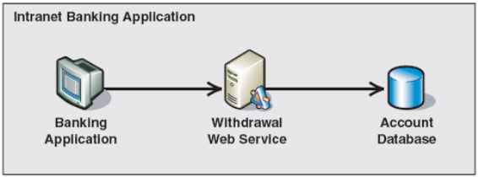
Figure 1 – Banking Application – Conceptual View [3]

However, after security requirements are analyzed and requirements such as allowing both the Web service and Database to perform authentication and authorization – not just of the node directly upstream, but of the credentials of the originating user - the solution becomes more complex.

A typical solution for these requirements is illustrated in Figure 2. It uses an extension of the standard Kerberos token to include a Privilege Attribute Certificate (PAC) within the Ticket Granting Token (TGT) that is returned from the Key Distribution Center (KDC). The PAC includes information from Active Directory (AD), including a unique identifier for the user and identifiers corresponding to the groups that the user is a member of. This information can be used by the Web service or database to perform role based authorization checks.

It also relies on an extension to the Kerberos protocol called S4U2Proxy. S4U2Proxy allows the security context of the service account (security principal) running the Web service to obtain a Service Ticket from the KDC to access the downstream database – using the service ticket that was presented by the originating user. This is referred to as constrained delegation.

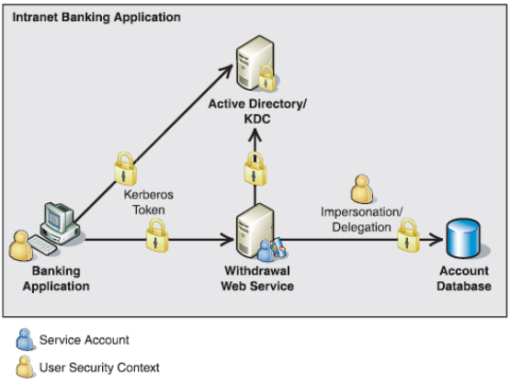
Figure 2 – Banking Application – Implementation View [3]

One side effect of the solution described above is that it requires application servers and databases to all be running on Microsoft’s Windows Server infrastructure. Sadly (speaking as a Microsoft employee ☺) this is often not the case within large organizations, and can almost never be assumed when interacting with business partners cross the Internet. Figure 3 illustrates a supply chain management application where a company is placing an order for supplies using a Web service that is provided by a supplier.

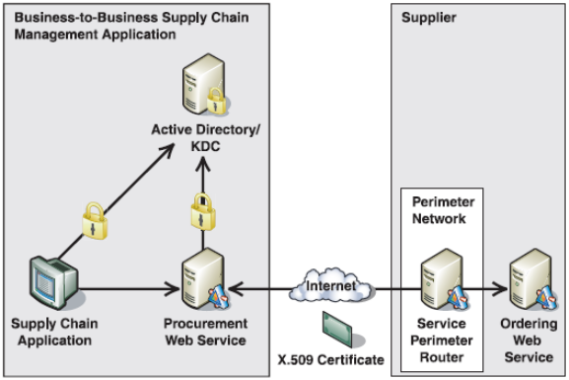
Figure 3 – Supply Chain Management Application – Implementation View [3]

An alternative to Kerberos based security is to use RSA public key encryption based on X.509 certificates. An X.509 certificate is essentially a collection of claims signed by a certificate authority. Claims commonly included within the certificate include:
- the public key of the subject of the certificate allowing the receiver of a message secured using the subject’s private key to verify proof of possession by verifying the signature using the public key
- a distinguished name (DN) that represents a unique identifier for the subject
- the digital signature of the certificate issuer forming the basis for a trust chain when signatures are verified.

The suppliers web service could be secured using either transport layer security using SSL / TLS or using SOAP message security using WS-Security[7]. X.509 certificates can be used to secure the messages between the client and service providing mutual authentication and ensuring data confidentiality as long as the two parties have a common Certificate Authority that they both trust.

X.509 certificates do have extensibility options allowing additional claims to be incorporated within the certificate, however there is no standards based solution for specifying complex authorization rules – although some work was performed on an authorization certificate specification. X.509 certificates cannot easily support delegation of fulfillment rights to another supplier, nor can they easily support incorporating a recent verifiable claim from a third party such as a bank establishing the client’s credit worthiness.

The overhead of managing a public key infrastructure also tends to grow significantly as the number of suppliers that the client interact with increase, or the number of clients that the supplier interact with.

XrML Licenses and Distributed Authorization
Extensible Rights Markup Language (XrML) is an XML language for specifying authorization rules related to the use and distribution of resources including digital content and Web services. XrML supports the ability to verify a particular Principal’s rights to access a particular resource based on a given authorization rule and the receiver’s trust relationship with the issuer of the license.

An XrML license is an XML structure that contains a series of claims which allow a rights holder to convey usage rights to a consumer of the license. An XrML license will typically contain:
- One or more grants, which convey to the license consumer (the Principal) the right to use a resource subject to certain conditions.
- An XML signature demonstrating that the license issuer is bestowing the grants to the Principal. The Principal is identified within the Grant as the KeyHolder.

Figure 4 –XrML license format
XrML License
Grant
KeyHolder
Rights
Resource
Conditions

Issuer
XML Signature
Time of Issuance

XrML Licenses

In its simplest form an XrML license can provide similar authentication capabilities to an X.509 certificate through an extension to the core XrML schema called the Standard Extensions schema. This includes a resource claim called “Name” which combined with a PossessProperty right allows a persons name to be bound to a principal.

The name can be specified using a common name (as is illustrated in this example), a DNS name, an email address or an X.509 subject name. The keyHolder right can also be granted to the same user, binding both their common name and public key to the license.

When this license is signed by a license issuer (conceptually similar to a certificate authority) this license could be used as the basis of authentication allowing a receiver to verify proof of possession via an XML signature verified using the public key within the reference.

<license>
<grant>
<keyHolder>
<info>
<dsig:KeyValue>
<dsig:RSAKeyValue>
<dsig:Modulus>Fb7wo6NYf...</dsig:Modulus>
<dsig:Exponent>AQABAA==</dsig:Exponent>
</dsig:RSAKeyValue>
</dsig:KeyValue>
</info>
</keyHolder>
<possessProperty/>
<sx:commonName>Jason Hogg</sx:commonName>
</grant>
<issuer>
<dsig:Signature>…</dsig:Signature>

<details>
<timeOfIssue>2000-01-27T15:30:00</timeOfIssue>
</details>
</issuer>
</license>

Figure 5 – Sample Xrml License [4]
This is one of the simplest illustrations of the use of XrML licenses to support authentication, however it is evident that some of the same requirements exist as exist for X.509 based solutions, including:
- License validity – The license contains a signature which is an XML signature (dsig:Signature element in the example) covering the XML elements within the license (other than the issuer) to allow verification that the license has not been tampered with.
- Trust – A service receiving a message signed using the private key related to the public key within this license would only accept the user’s identity as being legitimate if they trust the issuer of this license.
- Trust hierarchies – The X.509 path length extension controls the ability for certificate owners to issue additional certificates – building complex trust hierarchies. XrML licenses support even more complex delegation scenarios through a license owners ability to potentially generate new licenses issue rights or delegating control of a resource to other subjects.
- Revocation – As with X.509 certificates there exists a need to revoke licenses for various reasons. Depending on the application of the license (eg – DRM) this could be unwieldy or for Web service security an OCSP like model can be supported whereby a Web service would simply verify the license as part of its authentication and authorization strategy.

XrML Based Authorization

The real benefit of XrML over X.509 or Kerberos is its ability to support the definition of rules that can used to specify the conditions under which a subject can access a particular resource. The use of XML as the basis for the rule language supports platform independence, whilst the use of a core schema with inbuilt extensibility points supports the ability to define a rule with precision

Before returning to the scenarios illustrated in figure 2 and figure 3 it is worth taking a deeper look at the semantics of XrML – particularly the rights, resources and conditions supported within the core schema. This review is not intended to be comprehensive and focuses on concepts that are of interest when comparing with X.509 PKI based infrastructures. For a complete version of the XrML specification’s see [5].

Rights

Rights represent actions that a principal may perform on a particular resource.
- Issue Right – Allows the principal specified within the license to issue a new license. This is the fundamental way in which the XrML Authorization process allows chaining from one license to another. This is similar to the concept of a certificate authority in X.509 terms.
- Revoke Right – Supports the revocation of a signature within a license that was previously issued. The ability for a license holder or processor of a license to know that a license was revoked requires them to verify with the license issuer that the certificate is still valid. This is similar to the OCSP mechanism within an X.509 PKI.
- PossessProperty Right – Allows claims related to the principal to be bound to the license. For example the department in which an employee works; the spending limit of an employee; or like the Kerberos PAC the roles in which the employee is a member of.

Resources

Resources represent the object against which a right is being granted. A small subset of resources within the schema include:
- Resource – the abstract type for the Resource type model
- DigitalResource – A sequence of digital bits with which rights are assigned
- DigitalWork – Digital content that includes description, metadata, locator and parts.
- ServiceReference – A direct reference to a web service and its WSDL or an indirect reference via a pointer to its UDDI directory.

Conditions

Conditions represent the conditions with which the principal must abide before being granted the rights to the appropriate resources. Examples of conditions within the schema include:
- ValidityInterval – the period of time during which the license is valid
- RevocationFreshness – places an upper bound on the time taken between polling for revoked licenses.
- ExistsRight – Allows the issuer to grant certain rights directly

XrML was also designed with extensibility in mind. The XrML 2.0 specification actually includes a core schema plus several extensions to the schema. Later in this paper I also demonstrate one application of a custom extension to the schema which I believe is required to support a capability similar to Windows Server 2003’s constrained delegation capability.

License Issuance – Security Authorization Service

Various models exist for issuing XrML licenses. A centralized model similar to that used by an X.509 CA or the Kerberos KDC is possible. In this model the client and resource do not trust each other directly – but are able to broker trust through the use of a license issuer that they both trust.

More complex models are also possible whereby in order to establish trust with a license issuer that a service trusts you must first obtain a license from another license issuer. A real life example of this is when you apply for your driving license. Before you can apply you must first provide your birth certificate and only then (and possibly after passing your exam) will be issued a drivers license allowing you to drive. The ability to have dependencies between licenses is known as trust chaining.

Before we return to the supply chain management scenario and focus on the use of trust chaining to support a business to business supply chain management scenario it is important to take a quick look at one protocol that exists to support the issuance of XML tokens such as the XrML licenses.

The WS-Trust Security Token Service

Both Kerberos and X.509 CA’s have protocols that support the issuance and for X.509 revocation of tokens. A similar requirement exists for issuing XrML licenses. Where XrML licenses are being issued for the purpose of authenticating a user by an application or Web service it is likely that the WS-Trust protocol will be used.

WS-Trust builds upon the capabilities provided within the WS-Security specification (specifically message signing and encryption) and introduces a protocol for issuing, exchanging and verifying security tokens. The semantics of WS-Trust are similar in nature to the protocol used to ask for a ticket from the Kerberos TGS.

In essence a client can issue a request to a Security Token Service (STS) for a security token, including suitable credentials (identification and proof of possession) to allow the STS to authenticate the client. This request is called an RST – Request for Security Token.

After authenticating the client the Security Token Service (STS) can respond using the RSTR verb (Request for Security Token Response) including a security token that the client can then use to authenticate against a resource with whom it has no direct trust relationship.

The STS can also facilitate key exchange, allowing two parties to communicate securely. There are several approaches that can be taken, including a Kerberos like approach where a session key is generated and two copies are returned to the client. One is encrypted so only the client can see it (called a proof token) and the other is encrypted so only the remote resource can see it.

The revocation capability provided by an STS would be similar to the X.509 OCSP service – whereby a service could use the verify function to verify the integrity of a license as part of its authentication process.

Using XrML to support Federated Security Scenarios

The supply chain scenario described earlier is another example of a distributed application that may have a complex trust model. I will use this example to drill down into trust chaining. To recap this scenario, we have a user who is ordering merchandise from a remote suppler. The user is a member of a local Kerberos realm, and is using an application that must talk to an application within a remote suppliers security realm. Figure 6 provides a deployment topology demonstrating how two organizations can be federated through the use of two security token service’s.

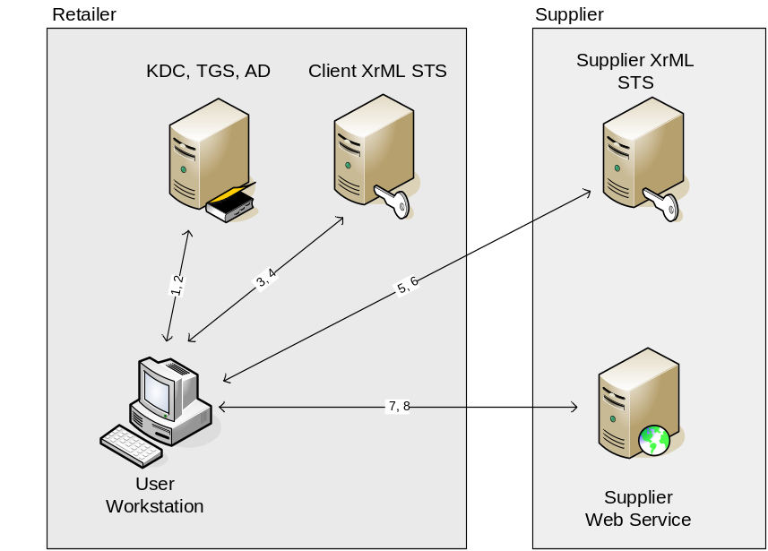
Figure 6 – Use of two security authorization services to federate two organizations

Esentially, the client within the Supplier uses their TGT (established when they logged on) to request a service ticket from their KDC (steps 1,2) that allows them to talk to their Retailer STS. The retailer STS authenticates the user and issues an XrML token (steps 3,4) that can then be used by the user to request an XrML token from the Supplier’s STS (steps 5,6) which would in turn allow the user to authenticate against the Supplier Web service (steps 7,8) allowing the user to place an order from the Supplier Web service. The Supplier Web service would authenticate the user using the XrML license issued by the Supplier’s STS, and can use rules dictated by both the Retailer and Supplier’s STS’s as part of its authorization process.

The two STS’s would either need to exchange keys (or certificates etc) out of band in order to establish trust between the Retailer and Supplier – or they could rely on an independent third party such as Verisign to broker the trust. Verisign could also issue XrML licenses, or could potentially use X.509 certificates as would be done within an X.509 PKI environment.

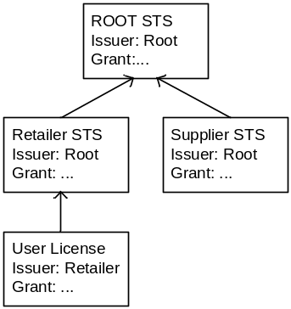
Figure 7 – Trust chain established through the use of Root STS trusted by both organiztions

Variations to this protocol would require the Web service to authenticate the user not only using the XrML license that its own STS had issued, but also verify the XrML license that was issued by the Retailer’s STS as well – thus chaining the two XrML licenses together. Figure 7 shows an example of a trust chain, whereby as part of the Web service’s authentication process it might need to evaluate the claims within the licenses provided by the Retailer STS and the end entity user themselves. This might also allow authorization rules to be extracted from each of the licenses within the trust chain. As with an X.509 infrastructure it is possibly to incorporate rules determining how many levels deep a license can be issued.

Using XrML to support Constrained Delegation within a Distributed Banking Scenario

Employees within a bank use a .Net WinForms application running on a Windows XP workstation. When a customer makes a withdrawal the teller uses this application which in turn calls a Withdrawal web service, which in turn calls an Account Web service which then interacts with the back end database. The application interacts with a large number of Web services – many of which are running on disparate platforms. The backend database is running on Oracle on a Solaris platform.

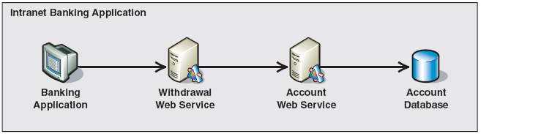
Figure 8 – Banking Application – Conceptual View [3]

In order to perform appropriate data entitlement logic each of the Web services want to authenticate not just the application that is calling them (as in a Trusted Subsystem model [1]) but the teller that logged on to the workstation. Such a requirement is not possible to fulfill using a PKI infrastructure as a user can only be authenticated based on establishing proof-of-possession (eg – by verifying a signature created using their private key) and there is no support for forwarding / delegation this information. As we mentioned earlier, Kerberos (as implemented on Windows Server 2003) does support this capability however, it requires that all resources be running on a Windows Server 2003 domain – which is not the case in this scenario.

The Bank can use a combined security solution, using Kerberos and Active Directory for authenticating tellers to their workstations and a centralized Security Token Service (STS) based on the WS-Trust protocol for issuing XrML licenses to support authentication and authorization requirements for resources within the distributed application.

In addition to using standard capabilities of an XrML license such as the ability to assign a key holder to a principal and specifying claims such as the possess property element to include information such as the teller’s role information and restrictions on the amount of money that can be transferred the bank also wishes to have the XrML token grant the right for the downstream systems to act on behalf of the teller. For example, allowing the Withdrawal Web service to call the Account Web service with a trust chain that demonstrates that the teller has authorized the Withdrawal Web service to act on their behalf.

XrML appears to support such a delegation right using two capabilities. The first approach is through a right called the issue right. This right allows a content owner such as a publisher the ability to grant a distributor a license which grants the distributor the right to issue additional licenses to consumers of the content.

The second approach is through a grant called a delegation control. A delegation control allows a depth to be placed on the number of additional delegations that can be performed. It also allows a right to be delegated to multiple parties.

Assuming the teller is issued an XrML license that includes a ServiceReference grant for the WithdrawalService the Withdrawal service would only be able to delegate (using either the IssueRights or Delegate control) this right to other services. Unlike typical Digital Rights Management (DRM) scenarios where the rights to a particular resource (eg – a movie or MP3 song) are being delegated, this solution does not appear to support the ticket forwarding requirements specified earlier.

A solution is required that would allow the WithdrawalService to actually act as the Teller when talking to the AccountService – without the Teller having to have any visibility into the resources that the WithdrawalService interacts with. (Caveat: It is possible that XrML does support this capability, however from my research I have not seen this to be the case – besides…)

This provides a good opportunity to demonstrate the extensibility of XrML’s schema combined with its ability to chain licenses together. To support this requirement we can create a custom right (extended from the base schema “Rights” object) called “ActOnBehalf” – which allows the STS to specify the right for a system to call other systems acting on behalf of an upstream user.

A Web service receiving a license that includes the ActOnBehalf right would need to validate not only the immediate license but the other licenses in the trust chain to ensure that at some point this right was actually granted and that it is still valid.

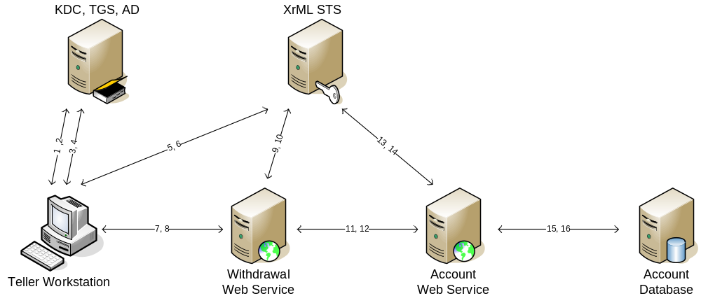
Figure 9 – Banking Application – Implementation View

Figure 9 illustrates what this solution could look like using a combination of Kerberos and an XrML STS.
- Steps 1 and 2 are the initial KRB_AS_REQ and KRB_AS_REP sequences establishing a TGT from when the teller logs on to their workstation.
- Steps 3 and 4 are the request for a service ticket using the KRBTGS_REQ and KRB_TGS_REP messages.
- Steps 5 and 6 are an RST and RSTR for an XrML license to talk to the withdrawal service. The STS also facilitates key exchange, by including the RSA public key for the service inside the license allowing encrypted messages to be sent from the client to the service.
- Steps 7 and 8 are the actual call from the Windows application to the Withdrawal web service – secured in this case using RSA keys that the STS has brokered.
- Steps 9 and 10 are the request by the Withdrawal Service to the STS for an XrML license to call the Account Web service. This call will include the teller’s license as the STS wants to authorize that the Teller actually has rights to the Account Web service (not just the Withdrawal service). The STS also facilitates key exchange, by including the public key for the service inside the license allowing encrypted messages to be sent to the service.
- Steps 11 and 12 are the call to the Account Web service which will include the license issued to the Withdrawal service and the teller’s license so the Account Web service can authenticate and authorize the Teller.
- Steps 13 and 14 are the request by the Account Service to the STS for an XrML license to communicate with the Account Database. This call will include the teller’s license, the Withdrawal services license and credentials for the Account Service to authenticate with.
- Steps 15 and 16 assume that the database OS or database server has a rules expression evaluation engine capable of processing XrML rules – at which point it can first of all verify the trust chain within the licenses from the Teller, the Withdrawal service and the Account service – and then it can review specific rules about the Teller’s entitlement to data. A common example for a teller would be to be able to view any customers account information – but not another staff members.

The sequence assumes that the STS’s license is already stored locally on the different tiers so the STS’s license does not have to also be flowed as part of the licenses flowed between nodes. The STS has also been used to include an RSA public key using the PosessPropertyRight to allow the upstream resource know how to encrypt data to the downstream resource.

The following table provides additional details as to what is included in each of the message exchanges.

No | Participants | Details
1 | Client to KDC | c, tgs
2 | KDC to Client | {Kc,tgs}Kc {Tc,tgs}Ktgs
3 | Client to TGS | {Ac,s}Kc,tgs {Tc,tgs}Ktgs
4 | TGS to Client | {Kc,sts}Kc,tgs {Tc,sts}Ksts
5 | Client to STS | SOAP{ RST(WWS) {Tc,sts}Ksts }Kc,sts
6 | STS to Client | SOAP{ RSTR(XrML Lc,wws)}Kc,sts  XrML Lc,wws contains:  - KeyHolder = Teller public key (Kc pub)  - Common name = Teller Name  - PossessPropertyRight = Teller’s Roles  - ActOnBehalfOfRight  - ValidityInterval = 600s  - ServiceReference = http://WithdrawalWebService  - PossessPropertyRight = Service public key (K wws pub)
7 | Client to Withdrawal Web service (WWS) | SOAP{ Withdraw request, XrML Lc,wws} Kc pri, Kwws pub
8 | WWS to Client | SOAP:{ Withdraw response } Kc pub, Kwws pri
9 | WWS to STS | SOAP:{ RST(WWS), XrML Lc,wws}Kwws pri, Ksts pri
10 | STS to WWS | SOAP{ RSTR(XrML Lwws,aws)}Ksts pri, Kwws pub  XrML Lwws,aws contains:  - KeyHolder = WWS public key (Kc pub)  - Common name = Withdrawal web service  - ValidityInterval = 600s  - ServiceReference = http://AccountWebService  PossessPropertyRight = Service public key (K aws pub)
11 | WWS to Account Web service (AWS) | SOAP{ ACWithdrawal request, XrML Lc,aws, XrML Lwws,aws} Kwws pri, Kaws pub
12 | AWS to WWS | SOAP {ACWithdraw response } Kwws pub, Kaws pri
13 | AWS to STS | SOAP{RST(DB), XrML Lc,wws, XrML Lwws,aws}Kaws pri, Ksts pri
14 | STS to AWS | SOAP{RSTR(DB), XrML Laws,db}Kaws pri, Ksts pri  XrML Laws,db contains:  - KeyHolder = WWS public key (Kc pub)  - Common name = Withdrawal web service  - ValidityInterval = 600s  - DigitalResource  - PossessPropertyRight = Service public key (K db pub)
15 | AWS to DB | {ACWithdraw sql request, XrML Lc,wws, XrML Lwws,aws, XrML Laws,db } Kaws pri, Kdb pub
16 | DB to AWS | {ACWithdraw sql response} Kaws pub, Kdb pri
Figure 10 – Protocol detail

The semantics used within this table are based on those described by Bruce Schneir [8]. I have also tried to incorporate a description of SOAP messages and the main characteristics of the XrML token returned by the STS along with support for XML signatures and encryption. For example, the following indicates that the SOAP message contains an ACWithdrawl message that is signed using the private key of Kaws, and encrypted using the public key of Kaws.
SOAP {ACWithdrawal response } Kwws pub, Kaws pri

Conclusion
This paper has compared and contrasted the capabilities of identity based authentication models based on Kerberos or X.509 technologies with the capabilities of a rights expression language such as XrML.

In order to evaluate the suitability of XrML for enterprise application development (as opposed to typical DRM scenarios) I described two common enterprise scenarios and then applied an XrML based solution –highlighting the benefits of XrML – including the extensibility of the language to support a ticket forwarding capability which appears to be lacking in the base specification.

I also demonstrated how XrML licenses can be used alongside existing Kerberos or X.509 based solutions – or how through the use of WS-Trust an XrML license could replace Kerberos or X.509 based solutions – offering both centralized management of identity information but also centralized management of complex authorization rules.

Overall I believe the advantages of a rich expression language such as XrML are clear – and that overtime an expression based language such as XrML will undoubtedly complement existing identity management solutions. The only questions are when and what format will the expression language take.

Bibliography
The following articles were cited or referenced during the research and development of this paper.

[1] Trusted Subsystem - http://g.msn.com/9SE/1?http://msdn.microsoft.com/library/en-us/dnpag2/html/wss_ch4_trustsub.asp
[2] XML Digital Signature - http://www.w3.org/TR/xmldsig-core/
[3] Web service security: Scenarios, Patterns and Implementations
[4] eXtensible rights Markup Language (XrML) Example Use Cases - http://www.xrml.org/spec/2001/11/ExampleUseCases.htm
[5] eXtensible rights Markup Language (XrML) 2.0 Specification
Part II: XrML Core Schema
[6] WS-Trust - http://g.msn.com/9SE/1?http://msdn.microsoft.com/library/en-us/dnglobspec/html/ws-trust.asp
[7] WS-Security - http://g.msn.com/9SE/1?http://msdn.microsoft.com/library/en-us/dnglobspec/html/ws-security.asp
[8] Applied Cryptography, Bruce Schneier
[9] “Reinventing PKI: Federated Identity and the Path to Practical Public Key Security” by Jamie Lewis, Burton Group CEO and Research Chair. http://www.burtongroup.com/promo/columns/column.asp?articleid=140&employeeid=3
[10] WS-Security Profile for XML-based Tokens
http://msdn.microsoft.com/webservices/default.aspx?pull=/library/en-us/dnglobspec/html/ws-security-xml-tokens.asp#ws-security-xml-tokens__toc18377177
[11] Content Guard Technical Documentation and Sample Use Cases, including:
http://www.contentguard.com/reference/docs/IssueContent.htm
http://www.contentguard.com/MPEGRELreference/docs/DelegationControl.htm
[12] Basic Overview of Kerberos User Authentication Protocol in Windows 2000 http://support.microsoft.com/kb/217098

