SimVote:

Engaging and informing citizens about land use and transportation ballot measures with urban simulation data

Chandrika Jayant, Jessica K. Miller and Yael F. Schwartzman
Computer Science and Engineering HCI project
{cjayant, jessica, yaels}@cs.washington.edu

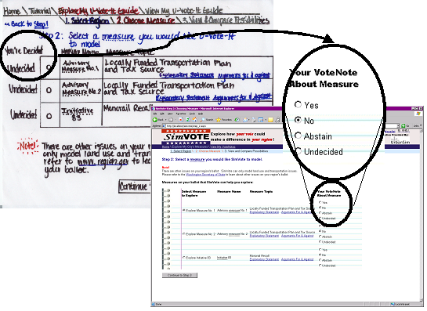
Figure 1. SimVote’s measure selection screen in the paper prototype (upper left) and final interface (lower right)

Abstract: This paper presents SimVote, an interface that uses UrbanSim simulations to help the general public understand, visualize, and make decisions about land use and transportation policies. Political scientists argue that informed citizenry is necessary for democracy [R 2]. Citizens engaging in democracy through their vote currently get informed by a number of information sources: the media, the Internet, their family and friends. Another valuable source that could be used to become informed about land use and transportation measures is urban simulation software such as UrbanSim, a software-based simulation model that incorporates the interactions between land use, transportation, and public policy [R 3]. SimVote attempts to present the very complex information produced by UrbanSim to all citizens in an understandable, simple manner. Additionally, SimVote attempts to inform the user about general voting terminology and practices. This paper presents SimVote as a first step toward providing a new type of information source for urban citizens by (a) discussing the interface itself and the design process that produced the interface, (b) drawing from techniques of user-centered design methodologies (including Value Sensitive Design) to understand and design for citizens, and (c) providing insight into future directions through our design experience.

TABLE OF CONTENTS

(CTRL + click to follow link)

Introduction ……………………………………………………………………3

1. Task Analysis……………………………………………………………….4

2. Paper Prototype………………………………………………………...5

3. Heuristic Evaluation……………………………………………………9

4. Interactive Prototype……………………………………………….10

5. Pilot Usability Test……………………………..……………………13

6. Conclusions and Future Work…………….…………………….15

Appendix A(Stranger Cheat Sheet) ………...…………………17
Appendix B(Heuristic Evaluation) ………………….………..…17
Appendix C(Interface Evaluation Document) ………………21

Introduction

One of the prominent classical models of democracy described by Held is the 'developmental model' of liberal democracy, in which an informed citizenry is viewed as a precondition for collective decision making that is created within the democratic process [R 2]. Information Technology provides a way in which to retrieve information about democratic elections but has trust and information overload issues [R 1]. In this paper we present the SimVote interface. SimVote attempts to help inform and engage citizens in two ways. First, SimVote uses urban simulation data to provide visualizations of scenarios pertaining to specific land use and transportation measures that are up for vote in the user’s region. Second, SimVote attempts to engage citizens and educate them about general voting terminology that appears on the ballot and political conversations on a daily basis.

Developing such an interface has been quite challenging for two reasons. First, SimVote’s visualizations are based on UrbanSim land use and transportation forecasting simulations. UrbanSim is a large-scale urban simulation tool that is primarily used by urban-planners and modelers to aid in more informed decision-making. UrbanSim is a very complex software system. Currently, it takes a good amount of urban planning expertise to be able to populate UrbanSim with a region’s data, run UrbanSim on the data, and understand and interpret its output. Our interface attempts to present this data in an understandable manner that citizens can relate to. Secondly, the voting process itself is quite complex. Initially our goal was just to use UrbanSim data to help users become more informed, but we soon realized that if the user didn’t understand the voting process in general, our work was going to do little to help them become more informed. Therefore, the second goal of informing the user about the general voting process and terminology emerged.

There already exist tools that allow people to get informed about public policy online. Although we did not perform extensive background research, we were able to distinguish several differences between our implementation and other work. We provide information that is visual, objectively forecasts possible futures of urban areas, and is free from bias. Related work relies on textual information [R 4], provides arguments for and against based on expert opinion [R 5] (and no forecasting evidence of future implications) and sometimee shows biased, one-sided information [R 6]. Furthermore, throughout our design process we have leveraged many approaches coming out of user-centered design. In order to understand what users currently do to become informed before they vote, we used task analysis. Since the interface is to be used by all citizens of an urban area, we wanted to design a simple, highly usable interface. To this end, we did rapid prototyping by creating a paper prototype and then had three people do heuristic evaluation to test the usability and simplicity of the prototype. In order to conceptualize direct and indirect stakeholders and understand the values we wanted to explicitly design for, we used methods from Value Sensitive Design. In line with UrbanSim’s explicitly supported values [R [R 8], we chosetly design for the following political and ethical values: informing and engaging citizens, accountability, and fairness. We performed three interface evaluation sessions with users to understand how our interface performs in supporting both the usability goals (i.e. a simple, highly usable interface) and the values outlined (i.e. informing and engaging citizens, accountability, and fairness).

The rest of the paper presents SimVote’s design process, starting with the task analysis in Section 1, followed by the first paper prototype in Section 2 and its heuristic evaluation in Section 3. Section 4 presents the Interactive prototype resulting from the heuristic evaluation. Section 5 presents the pilot usability test performed on the interactive prototype. Finally, Section 6 ends the paper with conclusions and future work.

Task Analysis
Lewis and Rieman argue that in order to design a successful interface the designers need to be clear about the users and the kinds of tasks that the interface should support[R 8 [R 8]. They propose conceptualizing tasks and users through a set of typical investigative questions such as ‘Where?’, ‘When?’, ‘How?’ and ‘Why?, as a way to accomplish a auccessful design.

In order to understand our design space we answered several task analysis questions based on informal peer interviews and in-group brainstorming. The questions and answers that had the most impact on our design follow.

What do people care about when they vote? People care about a variety of concerns including: economy (jobs, crime rate, business, taxes, utilities), health care, education, homeland security, all types of transportation (walking, riding, public transportation, cars, traffic), land use, real estate availability and prices, environment, regional aesthetics, tourism and culture.

Who would use SimVote? Value Sensitive Design suggests that designers look both at indirect and direct stakeholders’ values when designing an interface [R 7 ]. We identified that both indirect and direct stakeholder groups were rather large. Indirect stakeholders ranged from family member, to tourists and future generations. Direct stakeholders included voters, activists, businesses and corporations, among others. We decided, in the interest of time, to focus on somewhat engaged citizens that would either vote, or would like to be informed about land use and transportation measures and their possible future implications.

How do the users get informed about voting issues today? Users talk to their friends, families and neighbors to get informed. They rely on the media and get informed by outreach from activist organizations and political parties. They search the web for competing information and read voting guides. There are also a number of people that just align themselves with a political party or other people’s opinions (such as “the Stranger” magazine’s cheat sheet [Appendix A]). One thing that seemed compelling about the “cheat sheet” was that it contained clear information that a voter could take to the polls and refer to when voting. Additionally, since we want to explicitly inform and engage citizens, it was natural that our interface should produce a document similar to a cheat sheet, but rather than containing somebody else’s decisions, our document would contain the user’s informed decisions and information about these decisions.

What tasks are desired? This project started as an effort to begin exploring U-Build-It’s possibilities. Hence, we were thinking about allowing the users to assemble, submit and visualize UrbanSim scenarios. We discussed why users would use UrbanSim to build scenarios. We came up with several reasons: educational purposes (i.e. to teach about land use and transportation), informational purposes (e.g., somebody buying a house in a particular area might was to be informed about how certain policies might affect that area before buying) and voting (i.e. how should I vote on proposed land use and transportation policies). We found the last use (voting) most compelling because it seemed to be the most likely use and the use that would attract the most users. Voting immediately appeared to involve a number of interesting value issues at hand with this use: information bias, fairness, informing and engaging citizens, and democracy, just to name a few.

What are the values that SimVote should support? Since this project is an UrbanSim component and since UrbanSim’s design is guided by Value Sensitive Design, we chose our design to be guided by the values of democracy, accountability and fairness. In addition, since we want to reach all engaged citizens, our design had to be simple, accessible, informing and engaging.

Paper prototype
The basic structure of our paper prototype’s design was inspired by an online tax return website called Eztaxreturn [R 9]. We liked the structure of this website because it takes something quite complicated (taxes) that all citizens have to do and breaks it down into easy steps. Furthermore, according to Landay, e. al. this is a good pattern for websites that are not to be visited on a regular basis [R 10]. The paper prototype design was also inspired by “The Stranger’s” cheat sheet [R 11]h ed referred to the user’s “cheat sheet” as “MyBallot” which became our central metaphor. Other influences w by the online voting gu [R 11] , which became our main indicator of which kindof information was needed, andd by Wasatch Front Region UrbanSim Application final report [R 12], which was our main source of inspiration for choosing the kinds of visualizations that were needed.

Our system was called “U-Vote-It” [Figure 2]. The “Explore Your Ballot” section allowed the user to select a city or zip code [Figure 3], select a measure [Figure 4] and visualize and compare concerns [Figure Figure 66]. We also added an extra step that forced the user to review the measure’s explanatory statement before exploring the visualizations[Figure][Error: Reference source not found]. ast functionality shown in Figure 6 allows the user to visualize the effect that the vote could have on the different concerns by comparing these possibilities to each other and to the region’s current status through maps, graphs and tables. Each concern encompasses issues of importance that were discovered during our task analysis and can be informed by UrbanSim’s indicators. However we decided to group these indicators into concerns since indicators provide a level of information that is better suited for urban planners and modelers to understand. However, since determining which indicators belong to which concerns a quite complicablem this problem was out of the project’s scope and will hopefully be addressed in the futuons.We also had a “View you Ballot” page which allowed the users to manipulate (print, save, open, edit and delete) their measure decisions.

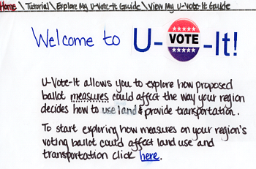

Figure 2. Welcoming page.

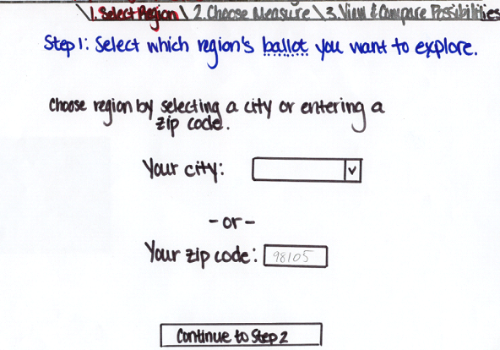

Figure 3.“Explore your Ballot” – select a city or zip code page

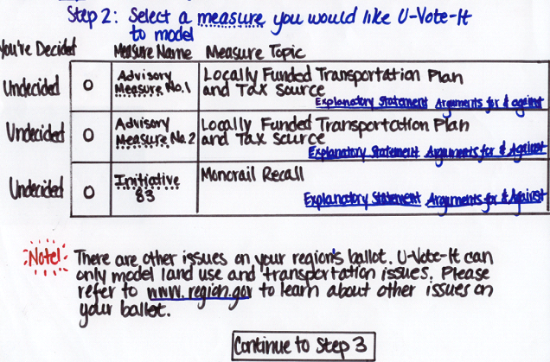
Figure 4."Select a measure" – Allowed users to select a measure in order to visualize it using UrbanSim visualizations and also allowed the user to review the measure’s Explanatory Statement and arguments for and against.

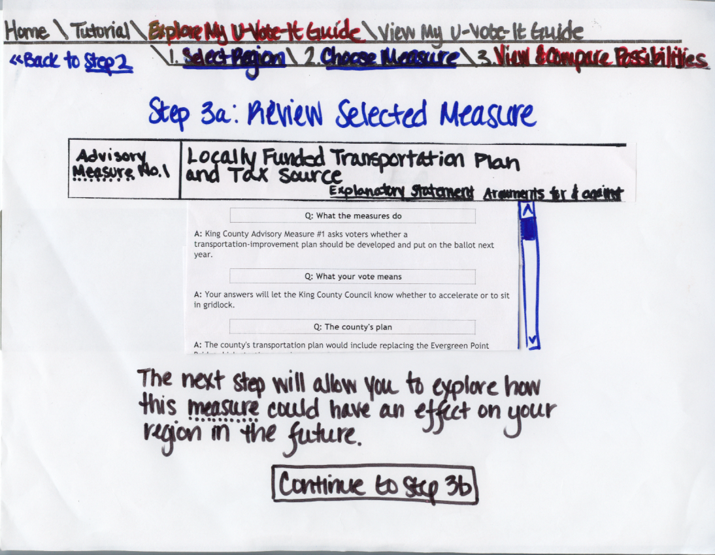
Figure 5. "Review selected measure". This page forced the user to review the measure’s documentation one more time before visualizing and comparing concerns.

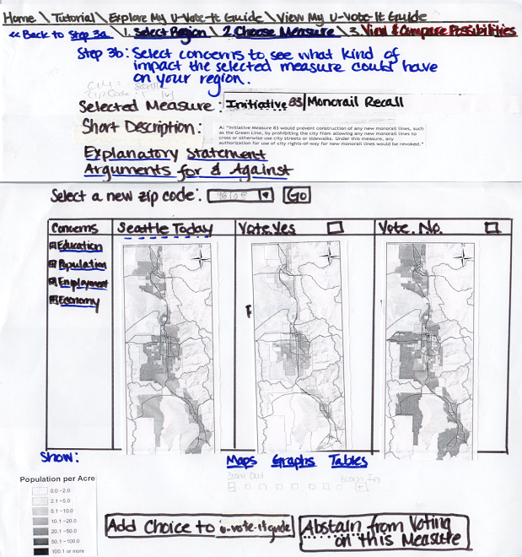

Figure 6.“Explore your Ballot” – view and compare concerns page

Heuristic Evaluation
In order to do our prototype’s first iteration of refinement we recruited three heuristic evaluators and asked them to evaluate our paper prototype based on Jacob Nielsen’s set of heuristics ]. We evaluated the interface based on one scenario and three tasks which can be found in Appendix C.

The evaluators found 28 violations, thirteen of which had a severity of three or four (on a zero-to-four scale). We found it necessary to categorize Nielsen’s heuristic violations into more high-level categories that were more specific to our interface in order to help us more clearly address our problems. The categories were: wording, interface, documentation, navigation, metaphor and visualization. The full heuristic evaluation can be found in Appendix B.

Wording: There were some wording issues related to how to signal different functionalities such as the ability to add or change a measure on the guide, how to visualize that the user had decided to vote for or against a particular measure, and how the user could change their mind after deciding on a measure.

Interface: The main violation found on the interface design was a violation to the user’s flexibility and freedom since we forced the user to have a second look at the explanatory statement and arguments for and against a measure before visualizing it, as a way to design for the value of information. However this particular issue got a severity rating of 3 by all evaluators.

Documentation: One of our concerns, which was corroborated by the evaluators, was that users would assume that by using our interface they would complete their voting duties. The evaluators were not able to access all the documentation and information that we intended to provide. Finally, the evaluators were not able to determine the source of information and hence were hesitant to trust the information provided by the interface.

Navigation: Some of the unavailable navigations appeared available. Namely, the first time that users go through the interface, they will not be able to advance to further steps unless they have completed earlier ones. Requirements like those should be apparent in the design.

Metaphor: We had originally thought about naming our website “U-Vote-It” and naming the guide a “U-Vote-It guide”. However, the evaluators noticed that “My U-Vote-It guide” is a confusing term (‘My’ followed by ‘U’) and also since the name “U-Vote-It” does not match the task that can be performed using the interface.

Visualization: The evaluators had some general concerns about visualizing the measure’s overview and other information in the printable guide and about the clarity of comparison that the visualization through maps provided.

Interactive Prototype
Using information gathered from our Heuristic Evaluation, we
then moved on to the second iteration of our prototype— this time, an interactive one. We created a web-based prototype which appropriately fits the future medium of our interface.

We fixed the most severe violations of our heuristics as well as many other less severe ones. Some problems emerged, we believe, from the paper prototype just because it was a paper prototype. Since our interface is meant to be used on the web, some issues fixed themselves in the web environment (difficulty with representations of blue links, scroll bars, etc.)

Wording and interface problems mentioned above were easily fixed, and work was made on improving navigation. Documentation and proper metaphors required more work. We realized that one of the users’ main confusions was that they did not understand if they were actually voting or not. The metaphor of the “ballot”, while providing familiarity and a good mapping to the everyday world, could be misleading in that users might think they were actually voting on our site when they were not. We rethought the name of our site and changed it to SimVote [Error: Reference source not foundFigure 7] Instead of adding decisions to “My U-Vote-It Guide” users now add their decisions to their VoteNotes [Error: Reference source not foundFigure 11] and instead of having the decisions scattered around the page, we concentrated them in one clear place[Figure9 ] We liked the idea of a VoteNote because we thought it would better signal to the user that the decisions they are making in the interface are just compiled init a note and are non actual votes. The “Measure Selection” page was cleaned up [Figure 8], as was the “Measure Exploration” page [Figure 10]- mostly pertaining to system status. at the end of using the interface the user can view and print out all of the VoteNotes they have takeFigure 8] and are directed to a link that helps them find their local polling place [Error: Reference source not foundFigure 11].

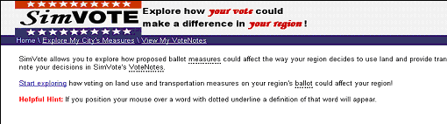

Figure 7. Interactive Prototype's Home Page
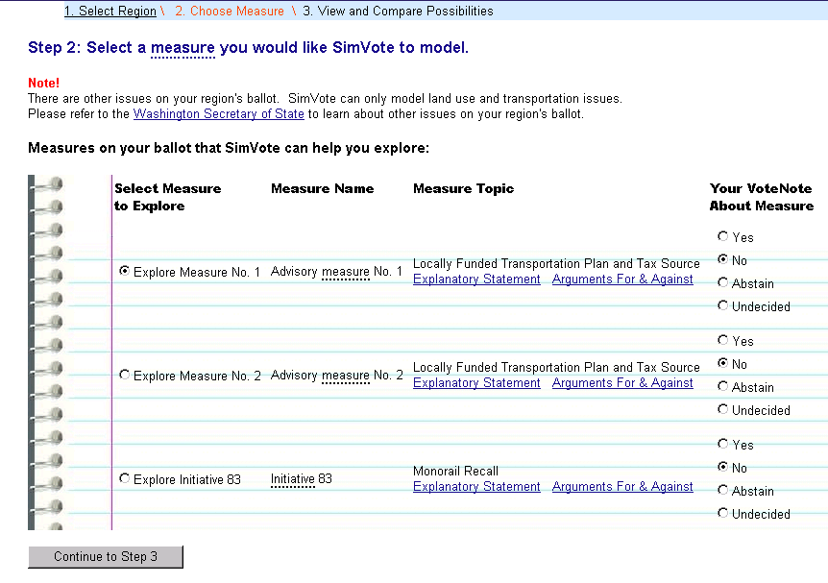
Figure 8. Interactive Prototype’s Measure Selection Page

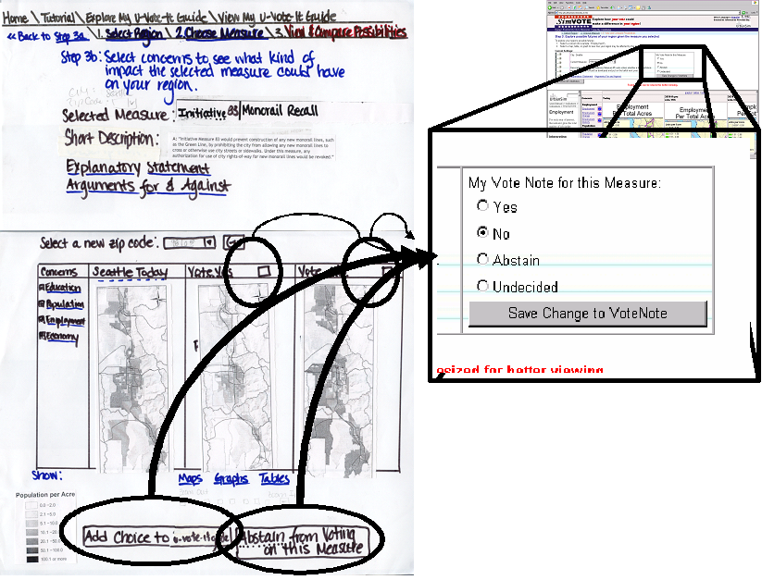
Figure 9. "Visualize and compare concerns". Instead of having the decisions scattered around the page we concentrated them in one clear place.

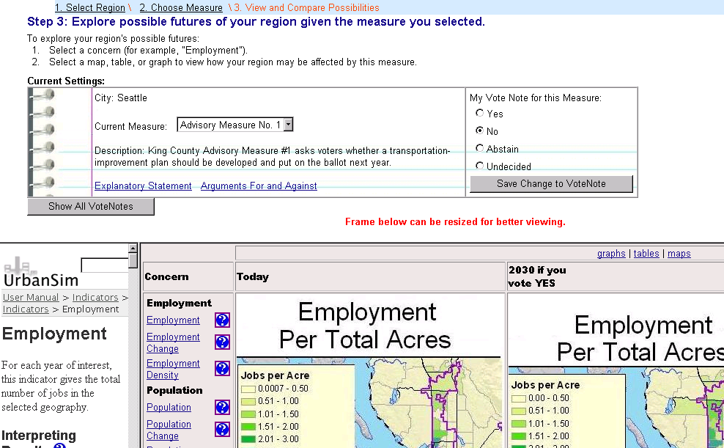
Figure 10. Interactive Prototype's Measure Exploration page

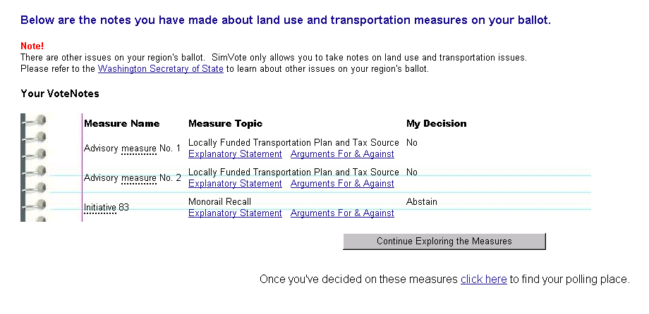
Figure 11. Interactive Prototype's VoteNotes page.

The visualization problems would still need to be tested more on the interactive prototype before more work could be done. We felt that it made more sense to see how the users dealt with the visualizations on a computer as opposed to paper, to see if that made a difference in clarity for them.

We kept the same navigational structure as what we had in the paper prototype with the exception of the extra step in between selecting a measure and exploring its visualizations, therefore trading off a more heavy handed approach to informing our users for more usability [Figure 5]. However we got rid of some functionality that was difficult to display in the interactive prototype without getting bogged down by implementation difficulties. Furthermore, those issues were not central to our interface goals so we didn’t feel it was a good use of our time) Some examples of these are the VoteNote open, save and print functionalities and the tutorial.

Pilot Usability Test

GOAL
The main goal behind this usability test was to perform a formative evaluation of the SimVote interface. The interface was assessed with respect to simplicity, usability, accountability, fairness and how much it informs and engages citizens.

METHOD
In order to test our interface we recruited three undergraduate students at the University of Washington that were interested in politics. We recruited our participants by sending out an email invitation to the following student groups at the University of Washington: the Earth Club, Libertarians at the UW, Sustainable UW Alliance, Young Democrats at the UW, and the College Republicans at the UW. The three respondents were all affiliated with Libertarians at the UW. Since this is a pilot test, we concluded that it was not necessary to test the interface with a more representative group but we realize that this is necessary future work. Appendix C shows the test’s full text.

Our evaluation had four parts:
- Interview: To understand users’ background with respect to the way that they usually vote and inform themselves on issues.
- Paper pre-questionnaire: To see how informed users were about land use and transportation measures and implications.
- Tasks and interview: To observe how usable and simple the interface was, and to observe how far it went in supporting usability and the ability to support the values of accountability, fairness, and informing and engaging citizens.
- Paper post-questionnaire: To see the impact that our interface had on the user’s knowledge about land use and transportation measures and ballot terminology.

RESULTS AND FUTURE DESIGN STEPS
We were evaluating our interface on the criteria of being highly usable and simple and the ability to support the values of informing and engaging citizens, accountability, and fairness. The following paragraphs present the results found for each of these criteria and values and some design steps that we would pursue on the next iteration.

Usability and simplicity. Our interface did moderately well at being usable and simple. The structure of the interface (i.e. the steps) seemed natural to the participants and the collection of indicators into concerns also seemed to be well-apprehended and did not give any user any trouble. Although the graphs and tables were very well-understood and liked by the users, the maps were not simple and were somewhat confusing to all of the users, which showed that more work on this last visualization format is needed. Two of three users had to be directed to the concern visualization page. Perhaps instead of having this screen’s submission button say “Continue to step 3” it should say something more descriptive such as “Go to step 3 to view and compare possibilities”.

Fairness and informing and engaging citizens. Overall, our final prototype went a ways in supporting fairness and informing and engaging citizens, but there is still work to be done. All participants understood that they were not voting and that there were additional issues on their ballot. A couple of users even commented that they liked the “VoteNote” metaphor. Unfortunately, 1/3 of the users did not use the mouse-overs that gave definitions of difficult voting terms. However, the participant that did use the mouse-overs learned the difference between an initiative and a measure by the end of the task. Perhaps this means mouse-overs aren’t a bad way of informing the user, but more care needs to be taken to introduce and highlight this functionality.

Accountability. Our interface did not do so well in supporting the value of accountability. The underlying interface components supporting this value should have enabled the users to know and understand where all of its data was coming from. However, none of the participants realized the simulation data was provided by UrbanSim and none of the participants knew what UrbanSim was. One reason why the second version of the interface may have been unsuccessful in informing the users of the answer to this question is that our heuristic evaluators were all graduate computer science students that already knew about our project and knew a bit about UrbanSim. Therefore, it was implicitly clear to them where the information was coming from. Based on their feedback, we weren't concerned with explicitly designing for accountability in our interactive prototype. This shows how important it is to choose the right population to test an interface. One simple solution to this problem would have been to enlarge the UrbanSim logo in each page and present this information in the home page. Furthermore, our interface did not inform the user about where the explanatory statements and arguments for and against were coming from (two users explicitly noted this as they were thinking aloud while they were using the interactive prototype).

Conclusions and Future Work

Designing the SimVote interface has made definite first steps in using UrbanSim simulation data to inform citizens as they vote, but there is still much work to be done. This paper has discussed how user-centered design has been key to designing this interface. Some lessons we have learned from this project follow:

- Metaphors are very useful to help the designers have an existing model by which to guide their design process when the metaphor is chosen very carefully. For example, the metaphor of the “ballot”, while providing familiarity and a good mapping to the everyday world, could be misleading in that users might think they were actually voting on our site when they were not. We had to spend a lot of time making sure the users did not get confused by this when maybe choosing a different metaphor would have been a better design solution.
- If the designers are committed to value sensitive design, then they need to check at each step of the process if they are still supporting the values that they identified in the conceptual investigation. For example, we did not check for accountability at each step and, as a consequence, were not able to have satisfactory results for this value in our two rounds of interface evaluation. In contrast,
- Sometimes usability issues will conflict with the values being designed for. Interface testing (“empirical investigation” in the language of Value Sensitive Design) is key to understanding what is best to tradeoff. In fact, the more iterations between an interface and interface evaluation the better and more thorough our interface got.
- Evaluating the interface using a questionnaire that explicitly addresses the goals of the interface is invaluable. It not only allows designers to have a clear view of what the interface goals are, but it also structures the evaluation and makes the time spent on each user more efficient and useful.

In order make the SimVote interface a reality, still much work remains. Amongst the most important issues that need to be addressed are figuring out the relationship between indicators and concerns, thoroughly testing different sorts of data visualizations, looking at the possibilities of explaining what the indicator’s numbers mean and how to explain them without being biased, and perhaps most importantly, testing the interface with users that are more representative of citizens of an urban American population. Finally, real UrbanSim simulations will need to be integrated into our system.

7. References
[R 1] Edwards, A. “TOWARDS AN INFORMED CITIZENRY? Information- and communication technologies and electoral choice” I.Th.M. Snellen & W.B.H.J. van de Donk (eds.) (1998), Public Administration in an information age. A Handbook, Amsterdam IOS Press: 191-206.
[R 2] Held, D. (1996), Models of democracy, Cambridge: Polity Press.
[R 3] Waddell, P. UrbanSim: Modeling Urban Development for Land Use, Transportation and Environmental Planning. Journal of the American Planning Association, Vol. 68 No. 3, Summer 2002, pages 297-314.
[R 4] http://www.easyvoter.org
[R 5] http://www.secstate.wa.gov/elections/guide/
[R 6] http://www.monorailrecall.com/
[R 7] Friedman, B. Khan, P. and Borning, A. Value Sensitive Design and Information Systems in P. Zhang & D. Galletta (Eds.), Human-Computer Interaction in Management Information Systems: Foundations. M.E. Sharpe, Inc: NY.
[R 8] Borning, A., Friedman B., Davis, J., and Lin, P. 2005 Informing Public Deliberation: Value Sensitive Design of Indicators for a Large-Scale Urban Simulation. to appear in Proceedings of the 2005 European Conference on Computer-Supported Cooperative Work.
[R 8] Lewis C. and Rieman J.,Task-Centered User Interface Design A Practical Introduction 1993, 1994
[R 9] http://www.eztaxreturn.com
[R 10] van Duyne, D. Landay, J. and Hoing, J. The Design of Sites: Patterns, Principles, and Processes for Crafting a Customer-Centered Web Experience
[R 11] http://www.seattle.gov/ethics/el04a/report/vpp/fameduct.htm
[R 12] Waddell, P. Franklin, J. and Britting J. UrbanSim: Development, Application and Integration with the Wasatch Front Regional Travel Model Technical Report CUSPA-03-01
[R 13] Nielsen, J. and Molich, R. Heuristic evaluation of user interfaces. Proceedings of CHI, 1990

Appendix A: “The Stranger” Cheat sheet
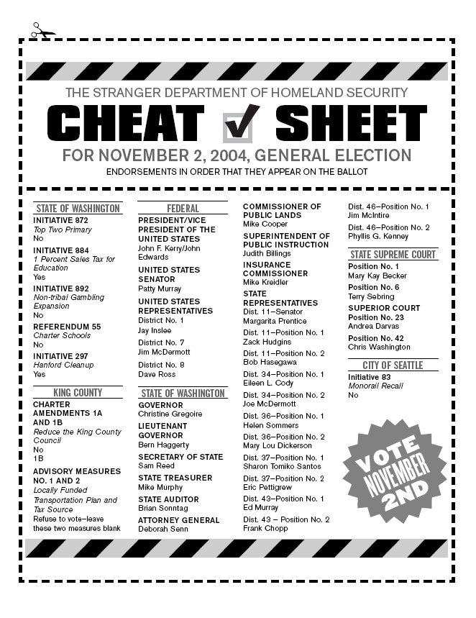

Appendix B: Heuristic Evaluation
General Scenario
You care about your city and you regularly vote but you don’t have a lot of time. You read “The Stranger” regularly and you were about to vote according to what the cheat sheet said but you saw that there were two measures whose decisions you found interesting. A friend told you about www.uvoteit.org and you decided to check it out.

Task 1
You want to see why “The Stranger” suggested you vote no on Initiative #83 “Monorail Recall” so you explore its “Explanatory Statement” and the “Arguments For And Against” but you get distracted so you don’t make a decision.

Task 2
You did not understand why “The Stranger” suggested you refrain from voting on the advisory measures no.1 and no.2. You decide to explore these measures on SimVote. You start by looking at measure no.1 and you explore the Employment growth and Population growth to see what could possibly happen if you were to vote yes or no on this measure. After reviewing it you realize you should vote on it rather than leaving it blank. You make a decision and record it and then you explore measure no. 2 and make a decision on it as well.

Task 3
You want to make sure that you’ve explored and made a decision on all the measures that UrbanSim simulates. Once you’ve explored and decided on all the measures, you print your decisions to take them with you to the voting booth.

Violations Found | P1 | P2 | P3
 | Severity | Severity | Severity
1. [H2-1: Visibility of System Status]
a. After Step 1 of “Explore My U-Vote-It Guide”, selected city/zip code not shown (P1, P2) | 2 | 2 | 0
b. Step 3a (“Review Selected Measure”) not shown on navigation bar (P1) | 2 | 1 | 0
2. [H2-2: Match Between System & Real World]
b. Concerns of Step 3b are too complicated (too much functionality) and confusing for target audience/user (P1, P2) | 2 | 2 | 3
d. The title “My U-Vote-It Guide” is weird because “my” is in first person and “U” (you) is in second person (P2) | 1 | 1 | 1
e. The “My U-Vote-It Guide” does not conceptually match what the user is doing in the interface; a “guide” helps signals something more static, where in the interface the user is really exploring options (P2,P3) | 2 | 1 | 3
f. 3 screens/ 2 votes/ don’t fit together? (P2) *** | 2 |  | 1
g. Unclear whether you can actually vote using this interface (P3) | 3 | 3 | 3
h. don’t know what terms ES and stuff means (P3) *** | 3 | 2 | 3
3. [H2-3: User Control & Freedom]

4. [H2-4: Consistency & Standards]
a. Steps 1, 2, 3 and then division of Step 3 into Step 3a and 3b (P1,P3) | 3 | 0 | 2
b. Zip code / city problem (P1) *** | 1 | 1 | 0
c. In Step 3b, cannot click on “Please Select Concern” to select a concern (must choose concern from left portion of the interface) (P1) | 1 | 1 | 3
d. In Step 3b, the button that says “Add choice to ballot” is confusing when the user has already made a decision about the measure (P1) | 2 | 2 | 1
e. In guide screen, confusion over what “Edit” means (with respect to a decision on a measure) (P1) | 2 | 0 | 1
f. In other parts of the interface, the user can hover over words they may not know the meaning of, but in Step 3b cannot hover over concerns (P2) | 2 | 1 | 2
g. It is confusing that the directions for the “start a new u-vote-it guide” say “click this button” in first screen of “Explore my U-vote-it guide”. (P3) | 2 | 1 | 2
h. Most of the sub-navigation bars (Step 1, Step 2, Step 3) are used for navigation and the last page (“My U-Vote-It guide”) uses it for functionality( Open, Save, Print) (P3) | 2 | 1 | 2
5. [H2-5: Error Prevention]
a. Unclear about what “Select New Zip Code” is going to do in Step 3b | 1 | 2 | 1
6. [H2-6: Recognition Rather Than Recall]
a. In Step 2 and in the guide (last screen), has to remember what the X and checkmark mean (i.e. no vote and yes vote, respectively) (P1) | 3 | 0 | 1
b. Then doesn’t know what choices made were- (P1) *** | 3 |  | 1
c. In Step 2 and in the guide (last screen), confusion about what X and checkmark mean (i.e. no vote and yes vote, respectively) (P1) | 4 | 0 | 2
7. [H2-7: Flexibility & Efficiency of Use]

a. In Step 3b, the button that says “Add choice to ballot” is confusing when the user has already made a decision about the measure (P2) | 2 | 1 | 3
b. If user has used the site many times, could be annoying to see 1st (informational) page over and over (P2) | 1 | 1 | 2
c. User has to select a radio button and then click on “continue to step 3” in step 2. These are too many clicks. (P3) | 1 | 1 | 3
8. [H2-8: Aesthetic & Minimalist Design]

a. User has to select a radio button and then click on “continue to step 3” in step 2. These are too many clicks. (P2,P3) | 1 | 1 | 3
b. Step 3a is unnecessary (P3) | 2 | 1 | 2
9. [H2-9: Help Users Recognize, Diagnose, & Recover from Errors]
a. Not enough information about what numbers mean (in Step 3b) (P1) | 4 |  | 3
10. [H2-10: Help & Documentation]

a. too repetitive? (P2) *** | 1 | 1 | 2
Total number of violations found | 13 | 10 | 10
Contributions | 13 | 9 | 6

Appendix C: Interface Evaluation Document

SimVote Interface Evaluation
Goals
This study is meant to perform a formative evaluation of the SimVote interface. The interface will be assessed with respect to simplicity, readiness-to-hand, freedom from bias, fairness and how much it informs and engages citizens.

Tell the participant: We’ve been designing an interface to aid engaged citizens make an informed vote through UrbanSim predictive simulation visualizations. UrbanSim is a an land use and transportation simulation system that allows people to explore how their region might look like 20-30 years from now. An important thing to keep in mind is that UrbanSim does not yet have the capability to provide our interface with real data. Any visualization data presented here was manufactured for testing purposes. However, UrbanSim will be able to provide this information soon and so we are interested in learning about how you might use this interface and how much you can learn and understand about land use and transportation policies throught it. We’d like to ask you about your interests and concerns, and also ask you to perform several tasks using the interface. We very much appreciate your willingness to participate.

Some details:
- Your participation is voluntary.
- You may discontinue your participation at any time.
- If I ask you a question that you're not comfortable with, you may chose not to answer.
- If you have any questions about the interview, I will be happy to answer them -- though I may ask you to wait until we've completed the interview so that my answers won't affect yours.
- Key presses and other inputs on the computer will be recorded.
- All results will be reported anonymously to protect your privacy.

(Give the participant time to read the form.)

May I ask you to sign this consent form agreeing to participate in the study.

(Participant must sign form.)
(Give the participant a blank copy of the consent form to take with them.)

Introduction (1 min)
I'm interested in finding out what you think and your reasons for why you think what you think. So, I'll be asking you "why?" a lot. That doesn't mean that I don't believe your answer or that I think it's the wrong answer. It's simply that I really do want to understand your point of view.
The study today is going to consist in X parts:
- Pre-questionnaire: we want to know some of your background with respect to public policy so we’ll be asking you a few informal questions and we will also ask you to fill out a short paper questionnaire
- Interface testing: I will briefly demo the interface that we have built and then I will ask you to complete three tasks using the interface. We would appreciate it if you think aloud that way we can evaluate the interface better.
- Post-questionnaire: We will be giving you a short questionnaire to understand how well our interface is doing what it’s supposed to do.

1. Pre-Questionnaire
I will ask you some questions about your background and then I’ll ask you to complete a short survey. This will take less than 10 mins. Are you ready?
- Did you vote in the last elections? Why, Why not? [background info.]

- Where did you get information from about the different policies at stake? [background info.]

- On a scale from 1 to 5, how informed do you think you were? [background info.]

- On a scale from 1 to 5, how informed would you have liked to be? If this number is different than the previous number, why is it so? [background info.]

- Do you think that these sources of information are fair and show all sides of the issue? [comparison w/other tools]

- Are they easy to understand? [comparison w/other tools]

- Did you take anything with you to the voting polls? (For example, a piece of paper saying what to vote for or a voting guide with your decisions filled in) [comparison w/other tools]

- How much time did it take you to prepare before voting for the last elections? [engagement]
  - Less than 30 mins
  - 30 mins. – 2 hours
  - 2 hours – 4 hours
  - more than 4 hours

- When was the last time you tried to find out information about a certain public policy? What were you looking for? How long did it take you to find the information you needed? [engagement]

Now I will give you this short paper questionnaire. Take your time to answer and if you don’t know the answer you can just leave it blank. [informed citizen]

- Define the following terms in your own words. If you believe that they are the synonyms you only need to define it once and state “synonym” for the other one(s)
  - Measure:
  - Initiative:
  - Referendum:
  - Explanatory statement:

- Please describe in a few sentences the long term implications that building the monorail in Seattle would have on the economy and population of Seattle.

- Do you remember King County’s Advisory Measure No. 1 about “Locally Funded Transportation Plan”? Can you describe it to me in your own words? What were the different arguments for and against? Who prepared them?

2. Tasks
Now we’ll give you three tasks that you need to complete using our interface. When you are done please say done and we’ll move on to the next tasks. This will take less than 20 mins. We want to hear what you’re thinking so please say whatever comes to your mind. I will demo the interface for you and then we will begin. Remember that the visualization data was manufactured for testing purposes. However, please pretend it is real for us to understand how the real data might be used when it becomes available in the near future.

[ come up with a short task here to demo]

[Make sure that we’re recording the screen]

The general scenario behind these tasks is that you care about your city and you regularly vote but you don’t have a lot of time. You read “The Stranger” regularly and you were about to vote according to what the cheat sheet said but you saw that there were two measures whose decisions you found interesting. A friend told you about www.simvote.org and you decided to check it out.

Task 1
You want to see why “The Stranger” suggested you vote no on Initiative #83 “Monorail Recall”. Please review its explanatory statement and the arguments for and against. Once you’re done reviewing them, please tell me which argument you find more compelling and why.

Task 2
You want to see why “The Stranger” suggested you refrain from voting on the advisory measures no.1 and no.2. Look at measure number 1. Specifically, look at the Employment and Population maps to see what could possibly happen if you were to vote yes or no on this measure. Please decide and record how you want to vote on this measure. Finally , look at measure 2 and its implications on Employment and Population. You can also look at the tables and charts to help you make a decision. Decide and record how you want to vote on this measure.

Task 3
Make sure that you’ve explored and made a decision on all the measures that UrbanSim simulates. Once you’ve explored and decided on all the measures, print your decisions to take them with you to the voting booth.

[stop recording of the screen]
3. Post-questionnaire
I will ask you some questions about the interface and then I will ask you to complete the questionnaire that we gave you at the beginning once again. This will take less than 10 mins.

Questions:
- Where did the information that was provided in the site come from? [accountability]

- Would you use a second source of information to double check? If so, which one?[trust-accountability]

- What is UrbanSim? [accountability]

- How much time would you invest using this system, for example, before the elections? [engaged]

- Do you think that the different visualizations of the information would be helpful for you once they present real data? Was one more helpful than the other? Were you able to distinguish differences amongst the maps? [simplicity- comprehension]

- Pretend you are taking a political science class and everyone needs to present one measure that was up for voting last elections in their region. Pretend you chose measure #83 (Seattle’s monorail initiative). How would you present it in terms. Namely, what props would you use and what would you say about it? [informed – simplicity – comprehension – readiness-to-hand]

- Do you think that looking at the visualizations would make you strengthen/change your mind once they present real data? Why? Why not? [informed]

Now I will give you this short paper questionnaire. Take your time to answer and if you don’t know the answer you can just leave it blank.

- Define the following terms in your own words. If you believe that they are the synonyms you only need to define it once and state “synonym” for the other one(s)
  - Measure:

  - Initiative:

  - Referendum:

  - Explanatory statement:

- Please describe in a few sentences the long term implications that building the monorail in Seattle would have on the economy and population of Seattle.

- Do you remember King County’s Advisory Measure No. 1 about “Locally Funded Transportation Plan”? Can you describe it to me in your own words? What were the different arguments for and against? Who prepared them?

Debriefing
Thanks for participating in our study. Do you have any comments you would like to add?
[wait for response]
Thank you again, your input is very helpful and we greatly appreciate your time and effort.
[give them the goodies]

Materials:
6 short surveys.
Computer to take notes on
Computer to show the interface on (make sure that interface and video work)
6 Consent forms (three for us and three for them)
Interface
Pens

Short pre- questionnaire
Please answer the following questions to the best of your abilities. If you do not know the answer please leave the question blank or write “ I don’t know”.

- Define the following terms in your own words. If you believe that they are the synonyms you only need to define it once and state “synonym” for the other one(s)
- Measure:

- Initiative:

- Referendum:

- Explanatory statement:

- Please describe in a few sentences the long term implications that building the monorail in Seattle might have on the economy and population of Seattle.

- Do you remember King County’s Advisory Measure No. 1 about “Locally Funded Transportation Plan”? Can you describe it to me in your own words? What were the different arguments for and against? Who prepared them?

Short post- questionnaire
Please answer the following questions to the best of your abilities. If you do not know the answer please leave the question blank or write “ I don’t know”.

- Define the following terms in your own words. If you believe that they are the synonyms you only need to define it once and state “synonym” for the other one(s)
- Measure:

- Initiative:

- Referendum:

- Explanatory statement:
- Pretending that the information we provided in our interface was real, please describe in a few sentences the long term implications that building the monorail in Seattle might have on the economy and population of Seattle.

- Do you remember King County’s Advisory Measure No. 1 about “Locally Funded Transportation Plan”? Can you describe it to me in your own words? What were the different arguments for and against? Who prepared them?

