CSEP 590b: Web Access Assignment
Authors: Chloe Claridad; Kevin Murphy; Additional analysis from Kam Chuen Mak and Brian Rogers and Johnny Ahmed

Introduction of Digital Defense Fund Website and Its Purpose
The Digital Defense Fund website contains resources on how to access abortion and other reproductive health care safely. These resources include topics around website security, staying safe online, and more. The purpose of these resources from Digital Defense Fund are meant to leverage technology to defend and secure access to abortion for organizations and individuals, especially to those who may be more vulnerable to surveillance because of their disabilities.

Currently, DDF develops and maintains several publicly facing technologies:
- digitaldefensefund.org: DDF’s primary web presence
- VolunteerMeet: A web application for managing volunteer applications and vetting
- CarrierPigeon: A text hotline with Slack integration for easier management
- Pigeon Slack App: A Slack-integrated application used to provide information, find clinics, and answer client’s questions

Assessment of the Digital Defense Fund Website

Sections of the Website Assessed and Evaluation Tools Used
An assessment of the accessibility of digitaldefensefund.org was performed through exploring the Learn and Press sections of the website, including completing the following tasks:
- Download and consume DDF media including “Zines,” guides, and slide decks using VoiceOver.
- Fill out a form on the website using only keyboard navigation.
- Read DDF’s Press Policy using VoiceOver.

Testing was done using Apple’s VoiceOver on macOS as a screen reader, an online Automatic Tool called WAVE (Web Accessibility Evaluation Tool), an iOS Screen Reader, and keyboard tab switch input.

Summary of Most Severe Problems Found in Assessment
The Digital Defense Fund website’s sections of Learn and Press violates the Web Content Accessibility Guidelines version number 2.1, also known as the abbreviation WCAG 2.1, set by The World Wide Web Consortium, also known as the abbreviation W3C. The most frequent and severe problems found in my assessment were the following:
- Missing Text Alternatives, also abbreviated to Text ALT, for images.
- Very low contrast ratio between text and background colors where this ratio is below 4.5:1.
- Heading levels are skipped. For example, there is a heading level 3 following a heading level 1.
- Spanish language content is not programmatically differentiated from English language content

Summary of Recommended Solutions for Most Severe Problems Found In Assessment
To address the issues found, I recommend the following solutions:
- Provide correct and descriptive alternatives for any non-text content near the image or in the alt attribute of the image.
- Increase the contrast between foreground and background color.
- Restructure the page headings so heading levels are not skipped.
- Update the `lang` attribute on surrounding HTML elements to provide necessary language content to the screen reader

Overview of Most Severe Problems Found
The following is an overview table of each type of WCAG violated and how often the problem occurs, categorized by severe, moderate or minor the problem is:

WCAG 2.1 # | # Severe problems | # Moderate problems | # Minor problems
1.1.1 (Non-text Content) - Perceivable | 10+ | 0 | 0
1.4.3 (Contrast) - Perceivable | 10+ | 0 | 0
2.4.1 (Bypass Blocks) - Operable | 0 | 1 | 0
2.4.6 (Headings and Labels) - Operable | 0 | 0 | 1
3.1.1 (Language of Page) - Understandable | 0 | 1 | 0
3.1.2 (Language of Parts) - Understandable | 0 | 1 | 0
3.3.2 (Labels or Instructions) - Understandable | 0 | 0 | 1

ALT Text for Above Table: Table containing WCAG 2.1 guidelines violated, categorized by how severe, moderate or minor each guideline violated is. The severe, moderate, and minor problems columns are the number of times it occurs for each column for each violated guideline.

Detailed Description of WCAG Violated
This section goes into detail about the specific Web Content Accessibility Guidelines (WCAG) 2.1 that are violated in the Learn and Press sections of the Digital Defense Fund website. The WCAG is built upon the four main guiding principles of accessibility. These four principles, commonly known by the acronym POUR, are perceivable, operable, understandable and robust. The following definitions is taken from WebAIM’s checklist definitions:
- Perceivable: Web content that is made available to the senses - sight, hearing, and/or touch.
- Operable: Interface forms, controls and navigation are operable.
- Understable: Information and the operation of the user interface must be understandable.
- Robust: Content must be robust enough that it can be interpreted by a wide variety of user agents, including assistive technologies.

WCAG 2.1: 1.1.1 - Non-Text Content
Guideline 1.1.1 of WCAG 2.1 is when text alternatives are provided for any non-text content. This means web content like images, image buttons contains correct and descriptive alternative text are all made easily available to the senses. This guideline follows the POUR principle, perceivable.

Detailed Issues Found on Website:
In the sections of Learn and Press on the Digital Defense Fund web pages, this issue occurs over 10 times. When using the automated tool, WAVE, it found only a few missing alternative text for images. However, when manually checking all the images on the page, most images had incorrect or missing alternative text. Also, the screen reader for iOS displayed the same issue because it would not display any content or information for that same image. This is a severe issue because of how frequent this issue occurs and the lack of information users are missing out on from missing alternative text.
An example of incorrect alternative text can be found on the Artwork & Zines from Digital Defense Fund page in the Digital Defense Fund Learn section. There are 7 tiles that contain images, each containing an alt attribute. However, the alt attribute description is not descriptive or incorrect in its description of the image. In the screenshot below, the image of the tile is a pigeon happily taking a bath while scrolling through its phone and the image is titled Browsing. However, the alt text only says the title of the tile which is “Cybersecurity with Pigeon: Confidential Browsing.” The description of the alt attribute does not capture the intent of the image.
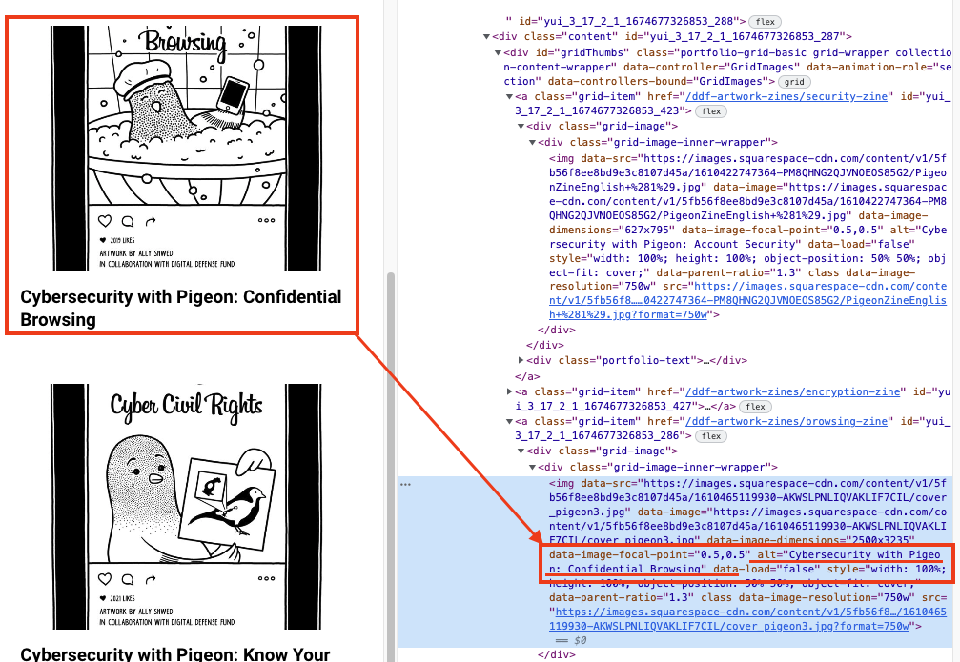

An example of missing alternative text was for the image under Digital Security for Abortion and Pregnancy Privacy. This image contained no alt attribute when inspecting the image. Also, the screen reader did not display any information for that image.
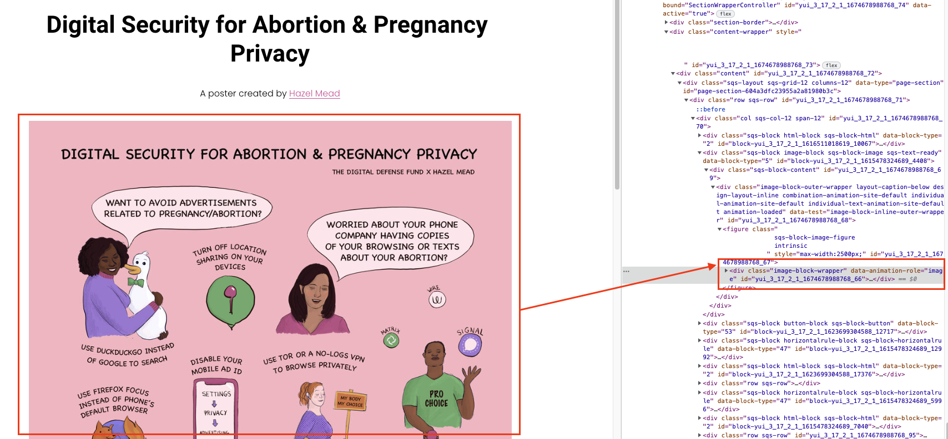

The following is how often missing or incorrect alternative text occurs on each sub-section of the Learn section:
- Artwork and Zines page: 7 times
  - All tiles displayed on the page are missing correct and descriptive alternative text. Please see Appendix to see which images are violating this guideline.
- DDF Guides page: 4 times
  - 4 tiles displayed on the page are missing correct and descriptive alternative text. Please see Appendix to see which images are violating this guideline.
- DDF Slide Decks page: 10 times
  - All tiles displayed on the page are missing correct and descriptive alternative text.

Possible Solution:
A quick solution for these issues would be to provide correct and descriptive alt text for every image on the site.

WCAG 2.1: 1.4.3 - Contrast (Minimum) (Level AA)
The visual presentation of foreground color, or text, and background color must have a minimum contrast ratio of at least 4.5:1, with a few exceptions listed in W3C Recommendations website. This guideline is another example that follows the POUR principle, perceivable.

Detailed Issues Found on Website:
When using the automated tool on all pages in the Learn and Press sections, the tool found there are over 100 total very low contrast errors. When there is a very low contrast error, this causes an issue because adequate contrast of text is necessary for all users, especially those with low vision. When there are this many low contrast hyperlinks, it can make it very difficult for users with low vision to be able to navigate through these pages. These contrast errors happen the most frequently with hyperlinks. This is a severe issue with the amount of times this issue occurs. It is also severe because a person with low vision can be severely impacted by being denied access to these valuable resources these links can lead to.
The following image is an example of how many low contrast errors WAVE found and the hyperlink in question.
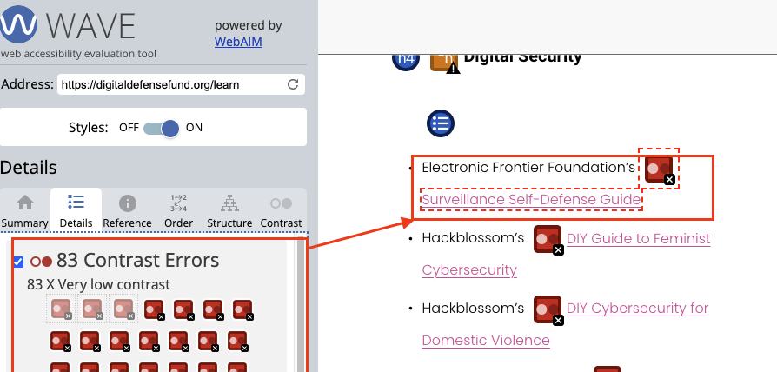

Possible Solution:
As a quick fix, increase the contrast between the foreground (text) and background colors to a minimum ratio of 4.5:1. Using the online tool WebAIM: Contrast Checker is a helpful tool to make sure all text and background color pass this ratio.

WCAG 2.1: 2.4.1 - Bypass Blocks (Level A)
Bypass Blocks is an example of providing ways to help users navigate, find content and determine where they are. Bypass blocks provide proper heading structure or identification of page regions. Bypass blocks also provide a link to skip navigation and other page elements that are repeated across web pages. This guideline falls under the Operable principle of POUR where interface forms, controls and navigation are operable.

Detailed Issues Found on Website:
On the Learn page of Digital Defense Fund page, heading levels are skipped from h2 to h4, as shown in the following photo.
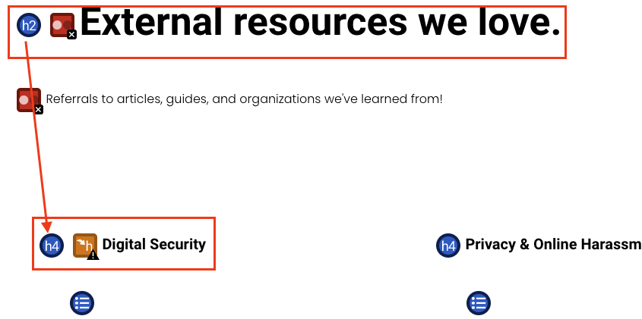
Although the frequency of this issue is low for this website, a screen reader will have difficulty navigating when heading levels are skipped. So users will be confused or have difficulty navigating around the page with this issue.

Possible Solution:
Ensure all headers are not skipped. With the issue found above, ensure the headers go from h2 to h3, instead of h2 to h4, as a quick fix.

WCAG 2.1: 2.4.6 - Headings and Labels (Level AA)
This guideline recommends that page headings and labels for forms or interactive controls are informative and not duplicated by name. For example, avoiding a heading with “More Details” or a label text with “First Name” unless it is clear there is a difference between them. This guideline is another example of helping users navigate, find content and find where they are. This guideline is also an example of the POUR principle, Operable since navigation is operable.

Detailed Issues Found on Website:
On the Press page, there is an empty header containing no content. This can be an issue especially for users that are keyboard or screen reader users navigating by heading elements can be confused or have lack of information form the empty header. In this case, this issue only occurs once in all the pages. Also, a user is able to still navigate and understand the content of the rest of the page. It is a minor issue that causes slight inconvenience and possible confusion to navigate past this empty header. Below is the photo found on the Press page when using WAVE to detect the missing header.

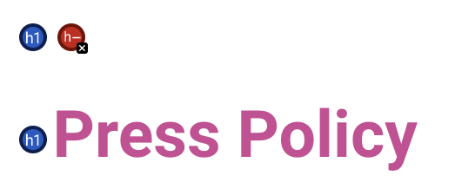

Possible Solution:
An easy solution would be to remove this header or add the appropriate content that was meant to be here.

WCAG 2.1: 2.4.3 (Focus Order)
Keyboard users who navigate websites expect elements to have a logical, usable focus order. Often this experience can be browser specific. For example, one evaluator found that when testing the switch input of the website, there were issues tabbing through the website. They were able to successfully get to each link and every part of the page easily. However, for another evaluator, the cookie notice that appears on digitaldefensefund.org (before a user has accepted or declined the use of cookies) blocks the first element that is focused during keyboard navigation. The keyboard user must then continually press tab until they reach the cookie notice, which is the last focusable element on each page.

In this illustration, on the index page, for example, using the tab key to focus the first element on the page brings the user to bottom of the page, but the focused search box is visually obscured by the cookie notice.
Because there is both a focusable “Search” field and a cookie notice on every page (until it is acknowledged), this issue exists on every page of the website. However, pages with longer forms are particularly problematic (for example, the “Projects” and “Contact Us” pages). In such cases, users cannot see what they are entering into the signup form until after they progress their focus, and users must navigate through many fields before they can acknowledge the cookie notice.

To fix this issue, the DDF can add a bottom margin to the body tag and place the cookie notice in that margin so that the cookie notice does not obscure the page’s main content. The body tag could be resized to reclaim the space using JavaScript once the cookie notice has been acknowledged.

WCAG 2.4.4 (Link Purpose (In Context))
Users of digitaldefensefund.org should be able to understand the purpose of links so that they can decide whether to follow them or not. In some cases, there is not enough information to understand the purpose of links, especially for users of screen readers who may navigate through links as a list (outside of the encoded document structure).

On the “External Resources” page, some links do not have useful, associated link text. As a result, it is difficult to determine if following those links would be valuable.
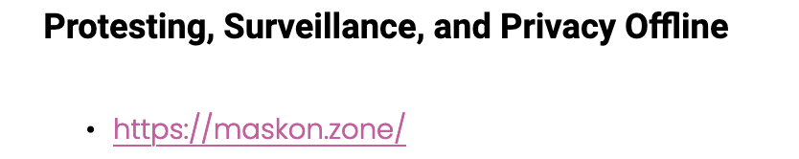

This violation occurs primarily on the “External Resource” page, but work should also be done to clarify the link text in the Spanish language section of the “Zine Detail” pages.
Currently, the links on the “External Resource” page are structured in unordered lists beneath headers that group links by their purpose. Sighted users may be able to understand the purpose of each link based on its visual position on the page. However, because a parent header does not qualify as “programmatically determined link context,” DDF should fix this by restructuring the page to use HTML tables with the purpose of each link section as the table column header. CSS can be used to achieve the desired visual appearance.

WCAG Section 3 (Understandable)

WCAG 3.1: 3.1.1-2 - Language of Page and Language of parts
Screen reading technology converts text to speech. For a screen reader to function properly, it must be able to programmatically determine the source language it is processing to make intelligible speech. Currently, the DDF website sporadically uses Spanish alongside English on its website without annotated differentiation. As a result, Screen Readers fails to produce a meaningful conversion to speech.
One example of Spanish being used as an undifferentiated second language alongside English is in the website’s navigation bar. A screen reader would not be able to provide an accurate verbalization of the Spanish language navigation item.
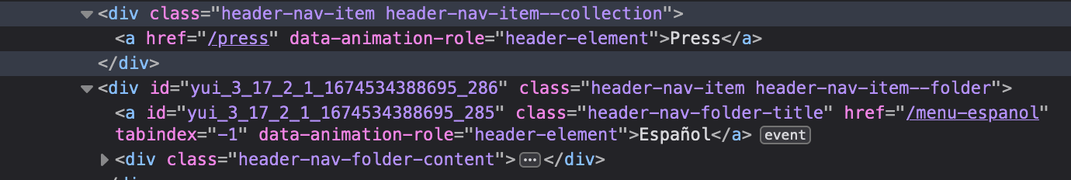
As an extraordinary case, the pages designed for Spanish Language speakers, such as “Who we are” have primary content written entirely in Spanish. Since the HTML `lang` attribute on the HTML element is assigned to United States English (“en-us”), the entire main content of the page is unusable by people who use screen readers to consume Spanish language content.
There are numerous pages impacted by the lack of differentiation between Spanish and English language content. In addition to the navigation bar item, the entire Spanish section of the website needs to be updated to identify the Spanish language content. Additionally, any references in Spanish from other sections of the website must also be addressed. For example, each of the Zines content pages must be updated to differentiate the Spanish used to direct Spanish speakers towards the Zines written in Spanish.

Possible Solution:
WCAG 3.1.1 refers to the language of the page is identified using the HTML lang attribute. For example, the following HTML lang attribute could be <html lang=”en”>. WCAG 3.1.2 refers specifically to the language of the content of the page in a different language identified using the lang attribute. For example, <blockquote lang=”es”>. WCAG recommends that "human language of each Web page" and the "human language of each passage or phrase in the content can be programmatically determined."
To address this issue, DDF should differentiate Spanish language content from English language content by assigning the Spanish ISO code (“es”) to the `lang` attribute on containing HTML elements.

WCAG 2.1: 3.3.2 (Labels or Instructions)
This guideline recommends there are sufficient labels for required interactive elements provided via instructions or properly positioned form labels. This guideline follows the POUR principle, Understandable. Form labels are important because they provide visible descriptions and larger clickable targets for form controls. By violating this guideline, if a form control does not have a correct text label, the function or purpose of that form control is not displayed from a screen reader.

Detailed Issues Found on Website:
Here is an example where the form label is missing on the website:

<div class="sqs-search-ui-text-input sqs-search-ui-button-wrapper color-light" data-source="block" data-preview="true" data-collection="" id="yui_3_17_2_1_1673900324200_124"> <div class="spinner-wrapper" id="yui_3_17_2_1_1673900324200_250" hidden="hidden" style="display: none;"></div> <input type="search" class="search-input hover-effect" value="" placeholder="Search" aria-label="Search"><div id="yui_3_17_2_1_1673900324200_129" class="yui3-widget sqs-widget sqs-search-preview"><div id="yui_3_17_2_1_1673900324200_131" class="sqs-search-preview-content"></div></div></div>

This issue is minor because this only happens once on one page. Johnny Ahmed wrote that this “does not impact the user’s ability to access the rest of the page content. It cannot be avoided but can be tabbed through quickly.” This is a larger issue for those who use screen readers.

Possible Solution:
By correctly using the <label> element to associate the text label with its corresponding form control would be a possible quick fix to this issue. However, if the text label is not visible, then providing a descriptive title attribute to the form control or reference the labels using the aria attribute ‘aria-labelledby,’ would be another solution.

WCAG Section 4 (Robust)
The team did not identify any WCAG Section 4 violations in their assessment of digitaldefensefund.org through the use cases.

Appendix A: More Information on Missing ALT Text Throughout Website
Below is a more detailed list of all images that are missing or have incorrect alt text in the Learn and Press sections of the website:

- Artwork and Zines page: 7 times
  - “Cybersecurity with Pigeon: Account Security” tile: Incorrect and not descriptive alternative text
    - The page this tile leads to is also missing descriptive alternative text for its comic.
  - “Cybersecurity with Pigeon: Encryption” tile: incorrect and not descriptive text
  - “Cybersecurity with Pigeon: Confidential Browsing” tile: Incorrect and not descriptive alternative text
    - The page this tile leads to is also missing descriptive alternative text for its comic.
  - “Cybersecurity with Pigeon: Protesting Safely” tile: Incorrect and not descriptive alternative text
    - The page this tile leads to is also missing descriptive alternative text for its comic.
  - “Pigeon Sticker Sheet” tile: Incorrect and not descriptive alternative text
    - The page this tile leads to is also missing descriptive alternative text for its comic.
  - “Cybersecurity with Pigeon: Know Your Cyber Civil Rights” tile: Incorrect and not descriptive alternative text
    - The page this tile leads to is also missing descriptive alternative text for its comic.
  - “Digital security for Abortion and Pregnancy Poster” tile: Incorrect and not descriptive alternative text.
    - The page this tile leads to is also missing descriptive alternative text for all images.
- DDF Guides page: 4 times
  - “Guides From Digital Defense Fund” banner alternative text is neither correct nor descriptive.
  - “DDF Guide To VPNs” tile alternative text is not correct. It does not describe correctly what the tile says.
  - “Data Breach Guide” tile alternative text is not correct. It does not describe correctly what the tile says.
  - “Social Media Guide” tile alternative text is not correct. It does not describe correctly what the tile says.
- DDF Slide Decks page: 10 times
  - All tiles displayed on page are missing correct and descriptive alternative text.

