DIGITAL DEFENSE FUND UARS

ID: AT-1
Problem
Name: Skipped Heading Level
Evidence: Guideline violated: 2.4.6 Headings and Labels (Headings and Labels)
- Screen Shot as the image and URL (https://digitaldefensefund.org/learn)
- 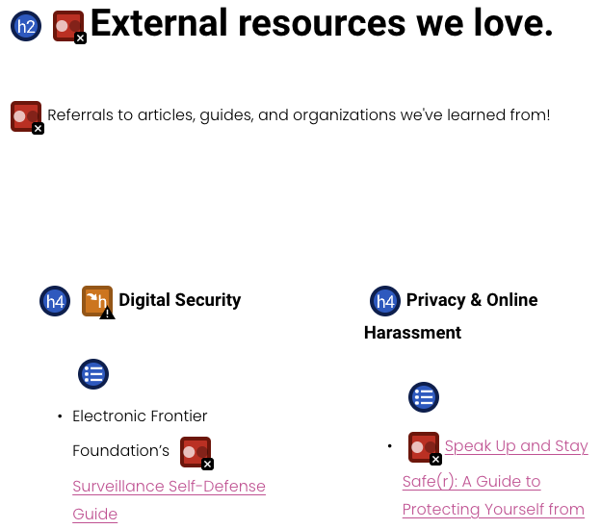
Explanation: A screen reader would have difficulty navigating when heading levels are skipped. So users will be confused or have difficulty navigating around the page with this issue.
Severity Rating: 2.
Justification: Frequency is low on this site because this only occurs once. Impact is low because it is possible to understand the structure of the page because this only occurs at the bottom of the page and there is a helpful section title, “External resources we love,” and can understand that the rest of the section are just helpful links. Persistence is high as it is not going to go away.
Relationships to other problems reported: This is the only area where the heading is skipped.

ID: AT-2
Problem
Name: Very Low Contrast
Evidence: Guideline violated: 1.4.3 Contrast (Minimum)
- Screen Shot as the image and URL (https://digitaldefensefund.org/learn)

- 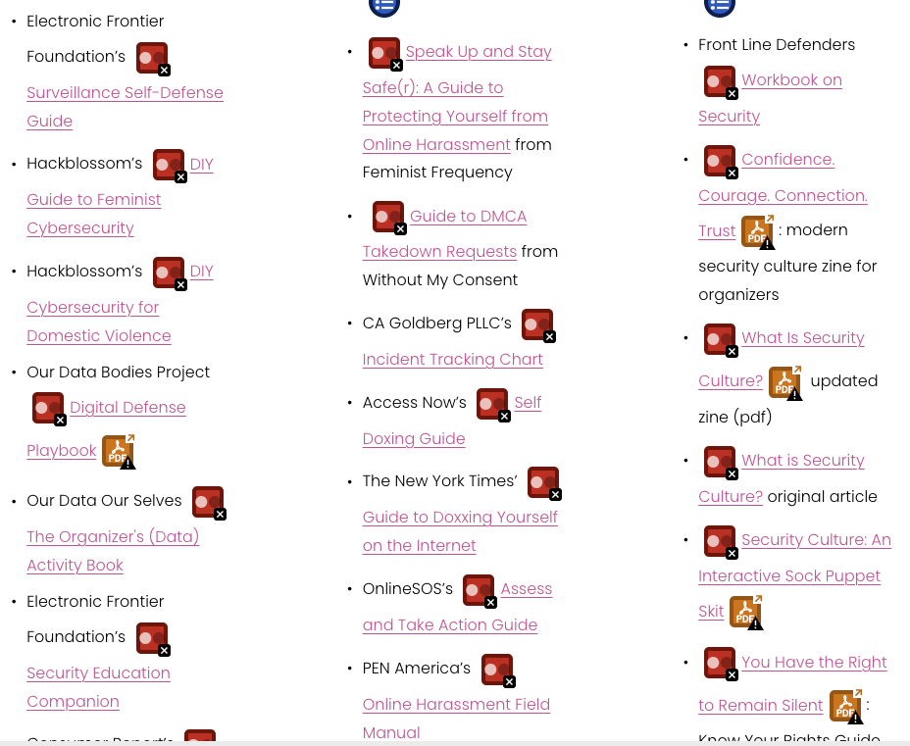
Explanation: A screen reader would not be able to have the required contrast ratio of at least 4.5:1 and so users, especially users with low vision, would have difficulty with the inadequate contrast of text.
Severity Rating: 3.
Justification: Frequency is high on this site because there are 83 contrast errors on this page. Impact is high because this can be an issue for users trying to view and understand the information on this page. Persistence is high as it is not going to go away.
Relationships to other problems reported: This problem occurs 83 times on this page.

ID: AT-3
Problem
Name: Empty Heading
Evidence: Guideline violated: 2.4.6 Headings and labels (Level AA); 2.4.1 Bypass Blocks (Level A
- Screen Shot as the image and URL (https://digitaldefensefund.org/press)
Explanation: A screen reader would have difficulty navigating by heading elements since this empty heading has no information present and can cause the user confusion.
Severity Rating: 3.
Justification: Frequency is low on this site because this only occurs once on the page. Impact is high because this can be an issue for users using screen readers and can get confused when navigating. Persistence is high as it is not going to go away.
Relationships to other problems reported: This does not occur anywhere else on this page nor on the Learn page.

Missing Form Label:
ID: AT-3
Problem
Name: Missing form label
Evidence:
Violates WCAG 2.1; 1.1.1 (Non-text Content); 1.3.1 (Info and Relationships); 2.4.6 (Headings and Labels); 3.3.2 (Labels or Instructions). Markup as follows:
<div class="sqs-search-ui-text-input sqs-search-ui-button-wrapper color-light" data-source="block" data-preview="true" data-collection="" id="yui_3_17_2_1_1673900324200_124"> <div class="spinner-wrapper" id="yui_3_17_2_1_1673900324200_250" hidden="hidden" style="display: none;"></div> <input type="search" class="search-input hover-effect" value="" placeholder="Search" aria-label="Search"><div id="yui_3_17_2_1_1673900324200_129" class="yui3-widget sqs-widget sqs-search-preview"><div id="yui_3_17_2_1_1673900324200_131" class="sqs-search-preview-content"></div></div></div>
Explanation:
If a form control does not have a properly associated text label, the function or purpose of that form control may not be presented to screen reader users. Form labels also provide visible descriptions and larger clickable targets for form controls.
Severity: 3
Justification:
The issue is infrequent, it happens on one page. It does not impact the user's ability to access the rest of the page content. It cannot be avoided but can be tabbed through quickly. This still has a greater impact on screen reader users.
Relationship to other problems: N/A

Spanish Language Not Semantically Included:
ID: SR-1
Problem
Name: Spanish language is not semantically indicated
Evidence:
Violates WCAG 2.1; 3.1.1 (Language of Page), 3.1.2 (Language of Parts). Markup for page as follows (partial):
<html xmlns:og="http://opengraphprotocol.org/schema/" xmlns:fb="http://www.facebook.com/2008/fbml" lang="en-US" . . .>
Markup for menu as follows (partial):
<div class="header-nav-folder-content" id="yui_3_17_2_1_1673737835516_482">
<div class="header-nav-folder-item" id="yui_3_17_2_1_1673737835516_481">
<a href="/espanol" id="yui_3_17_2_1_1673737835516_480">
<span class="header-nav-folder-item-content">
Quien Somos
</span>
</a>
</div>
<!-- . . . additional items omitted for brevity . . . -->
</div>

Explanation:
WCAG recommends that the "human language of each Web page" and the "human language of each passage or phrase in the content can be programmatically determined." In this case, there is Spanish language content on every page in the navigation header but it is not marked as such. In fact, every page, including the Spanish language pages, are attributed with lang="en-US". Screen readers therefore assume all content is in English. This results in incorrect narration of the Spanish language content, pronounced as if it were in English.
Severity: 4
Justification:
The issue applies to every page on the site. Users who operate multilingual screen readers will hear incorrect pronunciation of all Spanish content. The Spanish text, read as if it were English, is barely recognizable. While the site attempts to be inclusive of Spanish language users, the end result could be seen as offensive and demeaning to the audience.
Relationship to other problems: N/A

