Assignment 5: Setup Sound
PART 1
Setting Up the Spatializer:
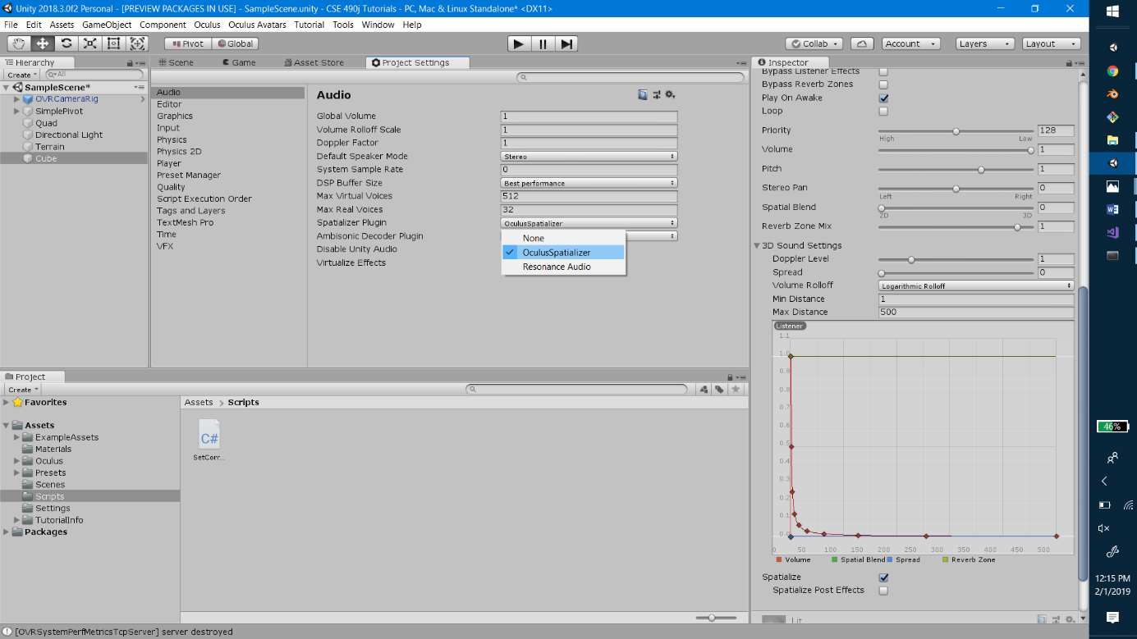
- In order to use spatialized audio, we need to enable it. To check to see if it is enabled, go to Edit -> Project Settings. This will bring up the project settings tab. Choose the Audio menu on the left side and find the setting labeled Spatializer. Click on the dropdown for Spatializer and look to see if Oculus Spatializer is an option. If it is, select it and Save Project, then continue on to part A.

- If not, you need to install it. You can do this by either Plugging In an Oculus Headset. This will enable you to use the spatializer and you can follow step 1 to set it up.
- If you don’t currently have access to an Oculus Headset, you can attempt to install the Oculus Integration Package. (BE CAREFUL DOING THIS because it could potentially break your project). You can still follow the tutorial and enable the spatializer settings later, if you would like to wait until you have a headset available.
- If still want to try, you can find the package by going to Window -> Asset Store and search for Oculus Integration. Download and import this package. This may take a while. Once it finishes installing, follow step 1 to enable the spatializer.

Part A: Ambient Audio
- Ambient Audio can be heard from anywhere in the scene; therefore, the ambient audio track can be placed anywhere in the scene. For this, make an empty GameObject and name it ‘Ambient Audio’ or something describing what the audio source is playing.

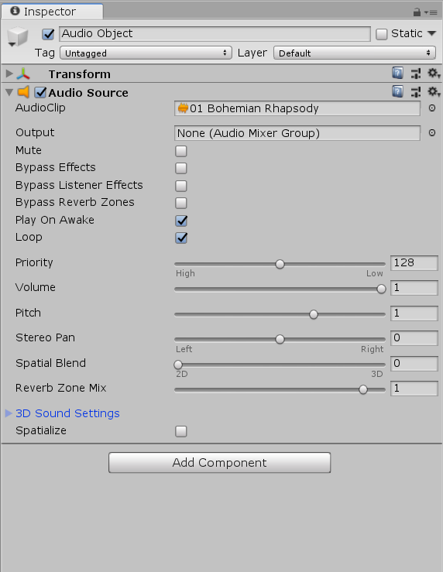
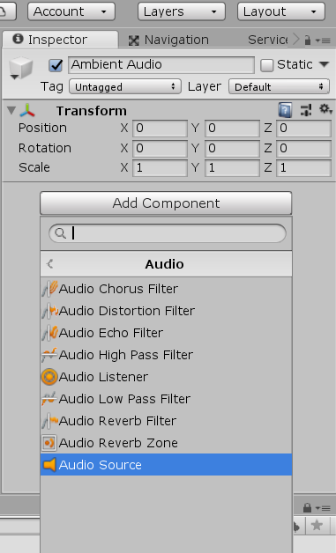
- Click on your ‘Ambient Audio’ object and look at the Inspector panel to the right. Scroll to the bottom of the inspector and click the Add Component button. A search bar will pop up and you can search for and select ‘Audio Source’; Alternatively you can select from the list Audio -> Audio Source.

- Now we can setup our audio source. If you look in the inspector find the component Audio Source component. Feel free to check out all of the attributes, but the one we care about first is the AudioClip at the very top. Find your audio file in your Assets folder in the Project tab. Click on the audio file and drag it to the AudioClip property in the inspector.

- Now the ambient sound should be setup. Feel free to press play and listen. However, you may notice that the sound stops after a certain amount of time. This is because the audio source has reached the end of the track. To make it play repeatedly we can set it to loop. To do this go to the Audio Source component again and check the box that says Loop. This will restart the track once it finishes playing.

Part B: Spatialized Audio
- When we interact with objects that make noise, we want to be able to hear them as we move closer to and farther away from them, or they move closer to or farther away from us. Therefore in this case, we will want to attach our audio source directly to the object that is making the noise.

- Find the object that you want to emit sound from and add an Audio Source component to it in the same way that you added your ambient audio source. Same as before, find your Audio Clip in the Project tab in the Assets folder.

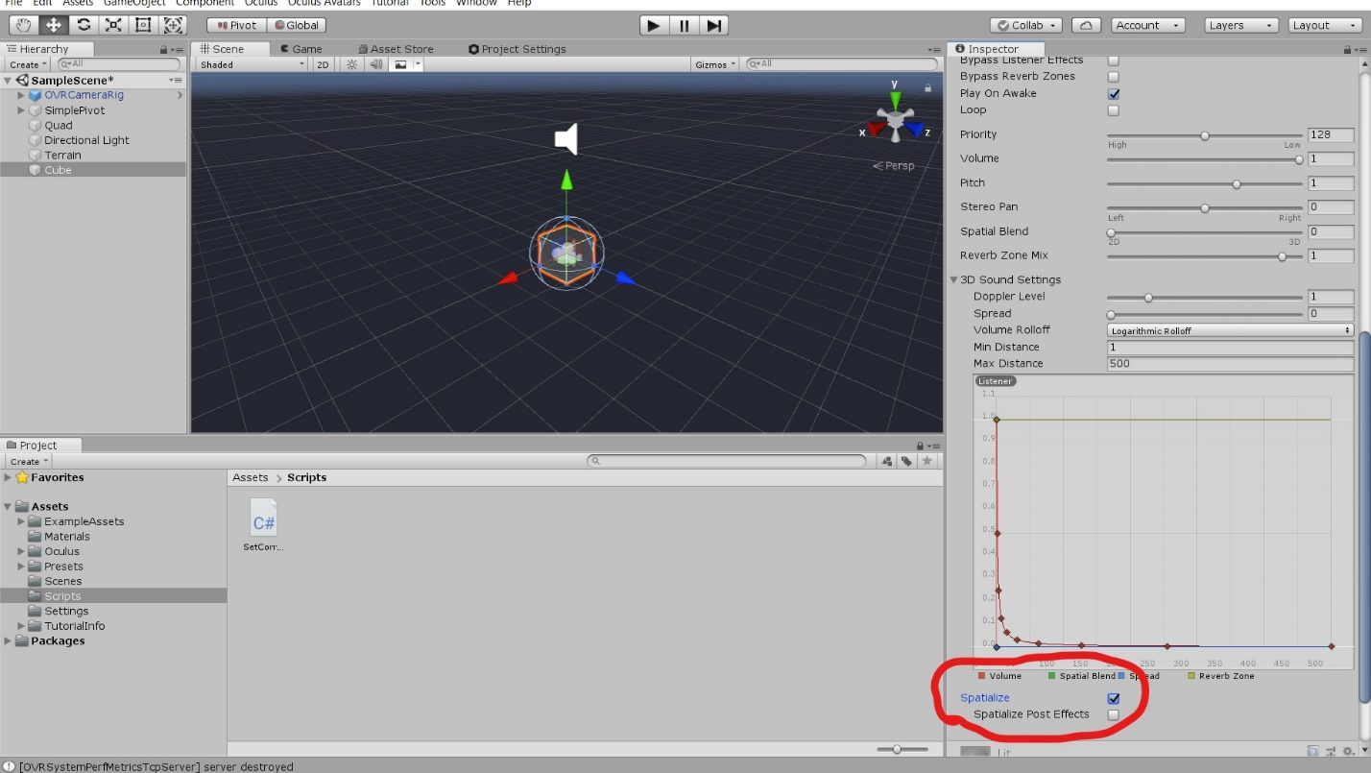
- In order to make this spatialized, look at the Audio Source component in the Inspector, and find the 3D Sound Settings dropdown. Open this and you will see some sliders and a graph. If you have the spatializer enabled, you will see a Checkbox below the graph, labeled Spatialize. Check this box, and your audio will be setup.

- If you did not have access to the headset, and don’t have Oculus spatializer enabled, you will not see the spatialize button. Once you have used the headset with your project, this will be enabled. Make sure to check this box when your spatializer is enabled.
PART 2

Each of you will be scheduling and attending three “ field trip” visits.

The mission of the first visit will be to plan your VR Installation. You will need to closely observe the space. You will also be expected to discuss your ideas for your “ scenario" with your group and how you, as a group, plan to integrate the physical and virtual space in the space given the drawing ( plan) you received already. Discuss with your group what experience you want the participants in your immersive space to experience. Consider the scale of the Orca Cove and the Orcas etc. What behavior (s) what sound (s) what emotion(s) are you striving for? How will you build that emotion, etc over time ? What do you want the participant to take with them when they leave your installation? How do they feel and what did they learn? What is needed for your cove to look like it supports your scenario? What interactions take place and where? What experience makes this unique? Sketch out your ideas for what is projected on the physical space and what you need in your virtual space. Review your twine designs and revise and update as needed. Bring all support ideas with you to class next week to pitch your idea next week in class. Practice your pitch several times before you present it. Write down your “in class” feedback in class next week and address it ( within your group) very soon after your pitch. Focus on the potential and focus on the positive.

Your mission for your second visit is to bring VR equipment into the space with your Unity project and do a dry run. You will need to videotape the participant as well as what they see and experience. Your TA’s can help with the technical aspects of the videotaping/capturing. After you take/capture the installation in the space you will edit a final clip of your project that clearly shows the scenario working in the space. You will be prepared to discuss how you addressed your feedback.

The third time you will visit the gallery you will install your project and troubleshoot until it works.

