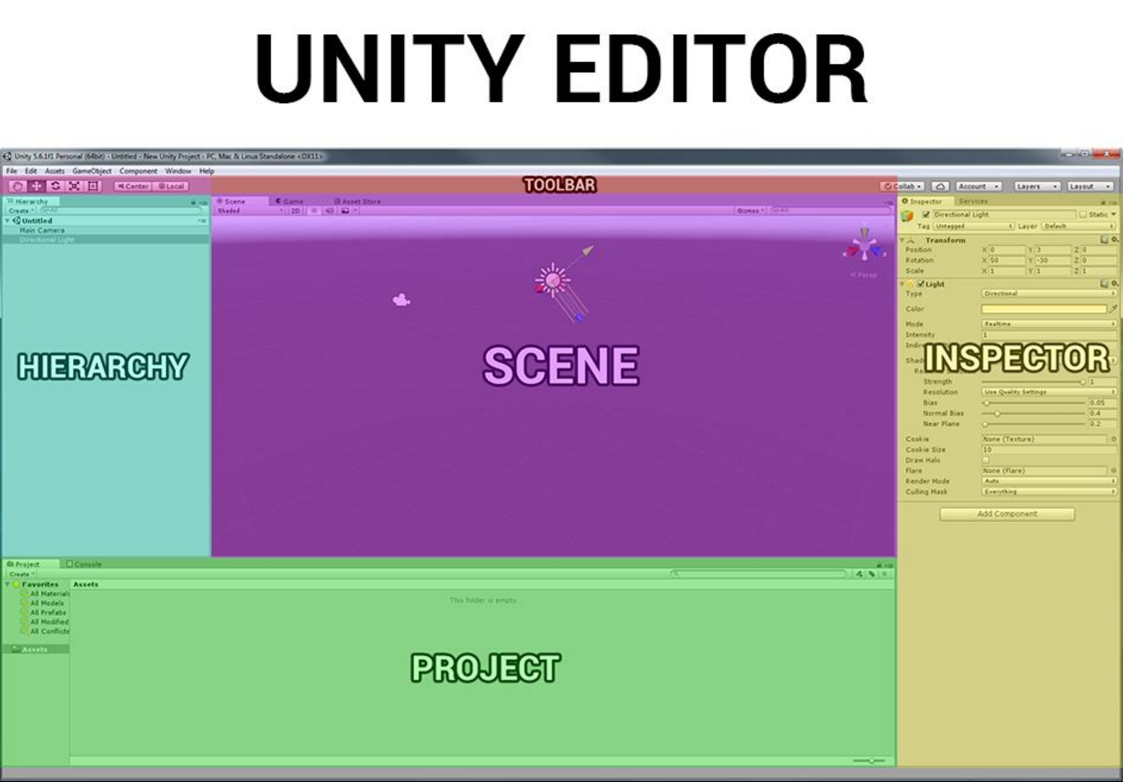

Tutorials related to film development in Unity
Unity for Artists: https://unity3d.com/learn/tutorials/s/unity-artists

Additional Tools
Cinemachine - https://www.assetstore.unity3d.com/en/#!/content/79898
New Post Processing - https://github.com/Unity-Technologies/PostProcessing
Oculus Utilites -https://developer.oculus.com/documentation/unity/latest/concepts/unity-utilities-overview/#unity-utilities-overview

Performance Guidelines
Oculus best practices - https://developer.oculus.com/documentation/unity/latest/concepts/unity-best-practices-intro/
Best practices content - https://unity3d.com/learn/tutorials/topics/unity-artists/best-practices?playlist=48370
Diagnosing problems and using profiling tools - https://unity3d.com/learn/tutorials/topics/performance-optimization

Additional Unity Tutorials
Animation - https://unity3d.com/learn/tutorials/s/animation
Writing Shaders - https://unity3d.com/learn/tutorials/topics/graphics/session-introduction?playlist=17102
Audio - https://unity3d.com/learn/tutorials/s/audio
http://blog.theknightsofunity.com/wrong-import-settings-killing-unity-game-part-2/

Source Control
Git lab- https://about.gitlab.com
Git hub - https://github.com
Subversion - https://tortoisesvn.net

