UW CSE 490A

Character Design and Animation For Real-Time Cinematics

Summer B Term, 2026

Website
Canvas: https://canvas.uw.edu/courses/1895801
Course Web: https://courses.cs.washington.edu/courses/cse490b/26su/

Personnel
Program Director:
- Barbara Mones: mones [at] cs.washington.edu
Instructor:
- Terrell Strong: stront2 [at] cs.washington.edu
TAs:
- Graham Godfrey
- Nina Uchtmann

Important Email Addresses
Staff Mailing List: cse490a-staff [at] cs.washington.edu
- If you need to contact the staff (and TAs), ask them a question, let them know of tardiness or absences, this is the email you must use.

Class Mailing List: cse490a [at] cs.washington.edu
- This will be the alias that we use to send announcements to the class

Support Email: support [at] cs.washington.edu
- When you have a computer or account issue, email the support help desk.
- Please CC the staff alias when contacting support so we can keep up to date on the status of any issues and/or requests

General Information

Course Overview
In this 4.5 week class students will learn to create their own animated character for real-time 3d in Unity, with art content creation in Maya. Classes include assignments that are designed to complement each other in skill progression. Covered are the fundamentals of real-time cinematic production including character design, modeling, rigging and animation. Students get hands-on experience working with real world industry tools and production pipelines. No prior experience is required.

Class Topics
1. Character design
2. Skeleton and block model
3. Gray model
4. Gray model pose testing
5. Costume modeling
6. Rigging, Animation - idle, wave
7. Animation - walk, jump
8. Lab time to prepare for Final Project

Class Format
Classes:
- Critique of previous assignments
- Lecture
- Demo of upcoming assignment
- (remainder) Supervised lab time
Labs:
- Progress check-ins with TAs
- Supervised lab time

Class is when we will introduce new concepts and their corresponding assignments.

Lab is scheduled time for you to work on assignments alongside other students while TAs, staff and instructors are all available to help and answer questions.

Office hours with TAs will be an opportunity to receive assistance outside of class and lab times.

Lab Rules
For the Animation Capstone Lab Spaces

- Only students of the Animation Capstone are allowed in the labs. Anyone else must obtain specific permission from Barbara Mones before entering. This means no significant others/ friends/family, etc. This is for the safety of the students as well as the security of our equipment.
- Our labs (CSE2 141 and 143) must be kept clean. They are community spaces, and it is important that they stay as clean as possible for everyone who uses them. This means keeping your own workstation clean, as well as doing your part to keep the floor and refrigerator clean. The kitchen in the undergraduate commons is also used by other programs, so it is essential that you clean up your own messes, as well as return any dishes you may have used as soon as possible after you are finished.
- Always follow the Golden Rules in the lab spaces.
- Follow all UW COVID-19 Procedures and Requirements at all times.

*Note: You will risk losing lab access if you are discovered breaking any of these rules.

Schedule
Summer Quarter B-Term UW academic calendar summer 2026
- First day of instruction: July 23
- Last day of instruction: August 21

Monday | Tuesday | Wednesday | Thursday | Friday
July 20 | 21 | 22 | 23  Class 1 | 24  Lab 1
27  Lab 2 | 28  Class 2 | 29  Lab 3 | 30  Class 3 | 31  Lab 4
August 3  Lab 5 | 4  Class 4 | 5  Lab 6 | 6  Class 5 | 7  Lab 7
10  Lab 8 | 11  Class 6 | 12  Lab 9 | 13  Class 7 | 14  Lab 10
17  Lab 11 | 18  Class 8 | 19  Lab 12 | 20  Final critique | 21

Classes: CSE2 141, Tuesday and Thursday 10:20am - 12:20pm

Labs: CSE2 143, Monday, Wednesday, and Friday 1:50pm - 4:00pm

Office Hours: Specific times are TBA

Class Details
Character class 1 | Character design
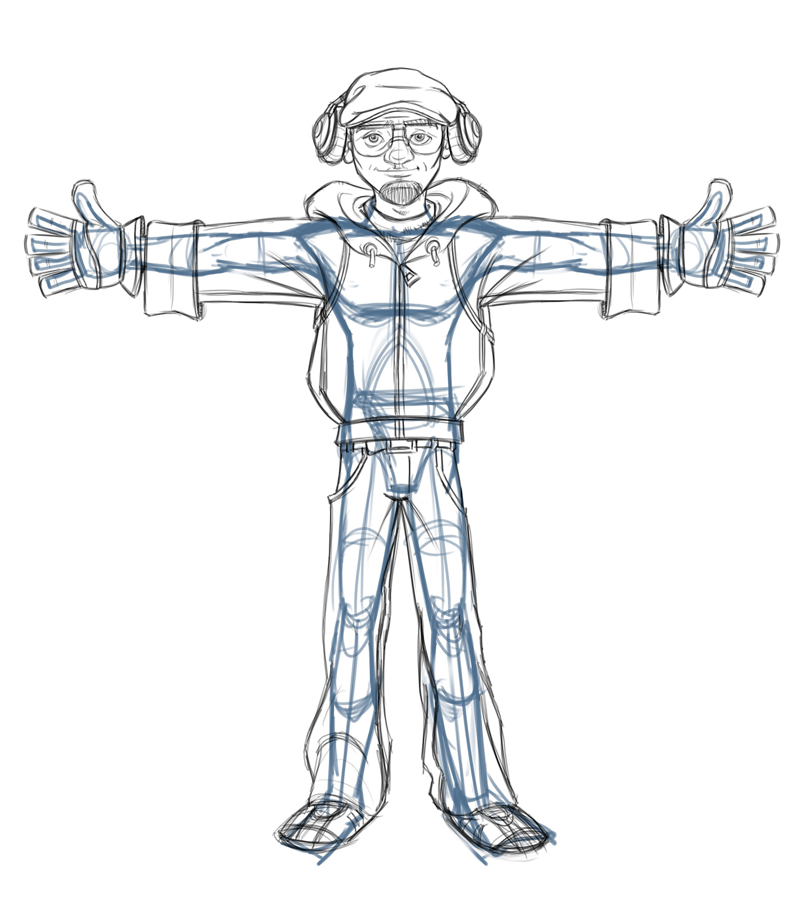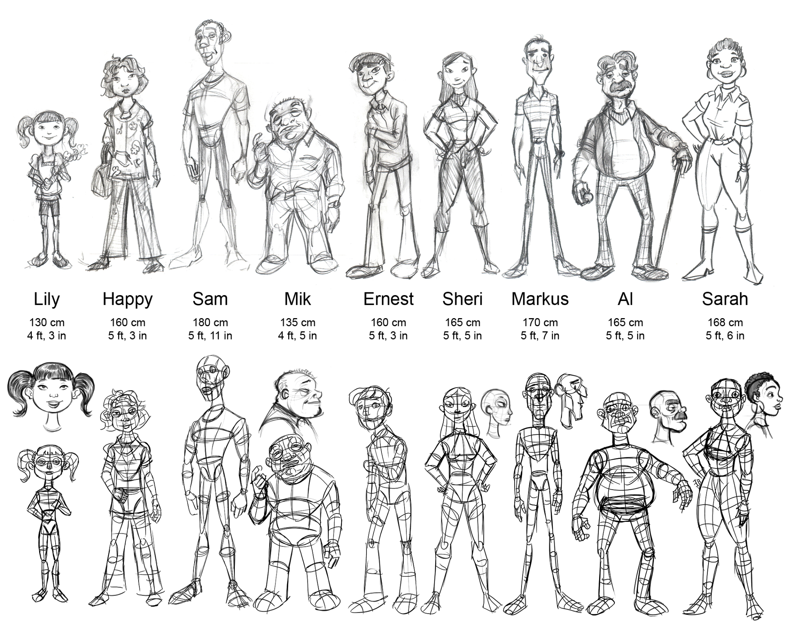 | Lecture presentation  - Class intro, character pre-production process  Assignment  - Write character description and story [Miro]  - Draw concept art and front/side orthographics  - Set up reference images in Maya  Skills learned:  - Sketching concept art  - Intro to Maya, reference image setup  Turn in for next class:  - Character concept art [Miro]  - Orthographics: front and side [Miro]  - Screenshots of ref images in Maya [Miro]  - Character description [Miro]  - Short character backstory [Miro]  - Reference images scene [Maya]  Programs: Maya, Miro

Character class 2 | Skeleton and block model
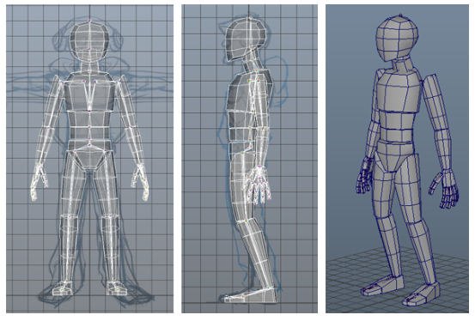 | Lecture presentation  - Block model / gray model iterations  Assignment  - Build skeleton based on orthographics [Maya]  - Build block model [Maya]  - Add to basic player control [Unity]  Skills learned:  - Skeleton building [Maya]  - Polygon modeling basics: object t-r-s, vertices,  edges, faces, insert edge loops [Maya]  - Animator state machine setup [Unity]  Programs: Maya, Unity

Character class 3 | Gray model
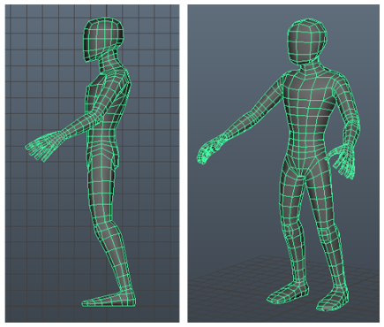 | Lecture presentation:  - Polygon topology for characters  - Polygon modeling demo part 2 [Maya]  Assignment  - Combine blocks, manifold gray model [Maya]  - Add to basic player control for critique [Unity]  Skills learned:  - Polygon topology theory [Maya]  - Polygon modeling part 2: combine, merge [Maya]  Programs: Maya, Unity

Character class 4 | Gray model pose test
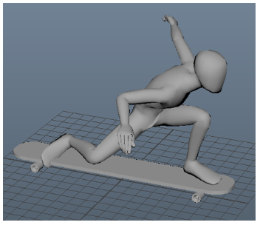 | Lecture presentation:  - Character deformations: skin weights  - Creating dynamic character poses  Assignment  - Paint skin weights [Maya]  - Pose testing with Timeline for critique [Unity]  Skills learned:  - Skin weights [Maya]  - Character posing [Unity]  - Sequencing poses with Timeline [Unity]  Programs: Maya, Unity

Character class 5 | Costume model
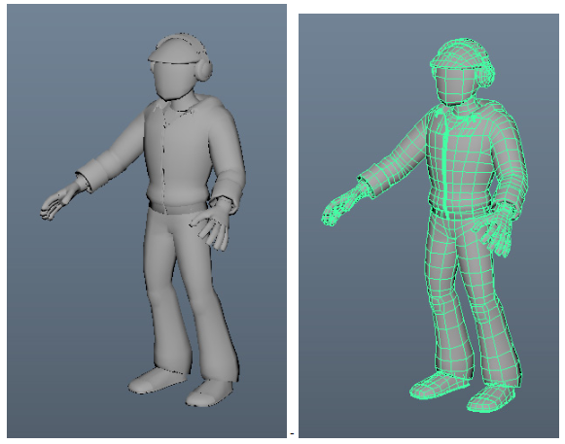 | Lecture presentation:  - Polygon modeling demo part 3 [Maya]  Assignment  - Model the character’s costume [Maya]  - Add to basic player control for critique [Unity]  Skills learned:  - Polygon modeling: cut, extrude, duplicate [Maya]  - Copy skin weights [Maya]  Programs: Maya, Unity

Character class 6 | Rigging and Animation - idle, wave
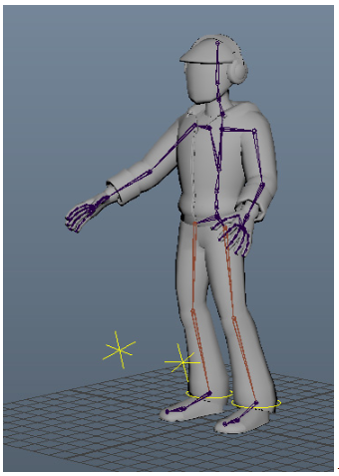 | Lecture presentation:  - Rigging for animation  Assignment  - Set up animation rig [Unity]  - Animate idle and wave  Skills learned:  - Building control rigs [Unity]  - Basic animation [Unity]  Programs: Unity

Character class 7 | Animation - walk
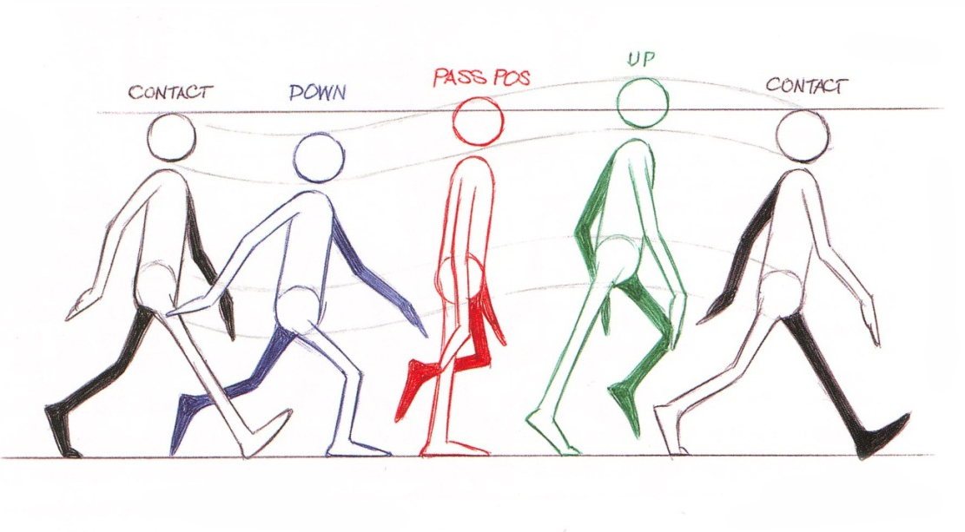 | Lecture presentation:  - Creating a walk cycle animation  Assignment  - Animate walk cycle [Unity]  - Add idle and walk to player control [Unity]  Skills learned:  - Animating motion cycles [Unity]  - Animation state machine setup [Unity]  Programs: Unity
 | Animation - jump
Lecture presentation:
- Creating a jump animation

Assignment (Optional)
- Animate jump [Unity]
- Add jump to player control [Unity]

Skills learned:
- Animating body mechanics [Unity]
- Animation state machine setup [Unity]

Programs: Unity

Grading
Participation - 25%
Assignments - 65%
Final - 10%

Each assignment document will include a rubric for how it will be graded. Assignments will be given twice a week and due a week from when they are assigned.

Final
Your final project is the culmination of all assignments. The final project is due August 20 at 10:20 am, before the final class period. During the final class, everyone will share a brief (~5 minute) presentation of their projects. The final is worth 10% of your course grade. The grading rubric will be handed out closer to the final date.

Attendance Policy
We take daily attendance. If you are late or absent, your grade will reflect this. If you are unable to attend class for any reason please contact the staff in advance and let us know your reasons. We will do our best to accommodate situations that are unavoidable.

Work Expectations
It is assumed that your work will be on time. Incomplete work should still be turned in on time so that it can be evaluated with everyone else. Under some rare and extenuating circumstances, the staff may decide to grade revised projects.

This is in line with the third golden rule we use in the animation capstone series of classes. Even if work is incomplete, it is important to have it available and presentable so that you can receive feedback and support to move forward.

Religious Accommodations
Washington state law requires that UW develop a policy for accommodation of student absences or significant hardship due to reasons of faith or conscience, or for organized religious activities. The UW’s policy, including more information about how to request an accommodation, is available at Religious Accommodations Policy
(https://registrar.washington.edu/staffandfaculty/religious-accommodations-policy/). Accommodations must be requested within the first two weeks of this course using the Religious Accommodations Request form
(https://registrar.washington.edu/students/religious-accommodations-request/).

Course Materials

CSE2 143 lab computers
The computer lab in CSE2 143 has all of the software required for the class, though all of the required software is also available to students to download and use for free on their personal machines.

Unity 6000.0.56f1
We will be working with Unity version 6000.0.56f1. First, install the Unity Hub from this address:
https://unity.com/download#how-get-started and then, within the Unity Hub select and install the
correct version. If you don’t see the appropriate version in Unity Hub, you can search for it in the download archive: https://unity.com/releases/editor/archive

Maya 2025.3.1
We will be using Maya version 2025. In order to get a Autodesk Maya educational license for use on personal computers, students will have to login at https://www.autodesk.com/education/home and they will be required to send a photo of their school ID to autodesk. It should be a quick process for them to approve it and
send a license.

Miro
We will be using Miro in order to organize screenshots and videos for each assignment. Miro works in the browser and doesn’t require a download. It will still require an account to be made using your school email before you can use it to create a board to present your work. You can access Miro via this link: https://miro.com/

Screen2Gif
We will be using Screen2Gif to create gifs and short videos of your work. It is available to download here: https://www.screentogif.com/. Once you reach the animation assignments, you will use this to capture clips of your character in motion to add to your miro board

