Hermes Project

George Huang
Huy Nguyen

Abstract

Optimizing workflow and job management are two important and critical tasks in hospitals. The Hermes project seeks to improve both of these by increasing connectivity and allowing a more efficient information exchange between hospital staff. In particular, the project targets the distribution of jobs to nurses. The current system operates on an outdated pager system; the proposed system would utilize both wireless devices and RFID tags to improve performance. By giving hospital staff a more dynamic and real-time system, it will allow jobs to be distributed and managed more effectively. Currently, development is being done on an iPaq platform with the SkyeRead RFID reader. A basic model has been developed at this time for a small number of users. Future work would allow for a large number of users as well as a more robust management interface. If completed and implemented, this project hopes to reinvent the daily operations in hospitals.

Introduction

Hospitals are a busy place where time is very valuable. Many hospital divisions are run on a patient/task system where nurses are assigned jobs based on their assigned locations. As of now, most hospitals operate with a pager and phone system.

The procedure for issuing a task in the current system involves the following. First, a task is sent out to a nurse on their pager. Next, a nurse must go to a phone station where they can call in to accept or decline the job and get all of the pertaining information. After performing the job, they must return to a phone station where they can report that they have finished the job. This system is functional, but has a couple of bottlenecks on performance.

The first bottleneck is the mode of communication. The extra travel time between the phone stations as well as the time it takes to relay the job is overhead that can be expensive in the long run. A second bottleneck occurs at the job management level, where jobs need to be sent out through a more primitive interface and there needs to be human interaction over the phone to communicate the full task.

The Hermes project proposes an alternative method to the current system for the management and distribution of jobs. To better communicate information, a mobile device would be given to each of the nurses that would allow jobs to be sent over a 802.11 wireless network. The device would also allow nurses to give an immediate response to the job request, reducing the delay of travel time. To further improve the workflow, RFID tags will be integrated into the process to make the procedure more transparent.

RFID tags will be associated with patients, rooms, and their respective jobs. This will allow nurses to scan various tags to indicate their progress on the job. The proposed model will be the as such: a nurse will receive a job on their mobile device and they will choose to accept or decline the job. Following this, they will go to the patient’s room and scan the room to indicate that they have started the job. Upon completion, they will scan the patient to indicate that they have finished and their mobile device will again be free to receive new jobs.

The benefits extend beyond the improved deployment speed of jobs. Various advantages are gained by giving an electronic interface to job distribution and associating RFID tags with various parts of the job.

First, those managing the tasks have a reduced overhead as they do not have to verbally communicate the task to the individual nurses. By communicating through the iPaq, the patient’s information is also protected from bystanders that could eavesdrop on the nurse’s phone conversation with the call center. This extra measure of security is needed in crowed hospitals where the phone stations are near other patients.

A second advantage is that the administration will have a better view on the workflow in the hospital as far as duration of tasks, travel time, and other such events that can be logged. This is critical in large hospitals. Also, processes and procedures that need to be performed on a regular basis can be enforced with more rigor.

A third advantage is that the information can be shared, so multiple people can be viewing or distributing tasks with minimal conflict. Also, information that manage by a computer system are less prone to simple human errors such as misplacing or displacing patients’ information.

Related Work

There are a few projects doing work related to the Hermes project. One project is the Automating Patient Records Management project that is under joint development by Swedish Medical and Ernst & Young. The idea behind their project is to give emergency room staff tablet PCs to manage and share patients’ data over a wireless network.

Like the Hermes project, the Patient Records project is geared towards improving communications and data sharing among hospital staff. Their approach to the problem is along a different line though, as they focus more on the patient’s data as opposed to individual tasks. Projects like these can all coexist and benefit one another, as different hospital units will have different efficiency bottlenecks and in turn will require different optimizations.

Another project that uses similar hardware to the Hermes project but for a different purpose is the Lingo Pal project by David Sunderland and Daniel Binuya. Their project uses a mobile device with 802.11 capabilities and an RFID reader to provide an educational device for children learning languages. It would allow users to move around and scan a set of tags that are attached and associated with different objects, providing the user with the verbal and written form of the word in various languages.

A third project that uses similar principles is the SAVi project by Andrew Ebaugh and Saurav Chatterjee. Shopping Assistant for the Visually Impaired (SAVi), is a system designed to aid the blind or the sight-impaired shopper in identifying and selecting products on the shelf in a store. It uses an RFID reader and a mote that transmits the tag to a server where it is translated into a sound.

The Approach

There are three main hardware components and two software components to this project. The hardware parts are the M1 RFReader, iPaq, and a database server. The two software applications (client and server) are the interface between the hardware. The client program is the communication bridge between the iPaq and RFReader. The server application handles the iPaq connection to the database containing the jobs for the nurses. To clearly explain the functionality of the software applications, the discussion below will discuss each of the application in its own section.

The client program is written in eMbedded C++ in the Windows CE 2002 operating system. The original plan was to develop the client program in Java on a Linux enviroment. We reasoned that if the client code is in Java, then a future generation device with a JRE could use the existing Java code. However, the various Java JRE’s (such as Blackdown Java and Kaffe) were very poorly supported. Some major packages were not implemented limiting the functionality of the project.

The server program was developed by using Perl and mySQL. Perl provides a flexible platform for both network interfaces as well as a dynamic web-based interface between the server and database. In addition to this, a Perl back-end allows for easy development of future extensions.

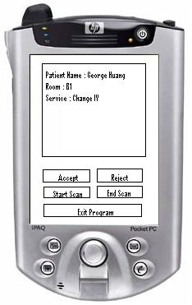

Client Program:

The basic model of the client program is that it will periodically connect to the server through TCP/IP with the 802.11 wireless technology of the iPaq. The client program then requests a job from the server. The server responds by sending a message back indicating the availability of a job. The format of the message from the iPaq to the server is iPaqID/CommandCode/Message. The iPaqId is unique to each iPaq to support multiple iPaqs and jobs. The server will use the CommandCode field to distinguish between five possible commands from the iPaq: job request, accept job, reject job, begin scan, and end scan. The message field is empty for job request, accept job, and reject job commands. It is the RF tag ID for begin and end scan commands. All of the commands, except for the job request, are initiated by the nurse through the GUI (graphic user interface). The job request command is executed when the iPaq connects to the server.

The GUI plays an important role in the management of when each command can be executed. This is important in managing the correct state of client and server program.

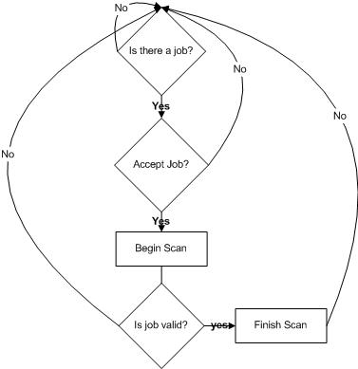

The state diagram above describes precisely when each command can be executed. The accept and reject command can only be executed if a job is available. Only if a job has been accepted, then the nurse can use the begin scan. The end scan of the tag on the patient is only available after the begin scan.

When the nurse execute the begin scan and end scan commands, the iPaq sends the read tag command “\r001400\r” to the RFReader. The command is sent through the serial port on the iPaq. The Serial IO package that is used is the WSC_eUSR by Marshall Soft. It could be downloaded at http://www.marshallsoft.com/. After sending the command, the iPaq waits for the ASCII encoded tag response from the RFReader. The client program will check for returned codes 94 and 84 indicating invalid tags and command. These invalid commands are ignored. Valid tags are saved and then sent to server through the wireless technology on the iPaq. The client will wait for the server to confirm that the job is correct in the begin scan, but not in the end scan case.

Server Program:

The basic structure for the server involves 3 main pieces, the network interface, a database for data management, and a user interface for the job dispatcher. The two interfaces were written in Perl, and the database is run on the mySQL platform.

The server network interface on the server side handles requests from the iPaq clients and processes the information. It is a multi-threaded server that allows multiple iPaqs to connect at the same time. The current jobs are tracked through the mySQL database, which is updated with each client request. The standard DBI interface for Perl is used to communicate with the mySQL database.

To send jobs to the iPaqs, a queue system is implemented with the database. A queue, represented by a table in the database, is associated with each iPaq. When the iPaqs connect to request a job, they send their unique id, which corresponds to one of the job queues. If there is a job available, the server sends the full text of the job to the iPaq.

When the iPaq accepts or declines the job, the queue is updated to indicate the status of the job. If declined, the job is taken off of the queue for reassignment. If accepted, the job is set to active. If the iPaq sends a start request for the job, the server checks to make sure that the RFID that is sent from the iPaq corresponds to that of the job, and then sets the job to started. Upon completion, the same procedure is followed and the job is removed from the queue and is labeled as a finished job.

The queue structure in the database is dynamic, allowing each iPaq to have a unique queue. These are the basis for communication between the back-end server network interface and the front-end server user interface. Dispatchers using sending jobs out will find this portion to be transparent to them, allowing for easier job management.

The front-end interface for the server is web-based and allows users to manage iPaqs and jobs by interacting with the database. Currently, the dispatcher can create jobs based on the patient database, edit jobs, edit iPaqs, and give jobs to iPaqs. These are handled through three pages, the job manager page, queue manager page, and the editor page.

The job manager allows the dispatcher to enqueue jobs to iPaqs, add new jobs, and view all of the ipaqs, current jobs, and finished jobs. From there, the user can go to the editor and the queue manager. The editor allows dispatchers to modify iPaq and job information. The queue manager accesses individual queues and shows the list of jobs that the iPaq was given.

Implementation

There are several key designs issue with the Hermes project: the language and environment of the applications, GUI design, job protocol, message format between the server and client, web server and database. The original code for the client program is in Java for the Familiar Linux environment. Java was the first choice for the client program because of the portability of the Java byte code. However, the Java version on the Familiar Linux distribution didn’t support the AWT package. The AWT package is essential to creating Graphic User Interface. This was a huge setback in the implementation of the Hermes project because the end-users are not accustomed to using command line programs. To develop a GUI, we had to switch environment and also language. The client code was rewritten in eMbedded C++ for the Windows CE 2002 environment. By using eMbedded C++, code portability was exchanged for functionality. This was a critical part of our project design.

After choosing eMbedded C++ as a platform for the application, we had to create a proper GUI. The design of the GUI had to account for the procedures of accepting a job and also the end users (nurses). We modeled the GUI after the steps the nurse has to take in order to accept a job. The buttons are placed and enabled in the sequential order which the nurse must follow to accept a job. We designed this way to protect and synchronize the server and client code.

The GUI was modeled after the job protocol. It is important to mention that changes that are made to the job protocol must be made to the GUI and server. The Hermes job protocol requiring tags on the room and patient is the result of an over simplified model of a real hospital. In a real setting, there could be multiple patients to a single room. Several assumptions were made to the hospital model inorder to provide a glimpse into the future of RFID and wireless mobile devices.

One of the important aspects of communication between mobile devices is the message protocol. There is a disparity between how the iPaq and server manage information. Even though the iPaq and server uses TCP/IP to pass information, the format of the message from server to iPaq and the iPaq to server has to be different. The iPaq client code is written in C++, while the server code is written in Perl. The winsock class that is used in the client code has several problems. The biggest problem is that the iPaq can’t listen for incoming connection. This limited our design to the iPaq always polling the server for jobs. Also, the iPaq can’t tell whether or not a connection is valid and if there is information from the socket. This requires our design of the message from the server to iPaq to have a length field so that the client code can keep track of incoming data. With the length field, the client code will be continuously loops wasting system resource.

On the server side, there was also a set of important design decisions that had to be made. First was the decision on the network model to use. The network interface application is a background service that handles the network requests from the iPaq client. The socket networking model used allows many kinds of server to be dropped in as long as the correct command protocol is maintained. The protocol follows a simple methodology, which is to keep the connection as little as possible. Because we are operating over a wireless network, it is impractical to assume that there will be 100% connectivity, so having short network interactions is best.

Because of this, we structured the model to have the server handle individual isolated requests from the iPaq, such as requesting a job, accepting a job, starting a job, and others. There were a few possible approaches to tracking the progress of the job with this model. One model was to keep a state machine on the server, remembering where each iPaq was in its given job. The model we chose instead was to track all information on the jobs and nurses through a database.

Using a database to track the jobs allows a few important benefits. First off, the server program does not need to have a state machine, but instead queries a database to find the current status. This allows less room for errors as well as more modular server code. Another benefit is that a server user interface for distributing jobs can be modular and replaceable as well. In addition to this, having the data in a database allows for reports to be easily generated on the workflow system. Tracking jobs as well as times will allow for more effective performance analysis by the administration.

Another important decision that had to be made was the language that the server was to be written in. To promote portability, the two main options were Java and scripting languages. Both Perl and Java share similar advantages when making this kind of server. Both are portable, both can be modular, and they can be distributed from a central location. In the end, we decided on Perl for a few reasons. With a web-based interface as opposed to an applet, the system requirements become a non-issue. In addition to this, Perl has easier parsing capabilities for requests and formatting messages. In the end though, either language would have been suitable, but Perl was much more practical for rapid development.

Evaluation

Overall, the Hermes project proves to be faster than the current system. The technical setback created by the winsock class has to be repair before the project can become more reliable. In several real user tests, the response time of when the job is dispatched and accepted is in the order of seconds. This when compared with the old system is a substantial improvement.

The biggest issue with the Hermes system is caused by the battery power of the M1 Reader. Low battery power can cause the Reader to miss the read command and not read the tags. In addition to to the missed tags, the range on the reader is also very short. The tag has to almost be touching the reader to get consistent results.

Another issue with the performance of the system is the wireless network. The iPaqs that were used for the project had ongoing connectivity issues with the wireless network, often losing its connection and requiring a reset. It was not the initial intention of the project to use the iPaq as a platform, and many of reliability and compatibility issues seem to reinforce this decision.

The iPaqs were definitely a suitable development platform, but they provide too much functionality and create too many compatibility issues for a final product. The packaging for a device such as this would need to be small enough to be carried around and easy to hold over tags. A two-way pager model would be a better design for a final product.

On the server side, dispatchers have a much faster turnaround time when sending out jobs. In addition to this, much less information has to be managed by people, reducing potential errors. The server functionality is sufficient for a demo, but is definitely not ready for actual use. There is a lot of functionality that must be added to the system, but because of the design model, this should not be an issue.

With the amount of the project that has been completed, a user would be capable of running through a full job scenario. They can receive jobs and interact with the jobs/Ids from the iPaq, and they can send out jobs and manage them from the server. The basic framework for the project has been laid out and it works as intended.

Conclusion and Future Work

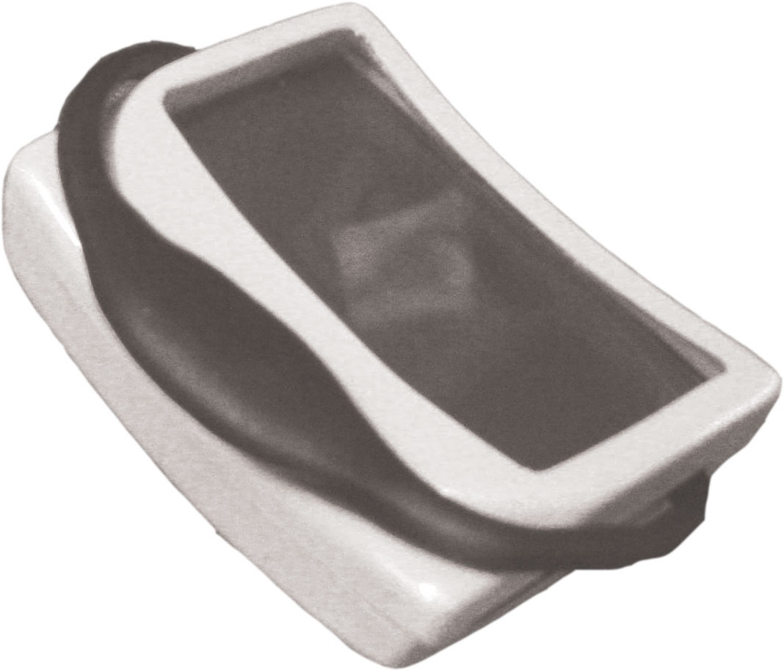
Future Designs
_{Clip}
_{Screen}

The Hermes project has reached a point where basic functionality is provided, but it leaves room for a great deal of improvements and additions. Some major issues that would need to be addressed were this system actually implemented would be the reliability and the form factor. Also, because of the simple network interface as well as the central database, there is much more information that can be transmitted and managed by the system.

With regards to the hardware, an iPaq is a suitable development environment, but impractical for hospital nurses. They provide too many features and have a poor form factor for nurses to handle. In addition to this, the RFID scanner is a hassle to use as an attachment to the device and would need to be incorporated in to the form factor.

On the iPaq side, it would certainly be conceivable to use a location tracking system with wireless access points to keep track of where nurses are. This would not only allow for better tracking of jobs, but it would give an interesting alternative to a server-side interface. As an example, it would be possible to find the nearest available nurse to any given patient.

One of the primary features of the system is that it can be used to enforce various processes in the hospital. The current client model is to receive a job, accept/reject it, scan to start it, and scan to end. It would definitely be possible to change the procedure or extend it for different kinds of jobs or tasks. The scanning order could be changed, the nurse could be required to scan different or additional things, and other such modifications could be implemented in the Hermes system.

The server side, though, is where a lot of the future work could be done. With a database back-end and any kind of user interface, whether it’s java or a web-based scripting language, there are many ways to proceed with development. The hospitals would be able to control what information they wanted to track and keep in their databases. Whether it’s time stamps to find durations of jobs or the steps in a process, finding trends in how nurses do jobs, or finding bottlenecks in workflow, reports would require little effort to generate and display.

Also, tools could be added to make dispatcher’s jobs much easier. Functionality supporting scheduled jobs, for instance are a necessary addition to the system. Tools to manage the patient database would also be necessary for functionality.

Virtually anything that can be done with a database can be integrated into the interface for the server. It’s mainly a question of how big and complicated the developer wants to make it. Development for this kind of system is very simple, because once the developer understands the network interface, the separate components are very modular and writing them is very straightforward. These enhancements can be added at the discretion of the hospitals, and they may be different between different hospitals.

One place for expansion would also be support for multiple dispatchers. As it stands, the framework is very suitable for allowing more than one operator to manage and distribute jobs. But the project has not yet progressed to the point where the reliability of the system under multiple users could be guaranteed. This is clearly an important factor to consider when dealing with institutions as large as hospitals.

Acknowledgements

We would like to thank Lauren Saint for inspiring our project and our TAs (Alan Liu and Waylon Brunette) for all their technical support. Tom Alders also provided valuable help with the existing lab equipment.

References

The WSC_eUSR eMbedded C++ serial package can be found at http://www.marshallsoft.com/.

Technical Reference

Client Installation:
(Note: the ip address on the iPaq set to where OUR server is. This needs to be modified (simple.cpp) and recompiled in order to get the client program to work)

- System Requirement:
  - iPaq 5400 series
  - Windows CE 2002

- Required files
  - The executable for the client program can be downloaded at simple.exe. The two packages file that are needed to downloaded and put in the iPaq \Windows directory are wsc32.dll and xym32.dll in the copy.zip file.
  - The serial package WSC4eVC can be downloaded at http://www.marshallsoft.com/ or WSC4eVC.
  - The source code files for the client are in simple.zip. These are eMbedded C++ files.
  - eMbedded C++ can be downloaded at the Microsoft mobile device webpage.

- Installation instruction
  - Download the executable to the iPaq
  - Put the two .dll files in the \Windows directory.

Server Installation:

- Required packages
  - ActivePerl 5.8.3 (With DBI and DBD-mysql packages)
  - MySQL (Can be any SQL database)
  - Apache Webserver (can be any webserver)

- Required Files
  - The source for all of the server scripts serverfiles.zip.
    - This includes the web-interface as well as the back-end server (serverc.pl (txt))
- Installation Instructions
  - Install ActivePerl.
  - If on a windows machine, the DBI and DBD-mysql packages can be found on PPM (Perl Package Manager). Otherwise, they can be located at http://www.cpan.org.
  - Download and install the latest MySQL from http://dev.mysql.com
  - Set up the database and tables.
    - For the current system, the following steps were taken from the MySQL command line
      - CREATE DATABASE Hermes;
      - use Hermes
      - CREATE TABLE jobs (JobID integer not null primary key, PatientID varchar(50), PatientName varchar(50), RoomName text, Description text, status varchar(30), FinishedBy text);
      - CREATE TABLE patients (PatientID varchar(50) not null primary key, PatientName varchar(50), RoomName text);
      - CREATE TABLE ipaqs (IpaqID integer not null primary key, Name text, Address varchar(30), Nurse varchar(50), status varchar(30));
      - CREATE TABLE rooms (RoomID varchar(50) not null primary key, RoomName text);
      - CREATE TABLE finishedjobs (JobID integer not null primary key, PatientID varchar(50), PatientName varchar(50), RoomName text, Description text, status varchar(30), FinishedBy text);
    - After this, the tables should all be set up in the database. Proceed to add some iPaqs, patients, and rooms to the tables to manage the jobs.
  - Download and install the Apache Webserver from http://www.apache.org. Any webserver can be used here in place of Apache.
  - Configure Apache
    - Edit the httpd.conf file
      - In the Options line for the webspace, add ExecCGI to the line
      - The line starting with AddHandler cgi-script, add .pl to the line
    - Apache should be configured and can be run
  - Unzip all of the required files into the webspace.
  - The script serverC.pl must be run in the background to handle iPaq requests.
  - The MySQL database must be up and running and be properly configured.
  - The dispatchers can perform their tasks by loading up jobmanc.pl in a web browser through the webserver.

