The Freshman’s Friend
Final Design Report

Submitted to:

CSE 477

Prepared by:
Brian Lenz, Mark Christiansen, and Adam Prewett

May 10, 2001

Abstract

We at Freshman's Friend Inc. realize the overwhelming landscape of the University of Washington campus. This causes numerous problems ranging from lost delivery drivers to crowds of freshmen huddled around campus maps. Our product, the Freshman's Friend, solves these problems by integrating Global Positioning System (GPS) technology into a handheld computing device. Using this technology our customers can view their exact location and ask for directions to any building on campus.

The Freshman's Friend is based upon three major components: the Compaq iPaq 3650 handheld computing device, the Garmin GPS25-LVS GPS receiver, and the Dinsmore 1490 digital compass. We integrate these devices using two 8051 microcontrollers and the serial communication port on the iPaq. Linked together with proprietary mapping software on the iPaq, the Freshman's Friend opens the door to a whole new world for collegiate freshmen at the University of Washington.
Table of Contents
Abstract ii
List of Illustrations iv
List of Figures iv
List of Tables iv
Introduction 1
Requirements 2
Overview 2
Digital Compass 2
Microcontroller 4
I²C Controller 5
RS-232 Level Converter 6
NAND Gate 6
Software 7
Design 8
Overview 8
GPS Unit 8
Digital Compass Unit 11
I²C and RS-232 Communication 12
Physical Design 15
Windows CE Application Design 16
Visual Basic vs. C++ 16
The User Interface 17
Image Display 18
Application Objects and Interaction 18
coord Object 18
ffmap_pt Object 19
ffMap Object 19
Directions System 19
Parts 21
Hardware 21
Development Tools 21
Problematic Parts 21
Analysis 23
Overview 23
GPS Microcontroller 23
Digital Compass Microcontroller 23
GPS Receiver 24
Digital Compass 24
Software 24
Test 25
Overview 25
Hardware Unit 25
Software Application 25
Design Issues 27
Overview 27
Hardware Unit 27
Windows CE Application 28
Response to Reviewer Comments 29
Overview 29
Recommendation 30
Analysis 31
Implementation 31
References 32

List of Illustrations

List of Figures
Figure 1. Digital Compass Pin Diagram 3
Figure 2. GPS Pin Diagram 4
Figure 3. Microcontroller Pin Diagram 5
Figure 4. I²C Pin Diagram 6
Figure 5. RS-232 Level Converter Pin Diagram 6
Figure 6. Quad 2-Input NAND Gate Pin Diagram 7
Figure 7. High-Level Block Diagram for the Freshman's Friend 8
Figure 8. Block Diagram for the GPS Interface to the Freshman's Friend 9
Figure 9. Block Diagram for the Digital Compass Interface to the Freshman's Friend 12
Figure 10. Block Diagram for the I2C Interface between the Microcontrollers 13
Figure 11. Communication Interfaces within the Hardware Unit 15
Figure 12. Diagram of the Freshman’s Friend Graphical User Interface 17
Figure 13. Size of a map zone in Windows CE application 20

List of Tables
Table 1. Voltage Requirements for the Digital Compass 2
Table 2. Power Consumption for the Digital Compass 2
Table 3. Voltage Requirements for the GPS receiver 3
Table 4. Power Consumption for the GPS receiver 3
Table 5. Voltage Requirements for the Microcontroller 4
Table 6. Pin Voltage Requirements for the Microcontroller 4
Table 7. Voltage Requirements for the I²C-Bus Controller 5
Table 8. Pin voltage Requirements for the I²C-Bus Controller 5
Table 9. Voltage Requirements for the RS-232 Level Converter 6
Table 10. Voltage Requirements for the NAND DIP 7
Table 11. One-Hot Encoding for the Current User Direction 11
Table 12. Properties of C++ and Visual Basic in Windows CE 16

Introduction

Every autumn, many new students enter the University of Washington as incoming freshmen. These new students are often disoriented when it comes to finding their way around a large and intimidating campus. As a result, many freshmen find themselves lost on campus and arriving to class late. The Freshman’s Friend provides a very sleek and innovative solution to this perennial problem.

The Freshman’s Friend will help students find their way around the unfamiliar University of Washington campus. It will do so by giving the students their current location relative to the rest of the campus. It will also let the students know which direction they are facing and which direction they need to go in order to get to their destination. Additionally, the Freshman’s Friend will automatically update the students’ locations and keep them informed of the best way to get to their destination, even if they go off the original course.

We have designed the Freshman’s Friend to be composed of three primary components: the Compaq iPaq 3650, the Garmin GPS25-LVS Global Positioning System (GPS) receiver, and the Dinsmore 1490 digital compass. We have selected two Atmel 89C55 microcontrollers to process the information and communicate data from the hardware components to the iPaq. One microcontroller processes data from the GPS receiver and sends the processed information to the second microcontroller. The second microcontroller samples the values of the digital compass and packages up the GPS and compass data before sending it off to the iPaq. The iPaq then processes the data and provides visual feedback to the user relating to the current position and heading.

Finally, the software will help the student find a way to a destination on campus. The student will select from a list of landmarks, and using the location they are currently at, the software will dynamically point them in that direction. As the student continues walking, our program will update the direction they need to take in order to reach their destination.

Requirements

Overview

We have divided the requirements of the Freshman’s Friend into different sections for each piece of hardware used in the application. We analyze the power and timing requirements for each component and also include pinout information. We will take these requirements into consideration during the development of the product.

The most important requirement of the Freshman’s Friend is to help people find their way around campus. It is essential that the Freshman’s Friend helps people find their destination quickly. For the best experience with the Freshman’s Friend, it is required that all of its components work. The digital compass must be give the correct heading, the GPS receiver must give proper position information, and the data path must ensure that it can update this information every second. If these functional requirements are not met, the rest of the requirements in this section are unimportant.

Digital Compass

Shown above are the maximum and minimum voltage levels of V_{CC} as well as the maximum and minimum power consumption levels. Below is the pin diagram for the digital compass. The individual V_{CC} and Ground signals can be connected together without any changes in electrical requirements. If the compass has 90 degrees of displacement, the digital compass can take up to 3 seconds to update accordingly. Additionally, the compass can only be guaranteed to give correct heading if there is less than 12 degrees of vertical tilt. Below are the voltage requirements, power consumption, and pin diagram of the digital compass.

Table 1. Voltage Requirements for the Digital Compass

Min | Max
5 V | 20 V

Table 2. Power Consumption for the Digital Compass

Min | Max
0.15W | 0.6 W

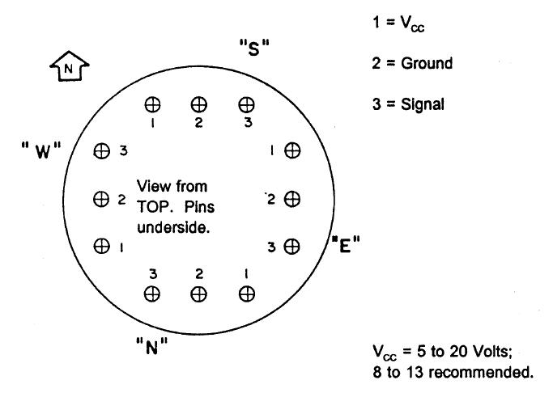
Figure 1. Digital Compass Pin Diagram

GPS Receiver

The GPS is responsible for giving us coordinates. It is not a requirement, but it is helpful to specify the NMEA sentences to be as short as possible, but with all of the critical position data. As shown below, V_{CC} cannot go below 3.6 V or above 6 V. Typical power consumption of the GPS Receiver will be 0.87W and at most 1.0W. The GPS Receiver updates every second. It will be communicating with a microcontroller using the RS-232 protocol at 9600 baud. Shown below are the voltage requirements, power consumption, and the pin diagram for the GPS receiver.

Table 3. Voltage Requirements for the GPS receiver

Min | Max
3.6 V | 6 V

Table 4. Power Consumption for the GPS receiver

Typical | Max
0.87W | 1.0 W

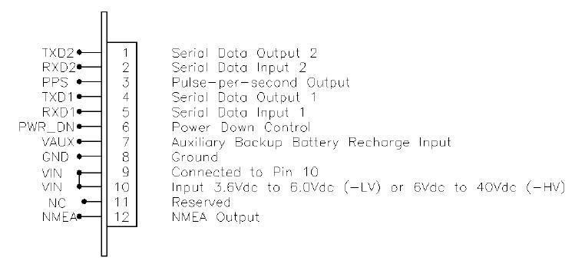
Figure 2. GPS Pin Diagram

Microcontroller

Each microcontroller must be able to process the data it receives in under a minute. One microcontroller will be receiving signals from the GPS, queuing the data, and then transmitting to the next microcontroller over the I²C bus. The second microcontroller will be reading the GPS information via the I²C bus, queuing the data, and then sending it to the iPaq via RS-232 communication with the compass reading appended. It is critical that both microcontrollers can do these tasks in less than a minute. Below are the voltage requirements and pin diagram of the 8051 microcontroller.

Table 5. Voltage Requirements for the Microcontroller

Min | Max
4.0 V | 6.6 V

Table 6. Pin Voltage Requirements for the Microcontroller

Min | Max
-1.0 V | 7.0 V

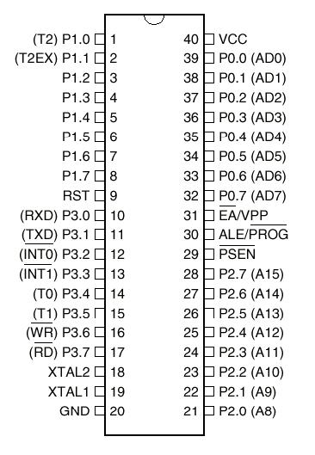
Figure 3. Microcontroller Pin Diagram

I²C Controller

It is essential that the I²C controller guarantee flawless communication between our two microcontrollers. It is crucial for passing the GPS information to the iPaq. Below are the voltage requirements and a pin diagram for the I²C DIP.

Table 7. Voltage Requirements for the I²C-Bus Controller

Min | Max
4.5 V | 5.5 V

Table 8. Pin voltage Requirements for the I²C-Bus Controller

Min | Max
-0.8 V | 6.0 V

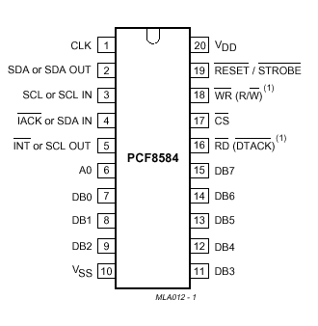
Figure 4. I²C Pin Diagram

RS-232 Level Converter

The RS-232 Level Converter must be able to take our standard CMOS voltage level of 5 volts, and convert the signal to true RS-232 voltage levels, and vice versa. Below are the pin diagram and the voltage requirements of the DIP.

Table 9. Voltage Requirements for the RS-232 Level Converter

Min | Max
4.5 V | 5.5 V

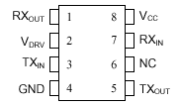
Figure 5. RS-232 Level Converter Pin Diagram

NAND Gate

The function of the NAND gate is to buffer the clock signal for the I²C bus. By putting the crystal-generated waveform into both inputs of a NAND gate, we are able to successfully drive the clock signal with the output of the gate. Below are the pin diagram and the voltage requirements for the NAND DIP.

Table 10. Voltage Requirements for the NAND DIP

Min | Max
4.75 V | 5.25 V

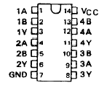
Figure 6. Quad 2-Input NAND Gate Pin Diagram

Software

The Compaq iPaq only has 16 MB of Flash ROM. We want to keep our program size at less than 20 percent of that, in order to have plenty of memory to spare. It is our goal to keep our program code and our map files under 3 MB.
We expect to have each map file roughly 40KB in size. Since we plan to have anywhere from 20 to 30 maps, we would like be able to have all of our maps take up less than 1.5 MB.
Since our GPS receiver transmits its position every second, the software must be able to process the data it receives from the microcontroller, update the position, the current path, the map displayed, and execute a progress checking algorithm in under a second.

Design

Overview

The design of the Freshman’s Friend is comprised of two main parts. The central unit of the design is the user interface and software application. The Compaq iPaq 3650 is the complete user interface to the application. The other component of the application is the hardware unit that is comprised of the Global Positioning System (GPS) unit and the digital compass unit. These two units communicate with each other and in turn transmit data to the iPaq. The Garmin GPS25-LVS GPS receiver provides a continuous signal to a microcontroller in the form of world coordinates. The microcontroller parses this data and then transmits it to a second microcontroller over an I²C bus. This second microcontroller also provides the interface to the digital compass. The digital compass provides the direction the user is currently heading. The digital compass outputs a continuous digital signal, which is translated by the second microcontroller. Finally, this microcontroller packages up the positioning and heading data and transmits it to the iPaq via an RS-232 serial link. The software application then translates the coordinates and heading information into our mapping system, which supplies a graphical reference of the user’s location and direction. The complete high-level block diagram for our design can be found in Figure 7.

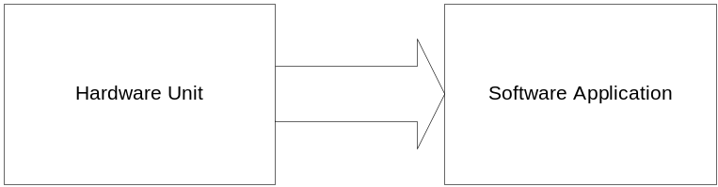
Figure 7. High-Level Block Diagram for the Freshman's Friend

GPS Unit

For our GPS receiver, we were initially going to use the ScoutMaster GPS receiver from the hardware lab. However, after looking into the manual for the ScoutMaster, we decided that it would not sufficiently provide GPS positioning information. The only GPS positioning output from the ScoutMaster was on the LCD screen. Since we need some interface from our GPS receiver to our software, this was an insufficient solution. As a result, we searched the World Wide Web for GPS receivers with serial outputs. We quickly found the Garmin GPS25-LVS receiver. This receiver provided all of the necessary functionality that our application requires. It provides positioning updates via a serial port at one-second intervals. After researching to ensure that this receiver would be a viable solution, we decided to use it in our application.

The GPS unit is composed primarily of the Garmin GPS25-LVS receiver. The GPS25-LVS has an RS-232 serial interface that allows two-way communication between the receiver and the host. RS-232 is the standard communications protocol for transmitting data over serial connections. In this case, the host unit is the application running on the Atmel 89C55 microcontroller. The application parses the data and transmits it over an I²C bus to a second microcontroller. This microcontroller then transmits the data to the iPaq via an RS-232 interface. The iPaq is able to directly communicate with the microcontroller through serial port device drivers provided in the Windows CE operating system that runs on the iPaq. The complete block diagram for the GPS unit interface with the iPaq is shown in Figure 8.

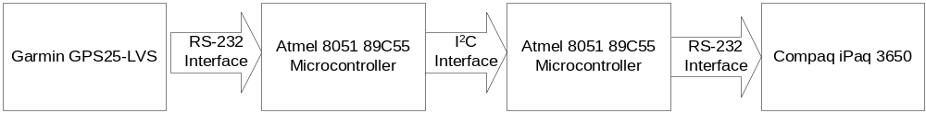
Figure 8. Block Diagram for the GPS Interface to the Freshman's Friend

The Garmin GPS25-LVS communicates with the first microcontroller in Figure 8 over the RS-232 connection. This connection is made via the Dallas Semiconductor DS275 Level Converter that converts the voltage levels of the microcontroller to standard RS-232 voltage levels and vice versa. The RS-232 protocol provides simple transmission of bytes of data. The GPS25-LVS actually communicates on a higher-level protocol over the RS-232 connection. The higher-level protocol is based on the National Marine Electronics Association’s NMEA 0183 ASCII interface specification. This interface specifies various sentences of data that are sent to and from the GPS receiver. The GPS receiver is configured to send out information at a frequency of 1 Hz. Additionally, we will set the serial port on the GPS receiver to transmit data at a 9600-baud rate. At a bit rate of 9600 bits per second (bps), the GPS receiver will be able to send 960 characters per second. The transfer of one character requires ten bits: eight bits for the ASCII character, one bit for the start bit, and one bit for the stop bit. By transferring data at this rate, our system will have a sufficient amount of time to transmit one sentence containing the current positioning, considering the fact that the maximum sentence length is 80 bytes.

The only data that our application needs from the GPS receiver is the positioning information. Thus, we must configure the GPS receiver to transmit only the sentence that contains the positioning information. First, we disable all sentences to be transmitted from the GPS receiver. After disabling each of these sentences, we enable the positioning sentence. By doing so, the only data transmitted from the GPS receiver to the microcontroller will be the positioning information. This information will be transmitted to the microcontroller at a specified frequency of 1 Hz. The frequency at which the GPS receiver transmits the sentences over the serial connection is pre-configured to 1 Hz through configuration software. Once these settings are configured, they are stored in non-volatile memory in the GPS receiver so that they are retained after power cycling the receiver.

We configure the GPS25-LVS by sending configuration sentences over the serial connection to the receiver. We use the following sentence to disable all outgoing sentences on the GPS receiver:

$PGRMO,,3<CR><LF>

The ‘$’ character is the first character transmitted in all NMEA 0183 sentences. The PGRMO command tells the GPS receiver that we are enabling or disabling output sentences. Each comma in the statement separates different parameters. The first parameter is empty when disabling all signals. The ‘3’ tells the GPS receiver that we are disabling all outgoing sentences. The <CR> and <LF> represent standard ASCII carriage return and line feed characters. These are the standard characters used to terminate all NMEA 0183 sentences. After disabling all of the outgoing sentences, we simply need to enable the positioning sentence. The following sentence will enable the positioning sentence:

$PGRMO,GPGGA,1<CR><LF>

The GPGGA parameter signifies the fact that we would like to change the transmission settings for this sentence. The GPGGA sentence transmits all necessary positioning information that our application needs to process. The ‘1’ parameter tells the receiver to enable this sentence. At this point in our application, the GPS receiver will continuously transmit positioning sentences until it is shutdown. When our application shuts down, we simply need to send a binary 1 on the Power Ground Control signal, pin 6, on the GPS receiver. The pin diagram for the GPS25-LVS can be found in Figure 2.

With the GPS receiver properly configured, the application running on the microcontroller does not need to transmit data to the GPS receiver. Instead, the software simply has to sample the incoming positioning sentences and extract the current position. The following is the format for a standard positioning sentence in NMEA 0183:

$GPGGA,<1>,<2>,<3>,<4>,<5>,<6>,<7>,<8>,<9>,<10>,<11>,<12><CR><LF>

The only parameters of the sentence that our application will be concerned with are parameters 2-5. Parameter 2 holds the latitude and parameter 4 holds the longitude. Parameters 3 and 5 hold the hemisphere values. In this case, parameter 2, the latitude hemisphere, should always be ‘N’ for the northern hemisphere, and parameter 4 should always be ‘W’ for the western hemisphere. We will ignore all of the other parameters in the positioning sentence.

At this point, the GPS unit design is completed. All configuration parameters have been set and all positioning information is ready to be received by the software. At this point, we simply have to get the software to properly recognize the incoming sentences and process them accordingly. We will describe the software design later in this document.

Digital Compass Unit

In designing the compass module for the Freshman’s Friend, we realized that we could easily integrate the digital compass with the current microcontroller setup used for the GPS unit. We can simply connect the digital compass outputs to the input pins on the microcontroller and poll the inputs. By doing so, we can package up the heading and direction information and transmit this data to the iPaq together.

The digital compass has four digital outputs that combine to make eight possible digital combinations. The digital compass has one output pin for each of the north, south, east, and west directions. The direction can be N, S, E, W, NE, NW, SE, or SW. If the current heading is north, then the north output pin on the compass will be high and all other outputs will be low. If the current heading is northeast, then both the north and the east output pins will be high while the south and west output pins will be low.

With the specification for the digital compass determined, we simply need to sample the data from the digital compass on the microcontroller. The microcontroller receives data from the other microcontroller at a frequency of 1 Hz. As a result, it can only send out positioning information at a frequency of 1 Hz. Thus, we will sample the digital compass at this same frequency. By doing so, we can easily package up the data to send to the iPaq. We will use a specialized protocol very similar to the NMEA protocol. Each packet transmitted will be the same length. The format for these packets is as follows:

$<1>,<2>,<3><CR><LF>

It will begin with a ‘$’ to signify the beginning of the message. Parameter 1 contains the latitude data and has a length of eight characters. Parameter 2 contains longitude data and has a length of nine characters. Parameter 3 contains the heading information and has a length of one character. The single heading character will use a one-hot encoding as shown in Table 11. Finally, each packet will be terminated with the carriage return and line feed characters.

Table 11. One-Hot Encoding for the Current User Direction

Bit | 7 | 6 | 5 | 4 | 3 | 2 | 1 | 0
Heading | SW | SE | NW | NE | W | E | S | N

The serial connection between the iPaq and the microcontroller is made through null modem adapter and the Dallas Semiconductor DS275 Level Converter. The null modem adapter is used to correctly verify transmissions to the iPaq and the level converter is used to convert between the microcontroller voltage levels and the standard RS-232 voltage levels. The data transmission from the microcontroller to the iPaq is strictly one-way communication. The iPaq does not need to transmit information to the microcontroller. As a result, we have a simplified system. The microcontroller constantly transmits the heading and position over the serial port, and the iPaq continuously samples this input and updates the user interface accordingly. The block diagram for the digital compass unit can be seen in Figure 9.

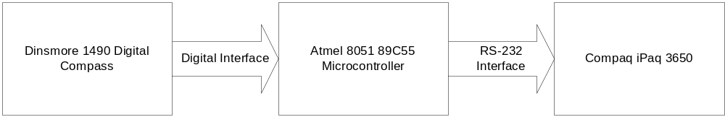
Figure 9. Block Diagram for the Digital Compass Interface to the Freshman's Friend

Once the digital compass unit has been electronically assembled and the software has been downloaded to the microcontroller, the iPaq simply has to process the incoming packets and update the heading and position accordingly. Using this heading, the user will be able to determine the correct direction to the destination. The compass on the user interface should update once per second, a rate that will probably be unnoticeable to the user.

I²C and RS-232 Communication

We chose to use an I²C bus as the method of communication between the two microcontrollers in the Freshman’s Friend. The I²C bus provides a well-defined specification of digital communication between microcontrollers without using a serial port. Each of the Atmel 89C55 microcontrollers has only one serial port and each serial port is already in use. The microcontroller used with the GPS receiver uses the serial port to obtain positioning information from the GPS receiver and the microcontroller used with the digital compass uses the serial port to communicate with the iPaq. As a result, we needed a digital interface between the two microcontrollers to allow communication between them.

We chose to use the Phillips PCF8584 I²C controllers to provide the I²C interface between our two microcontrollers. In order to provide the I²C bus between the two microcontrollers, each microcontroller needs its own I²C bus controller. Each time the Freshman’s Friend starts up, the I²C controllers must be configured by their respective microcontrollers. Each of the I²C bus controllers has the same configuration with the exception of the slave address and the clock configuration. Each of the bus controllers must have its own clock that derives from the host microcontrollers clock. We will pass the microcontrollers clock as input to the bus controllers via a NAND gate. The NAND gate will act as a buffer to strengthen the clock signal input into the bus controller. By doing so, the single crystal will not have to drive the clocks on both the microcontroller as well as the I²C bus controller. We will assign the GPS microcontroller a slave address of 2 and the digital compass microcontroller a slave address of 1. By doing so, we can easily transmit information across the bus. Additionally, the communication is simplified by the fact that the communication on the I²C bus is strictly one-way communication. The GPS microcontroller only needs to transmit data over the I²C bus and the digital compass microcontroller only needs to receive data over the I²C bus. The block diagram for the I²C interface between the two microcontrollers can be seen in Figure 10 below.

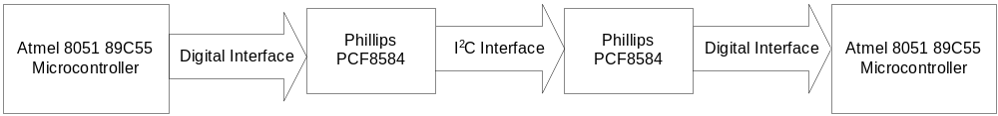
Figure 10. Block Diagram for the I2C Interface between the Microcontrollers

We initialize the I²C bus by modifying various registers in each of the bus controllers. We are able to do so seamlessly by treating the I²C bus controllers as external memories and using standard external memory reads and writes in the microcontrollers to communicate with the bus controllers. We configure the bus controllers to use interrupts for notification of events on the I²C bus. We use the external interrupts on the microcontrollers to signal the software when an I²C event occurs. When an I²C event occurs, it means that either we can read a data byte off the bus when the current microcontroller is the receiver or we can write another data byte to the bus if the current microcontroller is the transmitter.

The software for the microcontrollers can be designed for each of the specific purposes the two microcontrollers have. The GPS receiver microcontroller buffers an entire NMEA sentence from the GPS receiver. To do so, the microcontroller simply loops until data is received on the serial line. Once a character appears on the serial line, the microcontroller buffers it. We set the buffer to be 80 bytes, the maximum length of an NMEA sentence. As a result, the buffer cannot overflow. Once the entire sentence has been buffered, the microcontroller transmits the pertinent positioning data across the I²C bus, one byte at a time. Only 22 characters need to be transmitted across the bus with the GPS positioning information. The format of this packet is as follows:

$<1>,<2>,<CR><LF>

The ‘$’ signifies the beginning of a packet. Parameter 1 has eight bytes for the latitudinal information. Parameter 2 has nine bytes for the longitudinal information. The carriage return and line feed signify the end of the packet. Once the packet has been transmitted, the microcontroller is ready to buffer another NMEA sentence and so it waits for another serial transmission.

The software for the digital compass microcontroller is very similar. When an external interrupt occurs from the I²C bus, a character can be read from the bus controller. The microcontroller then buffers the entire packet in memory. When the packet has been stored, the microcontroller inserts the necessary heading information into the packet that it can read directly from the digital compass. At this point, the microcontroller must simply send this new packet to the iPaq over the RS-232 link. To do this, the microcontroller first writes a character to the serial buffer, which transmits the character over the serial connection. We use serial interrupts to interrupt the application when this has been completed. Once a character has completed transmission and the application gets an interrupt, we simply send another character over the serial line. We repeat this process until the entire packet has been transmitted. Once the packet has been transmitted, the microcontroller is ready to receive another packet over the I²C bus.

The software for the microcontrollers can be very specialized to the Freshman’s Friend application. As a result, we can provide a seamless method of communication between each of the hardware devices. By choosing the I²C bus and RS-232 serial connection for data transfer within the application, we have created a reliable communications backbone that will meet the design requirements for the Freshman’s Friend.

Physical Design

In summary, the Freshman’s Friend design is comprised of a software component running on the iPaq and a hardware component that transfers data to the software application. The hardware components communicate with each other to gather information and prepare it to be sent to the iPaq in a format that can be processed by the iPaq. The completed communication flow chart can be seen in Figure 11 below.

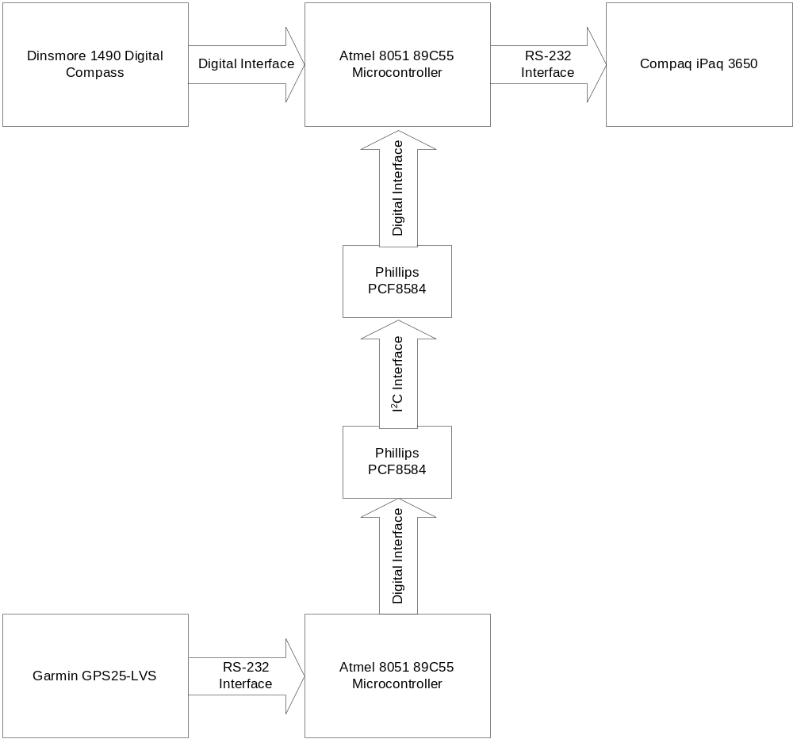
Figure 11. Communication Interfaces within the Hardware Unit

The hardware components need a power supply in order to operate. Each of the components used in the hardware unit are able to operate from a 5 Volt power supply. As a result of this, we will use a standard 9 Volt battery to power all of the units on the breadboard as well as the GPS receiver. We will use the Dallas Semiconductor LM338T-ND voltage regulator to generate the desired 5 Volt voltage level.

Both the hardware components and the iPaq must be physically connected to each other because of the serial connection between the two. As a result, we will need to somehow mount the hardware component to the iPaq. This includes the board containing the hardware units as well as the GPS receiver, the GPS receiver antenna, and the battery for the hardware unit. The serial cable for the iPaq is approximately 4 feet in length, so we will have to affix this to the hardware unit. Additionally, the GPS antenna is approximately 3 feet in length, so we need to store this with the hardware unit. We will mount the GPS receiver in a plastic case where we will also store the battery, antenna, and cables.

Windows CE Application Design

Visual Basic vs. C++

The first decision in the software design process was which programming language to use. The two most prevalent and supported languages are Visual Basic and C++. Both are included in Microsoft’s free distribution of Embedded Visual Tools. The following table highlights the strength of both languages with our project in mind.

Table 12. Properties of C++ and Visual Basic in Windows CE

Visual Basic | C++
Simple to design UI using Embedded Visual Tools | Straightforward, well-documented, UI development using MFC
Built –in controls for communicating with serial and infrared ports | Familiar language and development environment
Extensive online development community | More flexibility for defining data structures and route mapping

After reviewing each language we decided to develop using C++. Visual Basic initially seemed like the easiest choice, however, it lacked the necessary power to implement the route-mapping portion of the application. Another benefit of using C++ is our prior development experience with it.

The User Interface

The aim of the user interface is to be as simple as possible without leaving the user feeling limited. When looking at the screen the user should easily see what is going on and not be confused by what is shown on the screen. As shown in Figure 12, the map dominates the screen of the application. It is shown so large since the primary objective of Freshman’s Friend is to show the user where they are on campus.

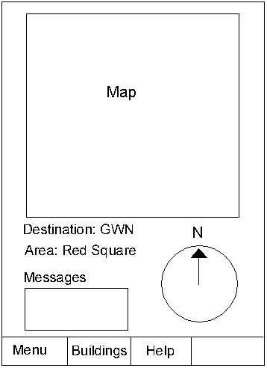

Figure 12. Diagram of the Freshman’s Friend Graphical User Interface

The only input in the application is the user’s destination. The user can select their destination by clicking on the buildings tab in the menu bar and choosing from the list of buildings. Once the building is selected an arrow will display on the map which path to take off of the current screen. The name of the building will also be displayed under the heading “Current Destination.”
Also included on the screen of the Freshman’s Friend is a compass indicating their current direction. This indicates the user’s general heading on the map. This is useful to the user when they are trying to get their bearings of an area. Displayed to the left of the compass is a description of the user’s current location. Examples of this are “Hub”, “Quad”, or “Red Square”.
Located below the current location of the user is a message box. This area will display system messages to the user. For example, if the user needs to keep the iPaq level to gather heading information it can display a warning or it might tell the user if they aren’t going in the right direction.

Image Display

The images in the Freshman’s Friend account for the largest percentage of the memory footprint of the program. Due to the size requirements imposed with developing for Windows CE we couldn’t afford to use bitmaps to store all of the map images. To conserve disk space each map will be save in the JPEG compressed image file format. Since the MFC doesn’t directly support JPEGs the application will use the IMGDECMP.DLL to show them. This is the same library used by Internet Explorer for Pocket PC’s. A few of the reasons we decided to use this library are:

- By using a common component such as the IMGDECMP DLL, we reduce the memory footprint of the application.
- Since it is already included in the Windows distribution we don’t need to worry about licensing agreements and implementation details.
- Performance is very good.
- Available developer resources make development easier
- Tested, bug-free code.

Application Objects and Interaction

This section details the properties and interactions between the user-defined objects in our design. Three main objects reside in the application. The coord object is a simple class that contains latitude and longitude information. The ffMap_pt object is another simple object that holds location information for a point on a map. The ffMap object is a structure that describes a single map zone. Following is some sample pseudo-code describing the data elements of each of these objects.

coord Object
{
int lat; \\Latitude information stored as DDHHMMSS
int lon; \\Longitude information stored as DDDHHMMSS
}

ffmap_pt Object
{
int x; \\Number of x-axis pixels from upper right corner
int y; \\Number of y-axis pixels from upper left corner
}

ffMap Object
{
char * area; \\Name of area the map covers
int resID; \\Resource ID number of corresponding image file
int numExitPts; \\Number of exit points on map
int numBldgs; \\Number of buildings on the current map
ffmap_pt exits[numExitPts] \\Array of exit points that holds a location on map
coord topLeft; \\The coordinates of the top left corner of the map
int nextExit [MAX_BLDGS] \\Lookup table that returns the number of the exit point that \\leads to the selected building
map_pt bldgs[numBldgs] \\Map locations of each building on the current map
}

The ffMap object is the center of the application. The current instance that is selected dictates what is displayed on the application and what processing takes place once a destination is selected. The ffMap objects will be contained in a large array inside the application and indexed using a currentMap global variable. Methods will check whether or not a map contains a given set of coordinates. Each time the application downloads GPS and compass data the application will check to see if the user has left the current map.

The largest amount of work to be done is with the initialization of each map instance. Since each map is unique a set of exit points, buildings, and mappings of buildings to exit points needs to be created. There is no easy or elegant way to do this so the code will have to be written uniquely for each of the 30-40 maps that will be part of the Freshman’s Friend.

Directions System

The directions system is the component of the application that tells the user where to go based upon their current location and destination. Due to complexity in design and implementation we tagged this as the most difficult part of the application. The program needs to determine which path the user needs to take in order to get to their destination. After thinking of numerous approaches we came up with a zone-based design that will direct the student to correct path out of the current zone based upon their destination. The next paragraph describes this feature in more detail.

The two main issues with a zone-based design are determining the size of each zone and how to direct the user between zones. The size of a zone is approximated to be the amount of time it takes to walk about five minutes. Since a zone is also the amount of area shown on the screen at any one time we didn’t want to make it so large that detail was lost. The map, however, needs to be big enough so the user can get a feeling for their general surroundings. Figure 13 shows the size of a zone just south of Meany Hall.
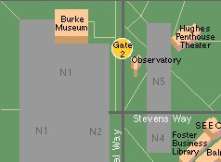
Figure 13. Size of a map zone in Windows CE application

The modularity of the zones was exploited in order to implement the directions system. When a user selects a destination, a method is invoked that determines which of the exit points on the current map leads to the selected destination. This can be easily implemented using a simple lookup table mapping buildings to exit points. The table needs to be specific to each map zone. Once a user leaves the current map the above steps are repeated on the new map zone. This process continues until the user arrives at the map that contains the destination building.

Parts

Hardware

Description | Part # | Cost per Unit | Quantity | Total
Atmel 8051 Microprocessor | AT89C55 | $12.20 | 2 | $24.40
Compaq iPaq Pocket PC | H3635 | $599.00 | 1 | $599.00
Dallas Semiconductor RS-232 Level Converter | DS275 | $4.00 | 2 | $8.00
Dinsmore Digital Compass Sensor | 1490 | $14.00 | 1 | $14.00
Duracell 9V Battery | MN1604 | $2.00 | 1 | $2.00
Garmin GPS25-LVS | 010-00124-02 | $129.95 | 1 | $129.95
Garmin Evaluation Kit | 010-10197-00 | $109.95 | 1 | $109.95
National Semiconductor Voltage Regulator | LM338T-ND | $3.00 | 1 | $3.00
Radio Shack Gender Changer | 950-0256 | $5.00 | 1 | $5.00
Radio Shack Null Modem | 26-264 | $6.00 | 1 | $6.00
Raltron Electronics 11 MHz Crystal | A-11.000-S | $4.00 | 2 | $8.00
Texas Instruments Quad 2-Input Nand | SN74LS00 | $1.00 | 1 | $1.00
Total Cost Per Freshman's Friend |  |  |  | $910.30

Development Tools

Description | Cost per Unit | Quantity | Total
Keil DK51 Developer's Kit | $0.00 | 1 | $0.00
Microsoft Embedded Visual Tools | $0.00 | 1 | $0.00

Problematic Parts

The GPS receiver is a critical component of our project. If the GPS fails on us for some unknown reason, then our application will be unable to continue running. It will not be able to update the user’s position, which is the main functionality of the Freshman’s Friend.

If the digital compass sensor fails, then our program would still work. However, it could do something worse. It may give out a bad signal, which would mislead the user and make them more lost than if they were not using the Freshman’s Friend. This is due to the fact that the digital compass has unpredictable behavior if it is not kept level.

The microcontroller and the IR transmitter are not problematic parts. If either of these parts fails to work properly, it would not prevent the user from using the Freshman’s Friend. The user would just not have the feature of knowing which direction they are facing. They would still be able to know their location and they could still track their movement to figure out how to get to their destination.

Analysis

Overview

The functionality of our design is based upon its modularity. The software component of the design can be tested independently and the hardware unit can be tested independently. Once the hardware unit transmits the desired output from the serial port of the digital compass microcontroller, it is successfully implemented. For the software application on the iPaq, it must update based on the transmitted data from the hardware unit as well as provide accurate mapping information. All the technology involved in the project is widely used and industry standard creating ample support online. The following sections outline the specific reasons why each module in the Freshman’s Friend will work correctly.

GPS Microcontroller

The one concern with the GPS microcontroller is that it must be able to capture the data from the GPS, and send the information to the next microcontroller in one second. Since the GPS gives its coordinates every second, it is critical that the microcontroller keep up to speed. This time frame is easily met. Since the GPS broadcasts 80 characters (800 transmission bits) at 9600 baud, the microcontroller is able to queue the entire sentence in roughly 83.3 milliseconds. Once it has received the whole sentence, it will parse the sentence and send only 22 bytes (220 transmission bits) across the I²C bus at 45KHz. This will take an additional five milliseconds. Overall, the GPS microcontroller accomplishes its tasks in less than 89 milliseconds, which is easily within requirements.

Digital Compass Microcontroller

Just like the GPS microcontroller, the digital compass microcontroller has one main concern. It must accomplish its tasks in less than one second so that it can process the position every second. The digital compass microcontroller will first take 22 bytes off of the I²C bus and buffer them. This will take five milliseconds as calculated above. Once the queue has received all 22 bytes, the microcontroller will begin to transmit the data in the buffer over the RS-232 link. Appending the direction byte to the position information, it will transmit 23 bytes (230 transmission bits). At 9600 baud, this will take 24 milliseconds. Overall, the digital compass microcontroller can accomplish all of its tasks in 29 milliseconds, and will easily be ready for the next set of data. Since both of the microcontrollers are able to perform their tasks in 113 milliseconds, they will easily make their deadline of one second.

GPS Receiver

Although the receiver can track up to 12 satellites, the GPS receiver does not give us values for position all of the time. In some buildings, the GPS receiver is unable to make a connection with at least three satellites to obtain position.

From the moment the GPS receiver is turned on, it can take up to five minutes to track its position. Once the GPS has been powered on, it takes up to 15 seconds to update the current position. In addition to being reasonably fast, the GPS has excellent accuracy. It can pinpoint its location to within 5 meters.

Digital Compass

Although the compass specifications state the compass will not give any more than two adjacent outputs at one time, it does. For example, when the situation arises where west, north, and east outputs are all high, then it is certain the compass is directed north. Unexpectedly, there exists roughly 15 degrees where both signals are high. From testing, it is obvious that this condition occurs when the compass is pointing north. Fortunately, this can be corrected with software in the digital compass microcontroller, before the iPaq makes use of the data.

Software

The software side of our project is based upon the Microsoft Foundation Classes for C++. The communication model in MFC is event based. Basically that means the application won’t do anything unless something tells it to. Relying on this fact our application should work as long as our hardware works correctly. If the iPaq loses its connection with one of the attached devices no events should be sent to the software so state won’t change. We will meet the size requirement by using compressed image files to display on the application. Besides the files themselves our application shouldn’t be more than 20-50k.

Test

Overview

When testing the Freshman’s Friend, the different components can be tested separately. This is because the hardware unit and the software application are independent of each other. If each standalone module works correctly, then the Freshman’s Friend should work successfully when both modules are connected together.

Hardware Unit

In order to test the hardware unit, we will have to test both the hardware and software. We will test the GPS receiver by hooking it up directly to a serial port on a PC. We will then connect to the GPS receiver through a terminal application. We should see bytes being sent to the terminal application from the GPS receiver at a rate of 1 sentence transmitted per second. If this result is achieved, the GPS receiver is successfully configured from the hardware perspective. Additionally, we will have to test the digital compass to ensure that it is giving correct output. This can be done easily by probing each of the four output pins with a voltage probe. We must verify that the digital compass gives the correct output when it is pointing in each of the eight possible directions. Also, we must test if the compass gives bad outputs such as North-South. We must determine what circumstances cause the compass to give these bad outputs as well as come up with a way to handle them in hardware. To overcome this problem, we will have the digital compass microcontroller keep track of the current heading. If a bad output is detected from the digital compass, then the software will simply use the old value of the heading.

From the software perspective, we will have to test to make sure that the incoming sentences are processed correctly on the GPS microcontroller. We can only test the software aspect of the GPS unit in conjunction with the digital compass unit. To do so, we will connect the output of the digital compass microcontroller to HyperTerminal and see if the expected output is generated. If the expected output is generated in HyperTerminal, then the hardware and software aspects of the hardware unit have been verified. Last, we will verify that the iPaq is able to correctly parse the incoming packets and update the screen accordingly. Once the screen updates correctly, we know that the hardware unit is working successfully.

Software Application

In addition to testing the purely hardware aspects of the Freshman’s Friend, we will need to test the software aspects as well. We must verify that the location algorithm works correctly. That is, given a destination and the current location, we must verify that the algorithm successfully directs the user to his destination. We will have to verify that the direction to the destination updates correctly as the user moves. We must also verify that the map correctly directs the user to the destination when the user goes the wrong way. We will have to verify that iPaq tells the user when the user proceeds in a direction away from the current destination.. In order to test all of these features, we are going to have to have first tested all of the hardware aspects of the design. Once we have validated the hardware specification, then we can take the Freshman’s Friend outside and verify that it operates properly under these various conditions. If circumstances prevent us from testing the softeare in the field we can simulate GPS coordinates and test it in the lab.

Design Issues

Overview

The issues we face in designing the Freshman’s Friend can be divided into software and hardware issues. The hardware issues are dependent of each other since each piece of hardware relies on other hardware for successful operation. The design issues for software are independent of the hardware and can be addressed separately. As a result, we will consider the hardware module and software module as independent units when designing the software application.

Hardware Unit

The primary hardware related issues relate to the microcontrollers, the I²C bus, and the digital compass. The GPS receiver is a standalone unit that we do not have control over other than through a serial interface. We only have control over how it is electrically hooked up to a power source and to the serial port. We will provide power to the GPS receiver via a battery and connect the receiver to the serial port directly through the breadboard. The primary design issue with respect to the GPS receiver will be with our software interface. The likely problem here would be with our software interface to the serial port. If the serial port is not configured properly from the software side, all of the GPS communication will fail. However, we are confident that this will not be a problem.

The most likely problem in our design will occur with the digital compass. This is because the digital compass must be kept level in order to provide an accurate reading. If the digital compass is tilted more than 12 degrees, the output is undefined. We will need to provide some notification to the user if the compass needs to be leveled out to provide an accurate reading. Other than this, the output of the digital compass is purely digital and continuous and should not pose a problem. This type of output can easily be sampled by the microcontroller.

The microcontrollers will likely cause design problems due to their electrical connectivity. We will have to be very precise in our electrical connections to the level converter and null modem adapter in order to ensure proper operation. Additionally, we will have to be attentive to detail in writing the software for the microcontrollers. First of all, we will have to ensure we read the GPS data from the serial port correctly. Second, we will have to ensure that we properly configure the I²C bus. Additionally, we will have to take care in ensuring the read and write operations to the I²C bus are performed correctly on the microcontrollers. Last, we will have to ensure that we correctly sample the digital compass outputs and properly send out the direction data over the serial port.

Windows CE Application

The only remaining software design issue regards the resource restrictions on the iPaq. Everything on the iPaq needs to fit in 16 megabytes of Flash ROM. Since our application uses a large amount of JPEGs we need to make sure that we don’t use up too much memory. It wouldn’t be very practical to use 50% of the iPaq’s memory on one application. If this became a major issue one way to get around it would be to use the web to display our current location. This would let us put all of the images on a different computer reducing the size of the application considerably. The downfall of this would be that the user would need a wireless Internet connection.

Response to Reviewer Comments

Overview

After our preliminary design package was completed, our package was sent to a reviewer to review our design. After our reviewer finished looking over our design, they had a recommendation for a modification to our design. We chose to accept their proposed modification and have integrated it into our final design package. Their design review of the Freshman’s Friend follows:

In analyzing “The Freshman’s Friend”, we focused on the logic and reasonableness in the design, whether the design would work as planned and whether there were any improvements that could be made to the design.

First, the project appears to be a completely viable project for the class. We noticed that it is highly software intensive, but because the design requires interfacing a GPS, a Palm device and micro-controllers, it is reasonable as a hardware project. Accordingly, the approach to the design is entirely logical and they have clearly outlined the use and functionality of each module.

According to the specifications and parameters outlined in the preliminary design report, we do not see any critical flaws in the operation of the system as a whole. Most notably, they know of and have commented on the instability of the IR interface suggested in the project, and so have included the stipulations on the devices use in their documentation. They have also commented on the slow reaction time and tilt tolerances of the compass and have addressed those in the specified functionality of their project. Though these two aspects can, and will likely, be hindrances to the overall efficiency and functionality of the device, their operation has been acknowledged and included in the operating specifications.

Accordingly, we have devised a solution that will help to overcome these two problems and create a more stable, efficient and operator friendly environment. This solution is outlined below.

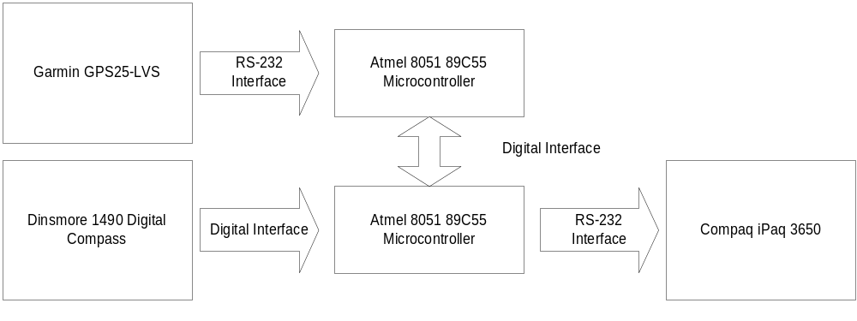As is shown in Figure 14, the IR interface between the compass and the GPS can be replaced with a straight digital interface with a micro-controller.
Figure 14. Suggested Interface between Modules
The original design used the iPaq as the primary coordination unit for the communication of the devices. This would have required a multi-threaded application to handle data from the compass over the IR interface and to handle data from the GPS through the serial connection. The data streams between these devices would not be coincidental and updates regarding position and direction would thus, not be coincidental. With the proposed structure in Figure 14, there is no need for multi-threading to handle the incoming data. All data would be gathered by the micro-controller and sent to the iPaq at once. All updates would then be synchronized and the code necessary to handle this communication would be much simpler and efficient. This format, however, does require that the group come up with some custom format and protocol for sending data to the iPaq from the micro-controller, since they will have to combine GPS data and compass data into one stream.

Another advantage of the proposed format is that the compass will now be part of the hand-held unit, as opposed to resting on a baseball cap. As was mentioned in the preliminary design package, the compass data is inaccurate when the compass itself is tilted too much. With the user looking around, adjusting the cap and looking down at the device in their hands, there would be much turbulence to disrupt the operation of the compass. If the compass is placed in the hand unit, as we have suggested, the compass will most likely be stable and level when the user is looking at the device. The reading would then be most accurate, especially when they are needed.

The most significant advantage of the changes we have proposed is the elimination of the unstable IR interface. Though it was recognized that the IR needs a direct connection to communicate, the design placed this burden on the user by indicating that the user will need to point their cap at the device to allow the data from the compass to be transmitted to the iPaq. We felt that this places an unnecessary burden on the user and is, even then, an unstable method for transmitting the data. The primary reason that this design decision was made was that the iPaq only has two interfaces for communication, the IR and serial port. Our suggested implementation uses one micro-controller to communicate with the GPS and with the other micro-controller, which in turn gathers data from the compass to pass along all of the data to the iPaq over the serial port. Even though the micro-controllers have four separate ports for communication, we suggest using two micro-controllers because it would be easier to use the RS-232 ports on each for the necessary interfacing. With these direct connections there is no need to worry about reliability in the transport interface.

Overall, the proposed project is well thought-out and genuinely useful. They have outlined the necessary components and possible design issues well and appear to have a solid grasp on the desired operation for the device. In light of this, we think that the project can be improved by eliminating the IR interface and replacing it with a micro-controller, as is suggested above. This adjustment should make the project easier to implement and a better, more stable product for the user to enjoy.

Recommendation

Our reviewer has proposed one primary design solution for the Freshman’s Friend. They feel that removing the infrared link in our design will provide a much more stable and robust solution. They propose that the infrared link be replaced with a digital interface between two microcontrollers. By doing so, the Freshman’s Friend will provide much more stable and predictable performance.

Analysis

After reviewing our design and analyzing the trade-offs, we completely agree with our reviewer’s design recommendation. By removing the infrared connection between the iPaq and the digital compass unit, we are removing the most unstable and unpredictable part of the design. Instead we will connect two microcontrollers via a digital interface, as our reviewer has recommended. As stated previously in this design document, the digital interface that we are using to communicate between the two different microcontrollers is the I²C bus.

Implementation

With two microcontrollers in the design, we will have one microcontroller process the incoming data from the GPS unit. It will then pass this processed data along to the second microcontroller over a digital interface. We will implement this interface in the form of an I²C bus. The second microcontroller will then parse this data along with the input from the digital compass and transmit the data to the iPaq over the serial RS-232 link.

References

Actisys Corporation
IR 220L/220L+: IrDA Com-Port Serial Adapter. 2000
April 19, 2001. http://www.actisys.com/ac200-220.html.

Atmel Corporation
8-bit Microcontroller with 20K Bytes Flash. 2000
April 19, 2001. http://64.71.159.17/atmel/acrobat/doc1921.pdf.

Compaq Computer Corporation.
iPaq H3000 Pocket PC. 2000
April 19, 2001. ftp://ftp.compaq.com/pub/supportinformation/techpubs/user_reference_guides/177711-003.pdf.

Dinsmore Instrument Company.
No. 1490 Digital Sensor. December 06, 1993.
April 19, 2001. http://www.hobbyrobot.com/sensors/docs/1490.pdf.

Duracell, Incorporated
MN1604 Battery Performance Curves. 2000.
May 10, 2001. http://www.duracell.com/OEM/Primary/Alkaline/1604pc.html.

Garmin.
GPS25 LP Series. GPS Sensor Boards. Technical Specification. 2000
April 19, 2001. http://www.garmin.com/manuals/spec25.pdf.

Microsoft Developer Network.
http://www.msdn.microsoft.com

Radio Shack Corporation.
Product Catalog. 2000.
May 10, 2001. http://www.radioshack.com.

