Video Imaged Spatial Position System
Final Design Review Document

Submitted to:
CSE 477 / TC 333

Prepared by:
Kevin Chan
Esteban Salazar
Cephas Lin

Friday, May 11, 2001

ABSTRACT

Video Imaged Spatial Positioning System, VISPS, is a system that uses stereo-vision to quickly and accurately find the X, Y, and Z coordinates of a laser marker projected into the visual field. VISPS uses the same principle of triangulation we use with our eyes to pick out objects and know their locations. This system is able to determine these coordinates much more quickly than traditional surveying techniques.

The laser marker is found in the visual data by monitoring the pixel data and finding the brightest pixel that also has a pixel next to it that is “bright.” We found that this is effective in finding the laser marker in the visual data. To make this simple algorithm effective we place a red filter in front of each camera. This filter removes most of the ambient light in an indoor setting so that the laser marker will always be the brightest pixels in the visual data.

VISPS is implemented using three hardware stages. We use two cameras to capture the visual data. The visual data from the cameras are then streamed frame by frame to an XSV300 FPGA over an asynchronous interface. The XSV300 board will attempt to find pixel coordinates of the center of the laser marker in the visual data. Upon finding the pixel coordinates, a four-way handshake is used to robustly transfer these coordinates to a PIC 16C73B microcontroller. The PIC microcontroller then applies mathematical equations to determine the X, Y, and Z coordinates of the laser marker. Once the coordinates are computed they are sent outside the system using an RS-232 serial interface.

One of our design goals is to make the math for determining X, Y, and Z simple. The primary reason is so that we would not need to import external math libraries into the code there by inflating the microcontroller program size. Normally triangulation requires the use of trigonometry for many of the calculation steps. However, we are able to show that trigonometry was not necessary to calculate X, Y, and Z.

Another design goal was that we be able to move to a higher resolution camera without major re-implementation of our design. The reason this is a concern is that it was determined that almost all of our error is a function of the low resolution of the inexpensive cameras we are using. To accomplish this goal we moved all computation after the pixel coordinate discovery to the PIC microcontroller. Also, all math in the PIC is assumed to be 16-bit even though the cameras only produce 8-bit coordinate values. Since we have made it easy to migrate to a higher resolution camera, it is easy with more expensive cameras to increase our accuracy linearly with linear increase in resolution.
Table of Contents

ABSTRACT I
INTRODUCTION 1
PROJECT DESIGN 2
Theory and Math 2
Proof and math to final equations 4
Finding Y, and Z 9
Implementation 12
PROJECT REQUIREMENTS 21
VISPS Requirements 21
VISPS Internal Parts Requirements 22
PARTS LIST 31
DESIGN ANALYSIS 32
Digital Image Consistency 32
System Accuracy 33
TEST PLANS 35
Testing the XSV300 35
Testing the PIC μC 35
DESIGN ISSUES 36
EVALUATING REVIEWER COMMENTS 37
Noise Filtering 37
Interfering Intense Sources 37
Averaging Frames 38
Memory Constraints 39
Floating Point Math 39
TECHNICAL REFERENCES 40

List of Tables

Table 1 – Variable names and descriptions 6
Table 2 – RS-232 protocol parameters 19
Table 3 – VISPS operating parameter 21
Table 4 – Laser flare specifications 22
Table 5 – Spectronix RC-2BW (VV5404) camera 23
Table 6 – VISPS requirements 24
Table 7 – Xess XSV300 operating parameters 24
Table 8 – XSV300 right bank I/O pin mapping 25
Table 9 – XSV300 left bank I/O pin mapping 26
Table 10 – PIC μC requirements 27
Table 11 – RS-232 configuration values 29
Table 12 – PIC μC Pinouts for the Four-way Handshake 30
Table 13 – VISPS parts list 31

List of Figures

Figure 1 – Triangulation problem summary 2
Figure 2 – The view of our two cameras in an example scene 3
Figure 3 – Calibration of cameras 3
Figure 4 – Pixel distances 4
Figure 5 – VISPS laser position cases 5
Figure 6 – Important variables 5
Figure 7 – Depictation of case 2 7
Figure 8 – Side View and Relevant Variables 9
Figure 9 – Subsystem relationships in VISPS 12
Figure 10 – Laser flare with baffle construction 13
Figure 11 – VISPS camera setup 14
Figure 12 – Pixel coordinates from image frame 15
Figure 13 – XSV300 FPGA schematic 16
Figure 14 – CAMERIN module schematic 17
Figure 15 – Finding the lasers center by averaging 18
Figure 16 – XSV300 to PIC μC Four-Way Handshake 19
Figure 17 – Diagram of the communication lines between the XSV300 and the PIC μC 27
Figure 18 – VISPS interfaces 28
Figure 19 – Order of bytes sent on RS-232 port by the PIC 8051 μC 29
Figure 20 – Pixel variance versus depth 33

INTRODUCTION

In many situations, it is useful to know the location of a point in space relative to some fixed reference frame. For example, a landscape architect may need to mark a specific height above a point in a yard. Another example is building contractors who need careful surveys to layout the exact location of the important points of a construction. Although there is a need for this kind of spatial data, current techniques are difficult and tedious. Surveyors need specialized training and expensive equipment to obtain an accurate spatial coordinate. The difficulty involved in these traditional techniques increases significantly if you wish to find the location of objects that have irregular shapes or are out of reach. Using traditional surveying techniques, obtaining more sophisticated spatial data, such as tracking the coordinates of a moving object, is nearly impossible.

It would be ideal in these situations if there were a way to know the exact location of a point instantly. For example, a person pointing at an object with a laser pen or holding up a location flare would be able to produce the X, Y, and Z coordinates of the indicated location without having to do any additional measurements or calculations.

The goal of our design, the Video Imaged Spatial Positioning System (VISPS), is to provide 3-D coordinate information using the concept of stereo-vision. By finding a laser marker in image frames captured from two cameras arranged side-by-side, and applying simple trigonometry, we will be able to determine the X, Y, Z coordinates of the laser marker relative to the two-camera system.

Not only will VISPS simplify the task of acquiring spatial coordinates; it will also extend the capability beyond what traditional techniques can provide. Digital hardware solutions intrinsically have an advantage over mechanical designs because data is easily fed to computers for quick analysis. The high frame rates of the cameras and the ability to do rapid mathematical calculations in hardware means that VISPS will be able to capture the coordinates of a moving point in rapid succession. For example, the laser, used either as a flare or a pointer, can actually be used to draw arbitrary shapes in space or against other objects. Since we will be tracking a laser dot, finding the coordinates of points that are out of reach will be trivially easy by simply pointing at the object with the laser.

PROJECT DESIGN

Triangulation is the idea behind stereo-vision. Stereo-vision allows things with two eyes (i.e. animals, VISPS) to determine X, Y, and Z coordinates for an arbitrary point in space. First, we will describe the theory and mathematics of triangulation and stereo-vision that make VISPS possible. Second, we will discuss how these calculations are implemented in hardware.

Theory and Math

Our goal is to determine X, Y, and Z coordinates for a marker in the visual field of two cameras. In our case, this marker is a laser pointer. Figure 1 below shows the basic trigonometry problem that we will need to solve to obtain these values.

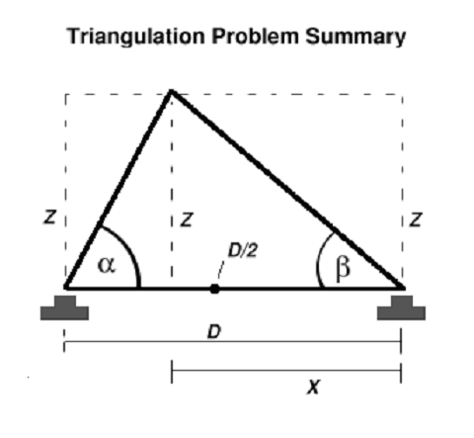
Figure 1 – Triangulation problem summary

Given any three known values of this triangle, all the other values can be determined using either the law of cosines or the law of sines. Once we have these knowns, we will then show the math to solve for X, Y, and Z. D is known to be the distance between the two cameras and can be measured directly. The other two values must be obtained directly from the visual data provided by the two cameras.

Figure 2 below is an example of the visual data obtained from the cameras. The white spot of saturation that appears in both images is the laser dot seen from the two slightly different angles of the cameras.

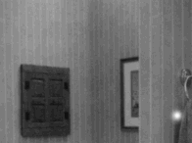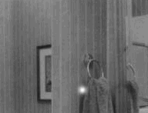
Left Camera
Right Camera

Figure 2 – The view of our two cameras in an example scene

Since it is impossible from one camera alone to know how far away an object is or it’s location, we will use this visual data to learn the angles α and β from Figure 1 above. Once we know these two angles, we have enough information to solve for X, Y, and Z.

The technique used for extracting the angles is based on the trigonometric notion of similar triangles. Once we know the relationships governing one triangle, we can know the relationships that govern all triangles that have the same proportions. For this first known triangle we simply look at the image produced by a single camera and manually measure the distance between the horizontal extremes of the viewable area at a fixed and known distance. Figure 3 below illustrates this arrangement.

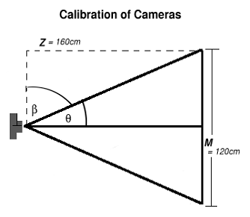
Figure 3 – Calibration of cameras

Since we know that there are 255pixels across our field of vision (the image is cropped in hardware to 255x255) we know that at this distance of 160cm each pixel represents 0.47cm/pixel. The distance Z can be represented as a pixel distance also if we say that h’ = pixel representation of Z, h’ = Zcm/(0.47cm/pixel) = 340pixles.

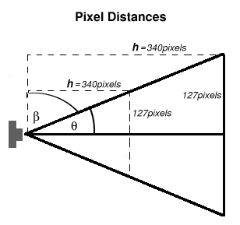
Figure 4 – Pixel distances

Notice in Figure 4 how the field of vision is always 255pixels at any physical distance and the angle θ does not change. Using similar triangles we know that the pixel distance h’ is also always the same, namely 340pixels. From now on we will call this pixel distance h.

Now if we solve for β using pixel values h and a, where a is the pixel distance from the center pixel of a frame, we see that,

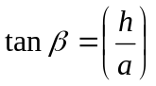 , and 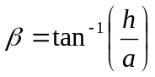

We can solve for the angles in the visual field using only pixel coordinates and the constant h. Most importantly, we can solve for these angles for any pixel value of a, not just when a is at the extreme edges of the visual field since we are only dealing in pixel values.

Proof and math to final equations

For our stereo-vision problem we have 3 cases, which are illustrated by Figure 5 below. First we will solve for X in Case 1. Then we will show that the equations for Case 1 also apply to Case 2. Equations that apply to Case 2 also must apply to Case 3 by symmetry. Once we have X for all cases, we will present the steps to finding Y and Z. Our goal is to find a single set of equations for X, Y, and Z that hold for all three cases. Additionally we have a secondary goal of reducing these equations so that no trigonometry is required. The importance of this secondary goal will be discussed further in the section Implementation.

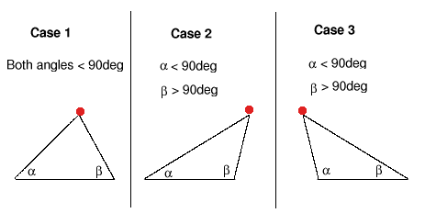
Figure 5 – VISPS laser position cases

Before starting with Case 1, we will introduce the important variables that we will be using and their definitions. These variables are shown in Figure 6 below in relation to the left and right cameras of VISPS.

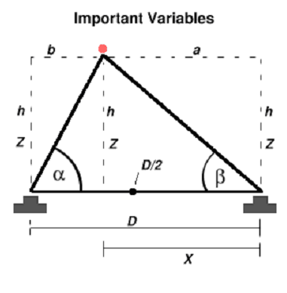
Figure 6 – Important variables

All variables in upper case are physical distances and all variables in lower case are pixel distances. Greek letters represents angles. Table 1 below describes each variable.

Table 1 – Variable names and descriptions
Variable | Description
a | The pixel distance to the laser marker left of the center pixel of the right camera.
b | The pixel distance to the laser marker right of the center pixel of the left camera.
c | The pixel distance to the laser marker up from the center pixel of either camera.
h | The pixel distance to the laser marker in the Z direction from the front each camera.
D | The physical distance between the two cameras.
X | The physical distance left of the right camera to the laser marker.
Y | The physical distance up from either camera to the laser marker.
Z | The physical distance in front of either camera to the laser marker.
α,β | Angles as defined by Figure 6.

Case 1

First, we solve for X in terms of the physical variables D, and Z.

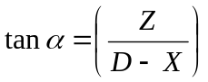 and 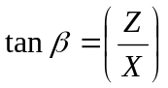 (1)

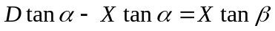 (2), from (1)

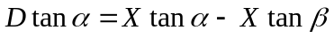 (3), from (2)

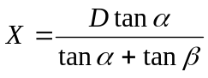 (4), from (3)

Now that we know X in terms of angles and D we can use the fact that our angles can also be determined by pixel information to simplify this equation. we know:

and 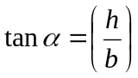 (5)

Substituting equations (5) into equation (4) we get:

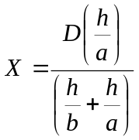, and after simplifying, 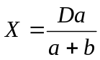 (6)

Case 2

The potential problem with Case 2 is that taking tan to find an angle greater than 90° does not evaluate as expected. β in Case 2 is greater than 90° and since in equation (4) from above we take the tangent of β, we may have trouble.

For an example case where β is equal to 126.8° we demonstrate the problem below.

What we expect is that β = 126.8° for h = 4 and a = -3. What we actually get is that β = -53.13°. However, we only want to know the tangent of β and since

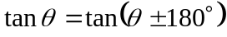

equation (6) holds. But does equation (4), from which equation (6) is derived, hold in Case 2? Again, the problem is that for angles greater than 90°, tangent evaluates to negative values. To show that equation (6) does hold we will solve for X using a new angle γ that is less than 90°. Then we will show that this equation is equivalent to equation (4), which reduces to equation (6).

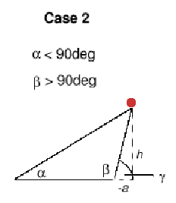
Figure 7 – Depictation of case 2

The equation below describes the relationship between Z, X, and γ.

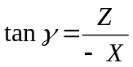 (7)

Using algebra we obtain a new equation (8) for X in terms of D, α, and γ that is similar to equation (4).

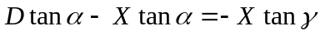

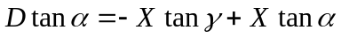

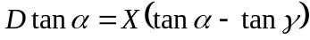

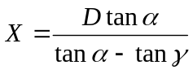 (8)

Using the definition of β in terms of γ, (9), and the two trigonometric identities shown in equations (10) and (11), we are able to convert equation (8) so that it is exactly the same as equation (4).

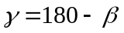 (9)

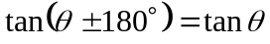 (10)

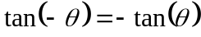 (11)

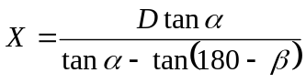 (12)

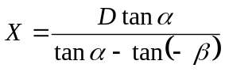 (13)

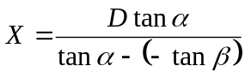 (14)

From here we get equation (4), which reduces to equation (6). Therefore, equation (6) is valid for Case 1 and Case 2, and by symmetry, Case 3.

Finding Y, and Z

We will now use the relationship we found in the previous section to find X, Y, and Z.

Determining the Z Coordinate

Starting in the same way that we obtained equation (4) we can obtain an expression for Z in terms of D and the angles α and β.

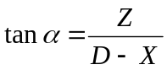 and 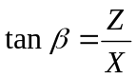

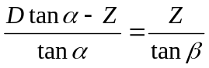

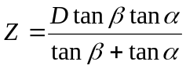

So, using equation (5) and simplifying, we get

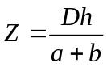 (16)

Determining the Y Coordinate

To find Y, we use the triangle described below.

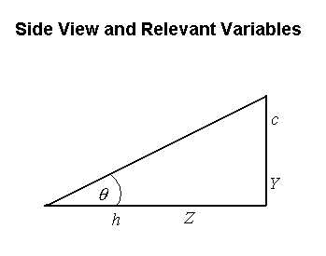
Figure 8 – Side View and Relevant Variables

From Figure 8 we get the relations below.

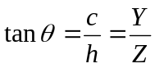

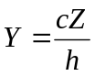

Substituting from equation (16), which describes Z, we get

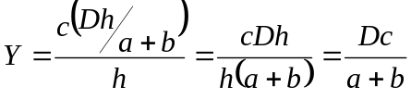 (17)

The ‘Zeroes’ Problem

One question remains regarding what happens when either α or β go to 90°. Equation (4), upon which all our final results shown in equation (15), (16), and (17) are based, requires the tangent of α and β but tangent is not defined at 90°. We know by inspection that when α = 90°, X = D and when β = 90°, X = 0 inches. We will show that these are the values for X that equation (4) actually produces.

Starting with equation (4), we replace tangents using the trigonometric identity below.

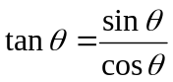

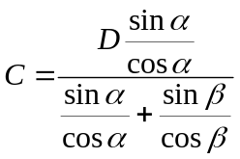 (18)

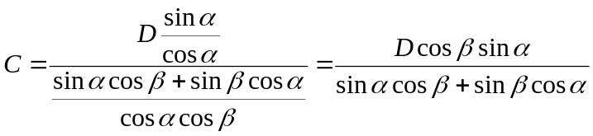 (19)

Now if we plug β = 90° and α = 90° into equation (19) we see that in fact, X goes to 0in and D respectively. Since equation (4) is valid when β = 90° and α = 90°, equations (15), (16), and (17) since they are derived directly from equation (4).

Summary of X, Y, and Z Equations

In summary, we now have equations for X, Y and Z strictly in terms of pixel coordinates and a single known constant D. Equations (6), (16), and (17) below are the results.

(6)

. (16)

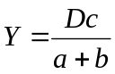 (17)

We are able to compute these values without using any trigonometry. In addition, because all three physical coordinates can be directly computed from pixel coordinates, there is no multiplication of error that we would incur if we were to use our results for X to compute Z or if we were to use Z to compute Y.

Implementation

VISPS produces X, Y, and Z coordinates from raw pixel data. The acquisition of pixel data, the conversion of pixel data to coordinates, and the export of those coordinates are achieved via a series of sequential operations. Each of these operations is performed by a piece of hardware in VISPS. Each operation prepares the data to be further manipulated in the next step. Since each piece of hardware is responsible for a series of steps, each piece of hardware is responsible for a functional transformation of its inputs and a delivery of outputs. The figure below outlines the hardware responsible for each step. In this section we will describe what steps each hardware component is responsible for and how these steps are implemented.

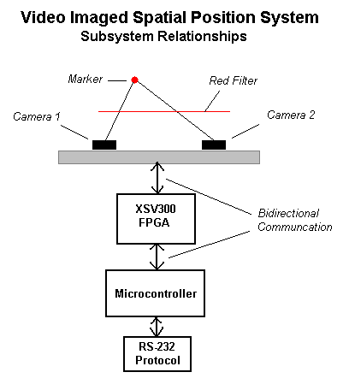
Figure 9 – Subsystem relationships in VISPS

One of our overall design goals was to keep that data paths wide enough to support a very high camera resolution. All of our error is linearly proportional to the resolution of the camera. We made sure that all computations happen as if the cameras could produce 16-bit coordinates even though they only produce 8-bit coordinates. In this way we have the ability to increase the accuracy of our system by increasing the resolution of the camera without having to redesign major portions of VISPS. The XSV300 is tailored specifically to interact with the low-resolution RC-2 cameras we are using. The output of the XSV300 and starting with the μC, all communication and computations assume a possible resolution of 65535 x 65535.

Laser Pointer

To produce the laser point in the visual field we are using a generic 5mW laser with a wavelength rated between 630-680nm.

We initially considered using a high contrast sticker as the marker. However, if we use a sticker we can only find the marker by searching for the sticker’s color or shape. Neither of these alternatives is practical. Firstly, the cameras can only produce black and white images so searching for color is impossible. Secondly, our initial research revealed that searching for a specific shape in an image is a difficult computational problem.

We found that the best marker option was to use a high intensity laser pointer. A laser delivers a high intensity and well-defined beam of light. This beam can easily be directed at an arbitrary point or be redirected into a baffle as shown in Figure 10 to form a flare. To construct the laser flare, a white baffle of reflective material will cross the laser’s beam to reflect light towards the cameras.

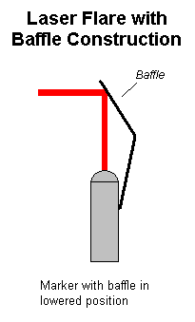
Figure 10 – Laser flare with baffle construction

This flexibility makes the idea of using a laser attractive from the user interface perspective.

Red Filter

As is discussed in our reviewer comments section, we need to remove light emitted by other bright objects in the visual field before we can process the visual data. This is because bright objects other than the laser marker can sometimes be indistinguishable from the laser marker itself. To accomplish this we place a small red filter in front of each camera. The filter we are using has a very wide pass band. Its exact width is unspecified by the manufacturer. This inexpensive filter is sufficient in most indoor settings to adequately filter light not emitted by our laser. However, lab use has shown that light from red LEDs and direct light sources such as sunlight or the powered light bulbs contain a sufficient red component that passes through the filter so that XSV300 will become confused and incorrectly identify the laser marker. A filter with a pass band of only 10nm centered on the exact wavelength of our laser can be purchased for $50. We felt that for the purposes of this project, the expenditure was not justified.

Black and White CMOS Cameras

The two cameras are Spectronix RC-2BW RoboCams. They capture visual data and deliver pixel intensity values over a 4-bit bus to the XSV300. The digital image is in CIF format with a size of 356 x 292. The cameras will be mounted so they face the same direction and the centers of the two cameras are one foot apart. Figure 11 below shows this configuration.

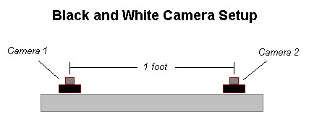
Figure 11 – VISPS camera setup

If the cameras are not perfectly parallel, the pixel coordinates will still be correct but their relationship to each other will be incorrect. Consequently, the equations derived in the Math and Theory section will not apply. Therefore it is imperative that we do our initial set up very carefully. The best way to do this is to measure the physical distance between the points corresponding to the center pixels of each camera. This distance will exactly equal D when the cameras are parallel.

If the cameras are perfectly parallel but together they are not perfectly horizontal, the values they produce will be correct but will be shifted by some degree proportional to the deviation from horizontal. Since users will be mounting the camera apparatus themselves, we cannot guarantee that that the cameras will be level. To aid users in setting up the camera we could fit the camera apparatus with inexpensive bubble levels. We will not actually be installing levels for this project.

The camera delivers pixel intensity values over a 4-bit bus to the FPGA at 24MHz.

XSV300 FPGA

The purpose of the XSV300 is to take a pair of images (one from each camera) and find the pixel coordinates in each image that correspond to the marker. Once the set of pixels is found, they deliver the pixel coordinates to the PIC16C73B microcontroller (PIC μC) for further processing.

The pixel coordinates of the marker in the image frame will be defined as the pair: (row, column). Figure 12 below shows the coordinates that will be generated.

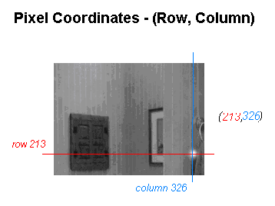
Figure 12 – Pixel coordinates from image frame

After the pixel coordinates are determined, the row coordinates from the two cameras are compared. Since both cameras are at the same altitude, they should produce approximately the same row coordinate. We will use this property as an initial error-checking scheme. The XSV300 will make sure that the two row indices are within six pixels of each other. If this condition fails, the XSV300 will resample the image from the cameras and recalculate the pixel locations. Otherwise, the XSV300 will send the two column indices and a row index to the PIC μC. The row index will be an average of the row indices obtained from the two cameras.

below in Figure 13 is the schematic of the logic programmed onto the XSV300 FPGA to parse the images from the two cameras.

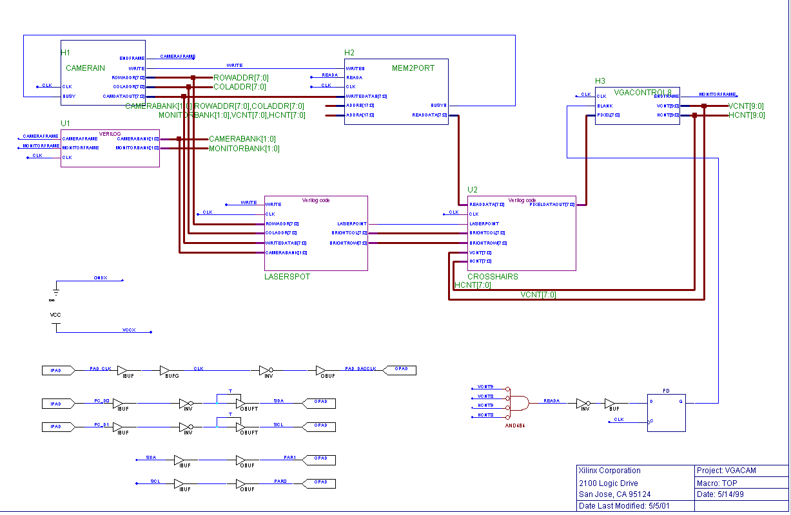
Figure 13 – XSV300 FPGA schematic

All of the modules shown in Figure 13 above except CAMERAIN and LASERSPOT are for displaying data to the VGA monitor which is not really part of VISP but is only included for testing purposes.
CAMERAIN contains logic to handle the asynchronous interface to the RC-2 camera shown in Figure 14 below.

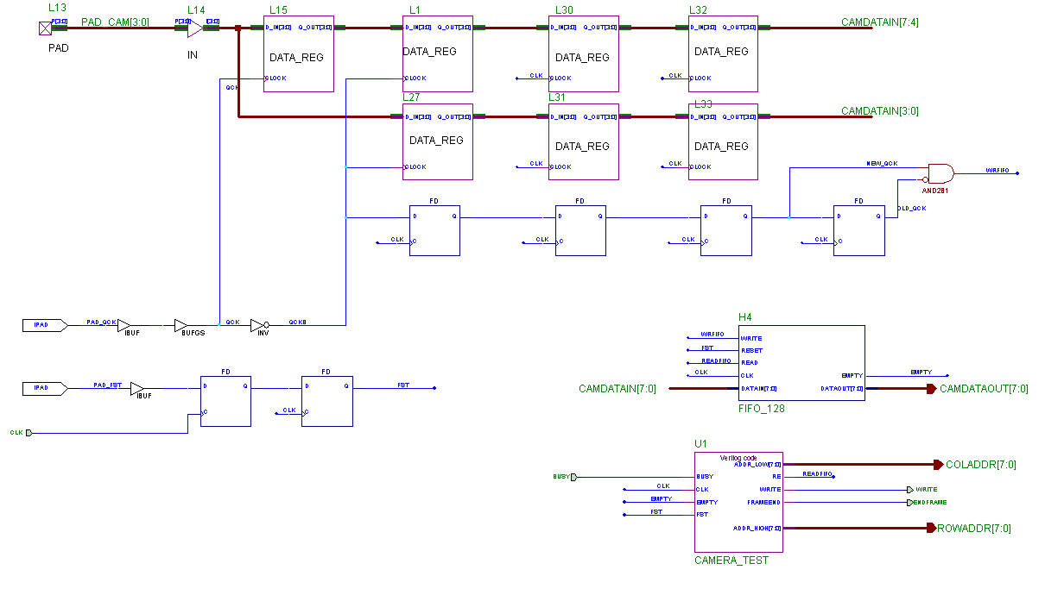
Figure 14 – CAMERIN module schematic

CAMERAIN also crops the camera image to 255 x 255 pixels. As pixel coordinates are streamed out from CAMERAIN with their intensity values, LASERSPOT determines the location of the laser and output the coordinates. If no laser is found, then LASERPOINT is set low.

To locate the laser point, the LASERSPOT module makes assumptions about the data it is receiving. It assumes that the brightest pixels in the image are all part of the region covered by the laser marker and that all those pixels are saturated. “Saturated” means that the intensity values are equal to 255. From our testing, this is known to be a valid assumption. To find the brightest pixel we look for the first brightest point in the data stream for each frame. Since we are assuming that all our laser pixels are equal to 255, this brightest point will have a value of 255. As a check against single pixel noise, we also check to see if the pixel next to this brightest point is “bright”. “Bright” in this case was determined experimentally to produce consistent results at a value of 240. In the evening with no sunlight in the lab, we were able to detect laser points on more surfaces and further away by reducing this “bright” value to 200. If we set this threshold too low, then common objects in the room such as white paper are confused for the laser.

Often the laser marker does not appear as a single pixel point in the image data. The saturation region surrounding the laser marker can be several pixels across. Not only do we want to locate the laser region, but we also want to determine a reasonable center of the saturation region to increase accuracy. At this point in the data processing, VISPS is assuming that there are no regions with intensity greater than 240 that are not a part of the laser pointer and that the main body of the laser marker in the visual data has an intensity equal to 255. Specifically, we are assuming that all points inside the marker have an equal intensity of 255. As we apply our search algorithm described above, we scan first from left to right then from top to bottom, so the first brightest point will be the upper left corner of the laser marker and the last brightest point will be the lower right corner of the laser marker. In the example above, we pick a new brightest point only if it is brighter than the previous brightest point. This will always pick the first of a set of equally bright points, or the upper left corner of our laser. If we do another search in parallel that instead chooses a new brightest point if it is brighter or equal in brightness to the previous brightest point, we will find the lower right corner of the laser point. Averaging these two brightest points will give the center of the region covered by the laser point.

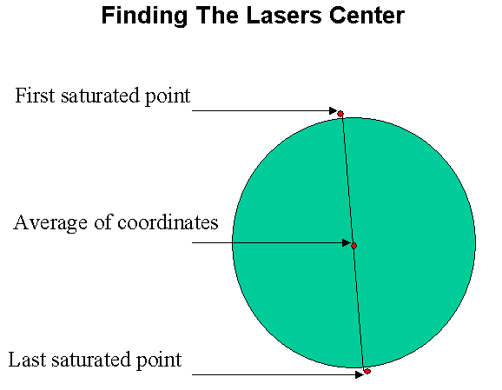
Figure 15 – Finding the lasers center by averaging

The communication between the PIC μC and the XSV300 will be handled through a four-way handshake as described in the Project Requirements section.

PIC μC

After the XSV300 produces the two column coordinates and the single row coordinate, the PIC μC applies the simple equations defined in the Math and Theory section to determine the spatial X, Y, and Z coordinates of the laser marker.

The reason we choose to implement these functions on a PIC μC are because of its processing capabilities. We will need to be able to perform mathematical computations with some degree of accuracy. This means floating-point arithmetic is required. Although the PIC μC does not have native support for floating-point operations, it can emulate floating-point operations with some reduction in throughput. In VISPS, the decrease in throughput of the PIC μC is not a concern because the data will be streaming out through the RS-232 port when the data is ready and not when the data is demanded.

To present the data, we chose to stream the data using the RS-232 protocol. The primary reason we chose RS-232 is that the PIC μC has native support for the protocol and it is easy to implement user applications that can read this protocol. We will use the RS-232 protocol with the parameters listed in Table 2 below.

Table 2 – RS-232 protocol parameters
Parameter | Value
Baud Rate | 19, 200 bps
Number of bits | 8
Parity | No parity
Number of stop bits | 1
Flow Control | None

The exact data format of our RS-232 transfer protocol is discussed in detail in the Project Requirements section.

The transfer of pixel coordinates from the XSV300 to the PIC μC is managed through a four-way handshake. Timing of the control and data signals is shown in Figure 16 below.

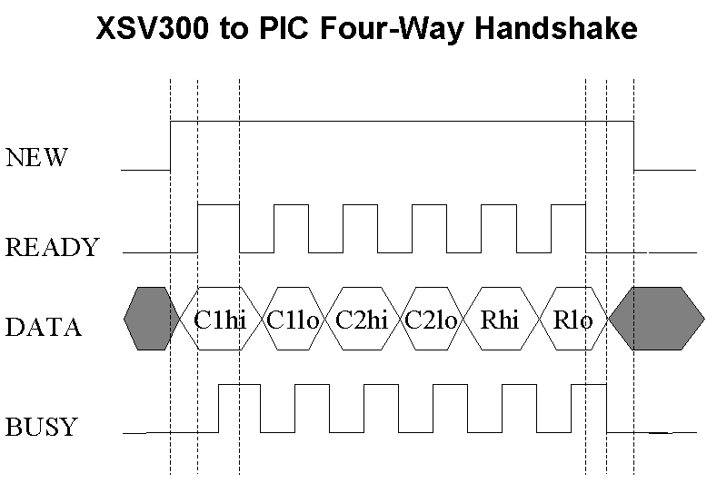
Figure 16 – XSV300 to PIC μC Four-Way Handshake

The PIC μC sets the NEW pin high to indicate a request for a fresh data set. Then six times it will do the following:

- Continually polls the READY pin until it is set high by the XSV300
- Read the data on PORTB, then set the BUSY pin high
- Continually polls the READY pin until it is set low by the XSV300
- Sets the NEQ bit low

The three data sets (the two column coordinates and the single row coordinate), grouped in pairs (a high-order and a low-order bytes), will then be converted to three floating point numbers by multiplying the high-order byte by 256, or 2⁸, and add the low-order byte to it. Then, using the floating-point operations that are inherent in the PIC C-compiler, the mathematical calculations will be applied to the three values to obtain the physical X, Y, and Z coordinates of the laser marker. At this point, the PIC μC will then output the three coordinates as a stream of characters through the RS-232 protocol to the presentation device, which is just the PC. This is done on the PIC simply using the standard I/O library that comes with the C-compiler (stdio.h). Then the PIC μC will set the NEW pin high to request a fresh data set and repeat this whole process again.

PROJECT REQUIREMENTS

For VISPS, we have defined a number of project requirements. Below are the operating parameters for VISPS and the operating conditions of the internal parts. We will also discuss the communication protocols that we will use between the subsystems.

VISPS Requirements

VISPS is required to operate under the conditions shown in Table 3 below.

Table 3 – VISPS operating parameter
Parameter | Value
Coordinate Accuracy | @ 63 inches the coordinates will be within 0.1 inch of its true location.
Data Output | RS-232 Protocol (19.2 Kbps / 8 data bits / 1 stop bit / no parity)
Voltage | Requires 9 and 12 V supply
Maximum Operating Distance | 60 feet
Laser Flare Wavelength | 630-680 nm
Laser Flare Max Output | < 1 mW

The maximum operating distance determined mathematically for the existing cameras is 340 feet. The system may not actually work at 340 feet. At 340 feet, a pixel in the Spectronix cameras that VISPS uses is 11 inches wide. Assuming that laser’s disperse at farther distance, if the laser flare is perfectly reflected back to the cameras there is a possibility that the cameras will detect the laser flares. But in reality, we hardly get perfect reflection. Thus we limit the distance to 60 feet because at 60 feet, a pixel is 2 inches wide. Assuming laser dispersion, we believe that the cameras will still detect the presence of the laser flare at 60 feet. (For more information look to the Design Issues section of the report.)

Finally, ideal operating conditions are that the laser flare is not used on light-diffusing material. Furthermore, the environment should not have any direct light or reflected light with wavelengths between 630-680 nm at an intensity greater than or equal to the intensity of the laser flare. If the environment does contain such conditions then VISPS will not work at all because VISPS will not be able to distinguish the difference between the laser flare and the surrounding environment.

VISPS Internal Parts Requirements

For the internal parts requirements, we will discuss what the hardware requirements will be, what input that piece of hardware is expecting, and what output the hardware will produce.

Laser Requirements

The laser flare consists of a laser pointer a baffle constructed out of paper that can help to deflect the laser light at a 90 degree angle. The laser pointer has the properties shown in Table 4 below.
Table 4 – Laser flare specifications
Parameter | Value
Max Output | < 1 mW
Operating Wavelength | 630-680 NM

The purpose of the laser flare is to act as the marker in VISPS.

Red Filter Requirements

The filter is a generic Quantaray 52mm red filter. The filter will be placed in front of the cameras and will serve to filter all extraneous light except for the laser flare. It is very important to get a filter that will allow the light of the laser flare to pass through. To improve the performance of VISPS use a filter that only allows the specific wavelength of the laser through. If the laser is changed, a matching filter for the laser must be used.

Camera Requirements

The two cameras are implemented by Spectronix RC-2BW cameras which have the properties shown in Table 5 below.

Table 5 – Spectronix RC-2BW (VV5404) camera
Operating Parameter | Value
Operating Voltage | 6.0-12.0V
Supply Current | < 75 mA
Image Format | CIF
Minimum Image Size | 255 x 255 pixels
Pixel Size in Bits | 8 Bits
Sensor Signal/Noise Ratio | 46dB
Minimum Illumination | 0.1 lux
Scope of Vision | 28 degrees
Chipset | VLSI Vision VV5404
Frame Rate | 30 fps
Internal Clock | 7.15 MHz
Qualification Clock | Slow QCK
Frame Start Signal | Yes
Color | 8 bit Greyscale

For the cameras, the frames must be streaming from the cameras at a rate of 30 fps. To signal the start of each frame, a frame start signal must be asserted and deasserted before the pixel data is transmitted.

The pixel data is transmitted using a 4-bit wide data bus using a qualification clock. This requires that every pixel must be transmitted in two nibbles, the most significant nibble first followed by the least significant nibble. To make sure that the bus contains valid data, a qualification clock (QCK) is used. For VISPS, QCK must be running in the slow frequency mode. In this mode, every rising edge of QCK means that the data bus contains the most significant nibble and every falling edge of QCK means that the data bus contains the least significant nibble. To configure this, an I2C bus is used. For I2C details refer to the I2C specification produced by Philips Semiconductor.

The input to the image capture subsystem is the laser flare. Both cameras are expected to take snapshots of the environment containing the laser flare. As outputs, the cameras are expected to stream the data frames as specified above.

XSV300 FPGA Requirements

To process the two images from the Spectronix Cameras, Table 6 below shows the approximate requirements by VISPS on an FPGA.

Table 6 – VISPS requirements
Operating Parameter | Value
External GCLKIOBs | 1
External IOBs | 64
SLICEs | 594
GCLKs | 4
TBUFs | 8
Minimum Frequency | 25

To handle VISPS FPGA requirements, we will use an XSV300. Table 7 below shows the operating parameters of the XSV300. As shown, the XSV300 can meet the requirements of VISPS.

Table 7 – Xess XSV300 operating parameters
Operating Parameter | Value
Operating Voltage | 9.0V (center positive)
Supply Current | < 25 mA
Clock Speed | 25 MHz
Gate Count | 300K
External GCLKIOBs | 4
External IOBs | 166
SLICEs | 3072
GCLKs | 4

The XSV300 will be processing two independent image streams from each camera to find the pixel coordinates of the marker. The pixel coordinates will be in relation to the upper left hand corner of the image and represented with 2 bytes. To output a coordinate, we will first send the high order byte then the low order byte. At a higher level of abstraction, the XSV300 will send the row and column coordinates of the left camera followed by the column coordinate of the right camera. The actual transfer of the coordinates will be described in the PIC μC Requirements section.

For debugging purposes, two frames will be captured and stored in a double-buffer scheme. The images are 255x255 at 8 bytes. This is approximate 64Kb. Since we are storing two images and we are using all of the IO pins, we are required to use off board static RAM. We will use asynchronous 128K x 8 DIP static RAM from Winbond Electronics. The part number is W241024AK-15.
Finally, Table 8 below shows the mapping between the right bank I/O pins on the XSV300 and the designated functions.
Table 8 – XSV300 right bank I/O pin mapping
FPGA Pin | Right Bank Connector | Function
53 | 2 | Camera 2 – I2C SCL
54 | 4 | Camera 2 – I2C SDA
55 | 5 | Camera 2 – Data_Bus[0]
56 | 6 | Camera 2 – Data_Bus[1]
57 | 8 | Camera 2 – Data_Bus[2]
63 | 9 | Camera 2 – Data_Bus[3]
64 | 10 | Camera 2 – QCK
65 | 12 | Camera 2 - FST
66 | 13 | VGA Monitor (for testing) – HSYNC
67 | 14 | VGA Monitor (for testing) – VSYNC
68 | 16 | VGA Monitor (for testing) – Data[0]
70 | 17 | VGA Monitor (for testing) – Data[1]
71 | 18 | VGA Monitor (for testing) – Data[2]
72 | 20 | VGA Monitor (for testing) – Data[3]
73 | 21 | VGA Monitor (for testing) – Data[4]
74 | 22 | VGA Monitor (for testing) – Data[5]
78 | 24 | VGA Monitor (for testing) – Data[6]
79 | 25 | VGA Monitor (for testing) – Data[7]
80 | 26 | Four-way Handshake – READY
81 | 28 | Four-way Handshake – BUSY
82 | 29 | Four-way Handshake – NEW
84 | 30 | Four-way Handshake – Data_Bus[0]
85 | 32 | Four-way Handshake – Data_Bus[1]
86 | 33 | Four-way Handshake – Data_Bus[2]
87 | 34 | Four-way Handshake – Data_Bus[3]
93 | 36 | Four-way Handshake – Data_Bus[4]
94 | 37 | Four-way Handshake – Data_Bus[5]
95 | 38 | Four-way Handshake – Data_Bus[6]
96 | 40 | Four-way Handshake – Data_Bus[7]
97 | 41 | Camera 1 – QCK
99 | 42 | Camera 1 – FST
100 | 44 | Camera 1 – Data_Bus[0]
101 | 45 | Camera 1 – Data_Bus[1]
102 | 46 | Camera 1 – Data_Bus[2]
103 | 48 | Camera 1 – Data_Bus[3]
107 | 49 | Camera 1 – I2C SCL
108 | 50 | Camera 1 – I2C SDA
109 | 1 | Disable Right SRAM Bank
Table 9 below shows the left bank I/O pin on the XSV300 and their corresponding functions.

Table 9 – XSV300 left bank I/O pin mapping
FPGA Pin | Left Bank Connector | Function
186 | 1 | Disable Left SRAM Bank
187 | 2 | Monitor DAC Clock
188 | 4
189 | 5 | External Ram CS1 (Active Low)
191 | 6 | External Ram CS2
192 | 8 | External Ram OE (Active Low)
193 | 9 | External Ram WE (Active Low)
194 | 10 | External Ram IO[0]
195 | 12 | External Ram IO[1]
199 | 13 | External Ram IO[2]
200 | 14 | External Ram IO[3]
201 | 16 | External Ram IO[4]
202 | 17 | External Ram IO[5]
203 | 18 | External Ram IO[6]
205 | 20 | External Ram IO[7]
206 | 21 | External Ram A[0]
207 | 22 | External Ram A[1]
208 | 24 | External Ram A[2]
209 | 25 | External Ram A[3]
215 | 26 | External Ram A[4]
216 | 28 | External Ram A[5]
217 | 29 | External Ram A[6]
218 | 30 | External Ram A[7]
220 | 32 | External Ram A[8]
221 | 33 | External Ram A[9]
222 | 34 | External Ram A[10]
223 | 36 | External Ram A[11]
224 | 37 | External Ram A[12]
228 | 38 | External Ram A[13]
229 | 40 | External Ram A[14]
230 | 41 | External Ram A[15]
231 | 42 | External Ram A[16]
232 | 44 | Parallel Port Data Register [0]
234 | 45 | Parallel Port Data Register [1]
235 | 46 | Parallel Port Status Register [3]
236 | 48 | Parallel Port Status Register [4]

For full specification on the use of the I/O pin banks refer to the Xess Board V1.0 Manual from Xess corporation.

PIC μC Requirements

The PIC μC is a self-contained unit. It will accept a set of pixel coordinates from the XSV300. With the pixel coordinates, the PIC μC must manipulate the pixel coordinates to then output the physical coordinates of the marker. The PIC μC requirements are shown Table 10 below.

Table 10 – PIC μC requirements
Operating Parameter | Value
Operating Voltage | 5 V
Supply Current | < 5 mA
Package | PDIP
Memory | 4K
Clock Speed | 20 Mhz

The PIC μC retrieves the pixel coordinates from the XSV300 across their asynchronous interface using a four-way handshake. Figure 17 shows a diagram of the control lines and the data bus.

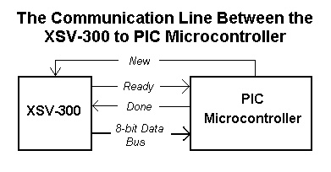
Figure 17 – Diagram of the communication lines between the XSV300 and the PIC μC

For the four-way handshake, an 8-bit data bus will be used to transfer the physical data and two extra control lines are used to reliably transfer the data to the PIC μC.
The four-way handshake protocol will occur in the following steps:

- XSV300 drives the READY line high when the data on the data bus becomes valid.
- When the PIC μC sees that the READY line is high, the μC reads that data and drives the DONE line high after it has finished reading the data.
- The XSV300 returns an acknowledgement by pulling the READY line low.
- The PIC μC completes the handshake by pulling the DONE signal low.

This four-way handshake will be used to transmit each of the three coordinates from the XSV300 to the PIC μC subsystem.

The final requirement is that the PIC μC must start the transfer. To do this, the PIC μC will raise the NEW line high. When the XSV300 sees the NEW line assert, the XSV300 will then begin transferring the pixel data using the four-way handshake. The reason that the PIC μC initiates the transfer is so because the PIC μC knows when it has fully completed its computation. Furthermore by initiating the transfer instead of streaming the data, we can guarantee that the set of coordinates is transferred to the PIC μC correctly and in the right order. In VISPS, the order in which the coordinates are transferred is critical. As shown in the XSV300 FPGA Requirements above, the order will be the row and column of the left camera before the row and column of the right camera.

To communicate with the outside world, the PIC μC will be talking through the onboard RS-232 protocol. The RS-232 protocol will have two output interface-lines shown in Figure 18.

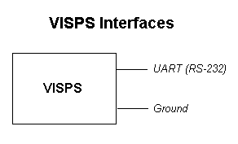
Figure 18 – VISPS interfaces

In VISPS, the RS-232 protocol will run with the configuration shown in Table 11.

Table 11 – RS-232 configuration values
Parameter | Value
Baud Rate | 19, 200 bps
Number of bits | 8
Parity | No parity
Number of stop bits | 1
Flow Control | None

The coordinates output by the PIC μC will be 16-bit X, Y, Z coordinates in inches. This output is scaled by a factor of ten so that we can have resolution up to 0.1 inches. When streaming the coordinates out, we will send the bytes the order shown in Figure 19.

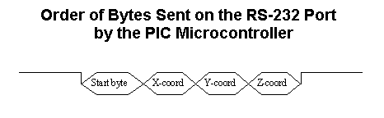
Figure 19 – Order of bytes sent on RS-232 port by the PIC 8051 μC

In the byte output, the start bytes will both be 255 (0xffff in hex) because no coordinate will have that value. Then the next six bytes are the X, Y, and Z coordinates.

The X and Y coordinates will be normalized to positive integers. When the PIC μC finished finding the coordinates, the X and Y coordinates will range from –32767 to 32767. Before outputting the X and Y coordinates, the PIC μC will normalize these coordinates so that –32767 will be 0 and 32767 will be 65535. For the Z coordinate, the output will not be normalized but the max value will be 65534. The primary reason is because the Z coordinate can never be negative. After normalizing X and Y and limiting the max value of Z, we can use the value 65535as the start byte since neither X, Y, nor Z will ever have this value.

We require the use of a start bytes so that whoever is interfacing with VISPS will be able to determine when VISPS begins transmitting a set of coordinates.

When no data is available, the PIC μC will not transmit anything. Thus the PIC μC will only transmit coordinates when they become available.

Finally for the four-way handshake and RS-232 transmission, the PIC μC will use the pins shown in Table 12 below.

Table 12 – PIC μC Pinouts for the Four-way Handshake
PIC μC Pins | Four-way Handshake Lines
A0 | READY
A1 | BUSY
A2 | NEW_DATA
B0 | Data Bus [0]
B1 | Data Bus [1]
B2 | Data Bus [2]
B3 | Data Bus [3]
B4 | Data Bus [4]
B5 | Data Bus [5]
B6 | Data Bus [6]
B7 | Data Bus [7]
C6 | RS-232 Transmit Line

PARTS LIST

To implement VISPS, we require the parts shown in Table 13 below:

Table 13 – VISPS parts list
Part Number | Description | Company | Quantity
Robocam RC-2BW | Black and white camera | Spectronix | 2
XSV300 | A Xess development board with a Xilinx FPGA that contains 300,000 gates | Xess Corporation | 1
Laser Pen | Laser Pointer at 630-680nm | Hi Output | 1
HyperTerminal | A terminal communication program included with all version of the MS Windows used for test environment | Hilgraeve | 1
PIC16C73B | PIC microcontroller used for the processing the images from the camera and for a test environment | Microchip | 2
N/A | 52mm red filter | Quantaray
W241024AK-15 | Static RAM (128K x 8 bit words) | Winbond Electronics | 2

DESIGN ANALYSIS

There are two major factors that will determine the success of the project. These factors are:

- Digital image consistency
- System accuracy

In the following sections we will discuss each area in more detail.

Digital Image Consistency

For digital image consistency, we are concerned that the images from the two cameras are not synchronized. This can occur if the cameras are capturing images at slightly different rates and the laser marker is shifted rapidly. In this case, one camera may stream an image where the laser marker is in the top left corner of the image when the other camera streams an image where the marker is in the lower right corner. To handle this situation, the XSV300 will compare the row coordinates of the pixels that define the marker. If the row coordinates are within six pixels of each other, then we will keep the coordinates the XSV300 finds. If the row coordinates are not within this range, we will simply discard the coordinates. The reason we can do this is because on a theoretical level the cameras are mounted on a level plane so that the center of both cameras are on the same horizontal plane. In this case, the laser marker will appear at the same vertical position in both images.

There is another consistency issue: what if the laser marker is visible in the image from one camera but not visible in the image from the other camera? This condition will occur due to the limited viewing angles of the cameras. The marker can be placed such that camera 1 will see the marker, but camera 2 will not see it. To handle this situation, the XSV300 will not notify the PIC μC that new data is available. Whenever the PIC μC does not have new data available, the PIC μC will not output anything. This is a reasonable solution and is within our operating parameters.

System Accuracy

The primary source of error comes from the low resolution of the cameras. A pixel is the map of a small area of light. As shown in Figure 20, the area that a pixel maps to increases. In VISPS, we found that for the Spectronix camera a pixel is 0.18 inches wide at a depth 63 inches. This means that if the marker is reflected from an object 63 inches from a camera, the marker can 0.09 inches to the left or right before it appears in an adjacent pixel. However, since our system RS-232 output is in units of tenths of inches, even thought we can compute coordinates with an accuracy of 0.09 inches, our system accuracy is limited to 0.1 inches. At distances farther than approximately 63 inches this limitation will no longer be the dominant source of error. Finally as the depth increases, the width of a pixel increases proportionally. The equation that describes this proportionality is shown in equation 18 where the depth and pixel_width are in inches.

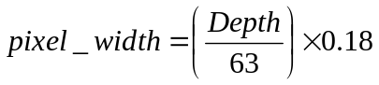 (18)

This means the deviation of the marker from the center of the pixel will be half the pixel_width.

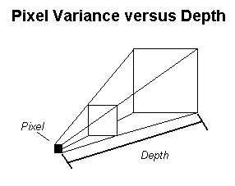
Figure 20 – Pixel variance versus depth

Therefore the system has an inherent source of error. Mathematically, the maximum depth that VISPS can support is 304 ft. Yet at 304 ft, a pixel is 11 inches wide according to equation (18) above. Because of this, we limit the maximum depth an object can be from VISPS to be 60 ft. The reason is that at 60 ft, a pixel is only 2 inches wide. Assuming that a laser beam disperses slightly over distance, the laser beam is roughly an inch wide. This means the laser beam will still cause the pixel to flare and the cameras will be able to find the pixel that corresponds to the marker.

Aside from the systematic error, we argue that there is no error resulting from the mathematical calculations. To support this, we first break this into two primary areas that may cause errors: determining the pixel coordinate and calculating the X, Y, and Z coordinates. Looking at the pixel coordinates, the error in this area is entirely systematic error as argued above. The hardware itself will not introduce any extra error. The reason for this is because the hardware will only report the pixel’s row and column as the coordinate. Furthermore, the hardware will report the center of the pixel that corresponds to the center of marker. Since we are only returning a pixel’s row and column coordinate and the pixel corresponds to the center of the marker in the digital image, no error is present.

Secondly, we evaluate the calculation of the X, Y, and Z coordinates. The PIC μC can only do integer math but can emulate 16-bit floating-point operations. With 16-bit floating-point numbers we can gain a precision of more than three decimal places. This is enough precision for VISPS. Thus through using floating-point emulation, we introduce little error into the X, Y, and Z calculations.

TEST PLANS

As described in the project design section, VISPS is broken into two main subsystems: the XSV300 and the PIC μC. In this section we will describe how we will test these subsystems.

Testing the XSV300

From our design, the XSV300 only finds the marker in the digital images. To test this functionality, we will create a test environment in hardware where we will capture the marker’s pixel location and stream the location in binary format out of an available pin on the XSV300 board. Then we can monitor this signal using a logic analyzer and see the coordinates our hardware actually produces. By comparing the outputted coordinates with the image on the monitor, we can see if the generated coordinates are in close proximity to the marker on the monitor. To get a more precise measurement, we plan to take the pixel coordinates and place a colored pixel there. So when the image is displayed on the monitor, we can see if the colored pixel is at the marker’s location.

Testing the PIC μC

The PIC μC takes three pixel coordinates: two column indices corresponding to the marker’s location in each image and an average of the row indices from the two images. From these pixel coordinates, the PIC μC will generate two azimuths and determine the coordinates. There are two sections to the PIC μC that needs to be tested. First, we need to test the interface between the PIC μC and the XSV300. Second, the logic to calculate the coordinates needs to be verified.

To begin testing the PIC μC (correlator PIC), we use a second PIC (test PIC) to simulate the XSV300. The test PIC will send mock data to the correlator PIC via the four-way handshake protocol. To test the four-way handshake protocol on the correlator PIC, we will make sure the correlator PIC can communicate with the test PIC and receive the data. To guarantee the data is received correctly, we will output the data to a PC. We will use the Hyperterminal software in MS Windows to display the data to the screen and compare the output to the test data we use to see if they match.

Once we verify the four-way handshake protocol, we will use the same test environment to test the logic for the coordinate calculations. We will have the correlator PIC ask the test PIC for data through the four-way handshake protocol. The correlator PIC will then process the data and output a set of coordinates via the RS-232 protocol to a PC. We can then verify that the coordinates that the PIC μC outputs are within reasonable error boundaries of the coordinates we calculate by hand.

DESIGN ISSUES

The first issue we had to deal with is how we would find the laser marker in the captured images. Our original idea was to find the brightest pixel in the images and there were concerns about whether the laser marker will be masked by the environmental light and its reflections off of light-colored objects. It turned out that this is not a concern. When we simulate this brightest-pixel method to make a crosshair of the brightest pixel on the VGA display, we found that most of the time the laser pointer is the brightest spot in the image. We also utilized a wide pass-band light filter that lets through only the light that is close to the laser’s spectrum, and this removes all the rest of the competing light sources from the image. The filter doesn’t work too well outdoors on a sunny day, but we believe that by using a filter that has a narrower band the system can work well outdoors under the sun.

Another issue we encountered is that the floating-point trigonometric calculations take up too much program memory for the PIC microcontroller’s 20Kb memory capacity to handle. We solved this problem by simplifying the floating-point calculations as shown in the Product Designs section to eliminate all the trigonometric steps. This makes the math simple, elegant, and most importantly, compact enough to fit the 20Kb program memory with no difficulty.

The issue we are facing currently is that the XS40 board on which we were previously implementing our image processing does not have enough I/O pins to perform data transmission to the PIC microcontroller, which requires at 11 pins. So right now we are trying to port the entire implementation to the XSV 300 Xilinx board, which has more than enough pins for us to utilize for the data transmission.

We are still facing the question of how accurate our X, Y, Z coordinate outputs will be given that all of the components of our system work perfectly. There are several sources error in our system. Most of this potential for error comes from potentially inaccurate camera calibration measurements or cameras not being arranged perfectly level or parallel. For our system to attain the full accuracy described above, we will need to make sure that our initial calibration of the cameras is done very carefully.

EVALUATING REVIEWER COMMENTS

The issues raised by group H include camera noise filtering, averaging sample frames, filtering non-laser intense areas, floating point math, and FPGA memory constraints.

Noise Filtering

Group H indicated that the bright random noise seen in the VGA output of the cameras could prove troublesome in determining the location of the laser. We also shared this concern. Their suggestion was to use a median filter that would replace each pixel with the average of the 8 pixels surrounding it. They also pointed out that large bright objects would further confuse our laser finding algorithm.

Our biggest concern about their solution to random pixel noise is the need to store a huge amount of data in registers. A 9-pixel median filter would require that we store all 8 brightness bits for two full rows of pixel data. There are 255 pixels per row so we would have needed to store 2 x 255 x 8 bits or approximately 4KB for the filter alone. As group H also pointed out, we need to be careful with the space on the FPGA. Because of FPGA limitations, we want to avoid this solution if possible.

Another solution that sounded feasible was to use an in-line 3-pixel median filter. To do this we would only have to store two pixels. We ended up using a similar solution that instead of using an extra stage for filtering before we look for our laser, we incorporate this 3-pixel filter into the laser finding algorithm. Since we are already making the assumption that our laser pointer is always greater than one pixel wide, we only consider points as candidates for the laser location if there is also a “bright” pixel immediately before the current pixel. The definition of “bright” is determined empirically. Testing this method with the VGA monitor as described in Section Test Plans, we found that a neighbor pixel with an intensity value of greater than 200 was sufficient to avoid confusion with single pixel noise.

A surprising discovery during the implementation and testing of the XSV300 module is that blooming pixels did occur, but their intensity was at 100 or less. Furthermore the white spots that we saw coming from the monitor was not actually pixel noise as we originally thought. The random specks of white we saw on the VGA output we believe comes from analog noise introduced by the DACs that convert the digital pixel data to output to a VGA monitor.

Interfering Intense Sources

Another concern of group H was that large bright objects would confuse the XSV300 and potentially limit the application of VISPS to dimly lit areas. Their solution was to strobe the light source using a spinning wheel that would interrupt the lasers beam so that it only appears in every other captured image frame. We could then subtract every other frame to get a difference. Since the laser beam’s intensity switches between 100% and 0%, every other frame would have the greatest change in intensity.

The apparatus for producing this strobe would be difficult to produce since we would need to make sure that it blocked the beam exactly every other frame. Since the clock for the FPGA, the camera, and the spinning wheel would all be slightly different. At best we would also have to deal with the problem of passing data between these asynchronous interfaces. To do this, we would need a clock for the strobing laser. This could have been obtained by passing another laser through the spinning wheel and having it hit on a light activated transistor. Although this solution does seem possible, it would require a substantial amount of calibration and time. Also, one of our goals was to make the laser as easy to hold and light as possible. Attaching an extra laser and a spinning wheel to the laser would have compromised this goal.

Fortunately we found a solution that was easy and inexpensive. We simply place a red filter in front of each camera so that only the red component of light is able to enter the camera. A cheap filter was able to reduce the brightness of common objects in the lab so that they were no longer a problem. The cameras perform perfectly with all the lights on. The red component in direct sunlight and red LEDs in the lab however is still strong enough so that VISPS does incorrectly choose the location of the laser marker. After speaking with Prof. John Staltenberg at the UW Physics Department we learned that highly accurate band-pass filters are available that could block light to within a 10nm band centered on the wavelength of our laser, which can be easily measured with the equipment he has in his laboratory. We feel that this will eliminate sufficient intensity from sunlight and random red lights so that we can use VISPS even in a bright outdoor setting. For the purpose of this project we cannot justify the $50 price for one of these filters.

Averaging Frames

Group H was concerned that the difficulty in holding the laser perfectly still when pointing at distant objects would result in unsatisfactorily jittery data. Their suggestion was to average the pixel coordinates we find for the laser over several frames. Although this solution would reduce the amount of jitter in the coordinates, we decided not to implement their solution for philosophical reasons.

Although we proposed using VISPS as either a surveying tool or a drawing wand, these are only suggestions. The fundamental function of VISPS is to return X, Y, Z coordinates of a laser point as accurately as possible. Although averaging does improve the stability of the data produced, it also compromises instantaneous accuracy. We can imagine many uses of VISPS where this instantaneous accuracy would be more important than smoothed data. Since averaging data is easy to do in software we decided that averaging should be left to the designer that implements a front end that uses data produced by VISPS. In situations where averaging is appropriate, averaging can easily be implemented in software. In situations where instantaneous accuracy is most important, the designer need not implement averaging.

Memory Constraints

Group H correctly pointed out that we would probably need to migrate the FPGA component of our design to the XSV300 FPGA instead of the XS-40 due to limited memory on the XS-40. Another limitation of the XS-40 is the small number of I/O pins available. Both memory and pin constraints have required us to move to the XSV300. We are in progress of porting the design to the XSV300.

Floating Point Math

Group H pointed out that computation of arctangent would be computationally expensive. This turned out to be true. The main problem is that the libraries included to perform the trigonometric computations are too large to fit on the PIC μC with the code we had written. We reconsidered the equations we were using to compute our coordinates from the pixel data and found that we were able to reduce them so that no trigonometry is needed.

TECHNICAL REFERENCES

Atmel. (2000). AT89C55-33PC Datasheet. http://64.71.159.17/atmel/acrobat/doc1921.pdf.

CSE Department. (2000). Camera Proto-board Schematic.

PIC Microchip Technology Inc. (2000). PIC16C73B Datasheet. http://www.microchip.com/download/lit/pline/picmicro/families/16c7x/devices/16c73b/30605c.pdf.

Sci.Electronics. (2000). I2C FAQ. http://perso.club-internet.fr/mbouget/i2c-faq.html.

Spectronix. (2000). RoboCam II Digital Camera Module Datasheet. http://www.spectronix.net/pdfs/RoboCam5404A.pdf.

VLSI Vision. (2000). VV5404 Datasheet. http://www.vvl.co.uk/tech_support/docs/datasheets/404.htm.

Xess Corporation. (2000). XS40-010XL User Manual. http://www.xess.com/manuals/xs40-manual-v1_4.pdf.

Xess Corporation. (2000). XS BOARD V1.0 User Manual. http://www.xess.com/manuals/xsv-manual-1_0.pdf.

