Your Name
Your UnetID

Active Reinforcement Learning
  - $Q_{k+1}\left(s,a\right)←\left(1-α\right)Q_{k}\left(s,a\right)+α∙\left[R\left(s,a,s^{'}\right)+γ\max_{a^{'}}Q_{k}(s,a) \right]$
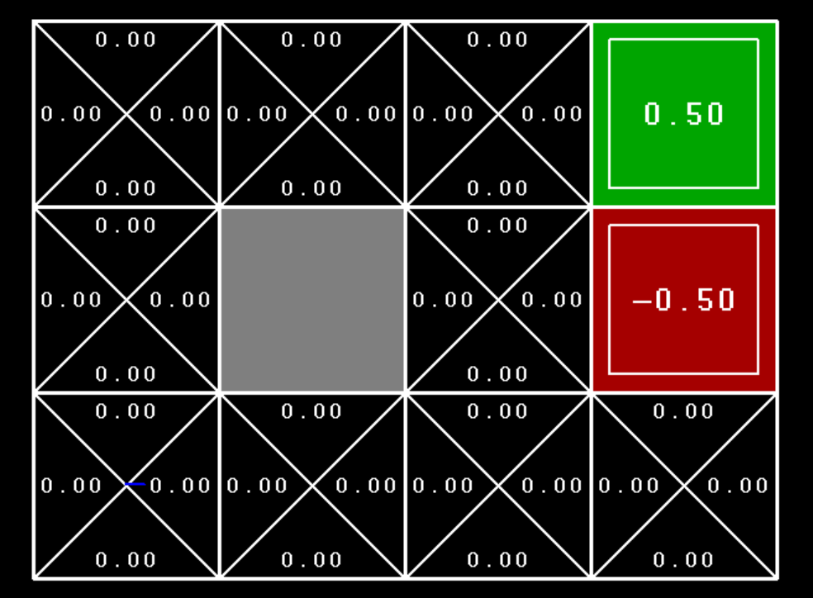 | After two episodes, one exiting from the negative exit, and the other exiting from the positive, we have these Q-values. What Q-values do we have if we exit from the (1,3) square through the positive exit?  Hint: two values change.  α=0.5, γ=0.9, $R\left(s,a,s^{'}\right)=0$
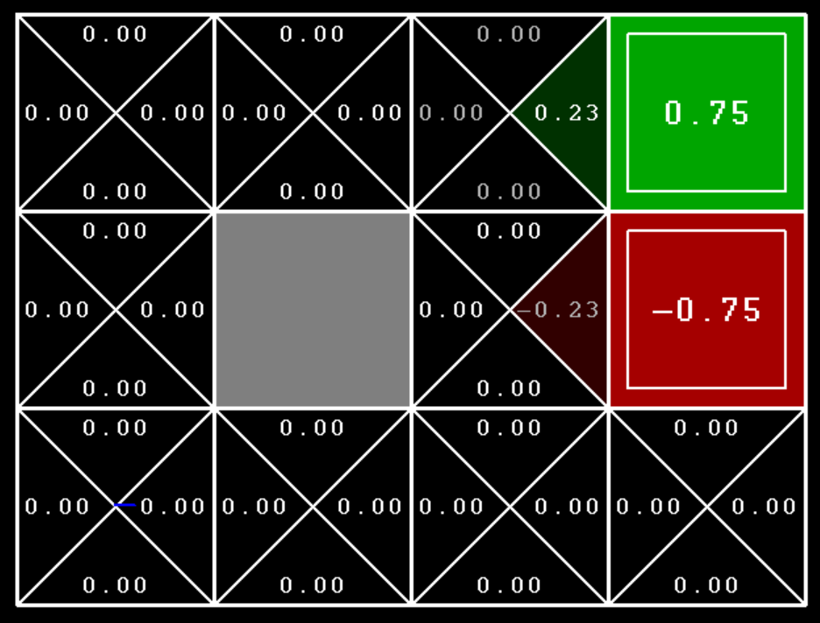 | After two more episode2, one exiting from (2,3) through the negative exit, and one exiting from (1,3) through the positive exit, what are our Q values?  What values change if we exit one more time through (1,3) through the positive exit? What are the new Q values?
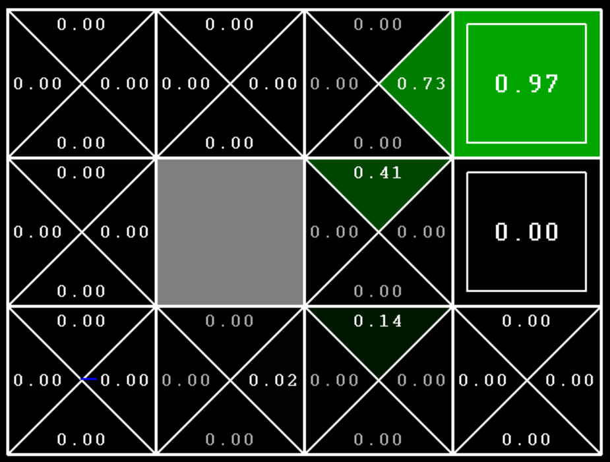 | These are the values after 5 episode moving long the bottom edge and then up column 3 to exit through the positive exit.  Why are there no negative Q values?

Exploration:
What does $f\left(u,n\right)=u+\frac{c}{n }$ with constant $c$
do as n->infinity?

Feature Driven Models:
What does $Q\left(s,a\right)=4.0∙f_{DOT}\left(s,a\right)-1.0∙f_{GST}\left(s,a\right)$
Become after the update?
F_{dot}(s,a) = distance to closest big dot with action a.
F_{gst}(s,a) = distance to closest ghost with action a

