Your Name
Your UnetID

Pacman Tree Search
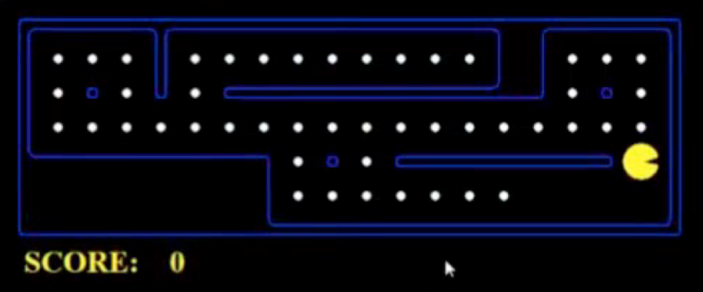 | Consider a search problem where you want to find the shortest path to get Pacman to a given location (x,y)?
What is a search state for Pacman?
What is a branching factor (b)?
What is the maximum depth (d)?
What is a likely solution depth (s)?

Uninformed search properties

Consider the following tree, with the goal state of 11: 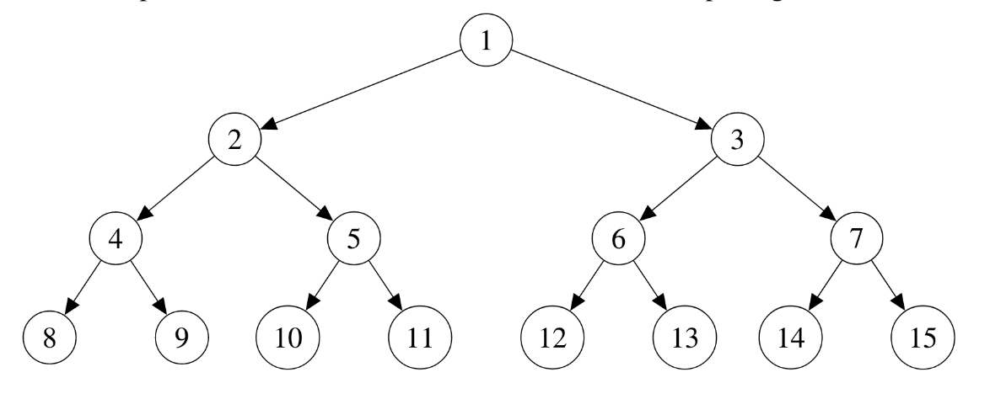
 | Optimal? | Space complexity | Time complexity | Nodes expanded in order | When to use this?
DFS

BFS

