Your Name
Your UnetID

Agents
How is Pacman an agent? What are Pacman’s sensors? And actuators?

How is an LLM an agent? What is an LLM’s sensors? And actuators?

Rationality
Does the environment need to be fully observable for an agent to be rational?

Does taking rational actions always result in the best outcome?

State-space
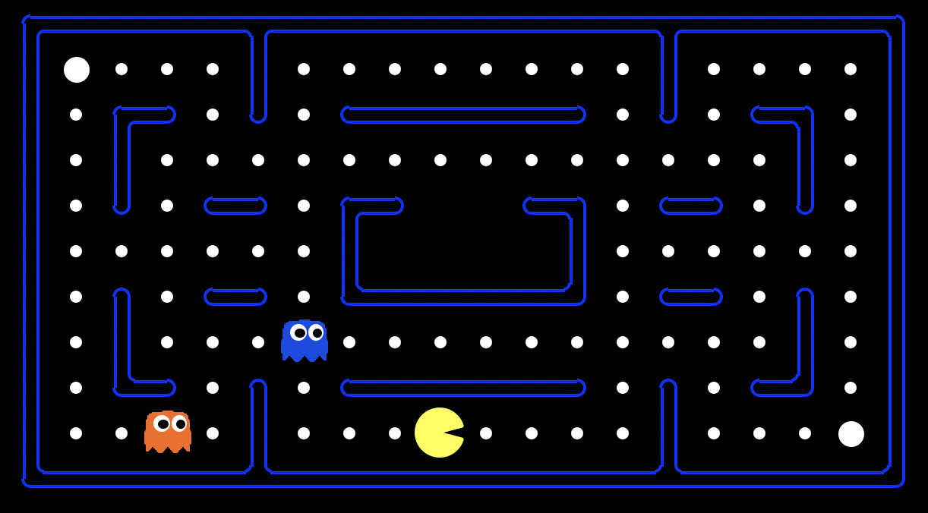 | If you have 5 coins, each of which can be heads or tails, how many possible arrangements do you have?
If the game board is MxN spaces, how many potential locations does Pacman have? | How do we account for the walls in a search state?

