Project 2 (Multi Agent Search) Question 6.

This non-programming problem is part of Project 2. Please add your answers to this document and submit your completed document along with your solution to the Pac-Man project.

Your little brother Pat wants a toy for his birthday. However, Mom thinks that he deserves the least expensive toy due to his misbehavior. Pat, of course, wants the most expensive toy. At your family’s weekly meeting, Dad has suggested, and all have agreed to a process involving some compromises on the parts of Pat and Mom. Mom has to drive so she will pick the city. All Pat can do is pick a store within the city Mom decides to drive to. You get to pick the toy itself, given the city and store. You don’t want to take sides so you decide you’ll pick a toy at random when the city and store have been settled. All toy prices (including X and Y) are assumed to be nonnegative. All the relevant information for purposes of choosing among the options has been gathered by Dad and is also provided in the tree below.

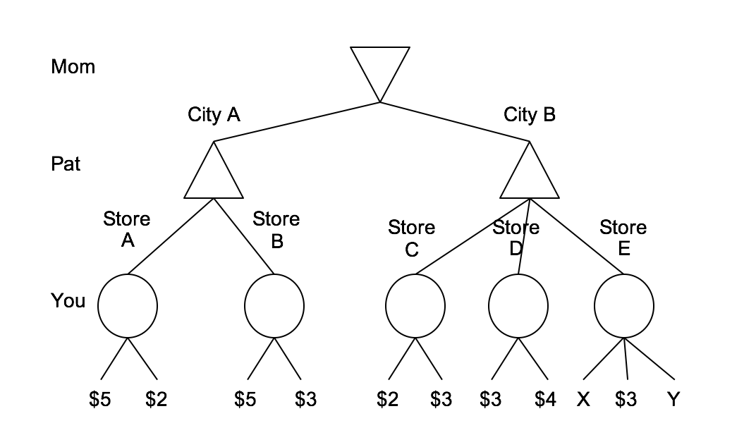

1) Fill in the values of all the nodes that do not depend on X and Y.

2) What values of X will make Mom pick City A regardless of the price of Y?

3) We know that Y is at most $2. What values of X will result in a toy from Store D regardless of the exact price of Y?

4) Normally, alpha-beta pruning is not used with expectimax search. However, with some additional information, it is possible to do something similar. Which one of the following conditions on a problem is required to be true in order to permit pruning with expectimax?

- The children of the expectation node are leaves.
- All values are positive.
- The children of the expectation node have specified ranges.
- The child to prune is last.

