Project 3 - Question 9

This non-programming problem is part of Project 3. Please add your answers to this document and submit your completed document along with your solution to the Pac-Man project.

The following problems take place in various scenarios of a 1D gridworld MDP.

In all cases double-rectangle states are exit states. From an exit state, the only action available is Exit, which results in the listed immediate reward and ends the game (by moving into a terminal state; not shown).

From non-exit states, the agent can choose either Left (L) or Right (R) actions, which move the agent in the corresponding direction. Assume that living rewards of -1 apply on transitions from states B, C, and D; the rewards from states A and E are as shown there, obtained by exiting the grid, which is the only permitted action in those states. Throughout this problem, assume that value iteration begins with initial values V0(s) = 0 for all states.

Consider the following scenario:

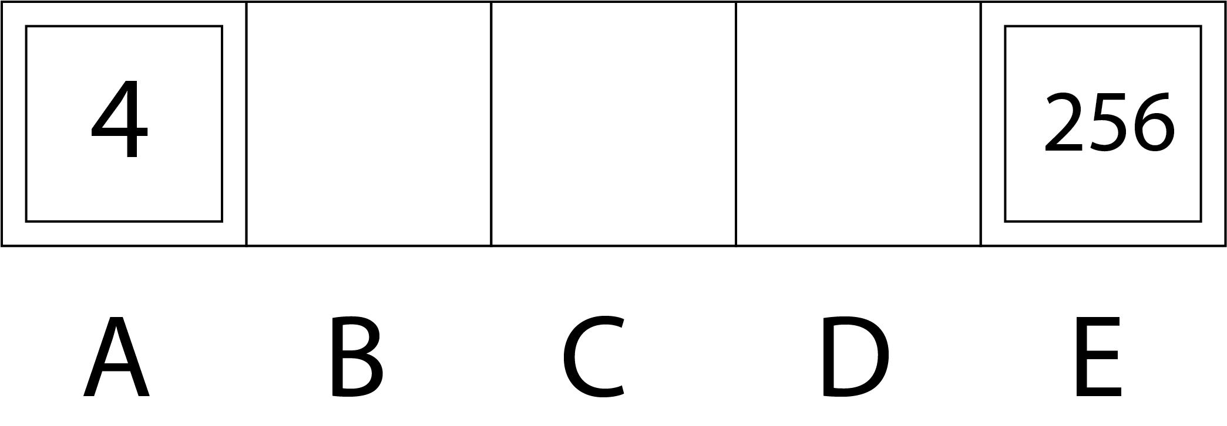

Let the discount factor be γ = 0.5, and let transitions be deterministic. Fill in the missing values for each state following the value iteration algorithm in the following table:

Step t | V_{t}(A) | V_{t}(B) | V_{t}(C) | V_{t}(D) | V_{t}(E)
0 | 0 | 0 | 0 | 0 | 0
1
2
3
4

What are the actions for states B, C, and D for each time step, according to the best policy that corresponds to the values at step t?

Time | π_{t} (B) | π_{t} (C) | π_{t} (D)
1
2
3
4

