CSE 473 Autumn 2018 – Project 1 Name:
Paul G. Allen School of CS & E

Project 1: Search
This non-programming problem is part of Project 1. Please add your answers to this document and submit your completed document along with your solution to the Pac-Man project.

Look at the following graph. Node A is the start node (indicated with the arrow) and G is the goal (indicated by the double circle).

The table gives you the heuristic values h(n) for each node, however h(B) is unknown.

n | h(n) | 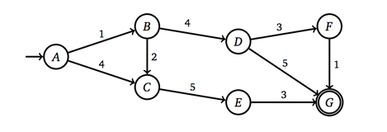
A | 5
B | ?
C | 4
D | 3
E | 3
F | 1
G | 0

Provide the range of values for h(B) for which h would be admissible.

If you were to follow the search strategies listed in the table, which of the listed paths are possible? Indicate valid paths by marking an X in the appropriate row(s). You may assume that h is admissible in each case. In some cases, more than one path may be a valid result, and you should mark all such paths.

Search algorithm | A – C – E – G | A – B – C – E – G | A – B – D – G | A – B – D – F – G
Depth first
Breadth first
A* with heuristic h

