Zbrush Hotkeys

Key | Function | Key | Function
Comma | toggles the top menu (lightbox) | Ctl + N | clears the canvas
T | toggles ‘Edit’ or 3D sculpting mode | X | toggles symmetry
Ctrl+Z | Undo | Shift+Ctrl+Z | Redo
Click & drag Background | Free Rotate | Click+drag, press Shift | Constrain to 90-degree rotation
Alt+Click & drag Background | Move | Alt+Click, Release Alt, drag Background | Scale
Shift, Click, release Shift, drag | Rotate around Z-axis | W | move mesh
E | scale mesh | R | rotate mesh
S & left click | adjust size of brush | B | bring up brush menu
D | toggle higher resolution mesh | Shift + D | toggle lower resolution mesh
Spacebar | brings up brush settings | Ctrl+H | View Mask
Ctrl+I | Invert Mask | Ctrl+A | Mask All
Ctrl+Click+ drag Background | Clear Mask | Ctrl+Click on mesh | Blur mask
Ctrl+Alt+Click on mesh | Sharpen mask

Terms
Tool – Zbrush object of different types
- Polymesh - A polymesh is a 3D model that is composed of polygons. In ZBrush, only polymeshes can be sculpted.
Subtool – Individual polygon mesh
Document – background 2D canvas
Dynamesh - base mesh generation tool
Zremesher – automatic retopology tool
Lightbox – Window that displays the content of the folders located in the root folder of ZBrush, by categories: Documents, Tool, Brushes, Material, Alphas, Textures, ZScript and Other.

Main Brushes
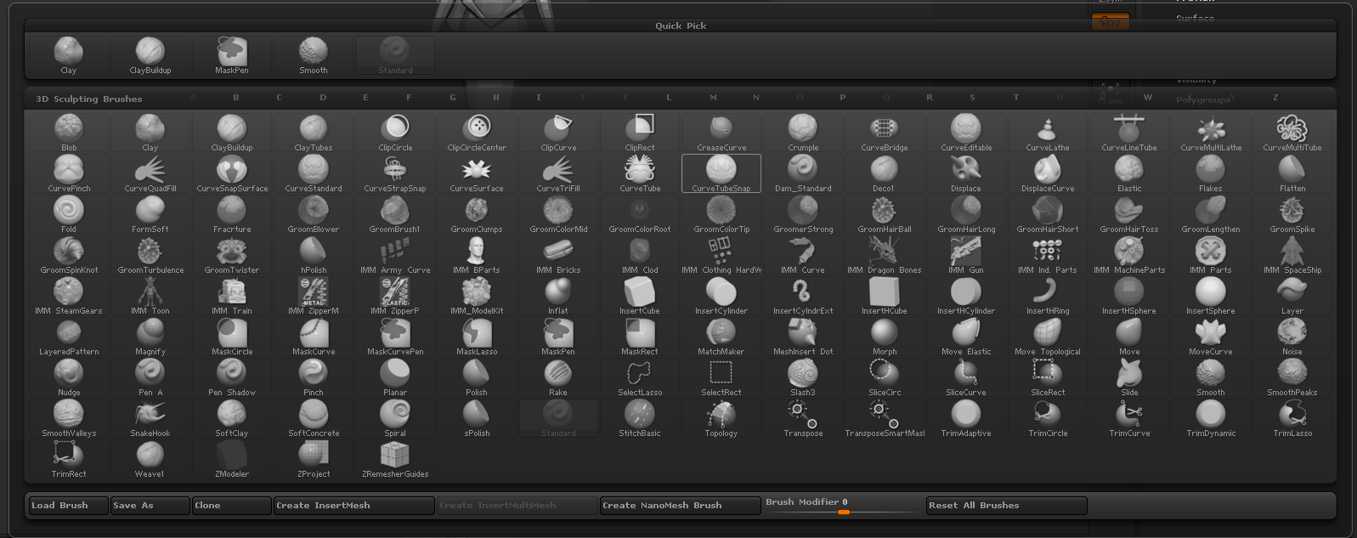

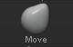 Move Brush (B + M + V)

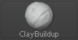 Clay Buildup – change alpha channel to influence shape (B + C + B)

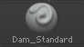 Dam Standard (Bb + D + S)

Brush Settings (Spacebar)

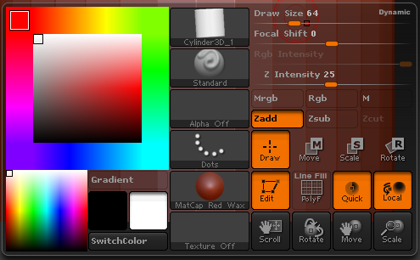
Zbrush Demo

Trial: https://pixologic.com/zbrush/trial/

- Setting Up

1.1 Exporting an OBJ from Maya
- Select your mesh, then go to File > Export Selection (Options)
- File type: OBJExport

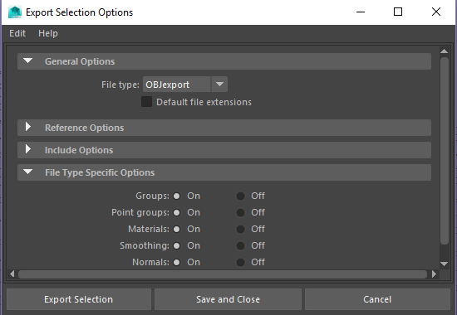

- If OBJExport is not in those options, go to Windows > Settings/Preferences > Plug-in Manager
- Make sure objExport.mll is loaded

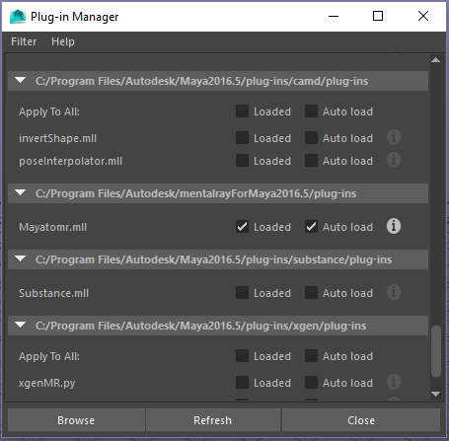

1.2 Open Zbrush and import your model

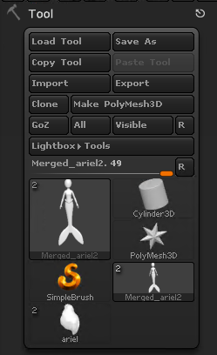

- Under Tool: Import
- Left-click and drag to put the mesh in the scene
- Press ‘T’ to make the object sculptable
- If you accidentally create a bunch of duplicate meshes, press ‘Control + N’ to clear the viewport

1.3 Change material to shiny gray

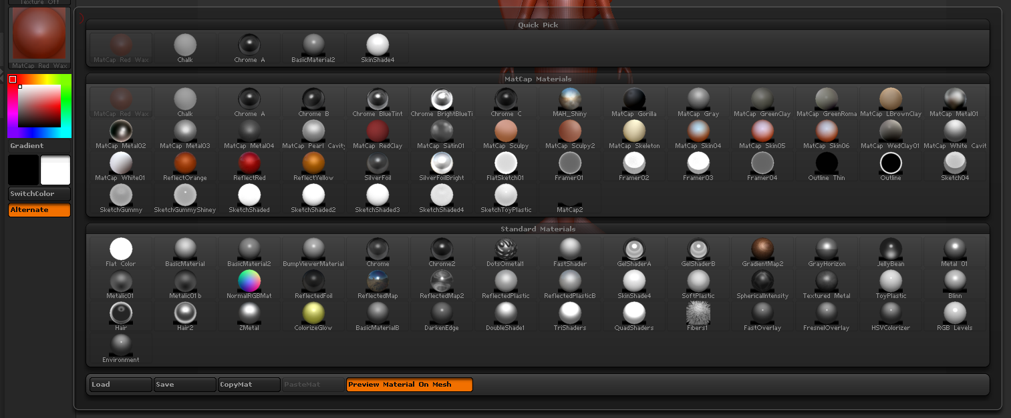

- Click the red circle on the left side of the screen
- Select new material: Basic Material 2

1.4 Change ramp in background (range to 0)
- Under Document, set Range to 0

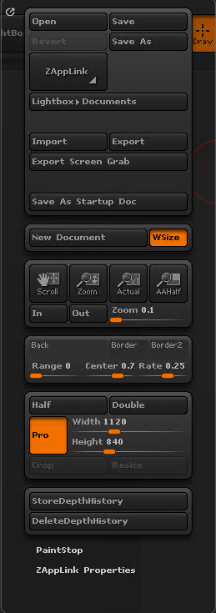

1.5 Save as PROJECT not Document
- File – Save As – Zbrush Project

- Sculpting

  - Activate Symmetry
- Press ‘x’, and use symmetry to make sure your mesh is oriented well

2.2 Sculpt on the mesh
- Work in the lowest resolution for as long as possible, then step up if you need to
- Use the ‘D’ hot key to ‘smooth’ the mesh, press Shift + D to unsmooth

2.3 Creating a Costume

- Paint a mask on the geo (hold Control and paint) where you want the new mesh
- Press Tool > SubTool > Extract will preview a new piece of geometry based on your mask. Press Accept to create a new SubTool of this new geometry. Remember to clear the mask when you no longer need it (Ctrl+Click+ drag Background).

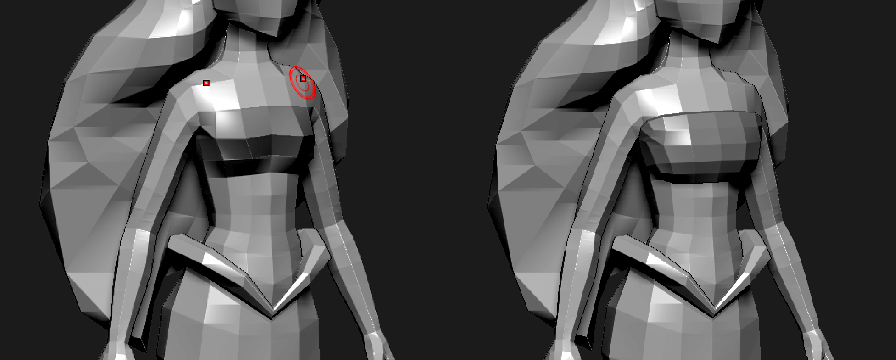

- Sculpt on new subtool
- Merge back together, similar to combining in Maya (Subtool – Merge – Merge Down with the top subtool selected)
- Geometry – Dynamesh: use this operation if you’d like to combine multiple pieces into one manifold piece of mesh
- Continue sculpting
- Geometry – Zremesher: use this operation to auto-generate new topology at adjustable resolution (Use Target Polygon Count to adjust the resolution of the new mesh)
- Continue sculpting
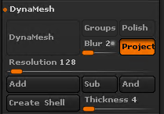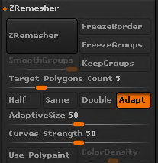

- Bring back to Maya

  - Export as an OBJ

- Make sure the mesh you are exporting isn’t super high res
- Tool – Export – OBJ Format

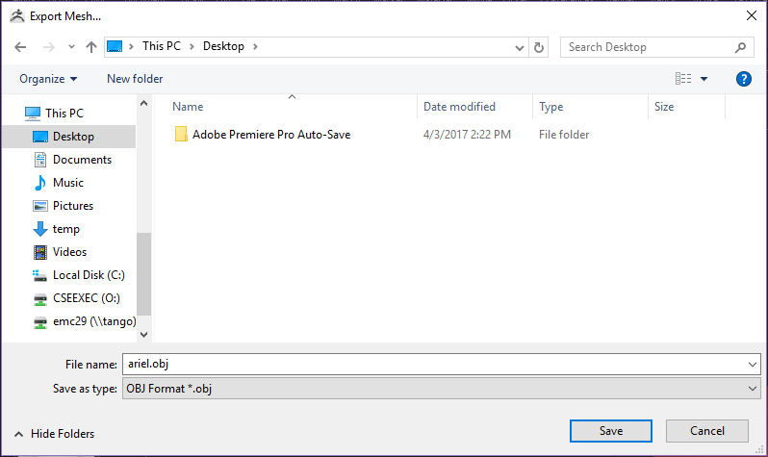
3.2 Import to Maya
- File > Import
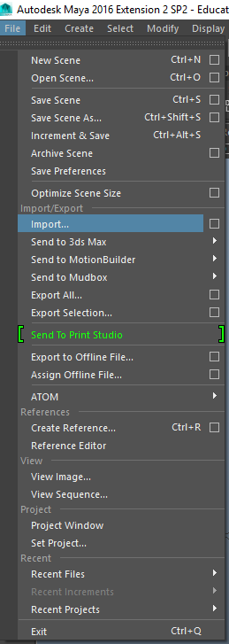

3.3 Copy weights (if new mesh is different or higher res than previous mesh)
  - Import your new mesh into the same file as your previous mesh
  - Bind your new mesh to the skeleton (Skin > Bind Skin)
  - Select your original mesh (source skin), then your new mesh (destination skin) and select Skin > Copy Skin Weights
  - You may need to do additional weights polishing after this step
