Assignment #5 – The Cardinal Expressions:
Due: by 11:59am on Tuesday
For this assignment, we will move onto the cardinal expressions, specifically surprise and fear. Now that you have separately worked on the eyes, eyebrows, and the mouth, you will coordinate them all to make expressions using all parts of the face. You will pose the face in surprise, and 2 different levels of intensity for fear: less intense fear and more intense fear. You will be using the Valencia rig for this assignment. Keep in mind that even the slightest details can change how the face is read, so make sure the movements you make show the correct expression you want it to be read as. Use the mirrors in the lab and yourself as reference.

 | Exceeds expectations  40 points | Meets expectations  30 points | Meets some expectations  20 points | Does not meet expectations  10 points | Did not turn in  0 points | Score
Surprise | -Eyebrows are clearly lifted straight up  -Eyes are open so that the whole iris is clearly visible but just enough so that the there’s a smidge of white above the iris  -Lower lid is completely relaxed  -Eye gaze is clearly straight ahead  -Mouth is clearly opened and completely relaxed  -Jaw is clearly dropped  -Upper teeth are generally visible  -Lower teeth are generally not visible  -Labial nasal folds are clearly deepened | -Eyebrows are generally lifted up  -Eyes are mostly open so that the whole iris is visible  -Lower lid is generally relaxed  -Eye gaze is generally straight ahead  -Mouth is mostly opened and generally relaxed  -Jaw is generally dropped  -Upper teeth are too visible or distracting  -Lower teeth are generally not visible  -Labial nasal folds are generally deepened | -Eyebrows are barely lifted up  -Eyes are barely open or are opened too wide  -Lower lid is barely relaxed  -Eye gaze is barely straight ahead  -Mouth is barely opened and barely relaxed  -Jaw is barely dropped  -Upper teeth are very distracting  -Too much lower teeth are visible  -Labial nasal folds are barely deepened | -Eyebrows are not lifted up  -Eyes are not open or the upper lid is lifted to the max  -Lower lid is not relaxed  -Eye gaze is not straight ahead  -Mouth is not opened and not relaxed  -Jaw is not dropped  -Upper teeth are not visible  -Lower teeth are visible  -Labial nasal folds are not deepened whatsoever | Did not turn in
Fear – More Intense | -Upper lid is completely retracted  -Eyeball is clearly pulled slightly forward from the socket so it bulges out  -Gaze is clearly looking to one side or down, not straight ahead  -Brow is clearly lifted inwardly oblique in a distress pattern  -Inner section of brow is clearly a little higher in the middle  -Lower lid is clearly lifted and tightened, clipping the iris from below  -The mouth is clearly opened to the max, jaw dropped to the max  -Lower lip is clearly curled out  -Mouth is clearly stretched sideways at the lower margin  -Clearly shows lower teeth  *visible upper teeth optional*  -Nasal labial fold is clearly deepened and frames the mouth, giving mouth a square shape | -Upper lid is generally retracted  -Eyeball is generally pulled forward from the socket  -Gaze is generally looking to one side or down  -Brow is generally lifted inwardly oblique in a distress pattern  -Inner section of brow is generally a little higher in the middle  -Lower lid is generally lifted and tightened, clipping the iris from below  -The mouth is generally opened, jaw mostly dropped  -Lower lip is generally curled out  -Mouth is mostly stretched sideways at the lower margin  -Generally shows lower teeth  *visible upper teeth optional*  -Nasal labial fold is generally deepened and frames the mouth, giving mouth a general square shape | -Upper lid is barely retracted  -Eyeball is barely pulled forward from the socket  -Gaze is barely looking to one side or down and is somewhat straight ahead  -Brow is barely lifted inwardly oblique in a distress pattern  -Inner section of brow is barely a little higher in the middle  -Lower lid is barely lifted and tightened, barely clipping the iris from below  -The mouth is barely opened, jaw barely dropped  -Lower lip is barely curled out  -Mouth is barely stretched sideways at the lower margin  -Barely shows lower teeth  -Nasal labial fold is barely deepened and frames the mouth, giving mouth a general square shape | -Upper lid is not retracted  --Eyeball is not pulled forward from the socket  -Gaze is straight  -Brow is not lifted inwardly oblique in a distress pattern  -Inner section of brow is not higher in the middle  -Lower lid is not lifted and tightened, not clipping the iris from below  -The mouth is not opened, jaw not dropped  -Lower lip is not curled out  -Mouth is not stretched sideways at the lower margin  -Lower teeth are not visible  -Nasal labial fold is not deepened, not giving mouth a general square shape | Did not turn in
Fear – Less Intense | -Upper lid is clearly retracted  -Eyes are clearly slightly wider than normal  -Lower lid is clearly lifted and tightened, clipping the iris from below  -Gaze is clearly looking to one side or down, not straight ahead  -Brow is clearly lifted inwardly oblique in a distress pattern  -Inner section of brow is clearly a little higher in the middle  -The mouth is clearly slightly opened  -Upper lip is clearly relaxed  -Lower lip is clearly stretched  -Nasal labial fold is clearly deepened | -Upper lid is generally retracted  -Eyes are generally slightly wider than normal  -Lower lid is generally lifted and tightened, clipping the iris from below  -Gaze is generally looking to one side or down, not straight ahead  -Brow is generally lifted inwardly oblique in a distress pattern  -Inner section of brow is generally a little higher in the middle  -The mouth is generally opened  -Upper lip is generally relaxed  -Lower lip is generally stretched  -Nasal labial fold is generally deepened | -Upper lid is barely retracted  -Eyes are barely wider than normal  -Lower lid is barely lifted and tightened  -Gaze is barely looking to one side or down or is almost straight ahead  -Brow is barely lifted inwardly oblique in a distress pattern  -Inner section of brow is barely higher in the middle  -The mouth is barely opened  -Upper lip is barely relaxed  -Lower lip is barely stretched  -Nasal labial fold is barely deepened | -Upper lid is not retracted  -Eyes are not wider than normal  -Lower lid is not lifted and tightened  -Gaze is not looking to one side or down or is straight ahead  -Brow is not lifted inwardly oblique in a distress pattern  -Inner section of brow is not higher in the middle  -The mouth is not opened  -Upper lip is not relaxed  -Lower lip is not stretched  -Nasal labial fold is not deepened | Did not turn in
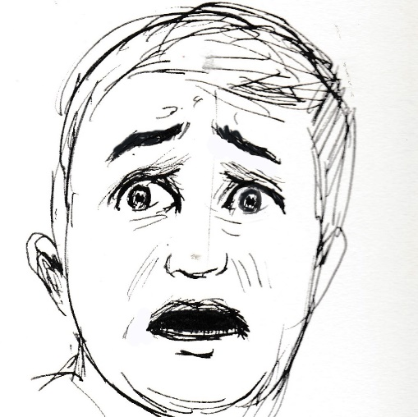
Surprise
Fear – More Intense
Fear – Less Intense

