Assignment #4 – Movements of the Mouth (Part 2)
Due: by 11:59pm on Sunday
For this assignment, we will continue to focus on the movements of the mouth, specifically the open mouth. You will show your ability to move the mouth into a relaxed open mouth (a little open, more open, and opened to the max), lower lip stretcher, snarl/disgust, and a smile. You will be using the Valencia rig for this assignment. Keep in mind that even the slightest details can change how the face is read, so make sure the movements you make show the correct expression you want it to be read as. Use the mirrors in the lab and yourself as reference.

 | Exceeds expectations  40 points | Meets expectations  30 points | Meets some expectations  20 points | Does not meet expectations  10 points | Did not turn in  0 points | Score
Open Mouth – Relaxed | -The mouth is clearly taller than it is wide  -Distinctly looks relaxed  -Jaw is clearly pulled down, with no sideways pull  -Upper teeth probably visible, lower teeth may be visible, but only slightly  -Has a clear oval shape when opened at its widest, with mouth corners just above the center of the mouth | -The mouth is generally taller than it is wide  -Generally looks relaxed  -Jaw is mostly pulled down, with no sideways pull  -Upper teeth or lower teeth are too visible  -Has a general oval shape when opened at its widest, with mouth corners somewhat near the center of the mouth | -The mouth is barely taller than it is wide  -Barely looks relaxed  -Jaw is barely pulled down, with some sideways pull  -Barely has an oval shape when opened at its widest, with mouth corners too high or too low | -The mouth is not taller than it is wide  -Not relaxed  -Jaw is not pulled down and/or has sideways pull  -The upper teeth aren’t visible and/or bottom teeth are clearly visible  -Does not have an oval shape when opened at its widest, with mouth corners much too high or much too low | Did not turn in
Lower Lip Stretcher | -Clearly stretches the lower lip sideways at the level of the mouth corner  -Distinctly slightly open  -Clearly stretches straight to the side  -Lower lip has a clear tight, straight upper edge  -Lower teeth are clearly visible, with no upper teeth visible  -The whole mouth is clearly angular with a distinct sideways “D” shape | -Generally stretches the lower lip sideways at the level of the mouth corner  -Generally slightly open  -Generally stretches straight to the side  -Lower lip has a general tight, straight upper edge  -Lower teeth are mostly visible, with no upper teeth visible  -The whole mouth is generally angular with a sideways “D” shape | -Barely stretches the lower lip sideways at the level of the mouth corner  -Barely slightly open or opened more than slightly  -Barely stretches straight to the side  -Lower lip barely has a tight, straight upper edge  -Lower teeth are barely visible and/or has some upper teeth visible  -The whole mouth is barely angular with a sideways “D” shape | -Does not stretch the lower lip sideways at the level of the mouth corner  -Mouth is closed or is opened too much  -Does not stretch straight to the side  -Lower lip does not have a tight, straight upper edge  -Lower teeth are not visible and/or upper teeth are clearly visible  -The whole mouth is not angular whatsoever | Did not turn in
Snarl/Disgust | -Upper lip is clearly lifted at the outer corners  -Upper lip has a clear square shape  -Can clearly see all upper teeth, especially at the corners  -Can be asymmetrical | -Upper lip is mostly lifted at the outer corners  -Upper lip has a general square shape  -Can generally see all upper teeth | -Upper lip is barely lifted at the outer corners  -Upper lip barely has square shape  -Can barely see all upper teeth | -Upper lip is not lifted at the outer corners  -Upper lip does not have square shape  -Doesn’t show upper teeth | Did not turn in
Smile | -Upper lip is clearly stretched and lifted closer to nose  -Clear divots at mouth corner  -Upper teeth are clearly visible, jaw is not dropped  -Upper lip is clearly thinned and stretched  -Lower lip clearly bends in a gentle, angular arc | -Upper lip is generally stretched and lifted closer to nose  -General divots at mouth corner  -Upper teeth are generally visible, jaw is slightly dropped  -Upper lip is generally thinned and stretched  -Lower lip generally bends in a gentle, angular arc | -Upper lip is barely stretched and lifted closer to nose  -Barely any divots at mouth corner  -Upper teeth are barely visible, jaw is dropped  -Upper lip is barely thinned and stretched  -Lower lip barely bends in a gentle, angular arc | -Upper lip is not stretched and lifted closer to nose  -No divots at mouth corner  -Upper teeth are not visible, jaw is dropped  -Upper lip is not thinned and stretched  -Lower lip does not bend in a gentle, angular arc | Did not turn in
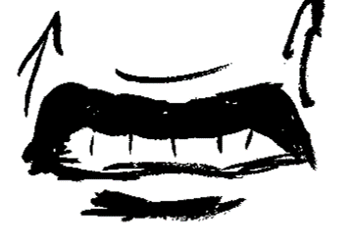
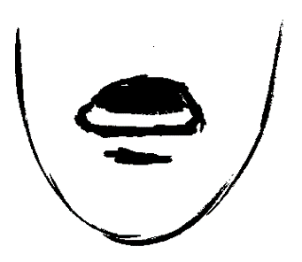
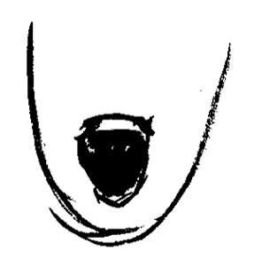
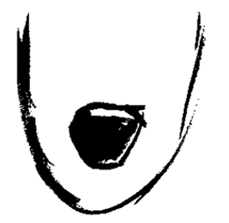
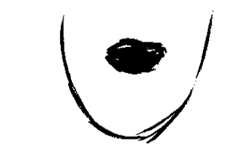
Open to the Max
Smile
Sneer/Disgust
Lower Lip Stretcher
A Little Open
More Open

