Assignment #6 – The Cardinal Expressions: Sadness
Due: by 11:59pm on Monday 7/15

For this assignment, we will continue to work on cardinal expressions, specifically sadness. You will pose the face in an open mouth crying pose, closed mouth crying, a very sad pose and a little sad pose. You will be using the Valencia rig for this assignment. Keep in mind that even the slightest details can change how the face is read, so make sure the movements you make show the correct expression you want it to be read as. Use the mirrors in the lab and yourself as reference.

 | Exceeds expectations  40 points | Meets expectations  30 points | Meets some expectations  20 points | Does not meet expectations  10 points | Did not turn in  0 points | Score
Open Mouth Crying | -Eyes are clearly squinting, looking stressed  -Clearly cannot see the pupil  -Eyebrows are clearly pulled down and together into a scowl  -Mouth is clearly widened and open  -Mouth clearly squared off in upper edge  -Upper lip is stretched, tightened, and thinned  -Lower edge of mouth is clearly stretched wide  -Lower lip clearly bulges in the middle, making it higher in the middle than the sides, giving it a wavy look to the lower lip  -Clearly does not see the upper teeth  *Some lower teeth may or may not be visible* | -Eyes are mostly squinting, looking stressed  -Generally cannot see the pupil  -Eyebrows are generally pulled down and together into a scowl  -Mouth is mostly widened and open  -Mouth generally squared off in upper edge  -Lips are generally tight  -Lower edge of mouth is generally stretched wide  - Lower lip generally bulges in the middle, making it higher in the middle than the sides  -Generally does not see the upper teeth  *Some lower teeth may or may not be visible* | -Eyes are barely squinting  -Can barely see the pupil  -Eyebrows are barely pulled down and together  -Mouth is barely widened and open  -Mouth barely squared off in upper edge  -Lips are barely tight  -Lower edge of mouth is barely stretched wide  - Lower lip barely bulges in the middle, barely higher in the middle than the sides  -Can barely see the upper teeth  *Some lower teeth may or may not be visible* | -Eyes are not squinting  -Can see the pupil  -Eyebrows are not pulled down and together  -Mouth is not widened and open  -Mouth is not squared off in upper edge  -Lips are not tight  -Lower edge of mouth is not stretched wide  - Lower lip does not bulge in the middle, making it equal or lower than the sides  -Can see the upper teeth  *Some lower teeth may or may not be visible* | Did not turn in
Closed Mouth Crying | -Eyes are clearly squinting, looking stressed. Nearly straight but can be slightly curved up from below.  -Clearly cannot see the pupil  -Eyebrows are clearly pulled down and together into a scowl, or are clearly in a distress pattern  -Lips are clearly stretched from side to side and straight in the middle, tightened but not thinned, should appear to bulge out.  -Outside corners of the mouth can be pulled down a small amount  - Lower lip bulges in the middle slightly, making it higher in the middle than the sides, giving it a wavy look to the lower lip | -Eyes are mostly squinting, looking stressed. Curved down or too curved up.  -Generally cannot see the pupil  -Eyebrows are generally pulled down and together into a scowl, or are generally in a distress pattern  -Lips are generally stretched from side to side and tightened  - Lower lip bulges too much or not enough, making the lower lip too curved or not enough of a pout. | -Eyes are barely squinting  -Can barely see the pupil  -Eyebrows are barely pulled down and together, or are barely in a distress pattern  -Lips are barely stretched from side to side and tightened  - Lower lip is too curved or not pouting at all. | -Eyes are not squinting  -Can see the pupil  -Eyebrows are not pulled down and together and are not in a distress pattern  -Lips are not stretched from side to side and tightened  - Lower lip is neutral | Did not turn in
Very Sad | -Top of iris is clearly clipped, not to the level of the pupil but its close  -Lower lid is clearly raised so eye looks a little squinted from below  -There’s clearly an oblique fold across upper lid (eye shape is slanted)  -Eyebrows are clearly distressed  -Mouth is clearly pouting and in a frown | -Top of iris is mostly clipped and close to the pupil  -Lower lid is generally raised so eye looks a little squinted from below  -There’s a general oblique fold across upper lid (eye shape is slanted)  -Eyebrows are generally distressed  -Mouth is generally pouting and in a frown | -Top of iris is barely clipped  -Lower lid is barely raised  -There’s barely an oblique fold across upper lid  -Eyebrows are barely distressed  -Mouth is barely pouting and/or barely in a frown | -Top of iris is not clipped  -Lower lid is not raised  -There’s no oblique fold across upper lid  -Eyebrows are not distressed  -Mouth is not pouting and not in a frown | Did not turn in
A Little Sad | -Eyelids are somewhat less squinted than in the “very sad” pose, but still clearly occluding the iris  -Eyebrows are clearly a little less tilted than brows in the “very sad” pose  -Mouth is clearly a little less pouty and less pulled down than mouth in the “very sad” pose | -Eyes are slightly too squinted or slightly too wide  -Eyebrows are generally a little less tilted than brows in the “very sad” pose  -Mouth is generally a little less pouty and less pulled down than mouth in the “very sad” pose | -Eyes are much too squinted or much too wide  -Eyebrows are barely a little less tilted than brows in the “very sad” pose  -Mouth is barely a little less pouty and barely pulled down less than mouth in the “very sad” pose | -Eyes are neutral  -Eyebrows are not less tilted than brows in the “very sad” pose  -Mouth is not less pouty and not pulled down less than mouth in the “very sad” pose | Did not turn in
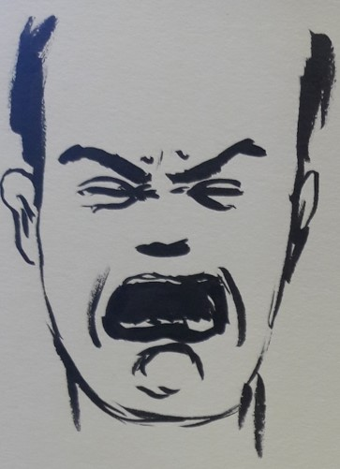
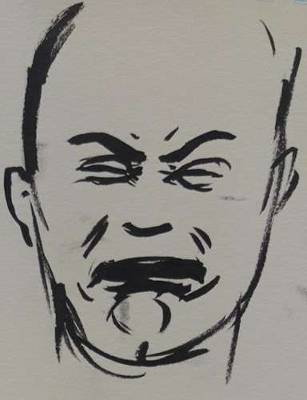
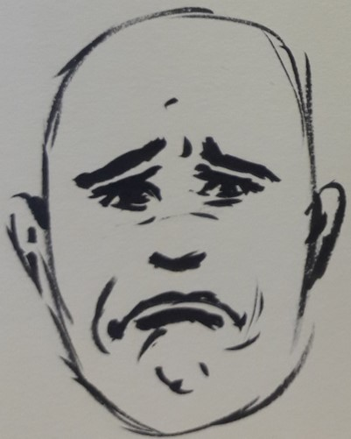
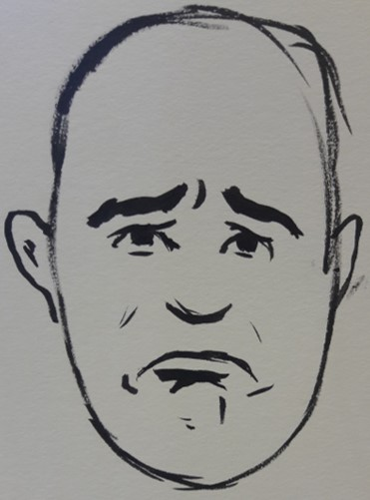
Closed Mouth Crying
Very Sad
A Little Sad
Open Mouth Crying

