Yacht Modeling Terms and Hotkeys/Tools
To model the yacht you will start with a cube, adding detail and sculpting until you have the final shape. This is a very standard style of modeling and one that you will use for the next 3 quarters. The main ways you will add detail are by extruding faces, and adding edge loops. Look at the yacht from all 3 orthographic views and from the perspective view as you work. The emphasis for this assignment should be on learning this modeling technique and how to use the tools available to you, not on creating a perfect yacht.
Terms
- Polygons - A modeling paradigm where you build with faces, edges, and vertexes.
- Quads - Everything you model should be quads; as in, all faces have four sides.
- Edge Loop - A series of connected edges going around an object with no "turns", where the first edge meets the last edge.
- Extrude - Duplicate the selected face/edge so it can be pushed out and still be connected to the original object.
Camera/Viewport
- Alt + Left-click and drag – Rotate the camera
- Alt + Right-click and drag / Scroll Wheel – Zoom the camera in and out
- Alt + Middle-click and drag – Move the camera
- f – Focus camera on the selected object. The camera will now rotate around that object.
- 4 – Display objects as wireframe.
- 5 – Display objects as solid.
- In four panel view: Hover mouse over viewport and press Spacebar to jump in and out.
Object/Component Selection
- q – Select Tool. Also useful for “canceling” out of another tool.
- F8 – Object selection mode.
- F9 – Vertex selection mode.
- F10 – Edge selection mode.
- F11 – Face selection mode.
- While doing either a single click or marquee selection: Hold Ctrl to deselect, hold Shift to toggle selection, or hold Ctrl + Shift to select without deselecting other components or objects.
Edge Selection
- Double click an edge to select the corresponding edge loop.
- Click first edge, hold Shift, then double click the second edge to select that part of the edge loop.
Object/Component Manipulation
- Red tool handles correspond to the x-axis, green to the y-axis, and blue to the z-axis. Remember this color scheme, as it is used consistently throughout Maya for easy axis identification.
- w – Move Tool
- e – Rotate Tool
- r – Scale Tool
- + (the plus key) – Makes the tool size larger (affects all manipulation tools). Bigger tool handle sizes make small adjustments easier.
- - (the minus key) – Makes the tool size smaller.
- x – Snap to grid. Hold while using the Move Tool to snap the selected component or object to a location on the grid.
- v – Snap to vertex. Hold while using the Move Tool, and hover the mouse over a vertex to snap the selected component or object to that vertex’s position. Works for both single-axis and multi-axis movement.
Mesh Editing Tools
- Insert Edge Loop Tool - Inserts a continuous loop of edges perpendicular to the edge specified. Left click, hold, and drag to choose where exactly the new loop goes.
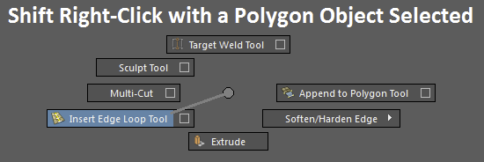

- Extrude Face - "Extrudes" a face or set of selected faces. Be careful not to extrude a face more than once without moving the extruded face first, as that will result in overlapping faces and tricky to fix geometry. There is also an equivalent for extruding edges.
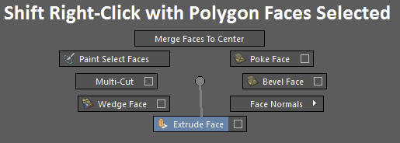
- Multi-Cut Tool - Select points on vertices, edges, or faces themselves to define where to cut edges into polygons. Also useful for inserting edge loops. While the tool is active you can hit Delete to go back one and right click to finalize.
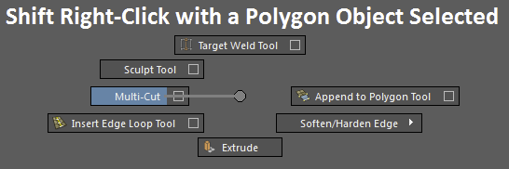
- Append to Polygon Tool - Connects two edges together with a new face. The edges being connected must be open (adjacent to a hole, not on a closed surface) and part of the same object.
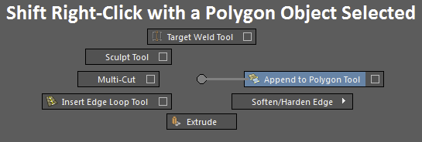

- Ctrl + d - Duplicate the selected objects.
- Mesh → Combine - Combines the selected meshes into one. Disconnected pieces of geometry will stay disconnected, but they will still count as part of the same object.
The Most Important Hotkeys You Will Ever Learn …Ever!
- z - Undo. Undoes the last thing you did. Applies to selections and deselections as well. Does not apply to camera movement by default. Maya's undo queue is initially set to only allow 50 undos in a row, so go to Window → Settings/Preferences → Preferences, select Undo from the list, and set the Queue Size to something like 500. You can set it to Infinite, but that may increase the likelihood of Maya crashing. Note for later in the year: importing resets the undo queue, so be careful.
- Z (Shift + z) - Redo. Undone things are reverted. Be careful not to select or deselect anything if you are doing of bunch of redos, as that will reset the redo queue.
- g - Repeat last action. If you need to perform a single action multiple times (such as extruding) but do not want to repeatedly dig through Maya's menus, just hit the g key.
Common Mistakes
- Extra geometry – Extra faces, edges, and vertices are easy to accidentally create and forget. Make sure you’re checking your work and keeping your model clean.
- Extra extrusions – It’s very easy to extrude a face and then forget about it, and extrude again on top of it. It creates extra faces layered right on top of each other.
- File Extension - You need to do File → Save As and then pick Maya ASCII from the dropdown. Just typing <filename>.ma will not actually make it an ASCII file.
- Crooked propellers and cabins - Pay attention to what you have selected when you're editing. Accidental vertex tweaks can make peoples cabin/propellers look skewed.
- Clean Outliner - There should only be 1 non-default object in the outliner, and it should be called something like "yacht".
- Workflow - It's usually more helpful to have a web browser open to view the assignment than to have the assignment printed out because the printouts are not in color and you can't zoom in on them. The dual-monitor setup in the lab facilities this. One monitor for the write-up and the other for Maya.
- Quads - Make sure every face in your model has 4 sides. To do this select the object, go to Mesh → Cleanup → Options. Choose "Select matching polygons" and "Apply to selected objects". Make sure that "4-sided faces" is the only checkbox selected in the lower panel. Click “Cleanup”. Then hold shift and select the whole object. You should now have all of the non-4-sided faces selected.
- Work in the lab! That's where the TAs and your classmates are and the best place to get help. If you don't need help, maybe you can help someone else out. As the assignments get more complicated and more collaborative it becomes easier to tell when you are working at home.

