LAB #1 – Introduction to Maya & Character Posing Group Assignment
12:20 – 2:00pm

Assigned: Monday, June 18th
Due: Wednesday, June 20th @ 2:00 PM

Resources:
- Posing A Character
- Production Rig Basics
- Character Rig Demo Outline

HELPFUL MAYA HOTKEYS:

Menu Navigation
Spacebar - Holding down this hotkey will bring up the "hotbox". The hotbox is all of Maya's menus in one place relative to the center of your mouse. This allows you to bypass having to switch menu sets every time you want to access certain functionality.

Camera/Viewport
- Alt + Left-click and drag - Rotate the camera.
- Alt + Right-click and drag / Scroll Wheel - Zoom the camera in and out.
- Alt + Middle-click and drag - Pan the camera.
- f - Focus camera on the selected object. The camera will now rotate around that object.
- 4 - Display objects as wireframe.
- 5 - Display objects as solid.
- 6 - Display objects with textures
- 7 – Display objects with lights
- In four panel view: Hover mouse over viewport and press Spacebar to jump in and out

Object/Component Manipulation
- Red tool handles correspond to the x-axis, green to the y-axis, and blue to the z-axis. Remember this color scheme, as it is used consistently throughout Maya for easy axis identification.
- w - Move Tool
- e - Rotate Tool
- r - Scale Tool
- + (the plus key) - Makes the tool size larger (affects all manipulation tools). Bigger tool handle sizes make small adjustments easier.
- - (the minus key) - Makes the tool size smaller.

Animation and Posing
- s – keys selected object. Make sure you have an anim selected first
- , and . (< and >) – toggles between keys of selected object
- alt + v – plays through the timeline
- ctrl + shift + a – brings up the marking menu. A super helpful tool!

IMPORTANT TERMS

Character Rig
A Character Rig is a model that has been given a skeleton and controls that we call “anims” that help us move the character around like a puppet.
When we key a pose, we are selecting and keying the anims.

The Timeline
Placed directly below the viewport, the timeline is the most visible animation tool in Maya. The dark gray bar is the time slider. Its position represents the scene's current animation frame. To change the slider's position, simply left click anywhere on the timeline. You can also "scrub" the slider across the timeline by left clicking and dragging the mouse left and right.

Keyframes
Maya uses "keyframes" for animation (we also refer to them in short as "keys"). A keyframe is a marker used to specify an object's position and attributes at a given point in time. It “saves” the pose at that space in time. To set a keyframe at the current frame, select the anim and hit s.
A red tick mark should appear on the timeline near the slider, indicating that you have "keyed" the selected object on the current frame.

OVERVIEW

In this assignment, you will be working with your group to pose a character rig. You will be working with the “Roy” rig, who comes with some handy features that should make the key-framing process a bit easier. To enable these features you first need to run a setup script. Simply go to the Windows start menu and paste the following path into your Search Bar, and hit enter:

O:\unix\projects\instr\capstone3\production\scripts\install_capstone_shelves_backup.py

A window will pop up indicating that the capstone shelves have been installed. Now when you load Maya in the lab a series of shelves containing tools used by the animation capstone will automatically update.

The next step is to grab a copy of the character rig, which you can find on canvas.

Work out of a separate copy of the file for each part of the assignment. If you want to familiarize yourself with the character rig basics then check out the Production Rig Basics tutorial.

Character Posing
Posing a character correctly is critical in telling a story. The better and clearer a pose is at conveying an idea, the more successful your storytelling will be.
The focus of this portion of the assignment is to give you practice executing the basic principles of posing: line of action, silhouette, and a sense of weight and balance.

It will be helpful to act out the character's actions yourself to give you an idea how weight is distributed.

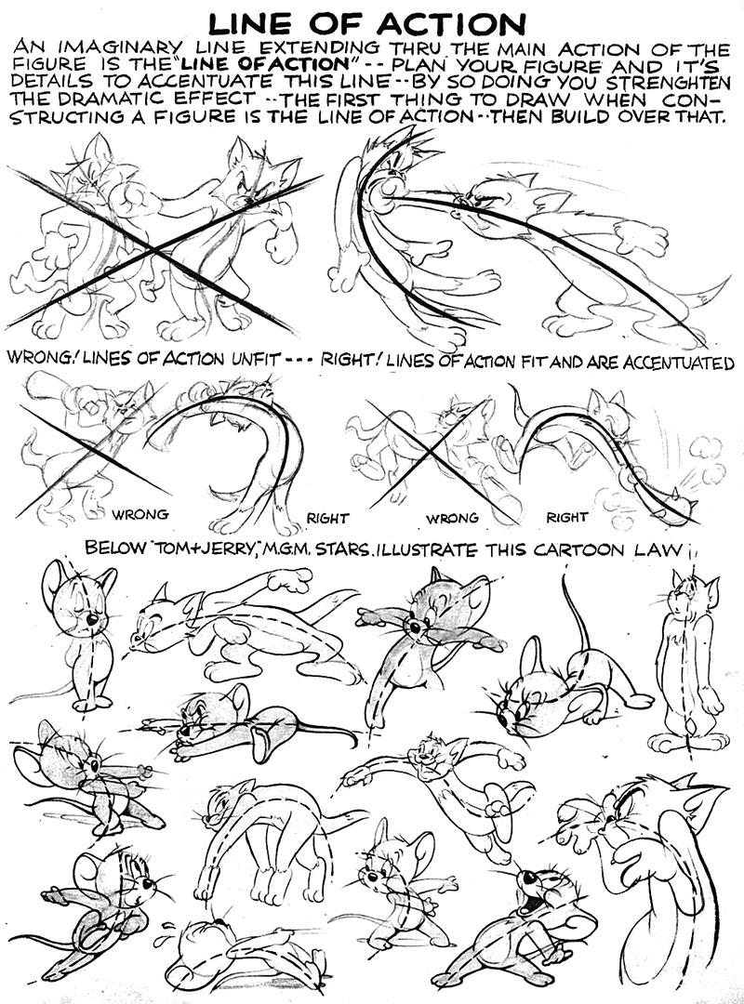
IMPORTANT TERMS
Read Posing A Character, to learn more about line of action and silhouette. Knowing what they are and how to follow those rules will make your poses stronger.

The line of action is an imaginary line that travels through your pose. These lines are usually broad "C" or "S" curves that define the direction of an action and/or how forces are applied. For example, the line of action of a character pushing a large object would originate at their feet, curve up their back, and finally end at their hands where the weight pushes into the object.

It is also important to note these lines are never completely straight. Even mundane actions such as a character simply standing and doing nothing should have a curved line of action, if only slightly. In general, lines of action make your poses more dynamic and believable.
The silhouette refers to just the outline of your character, which means that you should always pose your character relative to a fixed camera perspective. Good, clear silhouettes allow poses to read more easily, even if they are only on screen for fractions of a second.
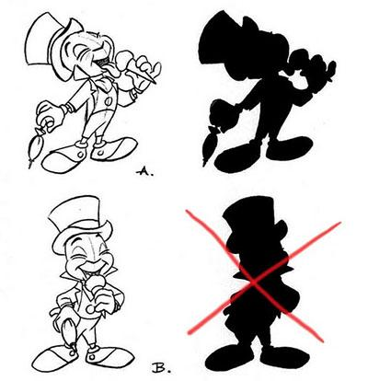

Helpful Silhouette Tip!
In Maya, you can disable the normal shading and see just the character's silhouette by hitting the 7 key, which displays the lights in the scene. Since there are no lights in the scene, the character will appear to be in shadow. This is an incredible helpful tool!

You will want to view the silhouette from time to time to assess how your poses are progressing, as poses should discernable by the silhouette alone.

Set-up
Click the Animation Preferences button () at the bottom right of the screen. Go to the Settings category and make sure that Time is 24 fps. In the Animation tab, make sure tangents are set to Default out: Clamped and Default in: Stepped.

LAB INSTRUCTIONS

In the Maya scene starting from your copy of the rig file (do not work in the source rig file), do the following:
- Review the poses you will be making and their examples below.

Pose the character balancing with one leg in lifted in front of it.
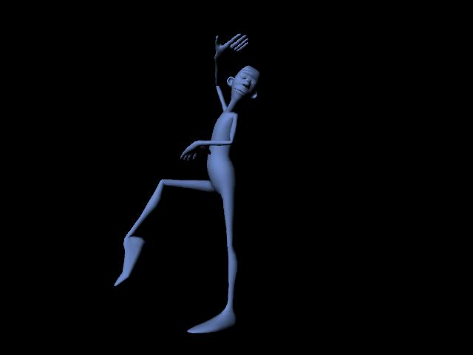

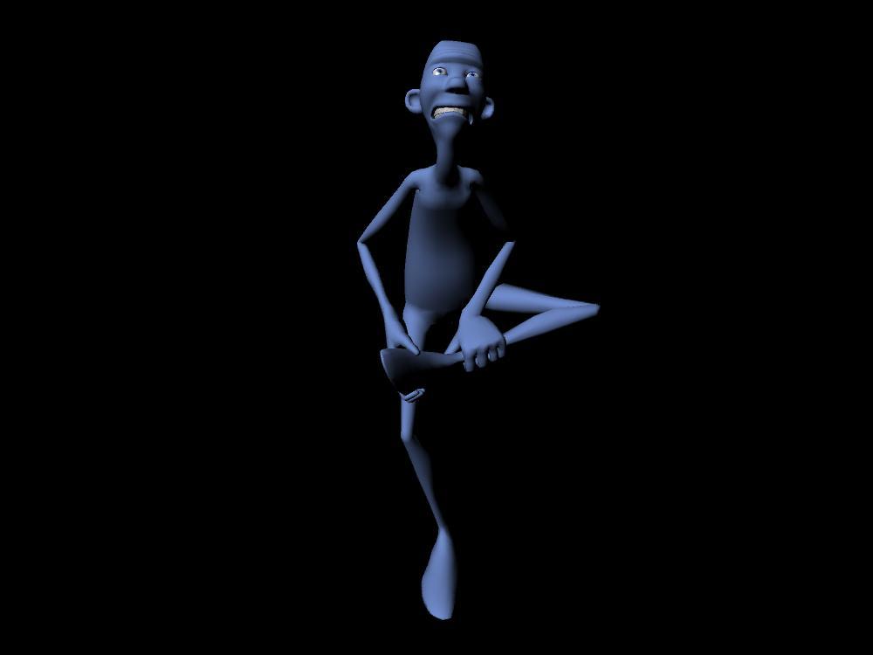
Pose the character balancing with one leg lifted high to the side. The character does not have to be holding their leg like in the examples.

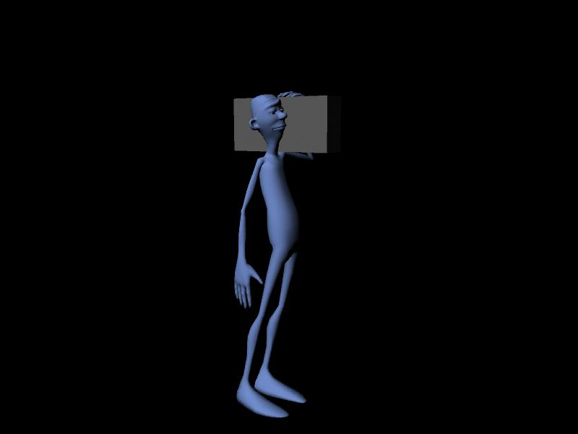
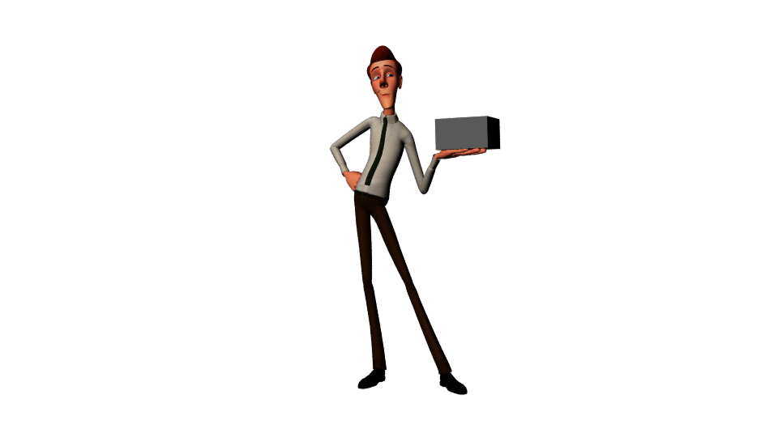Pose the character so that it is carrying an object that is light. You can create a simple cube for the character to hold with create > polygon > cube, then pressing ‘r’ to transform it. You can key the visibility as well!

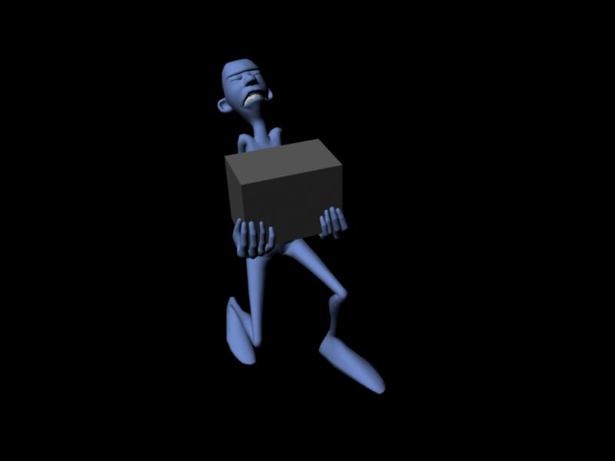
Pose the character so that it is carrying an object that is heavy.

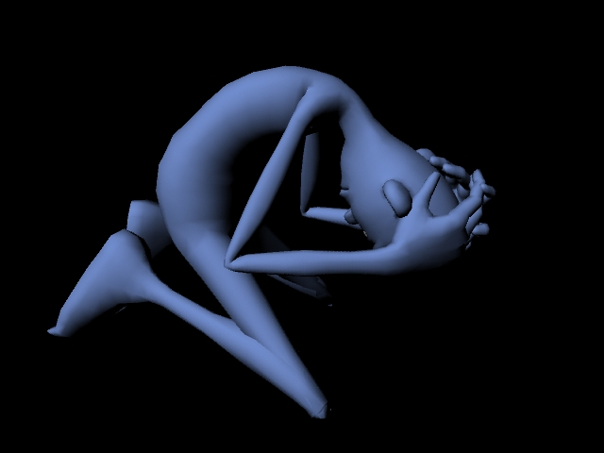
Pose the character so that it conveys the emotion of being sad.

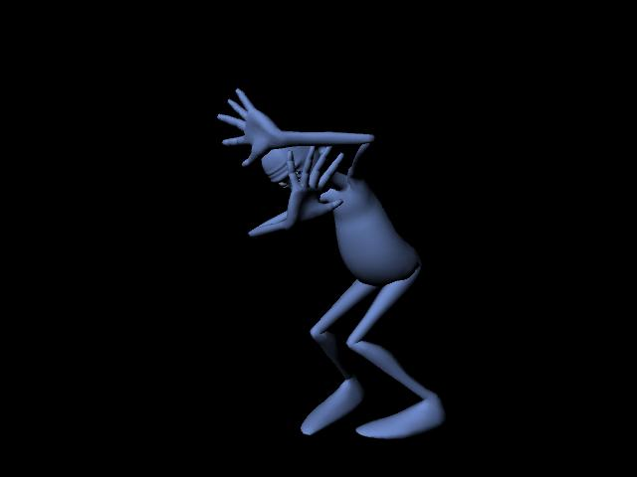
Pose the character so that it conveys the emotion of being frightened.
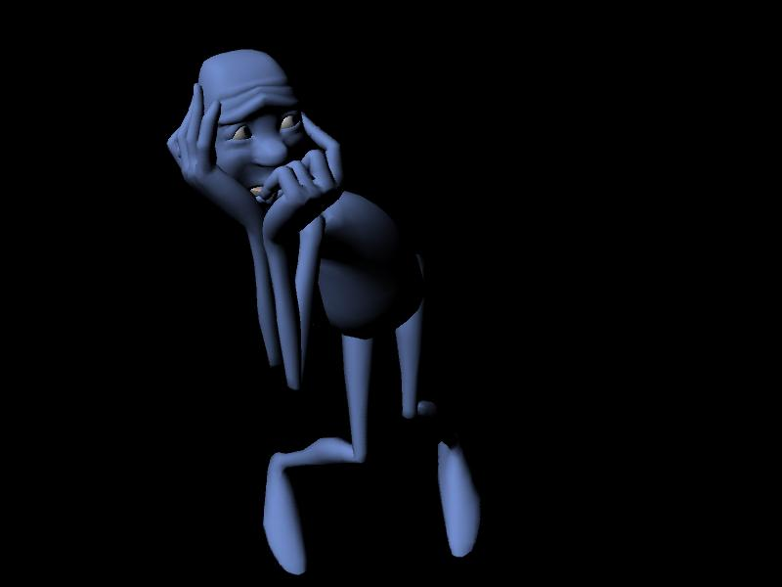

If you have extra time, feel free to come up with a pose on your own! Ex: What would an angry pose look like?

- Create a render camera and pose your character relative to this. How the silhouette, line of action, and weight come across in the final 2D image is what matters. Go to Create → Cameras → Camera. Name this new camera "render_cam".

- Next, go to Windows → Rendering Editors → Render Settings. Under the Common tab, scroll to Image Size. In the Presets drop-down menu, select "HD 720".

- Find a suitable position for the camera. Approximately, to the side and level with the ground should suffice. With the camera selected, click the “lock camera” button on the icons above the viewport. This will prevent the camera from moving.

- Remember to key all of the anims for each pose. (Use the marking menu). In addition, use stepped tangents. Making sure that the default tangents in your Animation Preferences are set to Clamped/Stepped.

- Now you are ready to pose! Key each new pose every ten frames in the order given. Balancing with one leg in front on frame 0, Balancing with a leg to the side on 10, holding a light object on frame 20, and so on.

- After you have finished posing, scrub to each pose and do a quick render. You will be submitting these six renders alongside your Maya file.

Grading Criteria and Turn-In Checklist:
You will be submitting your files into Canvas. Below is a list of criteria we will be using for grading, in addition to a list of the files you will need to turn in for each part of the assignment along with naming specifications.

Grading Criteria
- Poses
    - Clear line of action
    - Strong silhouette
    - Character appears to have the correct weight/balance
    - Full body posing
    - No twinning
    - Posed hands (no "pancake" hands)
    - Shoulders and hips oriented correctly
    - Dynamic/interesting
    - No foreshortening

  - Object interaction
    - Heavy object appears heavy
    - Light object appears light

- For Turn-In
  - ‘group#’_posing.ma (Maya file with the six poses)
  - A render of each pose:
    - ‘group#’_1_front_leg_lift.jpg
    - ‘group#’_2_side_leg_lift.jpg
    - ‘group#’_3_light_box.jpg
    - ‘group#’_4_heavy_box.jpg
    - ‘group#’_5_sad.jpg
    - ‘group#’_6_scared.jpg
    - ‘group#’_7_extra.jpg

