Audio Demo

Recording

You will soon be recording a voiceover describing the story in your animatic, but for now you will just be doing a test run by describing what’s going on in your chosen lab assignment.

Recording audio is a fairly straightforward process in Windows. Just plug in a microphone (there will be some in the lab) then open "Voice Recorder" from the Start Menu. If a settings window shows up, under the playback tab select your microphone and hit "OK".

If you cannot access voice recorder (as it can occasionally be a problem with Windows 10), then you can use a recording app like Audacity. http://www.audacityteam.org/download/
or from here:
\\ntdfs\cs\unix\projects\instr\production1\cse456_su16_student_files\07_18_files\audacity-win-2.1.2\Audacity

If you are also unable to hear your microphone, check the “recording devices” when right clicking the speaker icon n your taskbar, click your microphone, then add a microphone boost under microphone properties – Levels, and it should work. The green cable on the headset is for headphones. Pink is for the mic.

When doing your voiceover it may help to have your movie file playing in the background as reference.

Push "Start Recording" to begin. When you hit “Stop Recording” it will prompt you to save the file. If you click cancel you have the option to resume recording. If using audacity, instead click File – Export Audio. You may want to try two or three takes so you have several options to choose from. When you’re finished go ahead and import the files into Premiere.

Finding Music
Another task on its own is finding music that fits your piece. This is more of an optional “tips” step, but YouTube is probably your best bet to find something that works. The trick is downloading the file. There are many sites that allow you to do this. One solid option is keepvid.com.
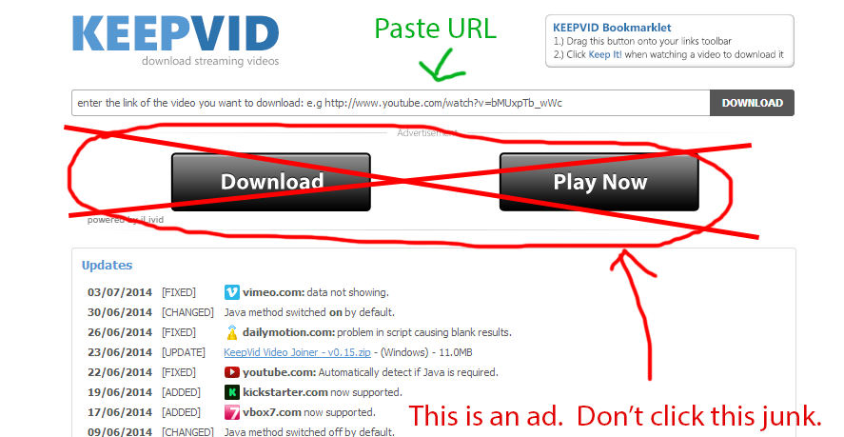
Just paste the URL in the top bar and click the small download button on the right. It will ask for permission to run a Java Applet. Click “Allow” or “Run this time” – it depends on the browser. Be sure NOT to click the ad, though. If you accidentally do and it tries to get you to download an executable file avoid it like the plague.
A list of download options will appear in the browser. The most direct option is an MP4. (Note that MP3 does show up as an option but it will just bring you to another site.) Right click the link and save the file to your student files folder. You can drag this file into Premiere. If Premiere takes issue with the MP4 a workaround is to just rename the file’s extension to “.mov”.
You can drag this file into the timeline, right click the MP4 clip and select “Unlink”. This will allow you to delete the video track while leaving the audio clip intact and free for editing.
Adding Foley/ Sound Effects:
You will be adding sound effects for your story board. There is a website you could go to for free sound effects, however, you will need to register an account. The link is: www.freesound.org
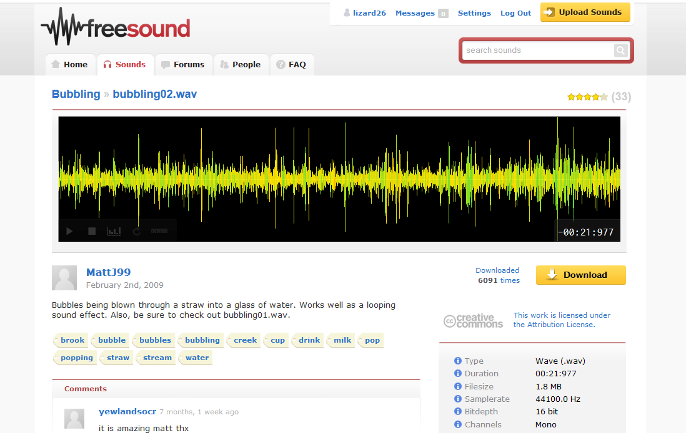
You can download the sound effect and import the file into Premiere. For organization purpose, be sure to add your sound effects to a separate media track and name it as “sfx”.
Music and Audio on the Server
As another option, on the server, we have a folder with sound effects and music you can use. \\ntdfs\cs\unix\projects\instr\production1\cse456_su16_student_files\_SoundLibrary

Audio Editing
Drag your audio files onto timeline. You’ll probably want to come up with some sort of organization. For example, voiceover on Track 1, music on Track 2, foley on Track 3 and Track 4, etc. Like video clips, you can hover the mouse cursor over the start/end edge of the clip then left click and drag to shorten or lengthen it.
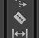
Alternatively, you can use razor tool in tool box (or hotkey c) to cut your audio into pieces. Select unnecessary part and hit “Delete” to delete.
Use multiple audio tracks to play different sound and music clips at same time. If you need more than the three audio timelines there, you can just right click the name of one of the audio tracks and choose “Add Tracks…”, then specify the number of audio (and video) tracks you want to add.
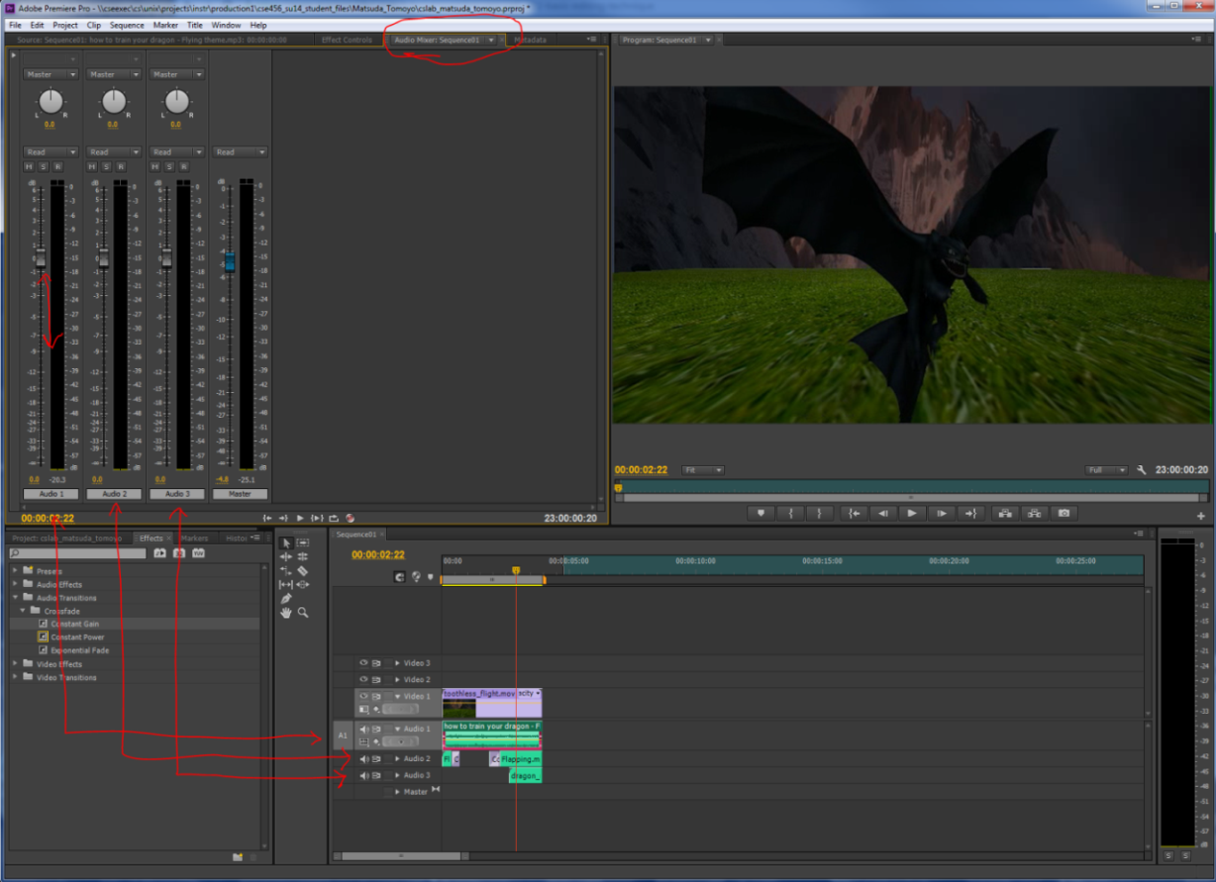
To control sound volume, go to the “Audio Mixer: [sequencename]” tab in the top left viewport. You can change the volume of each track on timeline by moving their assigned sliders up and down. The blue slider is the Master track, which allows you to control entire sound level.
You can also adjust the relative audio of individual clips by right clicking them and selecting “Audio Gain”. Select the “Set Gain to” option and just enter in a positive number for louder and a negative number for quieter. Click “Ok”.
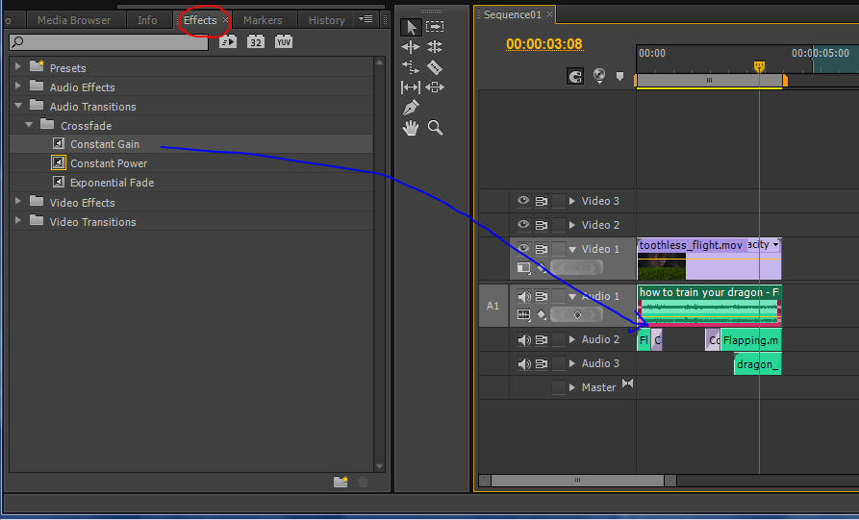
To add fade on your audio track, go to “Effects” tab in the Project Control Panel. Navigate to Audio Transitions → Crossfade→ Constant Gain. Drag Constant Gain to the timeline and drop it on the edge of and audio clip. You will see a fade effect pop in on that end of the clip. You can change the length of the effect by dragging the edge like other clips.
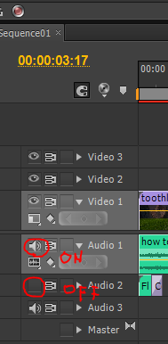
To turn on/ off the audio of a particular track just click the icon highlighted above.

8: Export the Sequences
The last step is to export your film. Select your sequence in the Project Control Panel and export it. Now go to File -> Export -> Media...
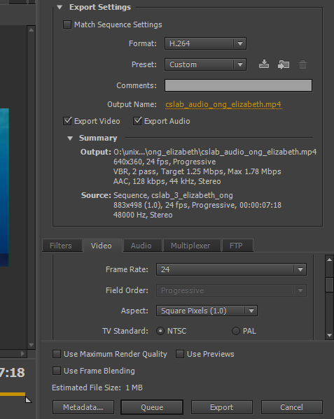
The file name should automatically be that of the sequence you are exporting.
Click cslab_audio_[lastname]_[firstname] and navigate to the place you want to export, which is your student folder.
Select "H.264" as the format. Go to the video tab, scroll down and find Basic Video Settings. Then change the Width and Height into 640*360. Make sure that Frame rate is “24” and Field order is “Progressive”.
Note that you will be exporting two files for this lab, one with voiceover and one with music/foley. Before exporting your music/foley pass be sure to temporarily disable your voiceover track as described in the audio section. Similarly, you should disable your music/foley tracks before exporting the voiceover.
When you’re ready, hit "Export". Don’t forget to save your premiere project. Make sure "Export Audio" is checked before you export.
Always remember to watch your export after it is finished to make sure everything is the way you want it.
In the future be sure to save your Premiere file frequently as you go and save iterations. This may not seem as relevant for this lab because it should be pretty quick, but it will become very important the more time you put into your editing later.
What to Turn-In
Turn the following two files in this location: \\ntdfs\cs\unix\projects\instr\production1\cse456_su16_student_files\07_18_turnin
Locations for files used in this demo: \\ntdfs\cs\unix\projects\instr\production1\cse456_su16_student_files\07_18_files
You will have:
- Your final video with music/foley (Turn off your voice over then export)
- Your final video with your voice over (Turn off other sounds then export)

