Name (last, first) _______SOLUTION____

MINIQUIZ - 2

1. Label the following program memory diagram with following components: global data, program, stack, and heap.

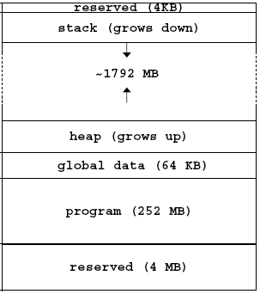

2. For a simple procedure, assign number 1 through 7 for each step in sequence for a procedure call.

__5__ Make result available to caller
__7__ Return point of call
__3__ Acquire storage resources
__2__ Transfer to procedure
__6__ Return storage resources
__4__ Do the desired function
__1__ Set up parameters

