1st Case:
- user enters customer data
- add customer object to model
- add customer to scheduler
- send address to mapper
- mapper returns corresponding zone
- send Estimated Time of Arrival (ETA) to model
- store customer in data store
- ETA to dispatcherUI

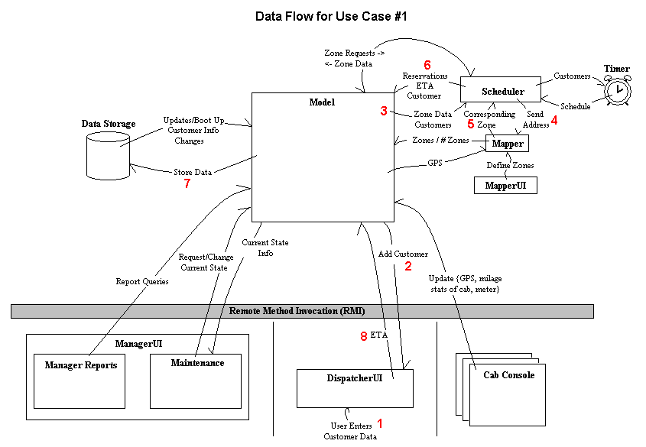

2nd Case:
- scheduler task fires
- zone object retrieved from model for customer pickup
- task generates request for a ride (sends request through model)
- accept / reject sent through model to scheduler
- scheduler tells model results of accept / reject
- model relays info to data store

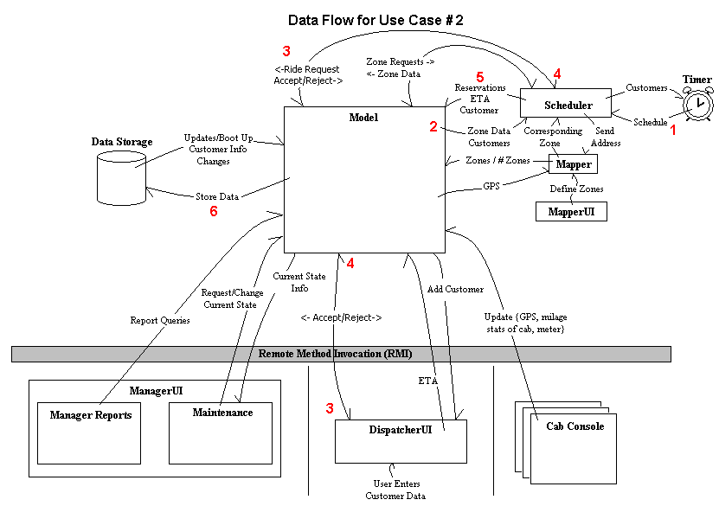

3rd Case:
Getting customer info.
1. dispatcher requests customer state from model
2. model requests customer state from scheduler
3. send data from scheduler to model
4. send state from model to dispatcher - return value

Canceling customer (continued from step 4)
5. dispatcher cancels the customer returned from model
6. model request the scheduler to cancel the customer
7. scheduler request model to notify the cab if the customer has been scheduled.
8. model notifies the cab
- model notifies the storage
- return true to dispatcher

Changing customer info/rescheduling (continued from step 4)
11. dispatcher edit customer information and changes the customer info
12. if the customer needs to be rescheduled
steps 6 – 9 are perfomed.
13. model reschedule the customer as a new customer.
see use case 1.
14. return new ETA to dispatcher

15. if the customer does not needs to be rescheduled, get customer from scheduler
16. change the customer info.
17. return the old ETA to dispatcher

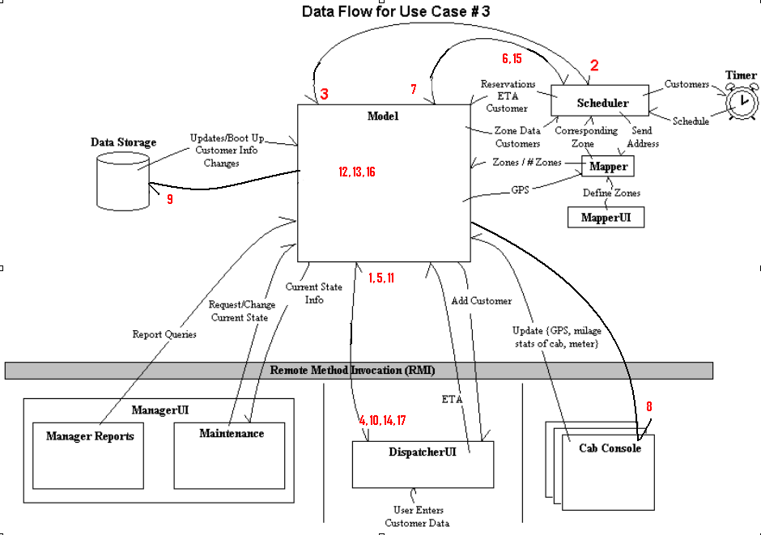

4th Case:
- customer dropped off
- cab tells model of drop off
- model updates datastore
- model internally updates cab object



