CSE 351 Section 2 – Pointers, Bit Operators, Integers
Pointers
A pointer is a variable that holds an address. C uses pointers explicitly. If we have a variable x, then &x gives the address of x rather than the value of x. If we have a pointer p, then *p gives us the value that p points to, rather than the value of p.
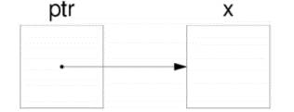
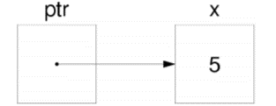
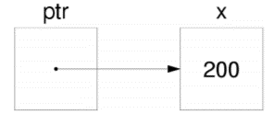
Consider the following declarations and assignments:

1)

2)

3)
int x;
int *ptr;
ptr = &x;
- We can represent the result of these three lines of code visually as shown.
The variable ptr stores the address of x, and we say “ptr points to x.”
x currently doesn’t contain a value since we did not assign x a value!
- After executing x = 5;, the memory diagram changes as shown.
- After executing *ptr = 200;, the memory diagram changes as shown.
We modified the value of x by dereferencing ptr.
Pointer Arithmetic
In C, arithmetic on pointers (++, +, --, -) is scaled by the size of the data type the pointer points to. That is, if p is declared with pointer type* p, then p + i will change the value of p (an address) by i*sizeof(type) (in bytes). If there is a line *p = *p + 1, regular arithmetic will apply unless *p is also a pointer datatype.
Exercise:
Draw out the memory diagram after sequential execution of each of the lines below:
int main(int argc, char **argv) {
int x = 410, y = 350; // assume &x = 0x10, &y = 0x14
int *p = &x; // p is a pointer to an integer
*p = y;
p = p + 4;
p = &y;
x = *p + 1;
}

Line 1: | Line 2: | Line 3:
Line 4: | Line 5: | Line 6:
C Bitwise Operators
& | 0 | 1 | $$←$$ | AND (&) outputs a 1 only when both input bits are 1. |  | | | 0 | 1
0 | 0 | 0 |  |  |  | 0 | 0 | 1
1 | 0 | 1 |  | OR (|) outputs a 1 when either input bit is 1. | $$→$$ | 1 | 1 | 1
^ | 0 | 1 | $$←$$ | XOR (^) outputs a 1 when either input is exclusively 1. |  | ~
0 | 0 | 1 |  |  |  | 0 | 1
1 | 1 | 0 |  | NOT (~) outputs the opposite of its input. | $$→$$ | 1 | 0
Masking is very commonly used with bitwise operations. A mask is a binary constant used to manipulate another bit string in a specific manner, such as setting specific bits to 1 or 0.
Exercises:
- [Autumn 2019 Midterm Q1B] If signed char a = 0x88, complete the bitwise C statement so that b = 0xF1. The first blank should be an operator and the second blank should be a numeral.

b = a __ 0x__

2) Implement the following C function using control structures and bitwise operators.
// returns the number of pairs of bits that are the
// opposite of each other (i.e. 0 and 1 or 1 and 0)
//
// bits are "paired" by taking adjacent bits
// starting at the lsb (0) and pairs do not overlap.
// For example, there are 16 distinct pairs in a 32-bit integer
int num_pairs_opposite(int x) {

}

Signed Integers with Two’s Complement
Two’s complement is the standard for representing signed integers:
- The most significant bit (MSB) has a negative value; all others have positive values (same as unsigned)
- Binary addition is performed the same way for signed and unsigned
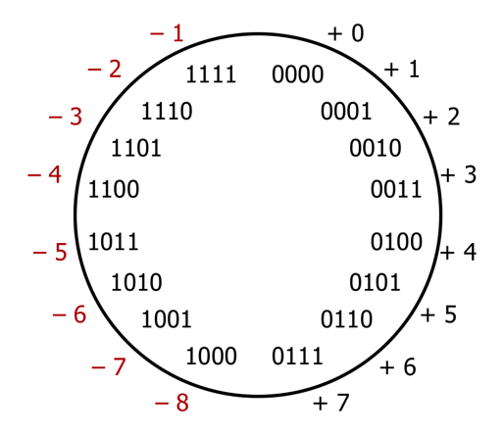
- The bit representation for the negative value (additive inverse) of a Two’s Complement number can be found by:
flipping all the bits and adding 1 (i.e. $-x=\sim x+1$).
The “number wheel” showing the relationship between 4-bit numerals and their Two’s Complement interpretations is shown on the right:
- The largest number is 7 whereas the smallest number is -8
- There is a nice symmetry between numbers and their negative counterparts except for -8

Exercises:
- If we have 8 bits to represent integers, answer the following questions:
  - What is the largest integer? The largest integer + 1? The most negative integer? If it doesn’t apply, write n/a.
Unsigned:  Largest:  Largest + 1:  Most Negative: | Two’s Complement:  Largest:  Largest + 1:  Most Negative:
  - How do you represent (if possible) the following numbers: 39, -39, 127?
Unsigned:  39:  -39:  127: | Two’s Complement:  39:  -39:  127:
- [Autumn 2017 Final M1A] Take the 32-bit numeral 0xC0800000. Circle the number representation below that has the most negative value for this numeral.
Sign & Magnitude Two’s Complement Unsigned
- [Winter 2018 Midterm 1C] Given the 4-bit bit vector 0b1101, what is its value in decimal (base 10)? Circle your answer.
13 -3 -5 Undefined

