0. Simulating DFS
Do a DFS traversal of this graph starting at node S
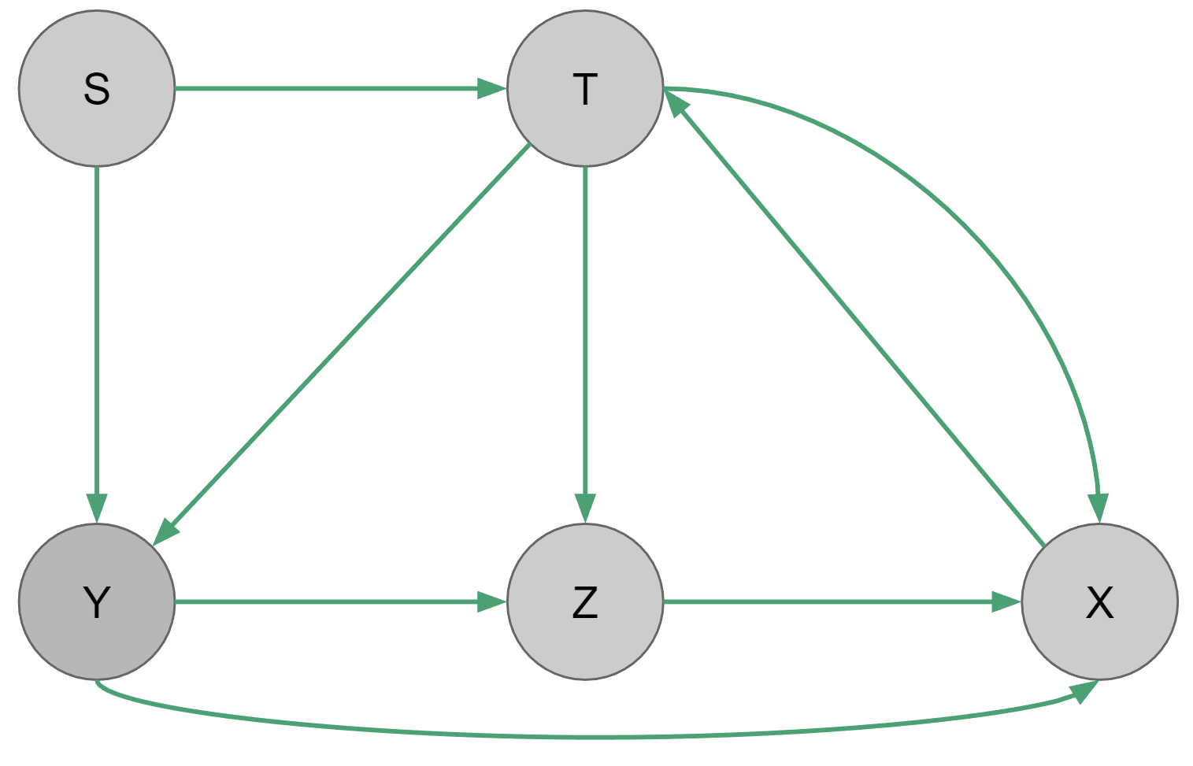
Vertex | Visited? | Done?
S
T
X
Y
Z

Stack frame:

1. Simulating BFS
Do a BFS traversal of this graph starting at node S. What is the resulting tree?
Vertex | Pred | Visited?
S
T
X
Y
Z

Queue:

Resulting Tree:

2. Velociraptors
Consider the following graph:
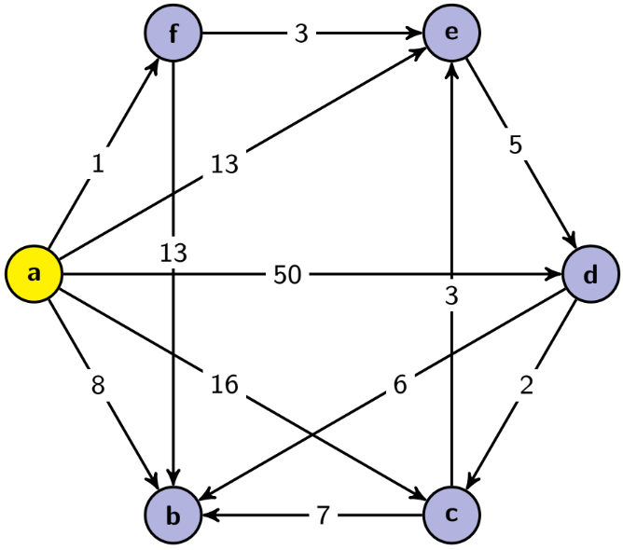
Suppose that you are at a and you are planning your escape from a bunch of hungry velociraptors (edge weights represent the expected number of velociraptors you will meet on this path). Run Dijkstra’s Algorithm to find the lengths of the shortest paths (fewest number of velociraptors met) from a to each of the other vertices. Remember to store the path variable and list the order vertices are added to the known set.

Vertex | Visited? | Cost of Path | Pred
a
b
c
d
e
f

Order added to known set:

3. Better Find the Shortest Path Before It Catches You!
Consider the following graph:
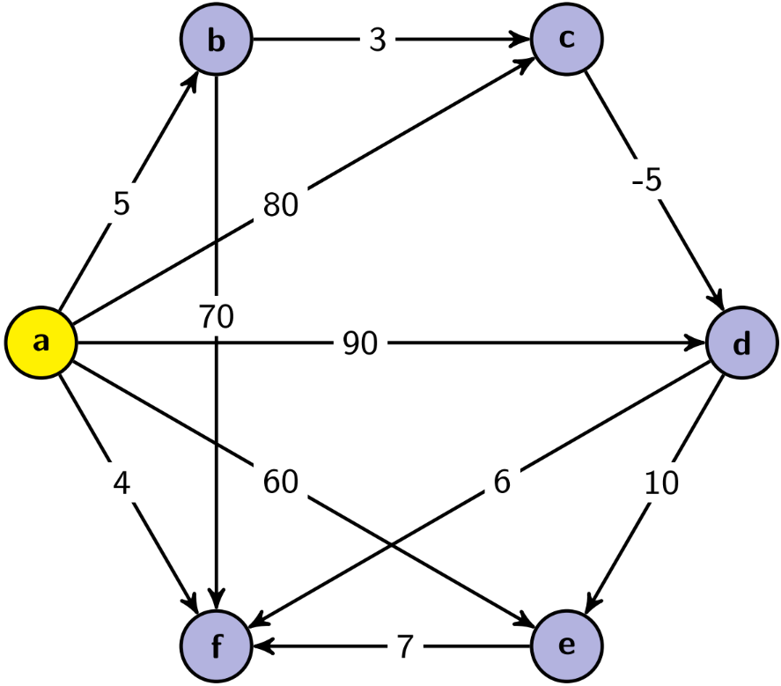
- Use Dijkstra’s Algorithm to find the lengths of the shortest paths from a to each of the other vertices. Show your work at every step.

Vertex | Visited? | Cost of Path | Pred
a
b
c
d
e
f
Order added to known set:

- Are any of the lengths you computed using Dijkstra’s Algorithm in part (a) incorrect? Why or why not?

- Explain how you would use Dijkstra’s Algorithm to recover the actual paths (rather than just the lengths).

