CSE 154, Autumn 2014
Final Exam, Tuesday, December 9, 2014

Name: ___________________________________________

Quiz Section: ___________________ TA: ___________________

Student ID #: ___________________

Rules:
- You have 110 minutes to complete this exam.
You may receive a deduction if you keep working after the instructor calls for papers.
- This test is open-book, but closed notes. You may not use printed/written notes or practice exams.
- You may not use any computing devices, including calculators, cell phones, or music players.
- Unless otherwise indicated, your code will be graded on proper behavior/output, not on style.
- Please do not abbreviate code, such as writing ditto marks ("") or dot-dot-dot marks (...).
You may write ID for document.getElementById and QS for document.querySelectorAll.
- You may not use JavaScript frameworks such as jQuery or Prototype when solving problems.
- If you enter the room, you must turn in an exam and will not be permitted to leave without doing so.
- You must show your Student ID to a TA or instructor for your submitted exam to be accepted.

Good luck! You can do it!

*('O')*

Problem | Description | Earned | Max
1 | Javascript |  | 20
2 | PHP |  | 22
3 | Ajax |  | 20
4 | Regular Expressions |  | 18
5 | SQL |  | 20
X | Extra Credit |  | 1
TOTAL | Total Points |  | 100
1. Javascript/DOM
Write JavaScript code in a file called simple.js for manipulating a list. The page UI allows the user to type some text into a text box. The user can click an "add" button to make the text appear in the list (put it inside the game div).
When the mouse enters a list item the background color of that item should turn cyan and the font size of that list item should increase by 5px. When it leaves that item the background color should turn back to white and the font size back to what it originally was. The original font size is included in a CSS file attached to the HTML. Your code should work for any starting font size value. You can view the current size with your code but not by opening the file and looking at it.
When the user clicks on an item it should be deleted.
You may not use any Javascript libraries such as Prototype and JQuery. You must write ALL Javascript to make the page work, none is provided. You can define any additional CSS you like as long as you label it in a clear way. You only need to write the appearance/CSS changes mentioned above. You can assume the page has a linked style sheet that provides the other styles visible in the screenshots.
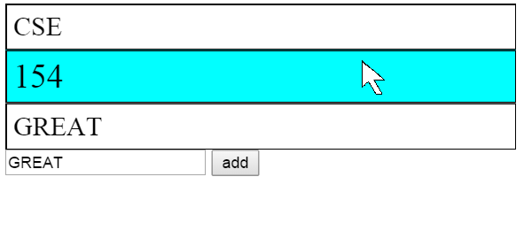
The page when it first loads The page after a couple adds with the mouse hovering

The page after “154” and “Great” have been clicked and removed

Your Javascript will be manipulating the following HTML code:
<!DOCTYPE html>
<html>
<head>
<script type="text/javascript" src="simple.js"></script>
<link rel="stylesheet" type="text/css" href="simple.css" />
</head>
<body>
<div id="game"></div>
<input id="input" type="text" />
<button id="add">add</button>
</body>
</html>

(Write your solution on the next page)

2. Javascript /DOM (Additional writing space)
2. PHP/JSON
Write the code for a web service courses.php that outputs JSON data about available courses at a school. This service should take two GET parameters named start and end, and search a data file for all courses that match those start/end times exactly and have open seats available.
Your PHP code will read a data file named courses.txt. Each line in that file matches the following format, with each token of information separated by a single space:
code startTime endTime seatsAvailable seatsTotal name
All tokens of data except the course name are guaranteed not to contain any spaces in them. You can assume all data in the file is valid, a number when you expect it to be a number and has no blank or malformed lines.
You may find an optional third parameter to the split function useful when writing your solution. If you pass split a number as a third parameter it will cap the number of times it splits to that number. Everything after the number of splits is passed will be placed in the last spot in the array. For example split(“:”, “h:i:j:k”, 3) would return {“h”, “i”, “j:k”}.
The JSON that is output should contain a number labeled “count”. This should represent a count of all courses at the given start and end times. It should also contain a list called “courses” that contains a list for each course exactly matching the start and end times that has open seats. The list for each course should contain the code labeled as “code”, the number of seats left (the total seats minus the seats available) labeled as “seats”, and the name labeled as “name”,
You can assume both parameters will be passed. If no courses match the start/end and have seats you should send back the same data as usual, just leave the course array empty.
An example input file:
CSE154 130 230 250 250 Web Programming
CSE143 130 230 700 800 Computer Programming I
ANTH300 130 230 13 14 Anthropology
DANCE250 130 3 40 50 World Dance History

Output using the above input file and courses.php?start=130&end=230
{ "count":3,
"courses":[ {"code" : "CSE143",
"seats" : 100,
"name" : "Computer Programming"
},
{"code" : "ANTH300",
"seats" : 1,
"name" : "Anthropology"
}
]
}

2. PHP /JSON (additional writing space)

3. Ajax/JSON
Write Javascript code in a file called courses.js that contacts the courses.php code that you wrote for question 3. You can assume courses.php and courses.js will be located in the same directory. Remember, courses.php takes start and end times as parameters and outputs data in the form of the data below:
{ "count":3,
"courses":[ {"code" : "CSE143",
"seats" : 100,
"name" : "Computer Programming"
},
{"code" : "ANTH300",
"seats" : 1,
"name" : "Anthropology"
}
]
}
Your Javascript code will be attached to the below HTML page:
<!DOCTYPE html>
<html>
<head><script type="text/javascript" src="courses.js"></script></head>
<body>
<h1>Search for open courses</h1>
<label>start time:<input id="start" type="text" /></label>
<label>end time:<input id="end" type="text" /></label>
<button id="search">search</button>
<ul id="results"></ul>
<p id="count"></p>
</body>
</html>
When the search button is clicked, clear the previous results on the page and request the JSON data for the input times with Ajax. Add each returned course to the list in the following format:
name - seats seats
Add the count to the count paragraph in the following format:
count total courses offered
You may assume that the JSON data is valid and in the format described previously, the data typed into the text boxes is valid, and that the .php service is reachable. You do not need to do anything special if there are no matching courses.
You may not use any Javascript libraries such as Prototype and JQuery.

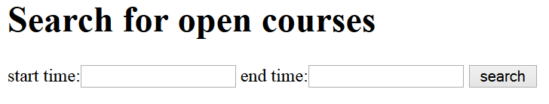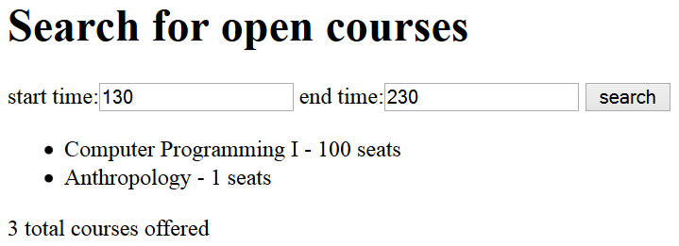
When the page first opens After a search for courses 130-230

(Write your solution on the next page)

3. Ajax/JSON (additional writing space)

4. Regular Expressions
a) Write a regular expression to match a hexadecimal color code. Remember, colors written in hexadecimal always start with a # and then contain 6 letters or numbers 0-9 and A-F. Letters can be lowercase or uppercase.
match: don’t match:
#000000 #1234567
#D3D3D3 4#D3D3D3
#abCDeF #abCDeG

b) Write a regular expression to validate a Mastercard number. Mastercards have a 16 digit long number. The first number is always 5 and the second number is a 1, 2, 3, 4 or 5. The rest of the numbers can be anything. You should not look for or try to match dashes (-).
match: don’t match:
5112345678901234 51123456789012
5555555555555555 55555a5555555b55

c) Write a regular expression to match a time written like 11:04 AM. Times consist of an hour (1-12) followed by a colon, followed by minutes (00-59), followed by a space and then either AM or PM.
match: don’t match:
12:00 AM 12:0 AM
1:11 PM 14:00 PM
4:59 PM 0:20 AM
02:00 AM
4:60 PM

[abc] A single character of: a, b, or c . Any single character
[^abc] Any single character except: a, b, or c \s Any whitespace character
[a-z] Any single character in the range a-z \S Any non-whitespace character
[a-zA-Z] Any single character in the range a-z or A-Z \d Any digit
^ Start of line \D Any non-digit
$ End of line \w Any word character (letter, number, underscore)
\A Start of string \W Any non-word character
\z End of string \b Any word boundary
(...) Capture everything enclosed a+ One or more of a
(a|b) a or b a{3} Exactly 3 of a
a? Zero or one of a a{3,} 3 or more of a
a* Zero or more of a a{3,6} Between 3 and 6 of a
5. SQL
Write an SQL query on the imdb database that will return the names of all characters that appeared in two or more of the Pirates of the Caribbean movies; that is, movies whose name begin with the substring "Pirates of the Caribbean". Ensure that the results are returned in alphabetical order. If it helps you, you may assume that the character is played by the same actor in both movies.
Recall the imdb database tables:
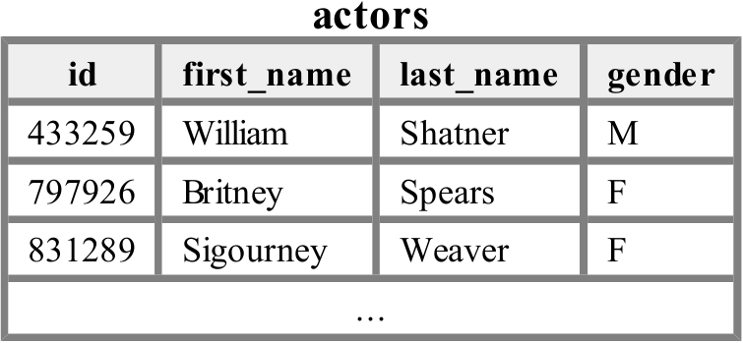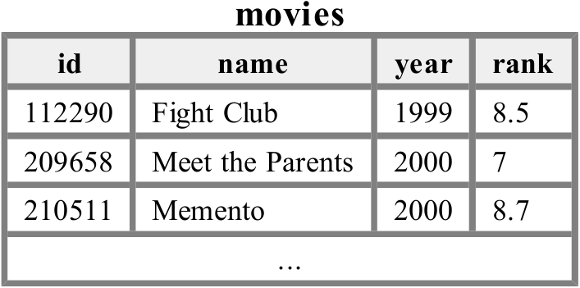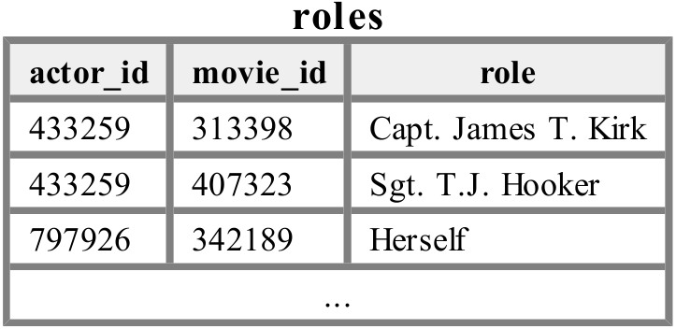
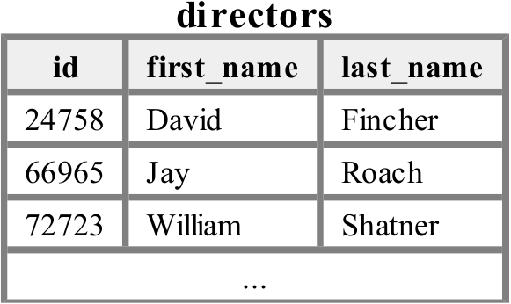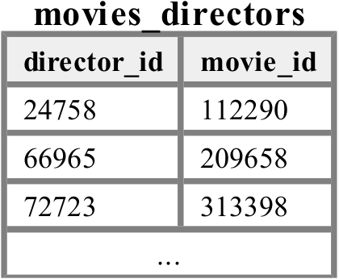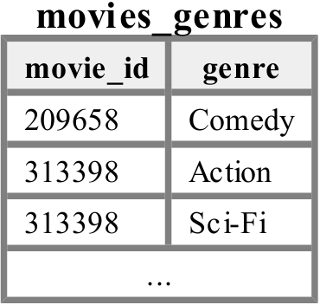
The following is a subset of the results returned:
+-------------+
| role |
+-------------+
| Himself |
| Marine |
| Will Turner |
+-------------+
If you join too many tables together that are not needed for the query, you will not receive full credit.
You should solve this problem using only the SQL syntax shown in class and the textbook.

X. Extra credit
Draw a picture of your TA as a superhero.
(any answer that reflects non-trivial effort will receive credit)

