CSE 190 M, Spring 2011, Final Exam
ANSWER KEY
1. HTML/CSS Tracing
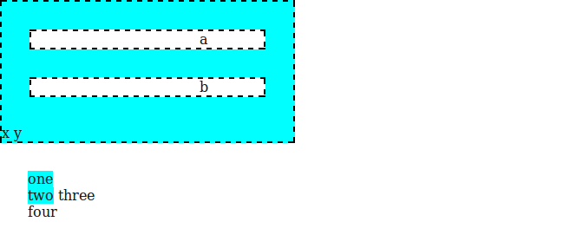

2. HTML/CSS Coding

<div id="main">
<div id="column1">
<h1>Zen Garden</h1>

<div id="slogan">
<p>A demonstration of...</p>
</div>

<div id="enlightenment">
<h3>The Road to Enlightenment</h3>
<p>Littering a dark and dreary road lay...</p>
<p>Today, we must clear the mind...</p>

<div id="selectadesign">
<h3>Select Design</h3>
<ul><li><a href="">Under the Sea!</a> by Eric Stoltz</li>
<li><a href="">Make 'em Proud</a> by Michael McAghon and Scotty</li>...</ul>
</div>
</div>
</div>

<div id="whatabout">
<h3>So What is This About?</h3>
<p>There is clearly a need for CSS to be taken seriously...</p>
<p>CSS allows complete and total control over the style of a hypertext doc...</p>

<h3>Participation</h3>
<ul>
<li>Graphic artists only please. You are modifying this page...</li>
<li>Zen editors modify the style sheet in any way you wish, but not ...</li>
</ul>
</div>
</div>

body {
background-image: url("heading.gif");
background-repeat: no-repeat;
color: #471C47;
font-family: Verdana, sans-serif;
font-size: 9pt;
}

#main { margin-left: 130px; }
h1 { display: none; }
#slogan { font-style: italic; }
#selectadesign { border-top: 3px solid #A690AF; }
#selectadesign a { font-weight: bold; }

#enlightenment {
background-image: url("toad.png");
background-repeat: no-repeat;
background-position: right bottom;
float: left;
padding-right: 1em;
width: 26em;
}

#whatabout {
background-color: #A690AF;
border: 2px solid #471C47;
float: left;
padding: 1em;
width: 21em;
}

#whatabout h3 { text-align: right; }
3. PHP

<?php
if (!isset($_GET["letter"]) || !isset($_GET["times"]) ||
strlen($_GET["letter"]) != 1 || $_GET["times"] <= 0) {
header("HTTP/1.1 400 Invalid Request");
die("invalid request");
}

$letter = strtolower($_GET["letter"]);
$times = (int) $_GET["times"];

$matches = 0;
foreach (file("peeps.txt", FILE_IGNORE_NEW_LINES) as $line) {
$lowerline = strtolower($line);
$count = 0;
for ($i = 0; $i < strlen($line); $i++) {
$ch = $lowerline[$i];
if ($ch == $letter) {
$count++;
}
}
if ($count >= $times) {
$matches++;
?>
<p><strong><?= $line ?></strong>
contains '<?= $letter ?>' exactly <?= $times ?> times.</p>
<?php
}
}

if ($matches == 0) {
?>
<p>No names contained '<?= $letter ?>' enough times.</p>
<?php
}
?>

4. JavaScript/DOM

window.onload = function() {
document.getElementById("blend").onclick = blendClick;
};

function blendClick() {
document.getElementById("output").innerHTML = "";

var name = document.getElementById("yourname").value;
var x = 0;
var y = 0;

for (var i = 0; i < name.length; i++) {
if (document.getElementById("sequential").checked) {
x = x + 12;
y = y + 12;
} else {
x = parseInt(Math.random() * 300);
y = parseInt(Math.random() * 100);
}
var span = document.createElement("span");
span.innerHTML = name[i];
span.style.fontFamily = document.getElementById("font").value;
span.style.fontSize = "18pt";
span.style.position = "absolute";
span.style.left = x + "px";
span.style.top = y + "px";
document.getElementById("output").appendChild(span);
}
}

5. Regular Expressions

a) /^[0-9]{5}(-[0-9]{4})?$/

b) ^\$[0-9]*\.[0-9][0-9]$

c) <[a-zA-Z]+( [a-zA-Z]+="[a-zA-Z]")*\/>

