University of Washington, CSE 154
Homework Assignment 8: Baby Names
This assignment is about using Ajax to fetch data in text, HTML, XML, and JSON formats.
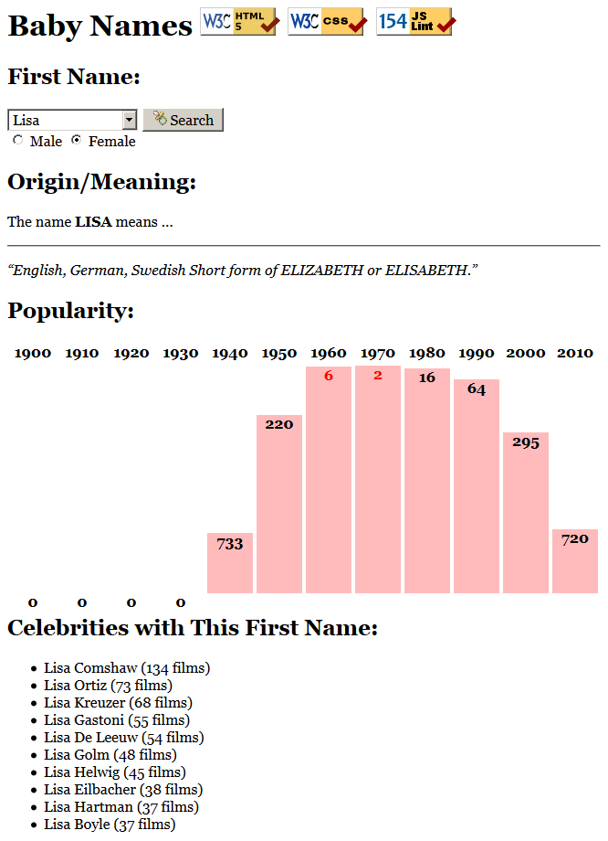
Every 10 years, the Social Security Administration provides data about the 1000 most popular boy and girl names for children born in the US for each gender, at http://www.ssa.gov/OACT/babynames/ . Your task for this assignment is to write JavaScript code for a web page to display the baby names, popularity rankings, and meanings.
We will provide you with the HTML (names.html) code to use. Turn in the following files:
- names.js, the JavaScript code for your Baby Names web page's behavior
- names.css, the CSS styles for your web page's appearance
- names.html, the Baby Names web page (you don't need to modify it, but you can if you like)
You are allowed to modify names.html but are not required to do so. You can change the page's general appearance, so long as it meets the requirements in this spec. We encourage you to be creative and have fun.
This program uses Ajax to fetch data from the Webster server. Ajax can only connect to a web server from a page located on that same server. This means that you must upload your page to Webster to test it. If you try to fetch data from Webster while viewing the page from your local hard drive, the Ajax request will fail.

Data:
Your program reads data from a web service at https://webster.cs.washington.edu/cse154/babynames.php . You may assume that all data sent to your program from babynames.php is valid and follows the formats below.
This web service accepts four different types of queries, specified using a query string with a parameter named type. Each type of query produces output in text, HTML, XML, or JSON format. (You can test queries by typing in their URLs in your web browser's address bar and seeing the result.) If you submit an invalid query, such as one missing a necessary parameter, your request will return an HTTP error code of 400 (Invalid Request) rather than the default 200.
1. list: The first query type is list, which outputs plain text containing all baby names on file in a plain text format, with each on its own line. The following query would return the results below (abbreviated):
https://webster.cs.washington.edu/cse154/babynames.php?type=list
Aaden
Aaliyah
Aaron ...
The provided web service generally returns the names in alphabetical order, but your code should not rely on this. Just display the names in whatever order the service returns them, and don't make assumptions about the order.
2. meaning: The second query type is meaning, which outputs information about that baby name's meaning in HTML format as a web page fragment. In addition to the always-required type query parameter, the meaning query requires a second parameter named name. The following query returns the results below:
https://webster.cs.washington.edu/cse154/babynames.php?type=meaning&name=morgan
<div><p>The name <strong>MORGAN</strong> means ...</p> <hr />
<p><q>Welsh, English From the Old Welsh masculine name Morcant, which was
possibly derived from Welsh mor "sea" and cant "circle".</q></p></div>
When this data comes back to your page from the server, inject it into the div with id of meaning:
<div id="meaning"> <!-- insert the HTML fragment here --> </div>
If the name you pass doesn't have any meaning data (such as "Mogran"), the babynames.php service will just output a general message about how that name has no known meaning; you can handle this case the same way as usual, by injecting the HTML that is returned into the page.
3. rank: The third query type is rank, which returns XML data about that baby name's popularity rank in each decade. The rank query requires two additional parameters named name and gender. The gender should be m or f. The server has separate data for each gender; the same name might be more/less popular for boys than for girls.
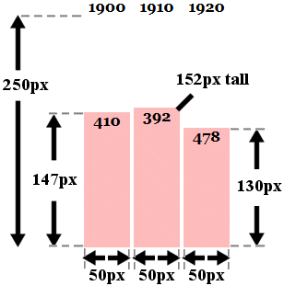
The overall XML document tag is called <baby> and has an attribute name for the baby's first name and gender. Inside the <baby> tag are several <rank> tags, one for each decade. Each <rank> tag contains an attribute named year representing the year of data. The text inside the <rank> tag is that name's popularity in that year.
The data has 12 rankings per name, from 1900 to 2010, from 1 (popular) to 999 (unpopular). A rank of 0 means the name was not in the top 1000. The following query would output the results below (abbreviated):
https://webster.cs.washington.edu/cse154/babynames.php?type=rank&name=morgan&gender=m
<baby name="Morgan" gender="m">
<rank year="1900">70</rank>
<rank year="1910">86</rank> ...
<rank year="2010">258</rank>
</baby>
If you submit a query for an unknown name, your request will return an HTTP error code of 410 (Gone).
The web service returns data starting at 1900 until 2010, but do not assume that the start year is 1900 or the increment is 10. Your code should examine the XML to find the years. The web service returns 12 rankings for each name, but your code should not assume this. You may assume that the ranks are in ascending order by year.
4. celebs: The fourth query type is celebs, which outputs JSON data about actors who have the same first name as the given baby name. The celebs query requires two additional parameters named name and gender.
The overall JSON data object contains a single field named actors, which is an array of matching celebrities (they come from the actors table of the imdb database). If no actors match, the array will be empty ([]).
Each matching actor is a nested object with three fields: strings called firstName and lastName representing the actor's name, and filmCount representing the number of films in which the actor has appeared.
The following query would return the results below (abbreviated):
https://webster.cs.washington.edu/cse154/babynames.php?type=celebs&name=morgan&gender=m
{ "actors": [
{"firstName": "Morgan", "lastName": "Alling", "filmCount": 6},
{"firstName": "Morgan", "lastName": "Andersson", "filmCount": 11}, ...,
{"firstName": "Morgan", "lastName": "Lund", "filmCount": 7}
]
}

Appearance and Behavior:
All style or appearance aspects not mentioned below are subject to the preference of the web browser. The screenshots in this document were taken in Firefox on Windows, which may differ from your system.
The font for the page body (including form controls such as text boxes and buttons) is 12pt Georgia, with a fallback of the default serif font on the system. Heading fonts are proportional to this.
The HTML page given to you shows a heading of "First Name:" followed by a select element with id of allnames. When the page loads, the box is empty and disabled. Using Ajax, the page should fetch the list of all names from the web service as described previously, fill itself with an option for each name, and then enable itself.
The rest of the page is inside of a large div with the id of resultsarea. Initially this div is hidden, but when the user clicks Search after selecting a name from the select box, you should make this area appear. (You can make an area of the page appear/disappear by setting the .style.display property on its HTML DOM object.) Nothing should happen and no data should be fetched if the user selects the initial blank "(choose a name)" option in the list.
Nothing should happen when the user chooses a name from the select box; wait until they click the Search button to search. You may assume that the user doesn't click Search again until the current search is done downloading.
Meanings: The next section of the page has the heading "Origin/Meaning:". It is initially blank. When the user chooses a name and clicks Search, that name's meaning data should be fetched using Ajax and injected into the page into the paragraph with id of meaning. The meaning has a q (quote) element that should appear in italic.
Rankings: The next section of the page has the heading "Popularity:". It is initially blank. When the user chooses a name and clicks Search, that name's ranking information should be fetched using Ajax and injected into the page into this area. Specifically, there is an HTML table with the id of graph in this area, initially empty:
<table id="graph"></table> <!-- baby name ranking data should be inserted here -->
If a name is selected from the selection box, you should use the DOM to fill the table with two rows of data: the first lists each of the decades as table header cells (th), and the second shows a vertical bar representing that name's ranking for that year in the data. For example, the table after searching for male name "Morgan" might look like this:
<table id="graph">
<tr><th>1900</th><th>1910</th><th>1920</th>...<th>2010</th></tr>
<tr><td><div>70</div></td> <!-- ranking for 1900 -->
<td><div>86</div></td> <!-- ranking for 1910 -->
... <td><div>258</div></td></tr> <!-- ranking for 2010 -->
</table>
The ranking bars are drawn as divs inside each table cell td of the second row of the table. Each ranking bar uses a pinkish background color of #FFBBBB. The bar's width is exactly 50px. Its height should be one fourth as many pixels as the "inverse ranking" for that decade. The inverse ranking is defined to be 1000 minus the ranking. For example, a ranking of 880 would lead to a bar with a height of 30 because one fourth of (1000 − 880), or 120, is 30.
(Division is exact in JavaScript: 13/4 is 3.25. Round down using Math.floor.)
The overall height of each td cell in the second row of the graph table is 250px. The bottoms of the bars are aligned vertically; achieve this by setting the td table cells to have a vertical-align of bottom.
If the given name was not in the top 999 rankings for that decade, its rank in the XML will be 0. You should handle this special case by drawing the ranking bar div with a height of 0 pixels tall.
Within each ranking bar appears the ranking number for that decade. The numbers appear in bold text at the top of the bar, horizontally centered within the bar. If the ranking is very popular (1 through 10 inclusive), the ranking number should appear in red. Some less popular rankings (around 900 and up, or 0) have numbers that drop below the bottom of the graph; this is expected and you don't need to treat this as a special case.
Some name/gender combinations (such as Aaliyah/male) in the overall list do not have any ranking data. In such a case, the babynames.php query will return an error code of 410. You should handle this case by displaying a message indicating that there was no ranking data for the chosen name. There is already a div in the page with the id of norankdata that contains such a message, but it is hidden by default, so you must show it in such cases.
<div id="norankdata"> <!-- show me when the name has no rank data -->
There is no ranking data for that name/gender combination.
</div>
You can check what kind of Ajax error occurred by examining the ajax.status field in your failure handler.
Celebs: The next section of the page has the heading "Celebrities with This First Name:". It is initially blank. When the user chooses a name and clicks Search, that name's celebrity information should be fetched using Ajax and injected into the page into this area. There is an HTML bulleted list (ul) with the id of celebs, initially empty:
<ul id="celebs"></ul> <!-- baby name celebrity data should be inserted here -->
If a name is selected from the selection box, you should use the DOM to fill the bulleted list with bullet items (li) of data, one for each celebrity that is returned in the JSON data on the server. Each bullet item should contain the actor's first and last name, followed by the actor's number of films in parentheses. For example, for male name Morgan, the list contains the following bullets (abbreviated):
- Morgan Wallace (119 films)
- Morgan Freeman (99 films) ...
- Morgan Jones (18 films)
If there are no celebrities with the given first name, the query will return JSON data with an empty array of actors. In this case, your page should just leave the bulleted list empty with no bullets in it. You don't need to do anything else or display any error message in this case.
Subsequent Searches: The user can use the page to make multiple searches. When making a search, any data from a previous name should be cleared from the screen. You can remove all HTML content inside an area of the page by setting its innerHTML to an empty string. For example, to clear out the div with the id of example:
document.getElementById("example").innerHTML = ""; // clear out any child elements
Be careful to test your page with several searches in a row. For example, if one search has no ranking data (such as Aaliyah/male), you will have shown the grapherror message. But on the next search, you should hide this message.
Loading Feedback: In each section of the page where data is shown, there is a small div with an animated "loading" GIF image that should be displayed while the data is being fetched from the server. For example:
<div class="loading" id="loadinggraph"> <img src="loading.gif" alt="icon" /> Searching...</div>
This HTML is already in the provided page, but it is your job to make it appear or disappear at appropriate times. There is a loading area with the id of loadingnames to the right of the Search button. It should be visible until the page is done loading the list of names from the server, then it should disappear for the remainder of the page view.
There are three other loading areas with ids of loadingmeaning, loadinggraph, and loadingcelebs. All three should be shown when the user clicks Search to search for data about a name. When the data for one of the Ajax requests arrives from the server and you are finished processing that data, hide the corresponding loading div. The page should work for multiple requests; show/hide these loading divs properly on each subsequent search as well.
If there is an error with any Ajax request, hide all of the loading areas on the page.
(The provided babynames.php web service delays itself by 1-2 seconds to help you test your loading behavior. If you want to test other delays, pass an optional parameter delay to the service for the number of seconds you want it to pause before returning its data.)
Error Handling: If an error occurs during any Ajax request, other than the expected HTTP 410 error when a name's ranking is not found, your program should show a descriptive error message about what went wrong. For full credit, your error message should not be an alert; it must be injected into the HTML page. The exact format of the error message is up to you, but it should at least include some descriptive error text about what went wrong. You can inject any error messages into the provided HTML page into the div with id of errors:
<div id="errors"></div> <!-- an empty div for inserting any error text -->
You should also hide all "loading" animation images on the page if any error occurs. In order to test your error-handling, try temporarily changing the URL of the web service in your code to a bogus file name such as notfound.php. This will trigger an HTTP 404 File Not Found error on every request.

Implementation and Grading:
For full credit, your HTML/CSS code must pass the W3C validators. Your JavaScript code should pass our JSLint tool with no errors. Your .js file must run in JavaScript strict mode by putting "use strict"; at the top.
Follow the course style guide. Separate content (HTML), presentation (CSS), and behavior (JS). As much as possible, your JS code should use styles/classes from the CSS rather than manually setting each style property in the JS. In particular, no CSS styles should be set in JS other than heights of the ranking bar divs drawn in the graph, or showing/hiding various elements on the page by setting their display property. Use unobtrusive JavaScript, so that no JavaScript code, onclick handlers, etc. are embedded into the HTML.
Follow reasonable style guidelines similar to a CSE 14x programming assignment. In particular, avoid redundant code, and use parameters and return values properly. Make extra effort to minimize redundant code. Capture common operations as functions to keep code size and complexity from growing.
Use the "module pattern" shown in class to wrap your code in an anonymous function. No global variables or symbols, nor "module-global" vars, are allowed on this assignment; values should be declared at the most local scope possible. If a constant value is used, you may declare it as a module-global "constant" variable IN_UPPER_CASE.
Fetch data using Ajax. Be careful to avoid redundancy in your Ajax code; if you do similar Ajax operations in many places, make a helper function(s). Process XML data using the XML DOM. Process JSON data using JSON.parse.
Your JavaScript code should have adequate commenting. The top of your file should have a descriptive comment header describing the assignment, and each function and complex section of code should be documented. If you make requests, comment about what you are requesting and what your code will do with the data that is returned.
Format your code similarly to the examples from class. Properly use whitespace and indentation. Use good variable and function names. Avoid lines of code more than 100 characters wide.
Do not place a solution to this assignment on a public web site. Upload your files to the Webster server at:
https://webster.cs.washington.edu/your_uwnetid/hw8/names.html
Copyright © Marty Stepp / Jessica Miller, licensed under Creative Commons Attribution 2.5 License. All rights reserved.

