University of Washington, CSE 154
Homework Assignment 7: Fifteen Puzzle
This assignment is about JavaScript's Document Object Model (DOM) and events. You'll write the following page:
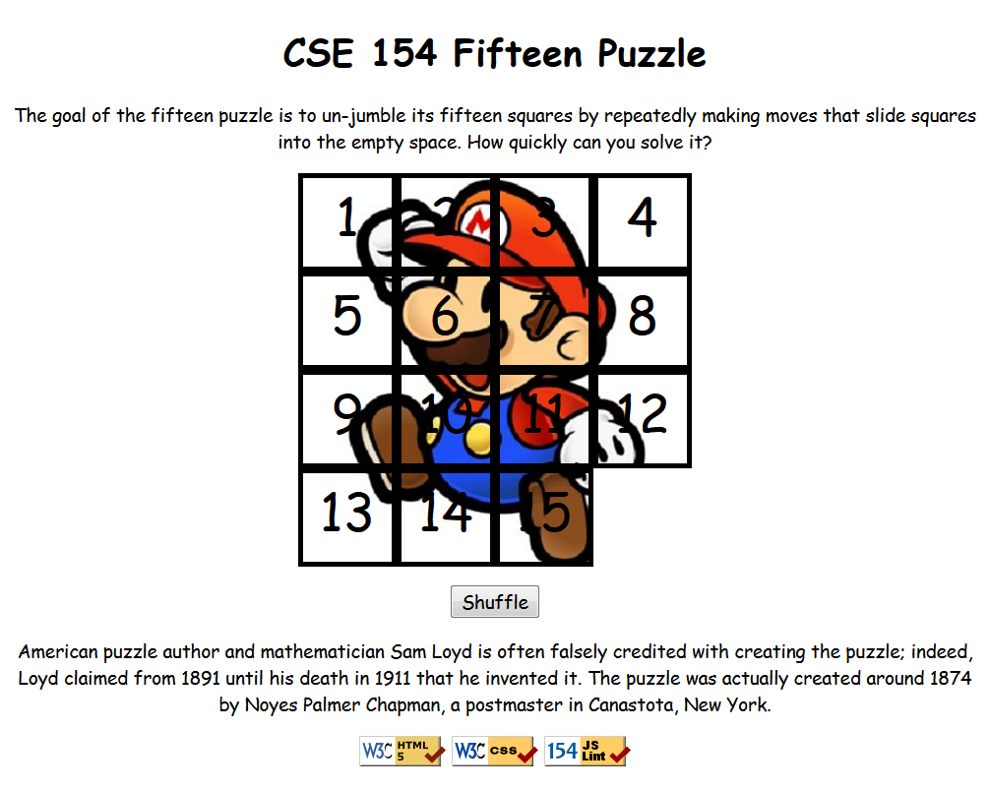

Background Information:
The Fifteen Puzzle (also called the Sliding Puzzle) is a simple classic game consisting of a 4×4 grid of numbered squares with one square missing. The object of the game is to arrange the tiles into numerical order by repeatedly sliding a square that neighbors the missing square into its empty space.
You will write the CSS and JavaScript code for a page fifteen.html that plays the Fifteen Puzzle. You will also submit a background image of your own choosing, displayed underneath the tiles of the board. Choose any image you like, so long as its tiles can be distinguished on the board. Turn in the following files:
- fifteen.js, the JavaScript code for your web page
- fifteen.css, the CSS styles for your web page
- background.jpg, your background image, suitable for a puzzle of size 400×400px
(You must supply your own background image; you may not use the Mario image from our example. We recommend using a site like Flickr, DeviantArt, or Google Image Search to find your own image. Look for images with lots of variation in color and shape, to give each square a distinctive look.)
You will not submit any .html file, nor directly write any HTML code. We will provide you with the HTML code to use, which should not be modified. (Download the .html file to your machine while writing your JavaScript code, but your code should work with the provided files unmodified.) You will write JavaScript code that interacts with the page using the DOM. To modify the page's appearance, write appropriate DOM code to change styles of on-screen elements by setting classes, IDs, and/or style properties on them.

Appearance Details:
All text on the page is displayed in a "cursive" font family, at a default font size of 14pt. Everything on the page is centered, including the top heading, paragraphs, the puzzle, the Shuffle button, and the W3C buttons at bottom.
In the center of the page are fifteen tiles representing the puzzle. The overall puzzle occupies 400×400 pixels on the page, horizontally centered. Each puzzle tile occupies a total of 100×100 pixels, but 5px on all four sides are occupied by a black border. This leaves 90×90 pixels of area inside each tile. The HTML file given to you does not contain the fifteen div elements to represent the puzzle pieces, and you are not supposed to modify the HTML file — so you will have to create the puzzle pieces and add them to the page yourself using JavaScript and the DOM. Initially the page should appear with the puzzle in its properly arranged order like in the screenshot on the first page of this spec, with 1 at top-left, 4 at top-right, 13 at bottom-left, the empty square at bottom-right, and so on.
Each tile displays a number from 1 to 15, in a 40pt font. Each tile displays part of the image background.jpg, which you should put in the same folder as your page. Which part of the image is displayed by each tile is related to that tile's number. The "1" tile shows the top-left 100×100 portion of the image. The "2" tile shows the next 100×100px of the background that would be to the right of the part shown under the "1" tile, and so on.
Your background image appears on the puzzle pieces when you set it as the background-image of each piece. By default, since each piece has its own background image, you will see the same top-left portion of the background image on each square. By adjusting the background-position property of each square, you can shift the background image to show a different portion of the background on each piece.
One confusing thing about background-position is that the x/y values shift the background in the direction opposite of what you might expect: if you position a square to the right by a certain amount, you need to shift that square's background to the left by the same amount in order for the correct portion of the image to be shown in that square — and to shift left, you need to use a negative value. (Likewise for shifting down/up.)
The following is a complete listing of the exact background-position values each location on the board should have:
0px 0px | -100px 0px | -200px 0px | -300px 0px
0px -100px | -100px -100px | -200px -100px | -300px -100px
0px -200px | -100px -200px | -200px -200px | -300px -200px
0px -300px | -100px -300px | -200px -300px | -300px -300px
Centered under the puzzle tiles is a Shuffle button that can be clicked to randomly rearrange the tiles of the puzzle. See the "Shuffle Algorithm" section of this spec for more details about implementing the shuffle behavior.
All other style elements on the page are subject to the preference of the web browser. The screenshots in this document were taken on Windows in Firefox, which may differ from your system.

Playing the Game:
When the mouse button is pressed on a puzzle square, if that square is next to the blank square, it is moved into the blank space. If the square does not neighbor the blank square, no action occurs. Similarly, if the mouse is pressed on the empty square or elsewhere on the page, no action occurs.
When the mouse hovers over a square that can be moved (neighbors the blank spot), its border and text color should become red, and the mouse cursor should change into a "hand" cursor (by setting the CSS cursor property to pointer). When the cursor hovers over a non-movable piece, the cursor and colors should not change. (You may find it useful to use the :hover CSS pseudo-class to help deal with hovering.)
The game is not required to take any particular action when the puzzle has been won. (There is an optional extra feature for doing something special when the user has won the game, like displaying an alert box congratulating the user. See the Extra Features spec if you would like to implement end-of-game behavior.)
(Tip for playing the game: First get the entire top/left sides into proper position. That is, put squares number 1, 2, 3, 4, 5, 9, and 13 into their proper places. Now never touch those squares again. What remains unsolved is now a 3 ×3 board, which is much easier.)

Shuffle Algorithm:
Centered under the puzzle tiles is a Shuffle button. When this is clicked, the puzzle tiles are rearranged into a random solvable state to give the user a challenging puzzle to solve.
The interesting thing about shuffling is that the tiles cannot simply be rearranged into any order: there are many puzzle states which are impossible to solve. (For example, if you simply swap the 14 and 15 tiles, the puzzle is impossible to solve.)
Therefore, for full credit, your Shuffle button must only rearrange the puzzle into a solvable state. The best way to do this is by repeatedly choosing one of the movable pieces at random and moving it — essentially, playing the puzzle backwards for a while. Roughly 1000 such random legal movements should produce a well-shuffled board. Here is a rough pseudo-code of the algorithm we suggest for shuffling.
about ~1000 times:
neighbors = an empty array.
if there exists a piece directly up from the empty square:
add it to the neighbors array.
(repeat for the pieces down, left, and right of the empty square.)
randomly choose a neighbor n from neighbors.
move n to the location of the empty square.
Notice that on each pass of our algorithm, it is guaranteed that one square will move. We also do not consider any pieces other than the ones we know are movable. Some students write an algorithm that randomly chooses any one of the 15 squares and tries to move it — skipping to the next iteration (i.e., wasting an iteration) if the randomly-chosen square is not movable. This is a very poor way to shuffle because most of the 15 squares are not movable, and as such, a good portion of the loop iterations will end up getting wasted. In which case, in order to shuffle effectively, the loop must repeat many more times, which may cause the page to lag. This is not acceptable.
Your algorithm should be efficient: if it takes more than 1 second to run or performs a large number of tests and calls unnecessarily, you may lose points. For full credit, your shuffle should have a good random distribution and thoroughly rearrange the tiles. You are not required to follow exactly the algorithm above, but if you don't, your algorithm must exhibit the desired properties described in this section to receive full credit.
Your shuffle algorithm will need to incorporate randomness. You can generate a random integer from 0 to K −1, which is helpful to randomly choose between K choices, by writing Math.floor(Math.random() * K) .
We suggest first making your shuffle function perform a single random move — that is, when Shuffle is clicked, randomly pick one square neighboring the empty square and move it. After you've done this once, then you can work on doing it many times in a loop.
In your shuffle algorithm, or elsewhere in your program, you may want access to the DOM object for a square at a particular row/column or x/y position. We suggest you write a function that accepts a row/column as parameters and returns the DOM object for the corresponding square.
It may be helpful to give an id to each square, such as "square_2_3" for the square in row 2, column 3, so that you can more easily access the squares later in your JavaScript code. (Note that if you do this you will need to update a square's id to match its new location when moved.) Use these ids appropriately. For example, you should never need to break apart the string "square_2_3" to extract the 2 and 3. You should only ever use ids in the other direction — that is, to get access to the DOM object in a specific row and column.

Development Strategy:
Students generally find this to be a tricky assignment. Here is a suggested ordering for tackling the steps:
- Make the fifteen puzzle pieces appear in the correct positions without any background behind them.
- Make the correct parts of the background show through behind each tile.
- Write the code that moves a tile when it is clicked from its current location to the empty square's location. Don't worry initially about whether the clicked tile is "movable" (whether it is next to the empty square).
- Write code to determine whether a square can move or not (whether it neighbors the empty square). Implement a highlight when the mouse hovers over movable tiles. Track where the empty square is at all times.

Hints:
- Use absolute positioning to set the x/y locations of each puzzle piece. The overall puzzle area must use a relative position in order for the x/y offsets of each piece to be relative to the puzzle area's location.
- You can convert a string to a number using parseInt. This also works for strings that start with a number and end with non-numeric content. For example, parseInt("123four") returns 123.
- Many students have bugs related to not setting their DOM style properties using proper units and formatting. The string you assign in your JS code must be exactly as it would be in the CSS file. For example, if you want to set the size of an element, a value like 42 or "42" will fail, but "42px" or "42em" will succeed. When setting a background image, a value like "foo.jpg" will fail, but "url(foo.jpg)" will succeed. When setting a background position, "42 35" will fail but "42px 35px" will succeed. And so on.
- We suggest that you do not explicitly make a div to represent the empty square of the puzzle. Keep track of where it is, such as by row/column or by x/y position, but don't create an actual DOM element for it. We also suggest that you not store your puzzle squares in a 2-D array. This might seem like a good idea because of the 4×4 appearance of the grid, but it will be difficult to keep this structure up to date as the squares move.
- Many students have redundant code because they don't create helper functions. You should write functions for common operations, such as moving a particular square, or for determining whether a given square currently can be moved. The this keyword (see book section 9.1) can be helpful for reducing redundancy.

Implementation and Grading:
For full credit, your CSS code must pass the W3C validator, and follow the style guide posted on the class web site.
Separate content (HTML), presentation (CSS), and behavior (JS). Your JS code should use styles and classes from the CSS rather than manually setting each style property in the JS. For example, rather than setting the .style of a DOM object, instead, give it a className and put the styles for that class in your CSS file. Style properties related to x/y positions of tiles and their backgrounds are impractical to put in the CSS file, so those can be in your JS code.
Use unobtrusive JavaScript so that no JavaScript code, onclick handlers, etc. are embedded into the HTML code.
You should not use any external JavaScript frameworks or libraries such as jQuery to solve this assignment.
Your JavaScript code should pass our JSLint tool with no errors.
Your .js file must run in strict mode by putting "use strict"; at the top.
Follow the JavaScript style guidelines posted on the class web site. Make extra effort to minimize redundant code. Capture common operations as functions to keep code size and complexity from growing. You can reduce your code size by using the this keyword in your event handlers.
No global variables or functions are allowed. To avoid globals, use the module pattern as taught in lecture, wrapping your code in an anonymous function invocation. Even using the module pattern, you should only use "module-global" variables that are truly necessary: values should be local as much as possible. Use module-global "constants" IN_UPPER_CASE for any literal values you use frequently. Do not store DOM objects, such as those returned by document.getElementById or document.querySelectorAll, as module-global variables. As a reference, our own solution has only four module-global variables: the empty square's row and column (initially both set to 3), the number of rows/cols in the puzzle (set to 4), and the pixel width/height of each tile (set to 100). The last two are essentially constants.
Your JavaScript code should have adequate commenting. The top of your file should have a descriptive comment header describing the assignment, and each function and complex section of code should be documented.
Format your code similarly to the examples from class. Properly use whitespace and indentation. Use good variable and method names. Avoid lines of code more than 100 characters wide. For reference, our .js file has roughly 160 lines (110 "substantive"), and our CSS file has roughly 50 lines.
Do not place your solution on a public web site. Submit your own work and follow the course misconduct policy.
Put your files on Webster at: https://webster.cs.washington.edu/your_uwnetid/hw7/fifteen.html
Copyright © Marty Stepp / Jessica Miller, licensed under Creative Commons Attribution 2.5 License. All rights reserved.

