University of Washington, CSE 154
Homework Assignment 6: ASCIImation
Special thanks to Dave Reed of Creighton University for the original idea of this assignment.

This assignment tests your understanding of JavaScript and its interaction with HTML user interfaces.
You must match the appearance and behavior of the following web page:
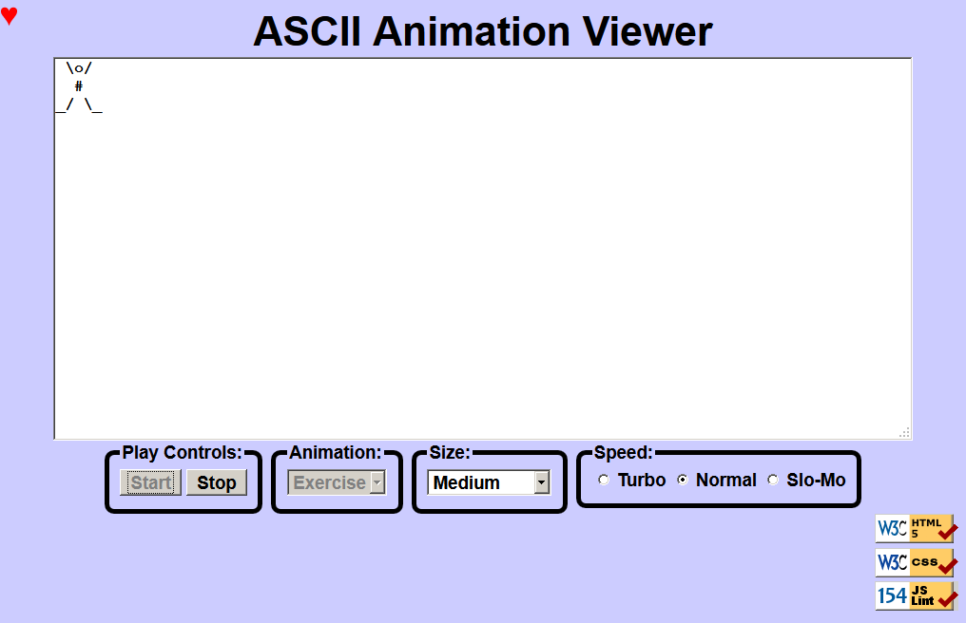
ASCII art is pictures that consist of text characters. ASCII art has a long history as a way to draw pictures for text-only monitors or printers. We will draw animated ASCII art, or "ASCIImation." Groups of nerds are working to recreate the entire movies Star Wars and The Matrix as ASCIImation.
The first task is to create a page ascii.html with a user interface (UI) for creating/viewing ASCIImations. No skeleton files are provided. Your page should link to a style sheet you'll write named ascii.css for styling the page. After creating your page, you must make the UI interactive by writing JavaScript code in ascii.js so that clicking the UI controls causes appropriate behavior. Your HTML page should link to your JS file in a script tag.
You should also create an ASCIImation of your own, stored in a file named myanimation.js. Your ASCIImation must show non-trivial effort, must have multiple frames of animation, and must be entirely your own work. Be creative! We will put students' ASCIImations on the course web site for others to see.
In total you will turn in the following files:
- ascii.html, your web page
- ascii.css, the style sheet for your web page
- ascii.js, the JavaScript code for your web page
- myanimation.js, your custom ASCII animation as JavaScript code (so it can be used on the page)
Our screenshots were taken on Windows in Firefox, which may differ from your system.

Additional required features for CSE majors are found in a separate spec on the class web site. Non-CSE majors do not need to complete any such features but can do so to earn extra late day(s).

Appearance Details:
The page should have a title of ASCIImation. Your page must link to the following JavaScript and CSS resources. Use an absolute URL path if an absolute path is listed below; if only a file name is shown, use a relative URL.
- https://webster.cs.washington.edu/js/asciimation/animations.js
- https://webster.cs.washington.edu/js/asciimation/gallery.js
- myanimation.js (you will write this file)
- ascii.js (you will write this file)
- ascii.css (you will write this file)
If you have linked to the above files properly, you will see a red "heart" icon appear in the top-left of your page.
The overall page has a background color of #CCCCFF. The preferred font for all text on the page is the default sans-serif font available on the system, in size 14pt, in bold.
The top of the page contains a heading in 32pt bold text, centered horizontally within the page. There is no margin between the heading content area and other neighboring content on the page.
Under the page's heading is a text box with 80 columns and 20 rows, centered horizontally. Its width is 90% of the page size and height is 400px. It uses a 12pt bold monospace font initially. CSS width/height properties will set the text box's size, but you must put rows/cols attributes in your textarea HTML element for the page to validate.
Below the text box is a set of controls grouped into several field sets, each with a 5px black border around it (with 10px border radius) and a label on top. To get the field sets to appear in a row horizontally, see textbook Chapter 4's section about Element Visibility and the display property. You should make sure that the tops of the field sets line up by setting their vertical alignment. The text area and control field sets are centered horizontally.
Below the controls is a right-aligned section with images that are links to the W3C validators and our own JSLint tool. Each image appears on its own line. The three images are found at the following URLs:
Image: Links to:
https://webster.cs.washington.edu/images/w3c-html.png https://webster.cs.washington.edu/validate-html.php
https://webster.cs.washington.edu/images/w3c-css.png https://webster.cs.washington.edu/validate-css.php
https://webster.cs.washington.edu/images/w3c-js.png https://webster.cs.washington.edu/jslint/?referer

Behavior Details:
The following are the groups of controls at the bottom of the page and each control's behavior. (NOTE: Although we put controls in a form in past assignments, do not use a form tag on your page this time.)

Play Controls:
Start: When clicked, animation begins. When the page is idle, all frames of the animation are visible. Frames are separated by 5 equals signs and a line break (\n) character.
When animation starts, whatever text is currently in the text box is broken apart to produce frames of animation. This might be a pre-set animation, or text that the user has typed manually. During animation, one frame is visible at any moment, starting with the first frame. By default, the animation changes frames once every 250ms. When the animation reaches the last frame, it loops back around and repeats indefinitely.
(For full credit, you must implement your animation using a JavaScript timer with the setInterval function.)
Stop: When clicked, halts any animation in progress. When animation is stopped, the text that was in the box prior to the start of animation is returned to the box (i.e., it should retain any changes made prior to starting).

Animation:
A drop-down list of ASCII animations. When one of the animations is chosen (onchange), the main text area updates to display all text of the chosen animation. The choices available are: Blank, Exercise, Juggler, Bike, Dive, Custom. Initially the Blank animation is selected and no text is showing in the text entry box.
Your ascii.html page should link to a provided file animations.js that declares the ASCIImations as global string variables named EXERCISE, JUGGLER, BIKE, and DIVE. You shouldn't edit this file, but your ascii.js file can refer to these variables. For example, if you have a textarea on your page with an id of mytextarea:
document.getElementById("mytextarea").value = JUGGLER;
The provided animations.js file also defines a global associative array named ANIMATIONS that maps from indexes (keys) that are strings equal to the names of the animations, such as "Bike" or "Exercise", to values that are long strings representing the entire animation text for that image. Using this array well can help you avoid redundancy.
Here is a short example that uses the ANIMATIONS array:
var whichOne = "Juggler";
document.getElementById("mytextarea").value = ANIMATIONS[whichOne];
The user may type new text in the field after choosing a pre-set animation. The animation shown when Play is pressed should reflect these changes (i.e., don't capture the text to animate until the user presses the Start button).
You may assume that the user will not try to type into the text area while animation is in progress. You may also assume that the user will not use the selection box to change to a new animation while animation is occurring; assume that the user will stop any existing animation before changing to a new one.

Custom Animation:
The Custom choice in the Animation box should show an animation that you have created. A StringMaker link on the web site converts your animation to a string you can put into myanimation.js. The text of your animation should consist entirely of plain ASCII characters, not special characters outside of the ASCII character range.

Font Size:
A drop-down list of font sizes. When one of the font sizes is chosen, it immediately sets the font size in the main text area. The font sizes listed in the drop-down list, and the corresponding font size to set, are:
- Tiny (7pt), Small (10pt), Medium (12pt), Large (16pt), Extra Large (24pt), XXL (32pt)
Initially Medium is selected and the text is 12pt in size. If the animation is playing and one of these buttons is clicked, the font size changes immediately.
Note that when you write the code for changing the font sizes, it is easy to introduce redundancy. By setting a value attribute on each of the options in the drop-down list, you can avoid a long series of if/else statements.

Speed:
Contains three radio buttons labeled "Turbo", "Normal", and "Slo-Mo". When one of the buttons (or the text next to it) is clicked, causing the box to become checked, it changes the speed of animation. Turbo uses a 50ms delay, Normal is 250ms, and Slo-Mo is 1500ms. Initially the Normal button is checked and the delay is 250ms.
If the animation is playing and the buttons are clicked, the change should take effect immediately (the user shouldn't have to stop and restart the animation to see the change). Checking the box shouldn't cause the animation to start if it wasn't already started. It also shouldn't reset what frame is showing; it should just change the delay immediately.

Control Enabling/Disabling:
Modify your GUI to disable elements that the user shouldn't be able to click at a given time. Initially and whenever animation is not in progress, the Stop button should be disabled. When animation is in progress, Start and the select box of animations should be disabled. The Size box and Speed radio buttons should always be enabled.
Enable or disable a control with its disabled property. For example, to disable a control with id of customerlist:
document.getElementById("customerlist").disabled = true;

Development Strategy and Hints:
- Write the basic HTML content including the proper UI controls. (Don't use the form tag.)
- Write your CSS code to achieve the proper layout.
- Write a small amount of "starter" JS code and make sure that it runs.
(For example, make it so that when the Start button is clicked, an alert box appears.)
- Implement code to change the animation text and font sizes. Make it so that when an option is chosen in the selection box, the proper text string appears in the text area. Get the font size options working.
- Implement a minimal Start behavior so that when Start is clicked, a single frame of animation is shown. Clicking Start multiple times would show successive frames of animation.
- Use a JavaScript timer to implement the proper animation based on your previous code.
We strongly recommend that you install and use the Firebug add-on for Firefox on this assignment, or use the similar tool built into other browsers such as Chrome. Firebug shows syntax errors in your JavaScript code. You can use it as a debugger, set breakpoints, type expressions on its Console, and watch variables' values. Firebug is essential for serious JavaScript programming.
Our JSLint tool can help you find common JavaScript bugs. Since this is your first JavaScript program, you will probably encounter tricky bugs. If so, paste your code into JSLint to look for possible errors or warnings. For full credit, your JavaScript code must pass the provided JSLint tool with no errors reported. ("Warnings" are okay.)
For full credit, your .js file must be written in JavaScript "strict" mode by putting this exact line of code at the top:
"use strict";

Implementation and Grading:
Submit your assignment online from the course web site. Our ascii.js is around 90 lines long (50 "substantive"). All of your HTML, CSS, and JavaScript code should follow the style guide posted on the class web site.
Implement your page using HTML5 as taught in class. Your page must pass the W3C HTML5 validator. Choose appropriate tags to match the structure of the page content. Do not express style information in the HTML page itself, such as inline styles or presentational HTML tags such as b or font. Use unobtrusive JavaScript so that no JavaScript code, onclick handlers, etc. are embedded into the HTML code.
Express all stylistic information on the page in CSS using your style sheet file. For full credit, your style sheet must successfully pass the W3C CSS validator. You should not use HTML or CSS constructs that have not been discussed in lecture, slides, or textbook chapters during the first six weeks of the course.
Format your HTML, CSS, and JS to be readable, like to the examples in class. Place a comment header atop each HTML/CSS/JS file. Your JavaScript should have more descriptive comments, including a header on each function (including anonymous) and complex sections of code describing the relevant code, the function's behavior, etc.
You should follow reasonable style guidelines similar to those of a CSE 14x programming assignment. In particular, avoid redundant code, and use parameters and return values properly.
Minimize the use of global variables. Do not ever store DOM element objects, such as those returned by the document.getElementById function, as global variables. As a reference, our own solution has five global variables, mostly related to the set of frames to draw, which frame is currently displayed, the delay between frames, and so on.
Format your code similarly to the examples from class. Properly use whitespace and indentation. In your HTML, do not place more than one block element on a line or begin a block element past the 100th character. In your JavaScript, properly space/indent your code, and do not write any lines of code longer than 100 characters.
You should not use any external JavaScript frameworks or libraries such as jQuery to solve this assignment. Do not place a solution to this assignment on a public web site. Upload your files to the Webster server at:
- https://webster.cs.washington.edu/your_uwnetid/hw7/ascii.html
Copyright © Marty Stepp / Jessica Miller, licensed under Creative Commons Attribution 2.5 License.
All rights reserved.

