University of Washington, CSE 154
Homework Assignment 6: ASCIImation
EXTRA FEATURES / CSE Majors Features
CSE majors must complete at least one (1) of the following extra features to add new functionality to the program. If a CSE major completes more than one extra feature successfully, they earn +1 extra late day for use on a future assignment (after HW6). (Not +1 late day per additional feature completed; +1 overall.)
Non-CSE majors are not required to complete any of these extra features, but if they do, each optional feature completed is worth +1 late day for use on a future assignment (after HW6), up to a maximum of +2.
Regardless of how many additions you write, the page behavior and appearance should still work as described in the main spec document. If you have a different idea for an extra feature, please ask us and we may approve it.
If you choose to do any of these extra features, indicate in your file's comment header which one(s) you did.

Extra Feature #1. Reverse Checkbox
Add a field set to the right of the other controls with "Order:" as its title label. In this field set, include a single checkbox labeled "Reverse". When this box is checked, the animation will display its frames in backward order. For example, if you are watching the Juggler animation, normally the juggler throws the balls upward and they travel to the right. With this box checked, the balls would travel to the left. For example, if there are four frames of animation, normally they are displayed as 0, 1, 2, 3, 0, 1, ... With the Reverse box checked, instead they are displayed as 0, 3, 2, 1, 0, 3, 2, 1, 0, ... Initially the Reverse box is unchecked and animation proceeds in its normal order.
The checkbox takes effect immediately as it is checked and unchecked; if an animation is currently playing, the moment that animation begins to display its next frame, that frame should instead become the previous frame, and so on. For example, if the animation has four frames from 0-3 the current frame is #2, and then the user checks Reverse, the next frame to display should be #1, then 0, 3, 2, 1, 0, etc. If the animation were proceeding in reverse order and was at frame #2 and the user unchecked the Reverse box, the next frame to display would be #3, then 0, 1, 2, 3, 0, etc. The animation should not immediately revert back to its beginning when the Reverse box is checked and unchecked; it should remain moving from its current point in the animation.

Extra Feature #2. Custom Font Size
Add an option at the end of the drop-down menu of font sizes labeled "Custom". When the user chooses this font size option, they are immediately presented with a pop-up input box asking them to type a custom font size. (Use the JavaScript prompt function for this.) You may assume that the user types a valid font size string such as "12pt" or "3em". Whatever the user types should be set as the font size of the text area. For example, the following screenshots show the user choosing a custom font size of 64pt:
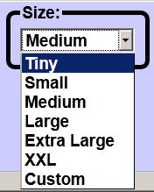 | 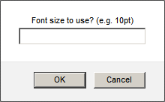 (Firefox)  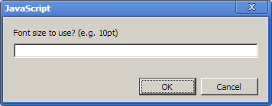 (Chrome) | 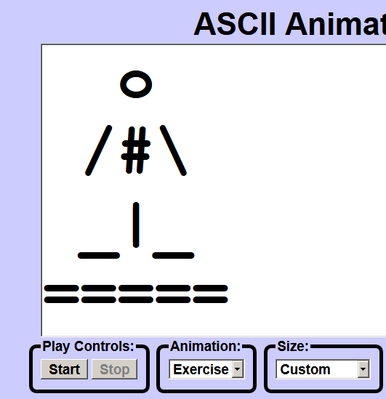
Copyright © Marty Stepp / Jessica Miller, licensed under Creative Commons Attribution 2.5 License.
All rights reserved.

