CSE 190 M, Spring 2012, Final Exam
ANSWER KEY
1. HTML / CSS Tracing
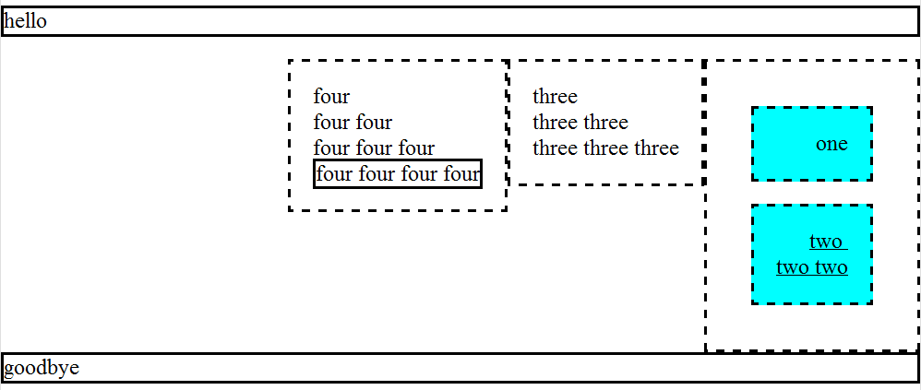

2. PHP

<!-- order.php -->
<form action="order-submit.php" method="post">
<div>
Food item:
<select name="food">
<?php foreach (glob("*.jpg") as $image) { ?>
<option> <?= str_replace(".jpg", "", $image) ?> </option>
<?php } ?>
</select>
</div>
<div> Quantity: <input type="text" name="quantity" size="2" /> </div>
<div> <input type="submit" value="Order" /> </div>
</form>

<?php
# order-submit.php
if (!isset($_POST["food"]) || !isset($_POST["quantity"])) {
header("HTTP/1.1 400 Invalid Request");
die();
}

$food = $_POST["food"];
$quantity = $_POST["quantity"];
$found = FALSE;
foreach (file("inventory.txt") as $line) {
list($item, $number, $price) = explode("\t", $line); # list() is optional
if ($item == $food && $number >= $quantity) {
$total = $quantity * $price;
?>

<p>
Order successful!
$<?= $total ?> is your total price.
Here is what you ordered:

<?php for ($i = 0; $i < $quantity; $i++) { ?>
<img src="<?= $food ?>.jpg" alt="food" />
<?php } ?>
</p>

<?php
$found = TRUE;
break; # optional
}
}

if (!$found) { ?>
<p>Sorry, we don't have <?= $quantity ?> of '<?= $food ?>' in stock.</p>
<?php } ?>
3. JavaScript / DOM

window.onload = function() {
document.getElementById("find").onclick = findClick;
};

function findClick() {
document.getElementById("palindromes").innerHTML = "";
var words = document.getElementById("phrase").value.split(" ");
var count = 0;
for (var i = 0; i < words.length; i++) {
if (document.getElementById("min").value &&
words[i].length < document.getElementById("min").value) { continue; }
if (document.getElementById("max").value &&
words[i].length > document.getElementById("max").value) { continue; }
if (isPalindrome(words[i])) {
var li = document.createElement("li");
li.innerHTML = words[i];
if (count % 2 == 0) {
li.style.backgroundColor = "#cccccc";
}
document.getElementById("palindromes").appendChild(li);
count++;
}
}
document.getElementById("count").innerHTML = count + " total palindrome(s).";
}

function isPalindrome(s) {
s = s.toLowerCase();
for (var i = 0; i < s.length / 2; i++) {
if (s[i] != s[s.length - 1 - i]) { return false; }
}
return true;
}

4. SQL

-- NOTE: *DON'T* run this query on imdb; it takes too long and hangs.
-- Run it on imdb_small only, please.

-- all directors who have made >= 2 movies across >= 2 genres
SELECT DISTINCT d.id, d.last_name d.first_name
FROM directors d
JOIN movies_directors md1 ON md1.director_id = d.id
JOIN movies_genres mg1 ON mg1.movie_id = md1.movie_id
JOIN movies_directors md2 ON md2.director_id = d.id
JOIN movies_genres mg2 ON mg2.movie_id = md2.movie_id
WHERE mg1.genre <> mg2.genre AND mg1.movie_id <> mg2.movie_id
ORDER BY d.last_name, d.first_name;

-- all directors who have made >= 2 movies across >= 2 genres
-- (includes movies table unnecessarily)
SELECT DISTINCT dir.id, dir.last_name, dir.first_name
FROM directors dir
JOIN movies_directors md1 ON md1.director_id = dir.id
JOIN movies m1 ON m1.id = md1.movie_id
JOIN movies_genres mg1 ON mg1.movie_id = m1.id
JOIN movies_directors md2 ON md2.director_id = dir.id
JOIN movies m2 ON m2.id = md2.movie_id
JOIN movies_genres mg2 ON mg2.movie_id = m2.id
WHERE m1.id <> m2.id AND mg1.genre <> mg2.genre
ORDER BY dir.last_name, dir.first_name;

