CSE 190 M, Summer 2010
Final Exam, Part 1 (LAB), version B
Friday, August 20, 2010

Name: ___________________________________________

Section: ___________________ TA: ___________________

Student ID #: ___________________

Rules:
- You have 60 minutes to complete this part of the exam.
You may receive a deduction if you keep working after the instructor calls for papers.
- This test is open-book/notes.
- You may not use any computing devices, including calculators, cell phones, or music players.
- Unless otherwise indicated, your code will be graded on proper behavior/output, not on style.
- Please do not abbreviate code, such as writing ditto marks ("") or dot-dot-dot marks (...).
- If you enter the room, you must turn in an exam and will not be permitted to leave without doing so.
- You must show your Student ID to a TA or instructor for your submitted exam to be accepted.

Good luck!

Problem | Description | Earned | Max
1 | HTML/CSS Tracing |  | 15
2 | HTML/CSS Coding |  | 15
3 | JavaScript/DOM |  | 15
TOTAL | Day's Total Points |  | 45

1. HTML/CSS Tracing
Draw a picture of how the following HTML and CSS code will look when the browser renders it on-screen. Assume that the HTML is wrapped in a valid full page with a head and body. Indicate a background coloring by shading lightly or by drawing repeated diagonal lines like  . If you can't clearly write italic text, circle it instead.

HTML:
<div id="one">
<div id="three">
<p class="three">
<span>A</span> <span>B</span> <span>C</span>
</p>

<div>D</div> <div>E</div> <div>F</div>

<span>G <br /> H <br /> I</span>
<span>J <br /> K <br /> L</span>
</div>
</div>

<div id="two" class="one">
<ul>
<li>alpha <span>hello</span> goodbye</li>
<li class="three">beta</li>
<li class="three">gamma</li>
</ul>
</div>

CSS:
div { overflow: hidden; }  div div div { text-decoration: underline;  background-color: cyan; }  li.three { background-color: yellow; }  div > span { float: right;  border: 1px solid black; } | #one { padding: 3em; }  #two { margin: 3em; }  #one, #two { border: 3px dashed black; }  #three { border: 2px dashed green; }

(This page is intentionally blank.)
2. HTML/CSS Coding
Write the HTML/CSS necessary to recreate the following appearance. No manual line breaks have been inserted.
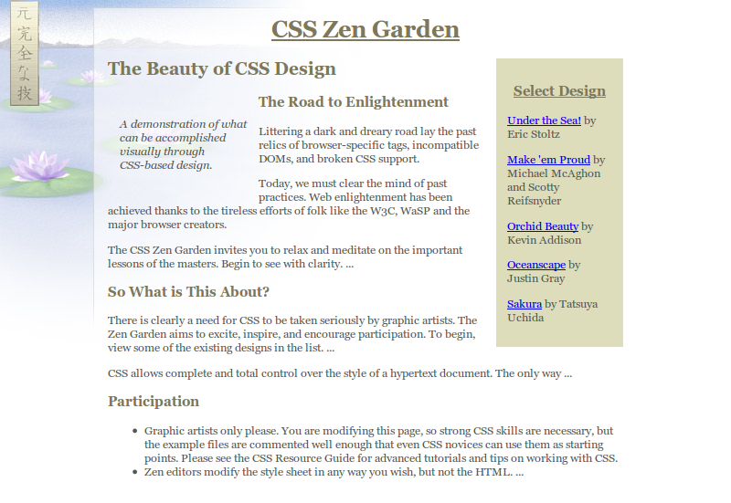
Most of the HTML code is given to you; the code given may not be modified. The only change you may make to the provided HTML code is that you may add any number of div and span elements, possibly with id and/or class attributes, as targets for CSS styling. Write valid HTML and CSS code that would pass the W3C validators. Assume that the HTML text shown would appear inside the body of the page.
- The overall page has a background of zen.jpg. The content is shifted right by 110px to avoid covering the background. Text on the page uses a 9pt font named "Georgia" or any sans-serif font available on the system.
- All headings on the page use the color #7d775c. The page's top heading is centered and underlined.
- The overall main content on the page is at most 50em in width, including all columns.
- The "A demonstration of..." paragraph appears in its own hovering column, 10em wide, with 1em separating it from any neighboring content. Its text is in italic.
- The "Select a Design" list of designs appears to the right of the other content, 9em wide, with a background color of #ddddbb. Its heading is centered and underlined. The list items do not have bullets. There is 1em between each list item and any neighboring list items, and 1em between items and the edge of the background color.
Mark up the text on the next page with your div/span tags. If a tag can't fit in the space provided, write it in the margins and draw an arrow to where to insert it. Any elements not described use the default browser styles.
Write your answer on the next page.

2. HTML/CSS Coding (writing space)
Mark up the HTML code below.

<h1>CSS Zen Garden</h1>

<h3>Select a Design</h3>

<ul>
<li><a href="">Under the Sea!</a> by Eric Stoltz</li> <!-- the link hrefs don't matter -->
<li><a href="">Make 'em Proud</a> by Michael McAghon and Scotty Reifsnyder</li>
<li><a href="">Orchid Beauty</a> by Kevin Addison</li>
<li><a href="">Oceanscape</a> by Justin Gray</li>
<li><a href="">Sakura</a> by Tatsuya Uchida</li>
</ul>

<h2>The Beauty of CSS Design</h2>

<p>A demonstration of what can be accomplished visually through CSS-based design.</p>

<h3>The Road to Enlightenment</h3>
<p>Littering a dark and dreary road lay the past relics of browser-specific tags, incompatible ...</p>
<p>Today, we must clear the mind of past practices. Web enlightenment has been achieved ...</p>
<p>The CSS Zen Garden invites you to relax and meditate on the important lessons of the ...</p>

<h3>So What is This About?</h3>
<p>There is clearly a need for CSS to be taken seriously by graphic artists. The Zen...</p>
<p>CSS allows complete and total control over the style of a hypertext document. ...</p>

<h3>Participation</h3>
<ul>
<li>Graphic artists only please. You are modifying this page, so strong CSS skills are...</li>
<li>Zen editors modify the style sheet in any way you wish, but not the HTML. ...</li>
</ul>

Write your CSS code here. Put your CSS in multiple columns if you need more writing space, or use scratch paper.
3. JavaScript/DOM
Write the Javascript code to add behavior to the following HTML code. This page performs a comparison of lines of two pieces of text placed into two textarea elements on the page. (It is similar to a simplified version of CSE 142's Output Comparison Tool and the program diff .)
When the user clicks "Compare", you should compare the two pieces of text, line by line. If a given line of the expected output doesn't match the corresponding line at the same index in the actual output, a new list item bullet should appear in the ul with id of differences. If the two text areas have a different number of lines, a bullet should be added that states that the number of lines differ and shows the lengths, as shown in the first image below.
If the "Compare" button is clicked multiple times, any bullets from past runs should be removed before proceeding.
If there are any differences, the ul should be given the CSS class of diffs. If there aren't any differences, a single bullet should be placed into the list that says "No differences found", and the ul should be given the class nodiffs.
You may assume that Prototype is included in the page. The relevant HTML/CSS code is the following.
HTML: | CSS:
<div class="column">  <h2>Expected output</h2>  <textarea id="expected" rows="8" cols="30"></textarea>  </div>  <div class="column">  <h2>Your actual output</h2>  <textarea id="actual" rows="8" cols="30"></textarea>  </div>  <div id="comparearea">  <button id="compare">Compare</button>  </div>  <ul id="differences"></ul> | .column { float: left;  margin-right: 1em; }  #comparearea { clear: left; }  #differences li {  font-family: monospace; /* makes it look */  white-space: pre; /* like a <pre> */  }  .nodiffs { background-color: #cfc; }  .diffs { background-color: #fcc;  font-weight: bold; }
The following screenshots show the initial state and state after some various text has been compared.
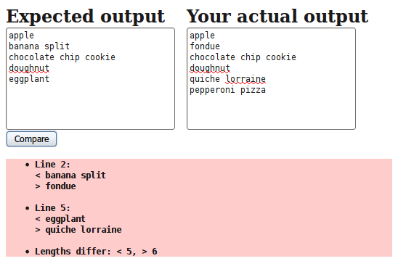 | 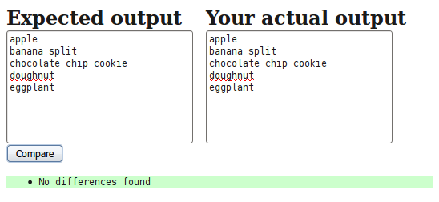
(Write your answer on the next page.)

3. JavaScript/DOM (writing space)

