CSE 190 M, Extra Exam Problems
ANSWER KEY
1. HTML / CSS Tracing
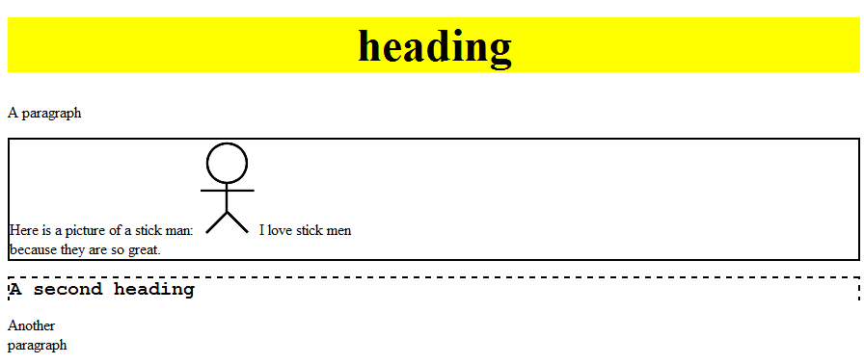

2. HTML / CSS Tracing
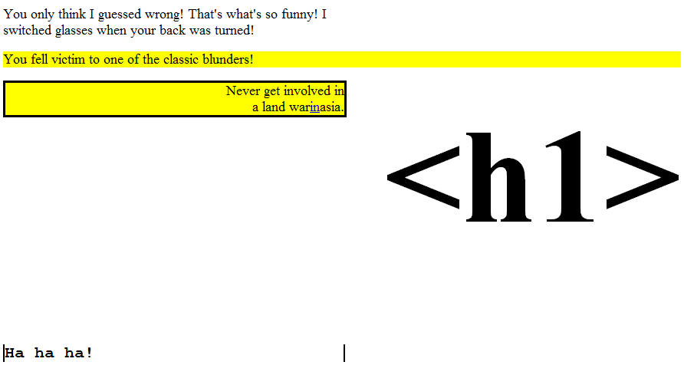

3. HTML / CSS Coding

<div class="dialogue">
<h2 class="vader">VADER</h2>
<p class="vader">If you only knew the power of the dark side.
Obi-Wan never told you what happened to your father.</p>

<h2 class="luke">LUKE</h2>
<p class="luke">He told me enough! It was you who killed him.</p>

<h2 class="vader">VADER</h2>
<p class="vader">No. I am your father.</p>

<h2 class="luke">LUKE</h2>
<p class="luke">No. No. That's not true!
<span class="impossible">That's impossible!</span></p>

<h2 class="vader">VADER</h2>
<p class="vader">Search your feelings.
<strong>You know it to be true.</strong></p>
</div>

div.dialogue {
width: 50%;
margin-left: auto;
margin-right: auto;
}

.luke, .vader {
margin: 0px;
}

.vader {
text-align: right;
}

.luke {
text-align: left;
}

span.impossible {
color: red;
}

.character {
width: 20%;
float: right;
}
4. JavaScript / DOM

window.onload = function() {
var chars = ["Garfield", "Odie", "Nermal", "Pooky", "Jon"];
for (var i = 0; i < chars.length; i++) {
var option = document.createElement("option");
option.innerHTML = option.value = chars[i];
document.getElementById("characters").appendChild(option);
}
setChar("garfield");

document.getElementById("characters").onchange = changeChar;
};

function changeChar() {
setChar(this.value.toLowerCase());
}

function setChar(character) {
document.getElementById("comic").src = "images/" + character + ".jpg";
}

5. JavaScript / DOM

window.onload = function() {
for (var i = 0; i < 20; i++) {
var square = document.createElement("div");
var c = 255 - 10 * i; // color
var xy = 10 * i;
var size = 400 - 2 * xy;
square.style.backgroundColor = "rgb(" + c + ", " + c + ", " + c + ")";
square.style.width = size + "px";
square.style.height = size + "px";
square.style.position = "absolute";
square.style.left = xy + "px";
square.style.top = xy + "px";
document.getElementById("gradient").appendChild(square);
}
};

