Analysis of Unemployment Rates
  - Homework #9 CSE 140
  - By Kari Hankins and Michael Lien
1. Summary
Research Question:
How did the housing bubble affect King County and Adams County?
This report will focus on analyzing the unemployment rates for the King County and Adams County to determine which counties were most impacted the recession based off of two data sets, the unemployment rate data for each county and the 2000 and 2010 census data that includes housing data such as occupancy rates and their respective changes. The results show that before and after the housing bubble the unemployment rate in Adams was above the state average at all times while the king county rate was below. King County also had a lower deviation from the state unemployment rate during the 5 year period. King County also experienced a higher percentage change in housing occupancy than Adams County as well.
2. Motivation
The motivation behind this problem is to examine a hot button political issue from the last election. In political debates many claims are made with a disregard for the data. Understanding the data and its ramifications is essential to having any intellectual debate and it is very important to know what the implications from the data means. This particular question is important to answer because the housing bubble is credited with being a large factor in the cause of the latest recession. The “bubble” happened in in late 2006 and lead into the financial crisis and current recession. Knowing the impact on the different counties in Washington is important to see how the bubble affected the housing market and jobs in the wide range of living conditions in the state, from more heavily urban counties like King County to more rural area east of the Cascade Mountains. Adams County is much different in all respects from King. It has a much smaller population, different political demographics, a much smaller average median income, and a smaller geographic foot print.
3. Data Sets
The data sets that will be examined are from the Washington State Data website. Both the census data and the unemployment data are both available to download for free as comma separated value files. They are available at the following URLs. After navigating to the respective pages, click export then select CSV to download the data sets.
- WAOFM - Population and Housing, Census 2000 and 2010:
https://data.wa.gov/Demographics/WAOFM-Population-and-Housing-Census-2000-and-2010/tx5i-i2ja
- King County Unemployment 2005 – 2010:
https://data.wa.gov/Economics/King-County-Unemployment-2005-2010/h6sn-55yw
- Adams County Unemployment 2005 – 2010:
https://data.wa.gov/Economics/Adams-County-Unemployment-2005-2010/ix8r-k9v8
The first data set is the Census and Housing data for 2000 and 2010. It contains population data for all census qualifying cities in the state of Washington. Also included here are housing figures such as occupancy rate and number of homes. The second and third data sets are unemployment data for King and Adams Counties from 2005 to 2010. Adams is missing the 2005 data so only the years 2006 to 2010 were examined.
4. Methodology
The data will first be imported into the python file using a csv file reader. From here the data will be cleaned up to remove any unnecessary and the important data will be compiled into their respective data structures of list and dictionaries. The unemployment data will only be considered from 2000 to 2010 so that it matches the census data. In order to compare the yearly census housing data with the monthly unemployment rates the yearly unemployment rate for each county will be computed. A graph will then be constructed to better visualize the unemployment data for each county for each year. The years of interest are from 2006 to 2010. Trends in the unemployment data will then be analyzed to see which counties were affected the most. The sum of squared residuals was used to calculate how much each counties rates differed from the state rate. Next the occupancy rate changes for each county were extracted from the census data along with the raw number of occupied houses.

5. Results
Results
Housing Occupancy Rate Change King County | -2.89 %
Occupied Homes Change King County | -76,226
Housing Occupancy Rate Change King County | -1.50 %
Occupied Homes Change Adams County | -287

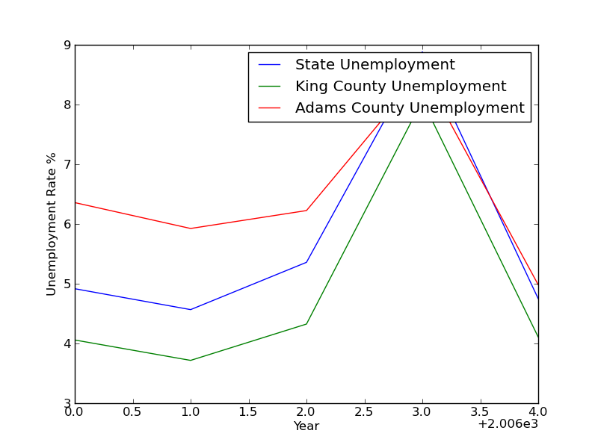
These are results for the unemployment analysis. The graph shows the unemployment rates for each county along with the state average. The sum of squared residuals for King County was calculated to be 3.61 and 4.84 for Adams County. This result means that on average King County was closer to the state average over time. However the King County rate was below the state at all times. The housing bubble occurred at the end of 2006, but the unemployment rates didn’t see a large increase until 2009. This result is more inline with the financial crisis which occurred after the housing bubble. King County saw a much larger increase here than Adams County which can be attributed to the different job markets for the areas, King County being home to more white collar jobs than blue collar ones. The housing data is more difficult to interpret due to the time frames not lining up correctly with the employment data. The data shows that however the occupancy rate is lower than previous years which goes against past trends of increased growth.
6. Reproducing the Results
First download each .csv file from data.wa.gov and place in the same directory as the unemployment_analysis.py file is. Next open the command prompt. Navigate to the directory where all of the files are kept. Then run the unemployment_analysis.py file from the command line. A .png graph will be produced and the output will be displayed in the command prompt.
7. Collaboration
No One
8. Reflection
We learned that finding data meaningful data can be difficult especially if you don’t know where to begin looking. Also that csv files are very handy to have data in because of the premade python tools for reading these files and examining the files in Excel is really handy as well. Manipulating .csv files can be more difficult when the files grow larger but the basis is still the same as when dealing with smaller problem.

