CSE 154, Spring 2013
Final Exam, Thursday, June 13, 2013

Name: ___________________________________________

Quiz Section: ___________________ TA: ___________________

Student ID #: ___________________

Rules:
- You have 110 minutes to complete this exam.
You may receive a deduction if you keep working after the instructor calls for papers.
- This test is open-book, but closed notes. You may not use printed/written notes or practice exams.
- You may not use any computing devices, including calculators, cell phones, or music players.
- Unless otherwise indicated, your code will be graded on proper behavior/output, not on style.
- Please do not abbreviate code, such as writing ditto marks ("") or dot-dot-dot marks (...).
You may write ID for document.getElementById and QS for document.querySelectorAll.
- You may not use JavaScript frameworks such as jQuery or Prototype when solving problems.
- If you enter the room, you must turn in an exam and will not be permitted to leave without doing so.
- You must show your Student ID to a TA or instructor for your submitted exam to be accepted.

Good luck! You can do it!

Problem | Description | Earned | Max
1 | HTML / CSS Tracing |  | 20
2 | CSS |  | 20
3 | PHP |  | 20
4 | JS / Ajax / JSON |  | 20
5 | SQL |  | 20
X | Extra Credit |  | 1
TOTAL | Total Points |  | 100

1. HTML / CSS Tracing
Draw a picture of how the following HTML/CSS code will look when the browser renders it on-screen. Assume that the HTML is wrapped in a valid full page with a head and body. Indicate a non-white background by shading lightly or by drawing diagonal lines like  . It is possible that some CSS rules shown will not apply to any elements.
<div>  <div class="id">A A A A</div>  <div>  <span>B B  B B</span>  <span id="id">C C C C</span>  <span class="class">D D D D</span>  </div>  <div class="class">  <span>E E E E</span>  <div class="id">F F<br />F F</div>  <div id="class">G G<br />G G</div>  <div id="H">H H H H</div>  </div>  </div> | div { border: 2px solid black;  padding: 1em;  background-color: white;  overflow: hidden; }  div div > div { background-color: red; }  div > div .class { text-decoration: underline; }  #id { padding: .9em;  border: 2px dashed black; }  .id { float: right; }  .class #class { float: left; }

2. CSS
Write the CSS code necessary to recreate the following appearance on-screen, exactly as shown.
The page uses the same HTML code as in the previous problem. You are not allowed to modify the HTML.
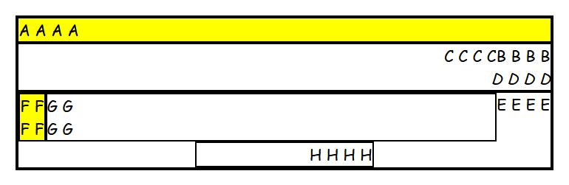
<div>  <div class="id">A A A A</div>  <div>  <span>B B  B B</span>  <span id="id">C C C C</span>  <span class="class">D D D D</span>  </div>  <div class="class">  <span>E E E E</span>  <div class="id">F F<br />F F</div>  <div id="class">G G<br />G G</div>  <div id="H">H H H H</div>  </div>  </div> | Text now uses Comic Sans MS font at the default size.  All borders shown are 2px thick and black in color.  The elements "A" and "F" have yellow background.  The element "D" now has italic text.  The element "H" is now each exactly one third (1/3) of the page width, in the page center; the "H H H H" text appears on the right edge of the element.

3. PHP
Write the PHP code for a web page books.php that searches for books in a bookstore for sale under a given maximum price. Assume that there is a provided page with a form where the user can type information about the category of books to search and the maximum price (inclusive) of book to show. The form will submit to your books.php. Here is the relevant HTML from that provided page, and a screenshot of its appearance:
<h1>Book Search</h1>
<form action="books.php" method="get">
<div><input id="ab" type="text" name="category" /> Category</div>
<div><input id="cd" type="text" name="max" /> Maximum Price</div>
<div><input id="ef" type="checkbox" name="prime" /> Prime Club Member?</div>
<div><input id="gh" type="submit" value="View Books" /></div>
</form>
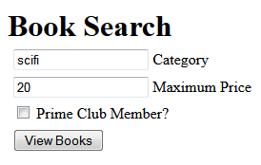 | Each category has a corresponding text file in the current directory that contains all books for sale in that category; for example the "fantasy" category is found in fantasy.txt. Each line of these files contains a book name followed by a colon (:) and the price of the book. For example, below are scifi.txt and fantasy.txt:
I, Robot:10.00  Hitchhiker's Guide to the Galaxy:5.58  Do Androids Dream of Electric Sheep?:22.95  Ringworld:34.25  Tunnel in the Sky:16.75 | Harry Potter:15.00  A Game of Thrones:15.89  Fellowship of the Ring:27.50  Dragonlance:12.95
Your PHP page should accept the query parameters from the above form, open the text file for the requested category, and search it for books whose price are less than the given maximum, inclusive. Match case-insensitively; the user might submit the category in any capitalization, but the input files are always in lower case. If the user types a category for which there is no corresponding text file, instead of the bulleted list, just display a paragraph saying, "Category not found." Your page should not produce any errors or warnings in such a case.
Display each matching book as a bullet in an unordered list, showing the price and the title separated by a dash (-). The form also has a "Prime Club Member" checkbox; if it is checked, you should reduce the price of every item by 20% before comparing it to the maximum and show the discounted prices in the list.
The following screenshots show the PHP page output after the user submits the form with various values:
scifi, max price 20:  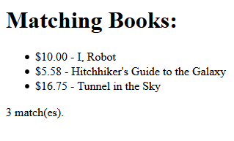 | scifi, max price 20, prime club:  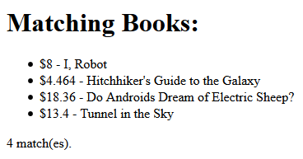 | category "silly":  
fantasy, max price 15:  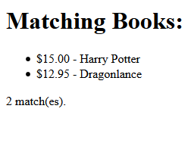 | fantasy, max 15, prime club:  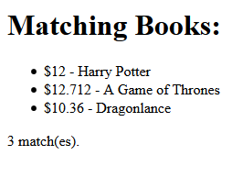 | fantasy, max 10:  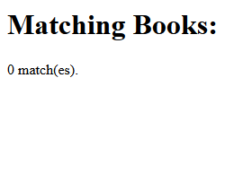
You may assume that the user will submit the form properly; assume all parameters are passed properly and have appropriate values (e.g. a non-negative max). You may assume that if the category file exists, it is valid in the format described above. You can write just the code that would go inside the page body; you don't need to output a head section or a complete page. Use the browser's default styling; do not write any CSS for this problem.
Write your answer on the next page.
3. PHP (writing space)

4. JavaScript / DOM
Write the JavaScript code to add behavior to the following page for manipulating strings. The page UI allows the user to type a phrase into a text box. The user can click the "Go!" button to display the words in that phrase in reverse order. Each word in the phrase should be inserted as a span with a class of word, inside a div with the id of words. (The word class gives the spans their appearance in the screenshots below, giving them a border and a background and so on.) Every other word (the first, third, fifth, etc.) should also be underlined.
The user can optionally specify a "filter" text by typing into a text box with the id of filter. If a non-blank filter is specified, you should exclude any words from the phrase that contain that filter text, case-insensitively. For example, if the filter text is "abc", exclude any words containing abc, ABC, aBc, etc. If any words are excluded, under the list of words you should modify the div with id of count to display text of the form, "5 word(s) filtered out".
The code should work for multiple clicks of the button. On each click it should clear any previous information you injected. You may assume that words in the phrase are separated by single spaces. Do not use any JavaScript libraries such as jQuery or Prototype. Here is the relevant HTML code for the page:
<h1>Sentence Reverser!</h1>
<div> Phrase: <input id="phrase" type="text" size="40" /> </div>
<div> Filter: <input id="filter" type="text" size="10" /> </div>
<div> <button id="go">Go!</button> </div>
<div id="words"></div>
<div id="count"></div>
These screenshots show the initial state, and after phrases have been typed and "Go!" is clicked.
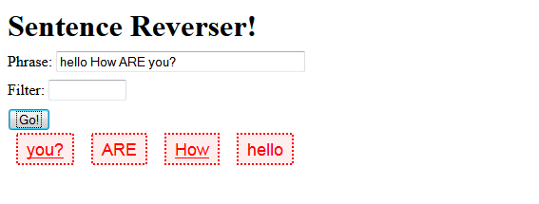  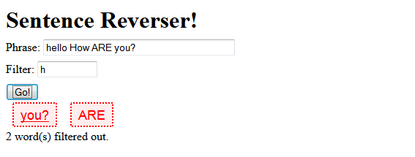 | 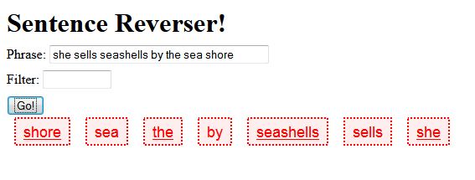  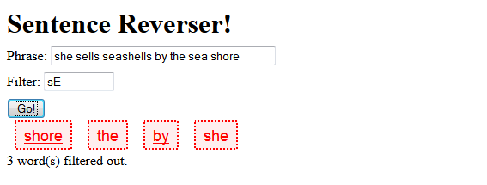

Write/finish your answer on the next page.
4. JavaScript / DOM (writing space)

5. SQL
Write an SQL query to search the imdb database for the names/years of all movies that had at least 2 directors, one of whom was Woody Allen, where Allen also acted in the movie. Show the movies in alphabetical order. Each actor/film combination should be listed only once. Woody Allen's first and last name in the database are "Woody" and "Allen" respectively, and you may assume that he is the only actor or director in the database with that exact first/last name pairing. Note that actor IDs do not match director IDs. Recall the imdb tables:
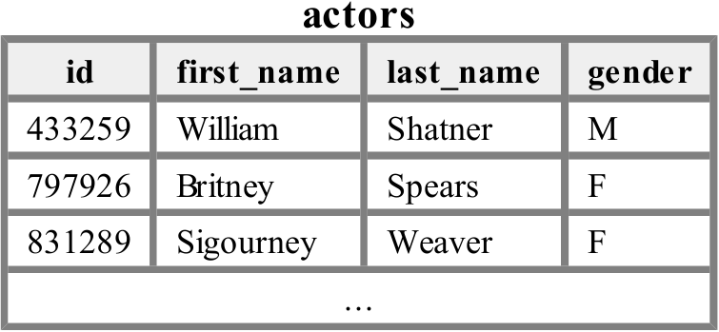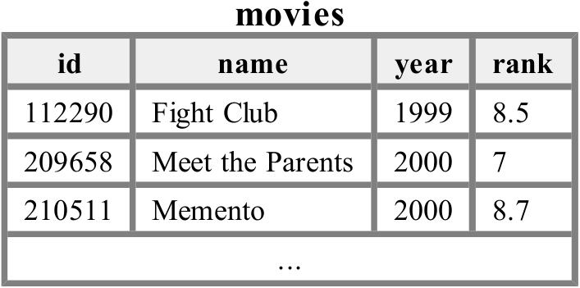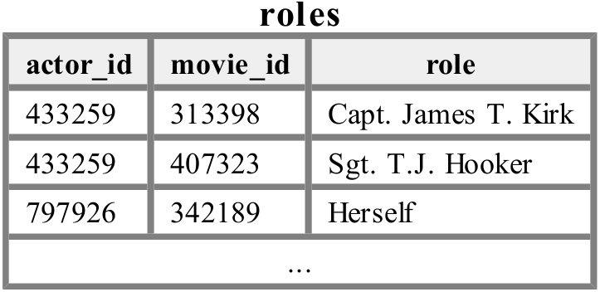
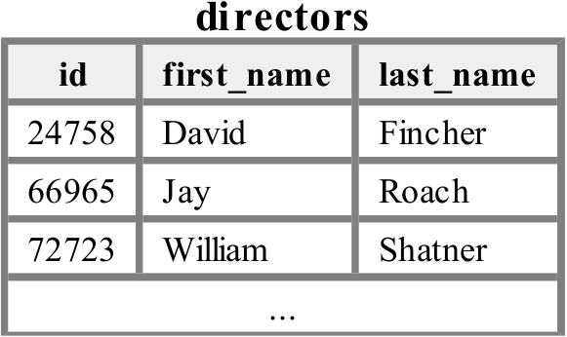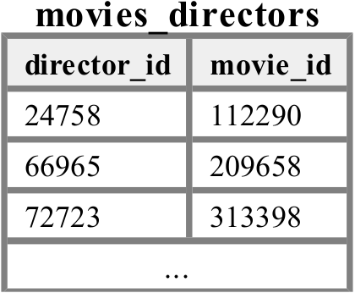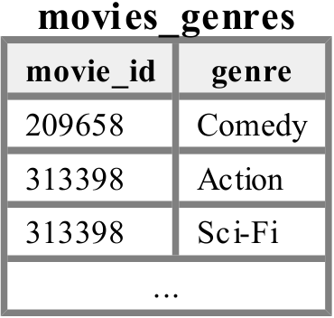
+------------------------+------+  | name | year |  +------------------------+------+  | New York Stories | 1989 |  | What's Up, Tiger Lily? | 1966 |  +------------------------+------+  2 rows in set (0.58 sec) | When run on imdb database, your query produces the results at left.  If you join too many tables together that are not needed for the query, you will not receive full credit. You should solve this problem using only the SQL syntax shown in class and the textbook.

X. Extra Credit
Draw a picture of what your TA would look like if he/she became a gangsta rapper or pop music star.
(This is just for fun; any picture that appears to reflect more than a few moments' work will receive credit.)

