Smart Ringer
Anh-Kiet Ngo
Ayman Abdo

Overview
In this modern environment, nearly everyone is equipped with a cell phone. It is a great technology in that it keeps us all connected to the ones we love. Or in the cases of emergencies, it allows us to get help regardless if we are stranded on a highway or losing our keys after a heavy night of binge drinking. Naturally, all of these conveniences mean that the cell phone is constantly by our side. This inevitably leads to the allowance of interruptions during important meetings or gatherings. The ringing of a cell phone in today's world is an annoyance that many people are plagued with. The odd thing is that the ability to control the ring of our devices is quite primitive and limited.

There are third party apps that attempt to alleviate this problem, but many are simply a calendaring system for us to indicate when and when not to ring. More advanced apps even allow us to set the ring by proximity to locations. However, these solutions do not take into account the dynamic nature of a person's schedule. For example, being in class is a situation where we do not want the phone to ring, but a meetup after class does not necessarily warrant the silencing of the ringer. Something as important as the ringer of a mobile phone cannot rely on one dimension of configurability alone.

By combining multiple configuration options, we believe that we can achieve something more useful and flexible than what is currently available to consumers. For example, by combining both the calendaring system and the GPS location, we can come up with a set of much clearer constraints for when the ringer should be silenced. We also propose a few new ways to interact with the device that could further enhance the experience of the consumer, such as the direct control of the ringer by using a device's orientation or proximity to an external device.

Contextual inquiries
To get at a better understanding, we interviewed a few people to see how they cope with this problem. Though it would have been great to be able to interview a more diverse group, we lack the time and connections to find and segment our interviewees. The reason we picked this group is because of the dynamic nature of their day-to-day schedule, their needs for an uninterrupted stretch of time, and our ease of access for an interview.

Participants

Job title: Corporate Attorney
Reason for selection: We believe that due to the nature of having to juggle many things all at once, a corporate attorney is a person that needs to be able to both respond to important phone calls quickly and have uninterrupted meetings. This profile is an extreme case of an individually having a changing schedule on a daily basis.
Environment: Though we could not spend all day with this person, we were able to observe her in an office environment for a stretch of time that included quiet time and a transitional period to her meeting.

Job title: Director of UI/UX
Reason for selection: Due to the level at which this person has to work, he is pulled in many directions all at once and has a strong need to prioritize his meetings and schedule. Being a creative professional and a father, there are moments where interruptions should not occur. However, being a person with many responsibilities, there are situations where he needs to be in touch with those around him, whether it be by phone or impromptu meetings.
Environment: Office

Job title: SDE II
Reason for selection: This person works in an intense team that do a lot of live bug fixes for customers. He gets on-call duties about once a month for a week. When he’s on-call, he must receive the notification or calls right away so that he’d be able to work on a fix ASAP. On the days he is not on-call, the phone calls and notifications are not very dire unless there is an emergency from his family who live overseas.
Environment: Office

Job title: Student
Reason for selection: This person has a different perspective on the phone use. She does not get a lot of phone calls. Instead she receives a lot of texts and notifications via different applications. Each notification has its importance for her depending on the application and time of the day. Mostly, her problem with unneeded notifications happen when she’s in class or when she’s spending some quality time with her family and friends.
Environment: School

Contextual inquiry results
One of the common themes we found among our participants was that they would silence the phone and then either keep it silent indefinitely, or that they would forget to turn the ringer back on. The opposite is also true, that is they would forget to silence the phone before going into a meeting. On one occasion, the ringer went off because the person had received a text message during a meeting. The reason for the forgetfulness appears to be a result of being preoccupied with other, more important matters, so the state of the phone ringer reduces in its level of importance.

Another aspect is the concept of a recurring event. The users like to have the ability to schedule something that's recurring. When prodded with how they were going to deal with changes in their schedule, it came back to the conversation that likely they will forget to unset the ringer. There were various suggestions that when they're in a recurring silencing mode that the phone's interface changes in some way to indicate that it is silenced. Essentially there was a need to indicate to the user somehow, when they're using the phone, that the phone is on silent.

In the case of the attorney, she mentioned that she would like the ability to "whitelist" contacts so that the phone would ring, no matter what. This is in response to handling of real emergencies. She also noted that a few other attorneys actually had two phones, one was for work while the other one was mainly for special occasions and emergencies. She was comparing this to the fact that if she had a proper way to manage her ringer, she would be able to accomplish what others would be able to with two phones.

Interestingly, the UX director had an idea that was exactly like one of the ones we have proposed. He would love to be able to set the phone in a face down position to indicate silencing or not. In fact, he pointed out that it could be a gesture of respect by showing the other party by placing the phone on the table facing down. It never occurred to us that there was a social aspect to this as well. His typical routine is to silence his phone when he gets to work. The main reason behind this is because he works in an open floor plan office, ringing will cause disruption.

The student shed some light on the problem of having many apps that send notifications on the phone. This brought up the need to have a unified place where we can see all the application that have permissions to send notifications to the user and have a fast and efficient way to adjust the settings for them. She thought that if her phone would understand that notification from applications like whatsapp and Facebook messenger during class are unimportant and should be ignored. But receiving an email that tells her that her grades for the other class are out and she can check them out is important and for her, it is worth checking the phone for.

Task Analysis Questions
Who is going to use the system?
We believe the people who will most benefit most from our app are the people who are constantly being interrupted by their phones or those who miss important phone calls because their phone is on silent/vibrate. Like the UX director who was interrupted by a text message during his meeting. Had he scheduled something on his calendar for the phone to be silenced, it would not have happened.

Working professionals who are constantly in and out of meetings all day long will benefit from our app as well. It allows them to have the peace of mind that they will not be interrupted or miss an important phone call.

What tasks do they now perform?
Most of the results that came out of our contextual inquiries indicated that people will, for the most part, keep their phone on silent. Unless they are expecting an important phone call or something preplanned, they err on the side of caution and keep it silent. This is to hopefully lessen the amount of interruptions and distractions they cause to others when they accidentally forget something. Also through observation of coworkers (not contextual inquiry), there are a select few who just keep the phone ringer on and do not care if they accidentally cause disruption or not.

What tasks are desired?
The user wants the ability to better and more granular control the phone's ringer. Given that all of these devices have so much computing power yet the default control that comes with these devices is nearly nonexistent.

How are the tasks learned?
We expect to have some defaults for the users to start out with that is least invasive, most conservative approach and gives the most benefit. Since there will be advanced options to indicate calendaring and GPS coordinates, we expect to have instructional screens in our app to give them a better idea of how it works. We would consider these to be advanced features that are not enabled by default. Things that could drastically change the way the user uses their phone will not be enabled, for example, we will not default the phone to being silent when faced down. This will have to be enabled by the user manually.

Where are the tasks performed?
The approach of this app, for the most part, will be hands off. The configuration of the application will be done at a time of leisure, but it will not force the user to set options. Since there are no requirements to access data from a remote server, internet connectivity is not required. However, if the user were to use the advanced option of using the GPS to include coordinates, then anywhere that the phone can receive GPS signals is required for that feature. For the case of using device orientation to indicate the phone's ring state, then really anywhere. Most likely this feature will be used in meetings or occasions where the user wants peace and quiet, like a long coding session for instance.

What is the relationship between customer and data?
Each user will have personal data that indicates who they are and what their settings are. With advanced integrations, the app will know about the user's calendar, which is private data. The app may also know of GPS information if the user allows it. For the use of the application, there will be no storage of data elsewhere. If in the future there is a need to store the data so that the user can recover (in cases of emergency), we will have to store this data in a server somewhere, but that would be outside the scope of this project.

What other tools does the customer have?
There are third party apps to achieve some of the functionalities we are talking about, such as calendar integration and GPS integration. The customer can also stick with what came with the device, a very basic mechanism to turn the ringer on or off. The customer also has the option to not carry the phone with them into important meetings.

How do customers communicate with each other?
There are no social aspects to this app. Since it is a personal thing, there are very little options in how we can handle this. If we did include an option for the user to communicate status, it will likely be anonymous.

How often are the tasks performed?
For the most part, it's a set and forget scenario. In the case where the user controls the ringer by orientation, then it will be every time the user places the phone down. He/she will have to remember to place it in the right orientation. However, we believe that for the most part users will place their phones facing up, so in the majority of the cases, there will be little impact to how the user will be using their phone. As far as configuration goes, it will be how often the user wants to change their settings.

What are the time constraints on the task?
None that we are aware of.

What happens when things go wrong?
In the worst case scenario, the ringer will go off when the user does not want it to. In this scenario, we feel that it would have happened anyway. So in the grand scheme of things, the user is no worse off than where he is currently. The other scenario is that the user misses an important phone call, this will be as if they had accidentally left the phone on silent.

Task Descriptions
Scheduled events
Existing task: Knowing that there will be a meeting in 10 minutes because of the reminder, the user then goes into the phone's settings and turn off the ringer. Most modern phones will also allow you to do this by using the volume key. After the meeting is done, the user has to remember to turn the ringer back on.
New task: Since the device is already integrated with the calendar, it will check to see if the calendar status indicates a ringer status. If not, it will prompt the user if they want to silence the phone during the meeting. After the meeting is over, it automatically enables the ringer.

Unscheduled events
Existing task: Remember that your phone is not silent. If it is not, then actively turn it off. Once the meeting is over, remember to turn it back on again.
New task: Leave the phone on the table, facing down to indicate that it needs to be silent.

Recurring reading with location
Existing task: Default device functionality. Remember to silence the device before the discussion meeting and remembering to enable it afterward.
Existing task: Third party app with calendar integration. The device is now aware of the meeting so it disables and enables the ringer automatically. In the case that the event was canceled, the user needs to remember to remove the calendar event for the ringer to be turned back on.
Existing task: Third party app with location integration. It detects that you are at the meeting location, and thus disables the ringer. The moment it detects that you are away, it turns it back on. In the case that it's a friend's house, if you are over to visit, you'll have to remember to turn the ringer on because it's not for the book discussion.
New task: With calendar and location integration, both requirements need to be satisfied before the silencing effect of the app kicks in. If either of those conditions fail, the app will keep the ringer on.

Storyboards
Design #1
This design focuses on a more conventional approach to how applications set its configurations. As a result, we get a lot of different screens for different configurations. The goal for this design is simplicity of configuration in that we allow for more text on the screen to guide the user. As of right now, the deepest screen is three taps in, which we don't think it's bad at all. If we're counting from the actual settings screen, it is only 2 taps away.
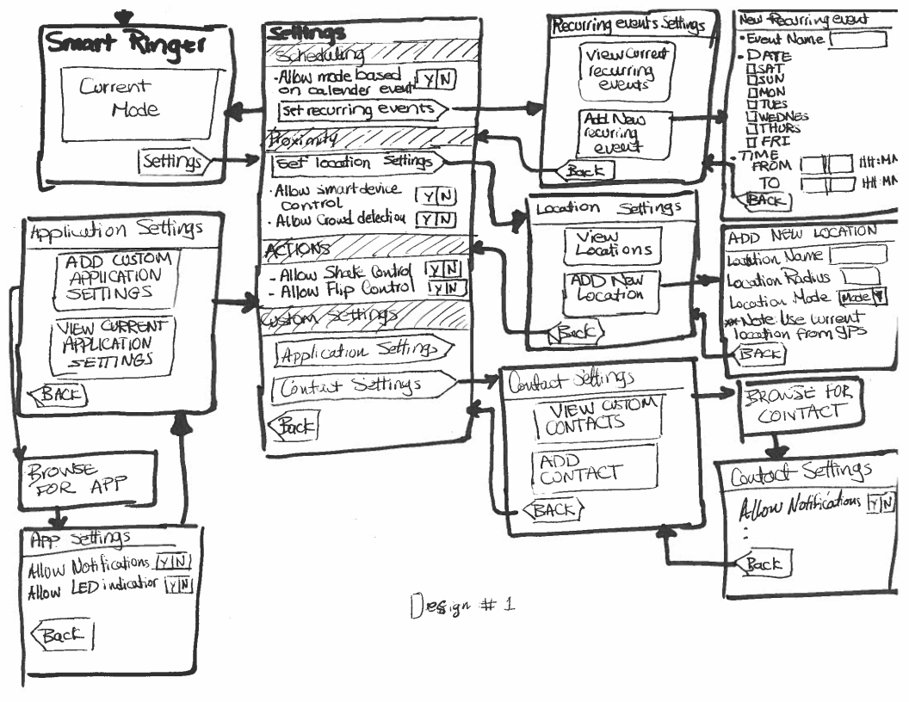

Design #2
This design is inspired by Outlook. It features fewer screens than the first, but the complexity is pushed to the actual configuration of each state. One of the down sides to this design is the lack of user feedback and guidance. It can be quite confusing to the user if it is their first time using and configuring this app.

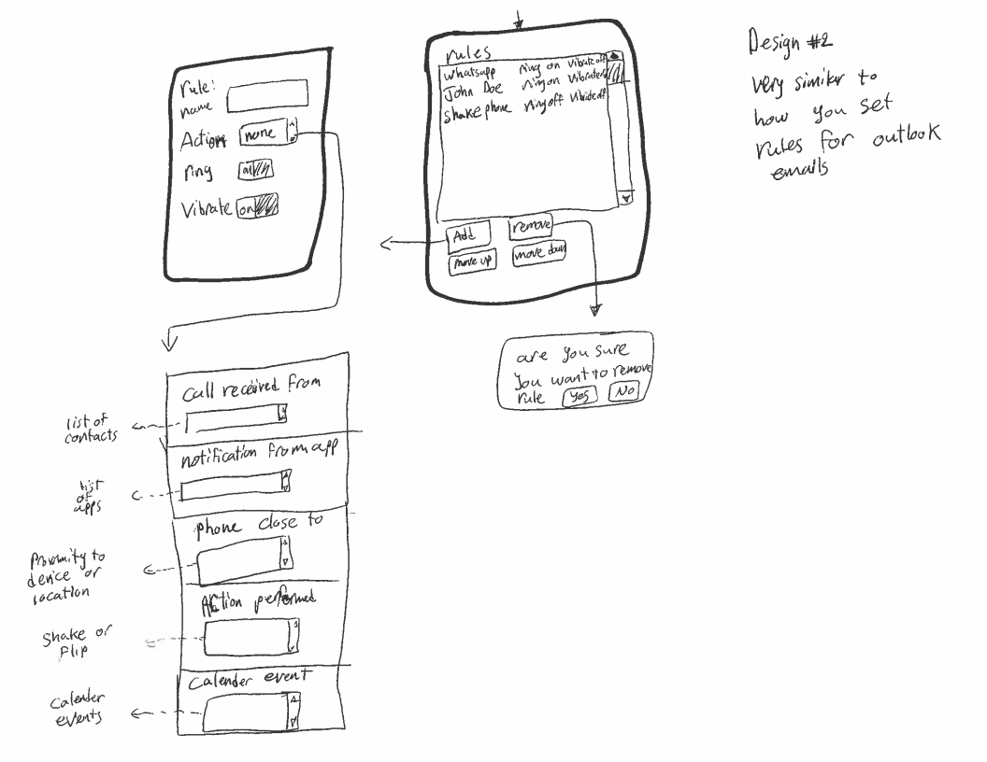

Design #3
This design focuses on letting the user quickly get to where they need to be. As a result, there is less focus on giving the user a better sense of the current settings.
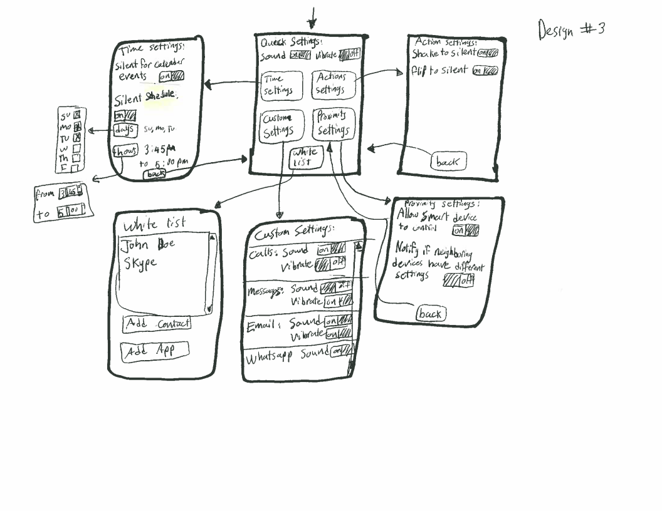

Selected interface design
Design choice
The final designed selected are made from the point of simplicity and user friendliness. Although there are more transitions in the first design than the other two designs, we feel that this segmentation allows for better usability and more guidance to the user. Unlike the second design, where the user is expected to know all of the various interactions between different features, the first design focuses on the experience of the first time user. The second design, due to its succinctness, could serve as an "advanced" configuration screen for a person who is already familiar with the application.

Design #1 also allows for better functionality expandability later on, which is a shortcoming of design #3. The scrolling nature of the first design's setting screen allows for segmentation and expansion, while the third design has limited screen space for navigating to various child configuration screens. In the case of the second design, the expansion of functionalities will be on the actual configuration screen, which could potentially confuse first time users. We may consider incorporating some of the ideas from the second and third design into the first design. This is to simplify some of the steps since it can reduce the number of screen transitions.

Functionalities of Smart Ringer
Scheduling - this allows the user to schedule when the ringer is supposed to be on or not. The user has the ability to see events that have already been scheduled and modify them as needed.

Contact whitelisting - the ability to allow a specific contact the ability to override restrictions. This can be used for cases of emergencies or important phone calls that cannot be missed.

Easy indicator - show the user the current status of the ringer via the LED indicator or various notifications/overlay on the screen. This lets the user quickly assess the state of the phone's ringer without having to go into configuration screens to figure it out.

Actions/Orientation - let the user control the ringer via alternative interaction methods. When a phone rings, we give the user the ability to shake the phone to silence it. Or in the case of a meeting, allow the user to put the phone face down to silence the ringer.

Location - allow the user to select a location via GPS coordinates to control the phone's ringer. When the user is near that point, then the phone automatically triggers an event to silence the phone.

User interface description
When the user launches Smart Ringer, they should be presented with the current state of the smart ringer. At this point, they have the option to toggle the application on/off or to change the current settings.

In the settings screen, they have the option to choose to schedule the ringer, set the proximity, change their actions, and set additional custom settings.

For application settings, the user has the ability to see which application on their system have which type of notifications. This way it's easy to know what could possibly go off unexpectedly, like a game.

Recurring events scheduling gives the user the ability to setup something recurring that is not on their calendar. Since there's also integration with the calendar, so we might be able to set the schedule here and have it appear on the calendar.

If the user needs to set a location setting, they'll need to go to the Location settings screen to do it. We are also letting them pick the radius from the current GPS location. This may, in the future, change to a map like integration to better visualize the radius and not have it just a number.

To allow for whitelisting of contacts, they can enter the contact settings and choose them to allow for notifications.

Scenarios
Since most of the actual use of the application is passive in nature, for some of the tasks we will describe the setup process in which the user configures the application to do what they want.

Scenario 1 - Scheduled events
John is a manager at an accounting firm. On a Monday morning, as he was getting his morning coffee from Starbucks. He’s phone sent him a 15-minutes-reminder about an early meeting that he had completely forgotten about. As he rushed to the office and was there just on time. In the middle of the meeting he heard a phone ringing. The presenter had to stop and everyone was now looking at John. John was looking for his phone in his briefcase as fast as he could. He found the phone and turned it off. The CEO didn’t seem very pleased. After the meeting, a coworker suggested that John would download the smart ringer app. John downloaded the application on his phone, he went to the setting, then he clicked on the radio button next to “Allow change mode for calendar events.” Now his phone turns off the ringer for the duration of the meetings scheduled on his phone’s calendar. No more unwelcomed phone ringing in the middle of meetings.

Scenario 2 - Unscheduled events
John was meeting a friend for coffee on Saturday. As his friend was in the middle of telling him about his work. John’s phone rang, he declined the call and apologized. One minute later the phone rang again interrupting john’s friend again. This time john decided to silent his phone’s ringer. So he went to the phone’s settings, notification, and clicked the radio button next to the “sound” it took a minute or so. After that, he apologized again but John’s friend had lost his train of thought by then. When John left, he remembered he had downloaded the smart ringer application the other day. So he decided to see if there is a feature that would help him avoid such an incident in the future. He went to the application’s settings, and clicked the radio button next to “allow flip control.” Next time he’s phone rings all he needs to do is flip the phone to turn off the ringer until he flips it back. Very simple, he thought.

Scenario 3 - Recurring reading with location
John was not feeling well on one Monday, he called in sick. He also called his doctor’s office to schedule an appointment for that day. They said they’d call him back in a while. Few minutes later, his phone sent a reminder for the meeting. He was almost grateful for being sick as he won’t have to attend that boring meeting this week. Half an hour later his phone rings and it was his doctor’s office calling him back to let him know that if he’d come in in the next 30 minutes the doctor will be able to see him. He was glad he didn’t miss that call because otherwise he wouldn’t be able to see the doctor on the same day. As he was waiting at the doctor’s office. He remembered that his phone shouldn’t have rang this morning. It should have been silent as the meeting was going on at the same time. He thought maybe the smart ringer app was turned off. He check the settings of the app, and in the description of the calendar events setting he read that if the phone wasn’t physically in the same location of the meeting it won’t be silenced. He thought it was a nifty feature.

