3D graphics software
A software package used in the development and manipulation of 3D computer graphics. Examples include 3ds Max, Blender, Maya, Mudbox, ZBrush.

Albedo
Texture map that denotes the colors of the surface of the object without any lighting information.
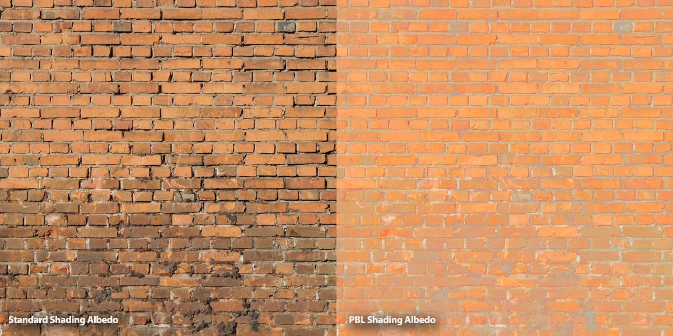
Alembic
Alembic is an interchange file format for computer graphics used by visual effects and animation professionals. Alembic efficiently stores animated vertex positions and transforms that result from arbitrarily complex animation and simulation. Alembic doesn’t store graph networks or relationships as in those created with rigging.
Aliasing
When referring to pictures, aliasing is the effect that occurs when a line looks jagged instead of smooth because of a contrast in colors. Usually, you can tell when this happens because the line between the colors looks very jagged, as if it were a flight of stairs, in fact it is often referred to as a "stairstepping" effect. For contrast, see antialiasing.
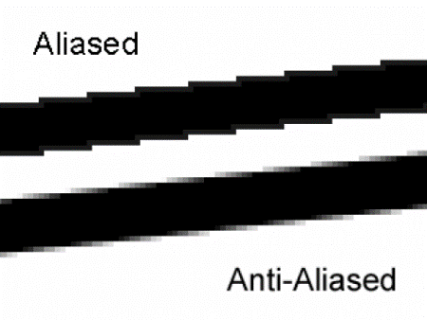
Alpha Channel
One of the four channels (or components) of information that make up every pixel in an image. There are three channels for red, green, and blue (RGB) and one alpha channel. The alpha channel is really a mask - it specifies the transparency of each pixel, which allows portions of the foreground image to reveal the background when two images are overlaid.
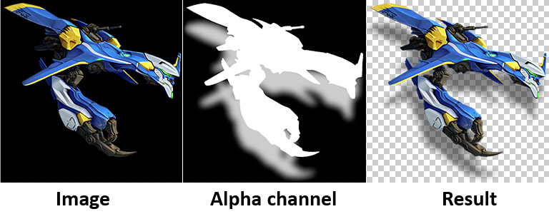
Ambient Light
All-directional light illuminating every object uniformly from all sides.
Ambient Occlusion
Method to approximate how bright light should be shining on any specific part of a surface, based on the light and its environment
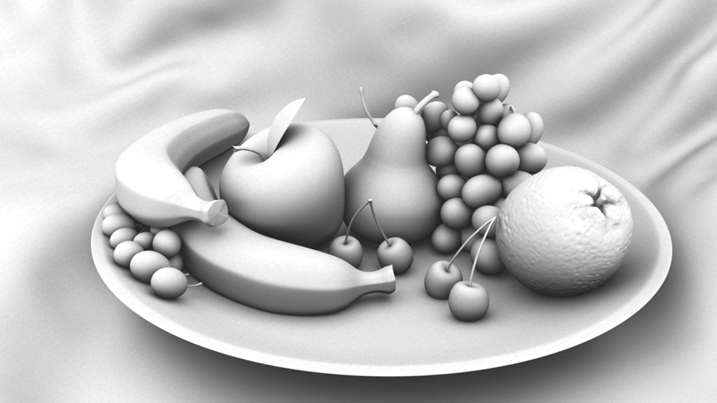
Anti-aliasing
A method for blending harsh contours and preventing staircasing or stairstepping. It is achieved by taking the surrounding areas into account when assigning a color value to pixels lying on an object's contour.
Area light
A special kind of point or spotlight. The rays emanate from a geometric area instead of a single point (entire surface uniformly emits light). This is useful for creating soft shadows with both an umbra (the full shadow) and a penumbra (the partial shadow).
Array
A set of elements put together into a single entity. A pixel array is an ordered set of colored elements used for display purposes.
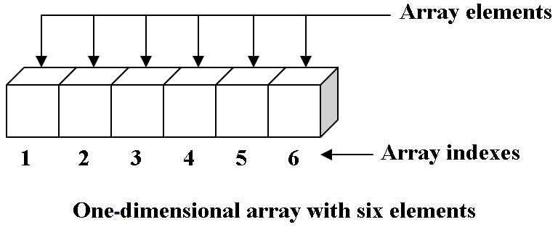
Aspect ratio
A description of the proportion of an image by comparing its width to its height. 16:9 is the common aspect ratio.
Attenuation
When light travels through air its strength diminishes with the distance. The further the light travels, the dimmer the light. In real life, the light attenuates by the inverse square of the distance. This means that if attenuation is turned on for a light only the geometry in its proximity will be lit. Not only is this more realistic for your renderings, it also helps speed up rendering time since only the geometry close enough to be affected by the light needs calculation time.
Backface culling
A process included in most 3D graphics pipelines, backface culling eliminates triangles facing away from the camera. This is most efficiently performed by checking the orientation of the triangle normal in relation to the camera. The technique ignores geometry seen from behind so that only the fronts of objects that are facing the camera are rendered. Both faces of an object are rendered by default; that is, the ones whose normals are facing the camera as well as those that are not. You can choose which faces of the object you want to render as part of the rendering options: front, back, or both faces. Back culling (rendering only the front) can improve performance because less geometry needs to be rendered.
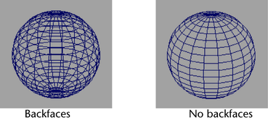
Baking
Consolidating a system of data into a simplified more permanent form. Example in light lightmap baking, texture baking and baking of simulation.
Bidirectional Reflectance Distribution Function
A function of four real variables that defines how light is reflected at an opaque surface. Incoming light direction, view direction, how much certain wavelengths are absorbed or reflected from a specific surface, and the positional variance of the surface
Billboard
A 2D image typically created to fake a 3D model by having it’s orientation automatically computed so that it always faces the camera.

Bit
The building blocks of computer data. Has either the value of 1 or 0 (current or no current). Bits can be grouped together to carry larger values.
Bump Map
Creates the illusion of three-dimensionality of a surface (protrusions and cavities) by recalculating the normals of the object, without changing the mesh itself. It is very common in 3D renderings and suitable for creating effects like wrinkles, creases, crumples, cracks, seams etc. The silhouette of a bump mapped object is a give-away since, in these areas, it is obvious that the mesh is left unaffected (if trying to create an orange by using a perfect sphere with an orange peel texture applied to it for bumpmapping will still have a impeccably round silhouette).
Byte
8 bits. Multiples of bytes make up the terms kilobyte (1024 bytes), megabytes (1024 kilobytes) and gigabyte (1024 megabytes).
Caching
Used to describe the processing of baking animation and simulation data to increase performance of your scene. The vertice locations are decided based on saved data from a past simulation instead of being re-calculated again each time it is played.
Clean Modeling
Refers to the practice of removing geometry from a model that is not wanted or needed. Also refers to the use of proper geometry construction techniques, such as creating continuous surfaces, minimizing narrow faces, and avoiding small corner angles.
Clipping
More often than not, much of the graphics drawn for a specific scene does not fit into the viewport of the camera. Accordingly, those which fall outside of the viewport must be clipped so as they are not drawn. Depending on the nature of the application, there are two kinds of clipping: 2D and 3D. The earlier simply compares each pixel against the extents of the rendering viewport, while the latter technique uses the six sides of the view frustum to determine whether a 3D vertex is inside the viewport or not.
Color Depth
Refers to the number of bits per pixel on a computer monitor used to represent a specific color. The more bits per pixel, the higher color variety and quality of the monitor. For example, an 8-bit image uses 2^8=256 colors. The bits are divided into red, green and blue (optionally an alpha channel as well).
The following table indicates the number of colors an image can have.
8-bit = 2^8 = 256
16-bit = 2^16 = 65536
24-bit = 2^24 = 16 million
32-bit = 2^32 = 4.3 billion

Color Model
A system used to specify colors. Two Popular models. HSV Hue, Saturation and Value. Hue refers to the position of the color in the spectrum, such as red, yellow, or green. Value is the amount of white mixed in a color, such as the difference between a pure red and pink. Saturation is the purity of the color, such as the difference between a pure red and a dusty rose - low saturation means that there is more grey in the color. RGB is a color model that mixes the three primary colors to produce colors. To create yellow, red and green are mixed without any blue component. The higher the value of the red, green and blue, the clearer the color. Lower RGB values give darker colors, higher gives lighter.
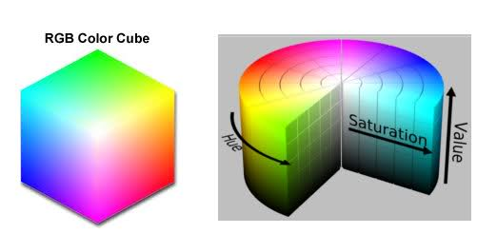

Cookie
A device for casting shadows or silhouettes to produce patterned illumination.
Cross Product
Using two vectors to calculate a normal of the two.
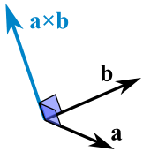
Cube map
A type of reflection map where the environment is projected onto the sides of a cube and stored as six square textures, or unfolded into six regions of a single texture. A shader can use this map to simulate a reflection.
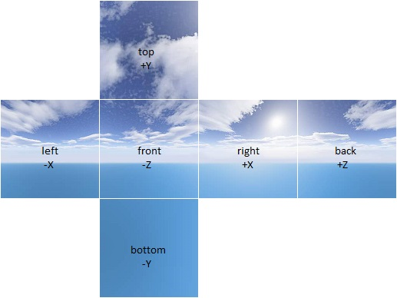

Deferred Rendering
Rasterizes all of the scene objects without lighting and stores specific information about the scene into a special buffer called the G-Buffer. This information includes screen space depth, surface normal, diffuse color, specular color and specular power. A lighting pass is performed by rendering each light as a geometric object in the scene and then each pixel touched by the light geometry is shaded by the desired lighting equation.
Depth buffer
Same as a Z-Buffer.
Depth of Field
The total distance, on either side of the point of focus, which, when viewed from an appropriate distance, APPEARS sharp in the final print.
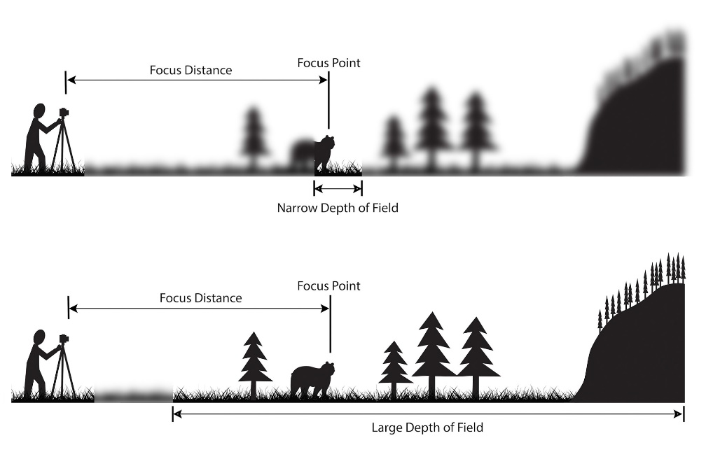
Dielectric
Term used in shading to describe nonmetal material
Directional Light
A light with color, intensity and direction. All rays emitted from a distant light are parallel, and therefore it has no obvious source. Directional lights can be used to simulate point lights from a great distance (whose rays can be approximated to be parallel) like for example the sun. The intensity from a distant light does not decay.
Displacement Map
Can be used to modify the actual mesh (as opposed to the bump map) to create wrinkles, creases, crumples etc. The displacement map will need a more complex mesh to create the same effect as bump mapping, but has the advantage of allowing more thorough close-ups, since the surface is actually deformed and not just simulated as being so.
Dithering
Creating the impression of having more color on the screen than there actually are by plotting pixels (with a limited amount) of different colors next to each other. Used to make cheaper textures. Can also be used to create transparency if done in the alpha channel.
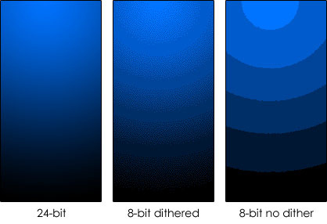
Dot Product
Technique used to find the relationship between two vectors. Two vectors at right angles to each other have a dot product of 0. If the angle between two vectors is less than 90 degrees, the dot product will be positive, if the angle between two vectors is greater than 90 degrees the dot product will be negative.
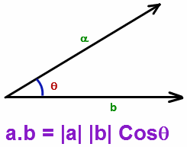
Draw Call
Draw calls are calls to the graphics card used to draw the mesh to the screen, reducing them reduces overhead for the GPU. Having too many draw calls can slow down performance
Environment Map
Map often used to simulate (fake) reflection of the surrounding world without using ray tracing.
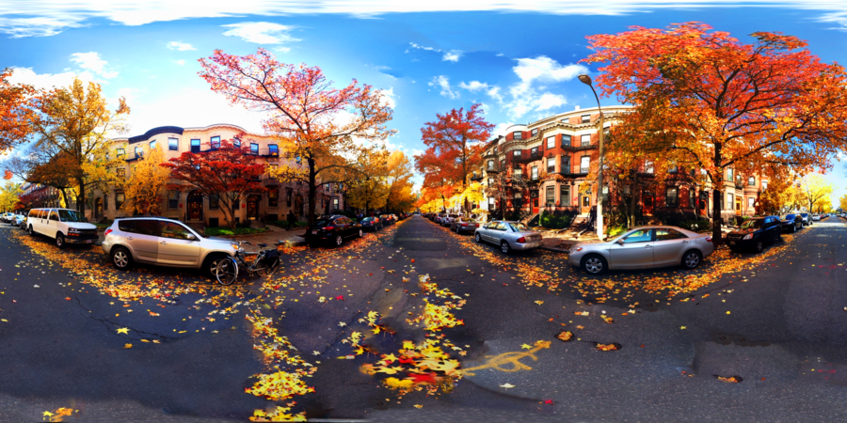
Euler Angles
Euler angles are one of the simplest methods of representing 3D rotations, and generally also the easiest to visualize. An object's rotation can be specified in terms of its yaw, pitch and roll, or rotation around the Y, X and Z axis, respectively. Euler angles suffer from singularities in the form of so-called Gimbal lock.
Face Normal
Also just known as the normal, this is a line perpendicular to the face that also describes which way the face is pointing in a one-sided polygon.
Field of View
(FOV) The angle of the view frustum. The wider the FOV, the more you see of the scene. Human eyes have a FOV of about 50 degrees, and normally virtual reality application use similar values to resemble real life.
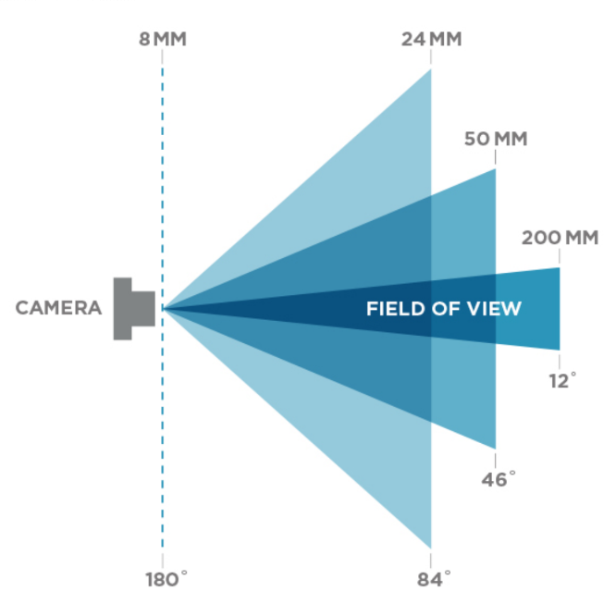
Fill Light
Additional light sources assisting the key light in a scene. Usually they are less intense than the key light and created using point light or spotlight.
Forward Rendering
Rasterizes each geometric object in the scene while considering the lights affecting it. All the different geometric objects that make up a scene are then blended together to create the final frame.
Frame-buffer
The memory a computer uses to hold one or more frames for later use.
Frame-rate
The speed at which a frame of animation is shown, usually expressed in frames per second (FPS). This is the main a unit of measure that is used to describe graphics and video performance. US TV is typically 29.97 frames, European is at 25 frames per second and movies are projected at 24 frames.
Fresnel
The Fresnel effect describes the relationship between the angle that you look at a surface the amount of reflectivity you see. The Fresnel describes how strong the Fresnel effect is at a specific point. Something with a high Fresnel effect makes the edges look brighter.

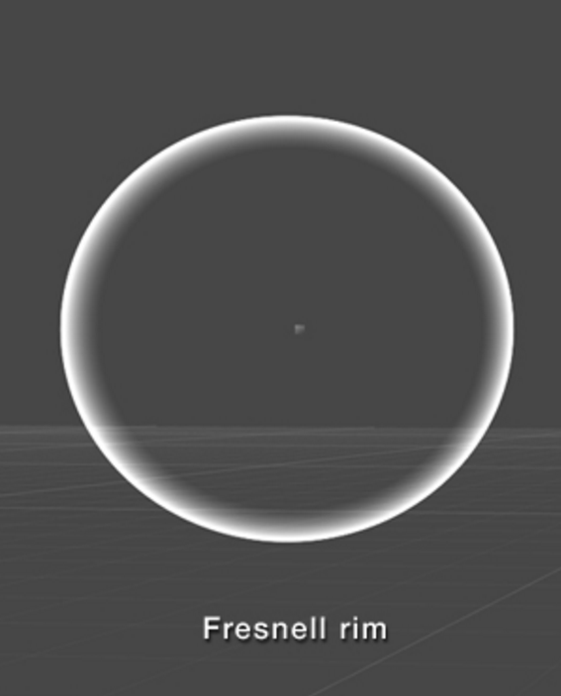

Game Engine
A software framework designed for the creation and development of video games.

Gimbal-Lock
What happens when two axes of rotation line up, thereby making 3-dimensional rotation impossible.
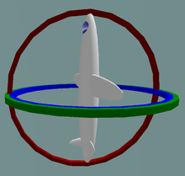
Global Illumination
Unlike the local illumination, this method of generating images supports effects not only linked directly to the light sources themselves. In real life, the intensity of a surface not only depends on direct illumination from the light source itself, but also from indirect illumination from surfaces being lit. First there is ray tracing that can cast shadows from one object onto a surface, allow objects to be reflected in shiny surfaces or refracted in transparent materials. Then there is radiosity, the effect of reflected light. If you have spotlights projected at the ceiling in a white room, the light would bounce back and light up the entire room. However, this can only happen if the renderer supports radiosity or other similar techniques.
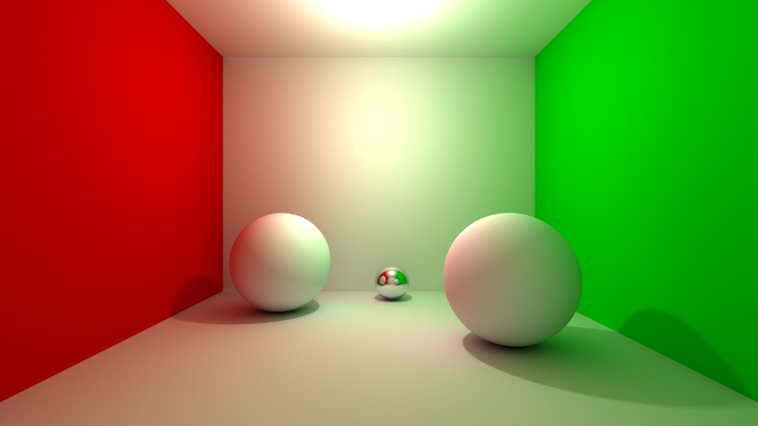
Glossiness
This option affects how spread out across a surface a highlight caused from a light is. Low glossiness makes a spread out highlight while high glossiness creates a more central, pinpointed highlight.
Glossiness Map
An image to control the glossiness of a surface. Bright values in the image indicate more glossiness, dark values less. The inverse of a Roughness Map.
GUI
Abbreviation for Graphical User Interface.
Hertz
Unity of frequency. The refresh rate of you monitor or television, how many times your screen draws per second.
High Dynamic Range Image
HDRI is an image with a wide intensity range between the brightest and darkest pixels. In typical 8/24-bit images, the maximum possible intensity range is 255 times brighter than the darkest gray pixel (with a value of 1). High Dynamic Range Rendering allows bright things to be really bright, dark things to be really dark, and details that can be seen in both. To display HDR images in games a larger value range then what is visible or possible to render to the screen is stored in the framebuffer. Then the final output (what is displayed on the screen) uses a tone map to match colors (after light computation) in the HDR to the suitable counterpart in the LDR (low dynamic range).
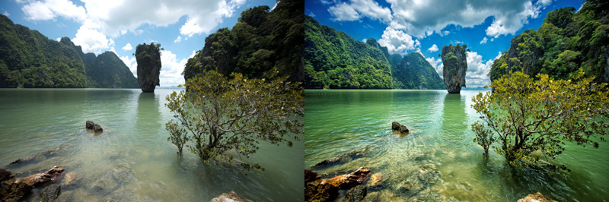
Indirect illumination
Light that bounces of one surface and illuminates another surface.
Interpolation
The process used to estimate an unknown value between two or more known values.
Interreflection
When a reflective object reflects another reflective object. For example, if you place two mirrors in front of each other, the first one will display the second one, who, in turn, shows the first one. In real-life, there is virtually no upper limit of how many interreflections that may occur, whereas in 3D rendering, one must set an upper limit to be able to render the scene.
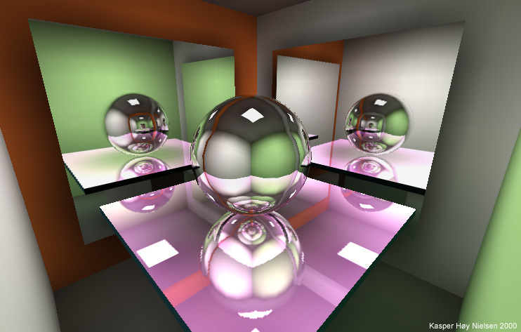
JPEG (Joint Photographic Experts Group)
A widely accepted, international standard for compression of color images.
Key, Keyframe
A marker on the animation timeline that shows that a node's (e.g. an object, a material or a light) attribute (e.g. position, color or intensity) in the scene graph has been assigned a new value. Most animation programs interpolate the node attribute values from one key to the next, creating smooth transitions - so the user does not have to key every single frame. See also tween.
Lens flare
Optical light effect made up from a number of bright discs. If the rays from a light source reflects off the surface of a compound lens in a camera, it can generate star-like patterns on the image. Created using a billboard image attached to the light.
a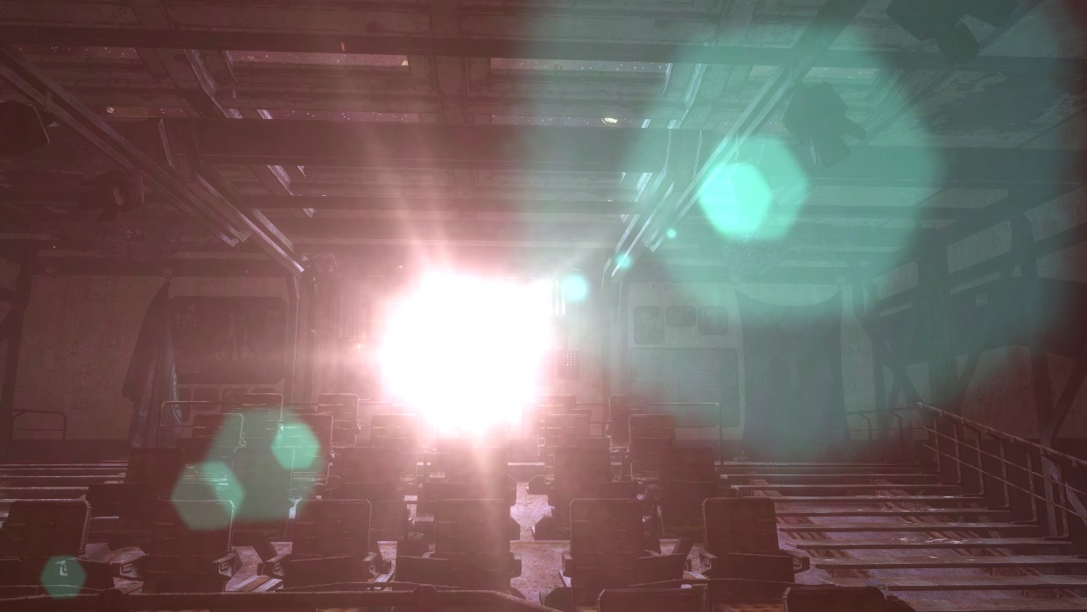
Level-of-detail
This is a term that is talking about varying the amount of detail in an object depending on the distance from the object to the camera. Example: A car for a close-up would need to have every little detail modeled into it. Chrome, bumpers, body seams, door handles, etc. But that same car, as seen from a helicopter flying over a highway, might be able to be a simple cube with an image map applied to it.
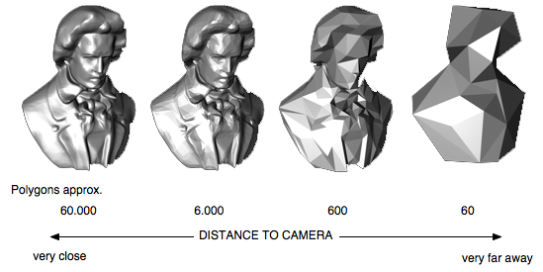
Lightmaps
Baked lightmaps are texture maps that include all the lighting information in a certain level of a game. These texture maps are used to update the look of the asset in the level as if they are being affected by lights at runtime. This means well-lit areas can have the fraction of the performance cost. Assets using lightmaps can also be affected by dynamic lights (lights that are not included in the lighting used to bake the light maps).
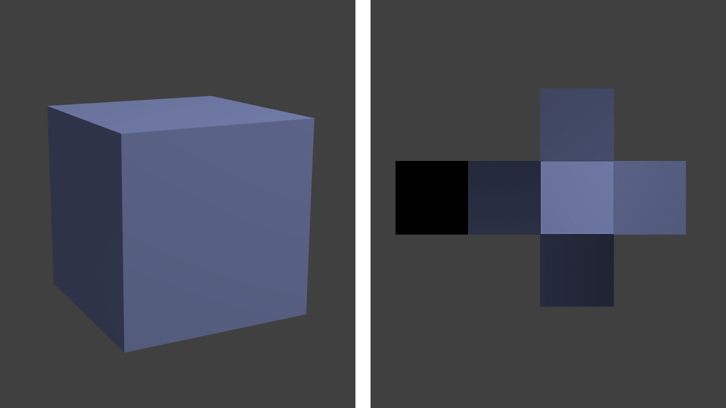
Local coordinate system
As opposed to the world coordinate system the Local Coordinate System is tied to a specific object. LCS are used, among other reasons, to simplify the representation of complex objects by using several, different LCSes as reference points for the object's vertices. It is also easier to transform the object if you for instance can rotate it around its own "center of gravity" instead of the origin of the World Coordinate System.
Matrix
Matrices form the core of linear algebra and are important tools in most engineering disciplines. In essence a two-dimensional array of numbers, matrices are often used in transforms of different properties, such as rotation, scaling, translation, deformation, and much more.
Metadata
Data providing information about one or more aspects of the data; it is used to summarize basic information about data which can make tracking and working with specific data easier.
Metalness Map
Black and white map that labels the parts of a model that are metal. White means it is metal, black means it is dielectric.
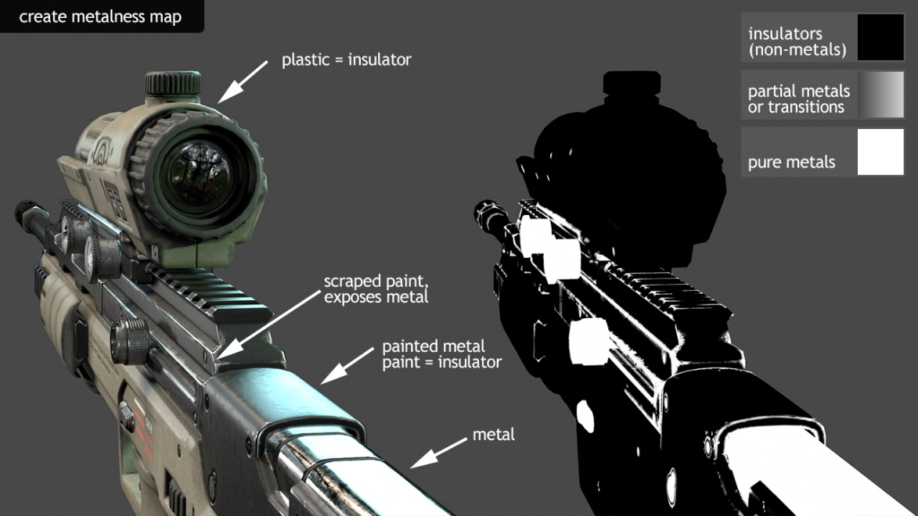
MIP-mapping
Using a pyramid structure of a predefined fixed amount of differently sized bitmaps (original size, original size/2, original size/4, etc) to speed up rendering time by using less detailed textures for distant objects (represented by only a few pixels on the screen), and the full-sized version of the bitmap when the objects is closer to the observer. This way, moiré-pattern can be avoided.
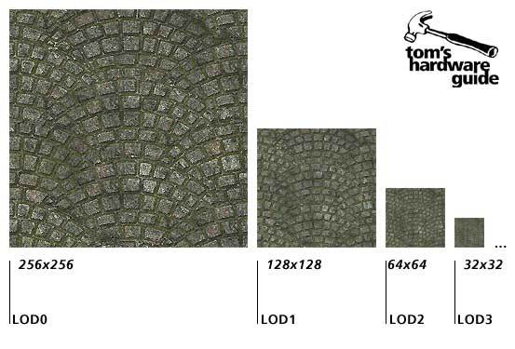
Moiré pattern
Optical pattern created due to aliasing. Usually appears as a swirling pattern along a distant edge.
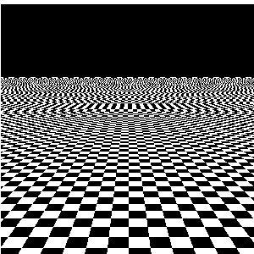
Motion blur
The blurring of objects that move while the camera shutter is open, creating the illusion of movement. Motion blur also prevents strobing caused by too-rapid of movement.
Node
The basic graph element used to represent distinct items that when used together build a larger network. This larger network or graph can represent some elements of your game such as a 3d model, material or gameplay mechanic.
Normal
A normal is a vector that is perpendicular to a mathematical entity, such as a line or a plane. In 3D, the normal can be used to define the direction a polygon is facing.
Normal map
An image that stores a direction at each pixel. These directions are called normal. The red, green and blue channels of the image are used to control the direction of each pixel’s normal. This creates the illusion of more detail allowing for a smaller vertex count on the mesh.
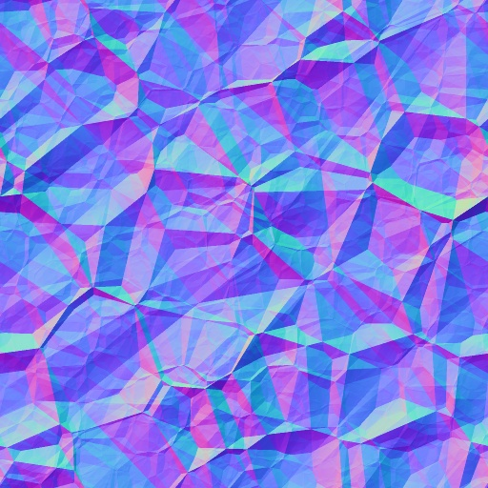
Pan
To rotate the camera horizontally. As opposed to the orbit movement, the pan rotates the camera around a single axis, as if it where mounted on a tripod.

Parallax mapping
A surface technique that significantly boosts a textured surface’s detail and gives it a sense of depth It is a shading technique that displaces the individual pixel height of a surface so that when you look at it at an angle the high points will obscure the lower points behind them making it look three-dimensional.

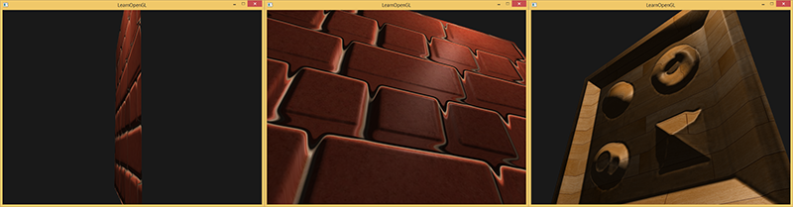

Penumbra
A partial shadow, as in an eclipse, between regions of complete shadow and complete illumination, a fringe region of partial shadow around an umbra.

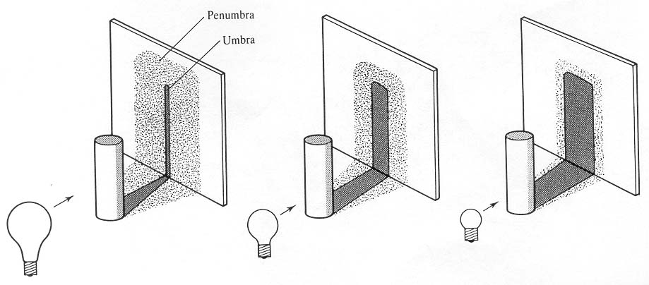

Pipeline
Generic term to describe the steps required to take something from start to finish. A set of data processing elements connected in series, where the output of one element is the input of the next one.

Pitch
The amount that the camera or an object in the scene is tilted up or down. If you nod your head yes, you are rotating your head in the pitch axis.

Pixel
Short for Picture Element, a pixel is the smallest element of computer or video display.

Pixel Shader
Also called a fragment shader. The Pixel Shader is a program that computes the color of a pixel based on information supplied by the Vertex Shader, textures, and other user added input. Pixel Shaders create the details of your assets. Handles calculations of lighting, shadowing, specularity, reflectivity as well as many other surface effects
Physical Based Rendering
Physically-based rendering (PBR) is a method of shading & rendering, used in order to provide a more accurate representation of the real (physics-based) world around us.

Point light
Light source emitting light in all directions (omni-directionally) from a single point in space. It takes six shadow (one in each orthogonal direction) calculations to render shadows generated by a point light, which means that inserting multiple point lights in a scene might slow down rendering time considerably. Point light emanates in all directions, think "light bulb".

Quaternion
Quaternions are mathematical objects consisting of a scalar and a vector which together form a four-dimensional vector space. Although having interesting uses in mathematics, their main use in computer graphics resides in their capability of easily representing 3D rotations. Although impossible to visualize, they suffer from no singularities like Euler angles. They are useful to calculating the shortest rotational steps required for an object update its rotation.

Radiosity
A more physically correct approach (developed in 1984 by Siegel and Howell) to simulate propagation of light in a virtual environment. It takes into account the fact that light bounces off a surface and creates diffused lighting on the surrounding objects. The scene is divided into a certain amount of triangles that are used to represent the original scene (which speeds up the time-consuming process), and then radiation interaction is calculated using these triangles. As far as visual quality is concerned, the more crucial the part of the scene the denser the triangles must be. This technique creates much more realistically lit environments, however it takes much longer to render due to the massive amount of calculations.

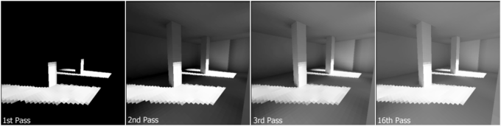
Rasterization
The process of, on a per pixel basis, determining what value to assign to the pixels on the screen from a vector based image.
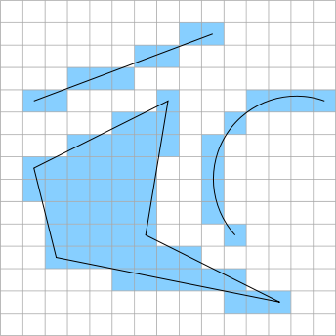
Ray-traced shadow
Shadow created by tracing the light rays from a light source. The ray-traced shadows are more accurate than those created by shadow map, but takes longer time to render and always have crisp edges
Ray tracing
An advanced rendering technique capable of calculating reflections, refractions and shadows. Raytraced renderings take more time to generate, but have a photorealistic quality.
Ray tracing depth (ray recursion limit)
Number of times the light bounces off a surface when ray tracing. Used to create reflections and/or refractions. For example, ray tracing two mirrors facing each other with the ray tracing depth set to 3 will allow the image of the reflected mirror to show the first mirror in it.
Reflection
Light that bounces off a surface. A mirror is highly reflective, whereas the reflection of a matte rubber surface is insignificant. See Metal Map.
Reflection map
Simulates reflections in a surface using the reflection map instead of actually ray tracing the reflected image. It is an efficient image-based lighting technique for approximating the appearance of a reflective surface by means of a precomputed texture image. A cube map is a type of reflection map.
Refraction
When light passes through a transparent material and into a denser or less dense medium the light rays are refracted and change direction. Each material has its own and depending on the density of the material the refraction is more or less evident. Refractions are calculated similarly to reflections using ray tracing.
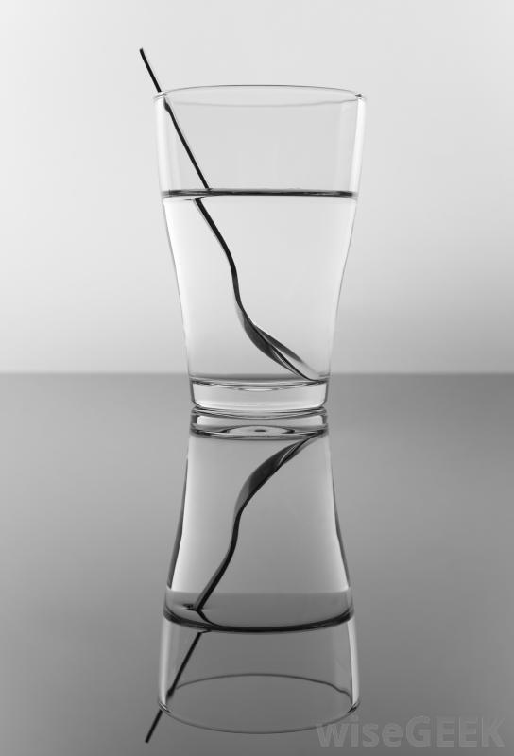
Refraction index
A value describing the amount of refraction that takes place in a specific transparent material. For vacuum the refraction index is 1.0000, for air 1.0003, for glass approximately 1.5 and for water 1.3333.
Refraction map
An image to control the level of refraction across a surface where dark values indicate a low refractive index and bright ones a high refractive index.
Render
To cause to become, to make, to process. To mathematically generate geometries, algorithms, reflections, etc. Our work would be meaningless without the ability to render. Creating a final image of a model that shows all of the surface properties that have been applied to an object. This process involves adding all colors; bump maps; shading; and other elements that add realism. In a normal 3D program, the user can view the wireframe of the created image. When an image is rendered, the wireframe is covered with the specified colors and properties.
Render pass
A division of a scene according to different aspects (such as highlight, mattes, or shadows) for the purposes of applying specific rendering options. Passes can then be composited during post-production. The default pass is the beauty pass, which includes all objects in the scene. Preset passes include matte, shadow, and highlight passes. You can also define your own passes to include any object you want to be affected by specific rendering properties. Render passes are further divided into partitions.
Rendering pipeline
Description given to the process of creating the rendered images. Some studios have a process by which all the images go through. Some render in passes, one for the base, then the shadows, then the reflections, etc. This process is the pipeline.
Resolution
The number of picture elements (pixels) in an image.
Rigging
The process of making an object ready for animation. This does not have to be just characters; it is the same for all objects. Rigging involves creation and implementation of bones, hierarchies, clamps, weight maps and sliders.
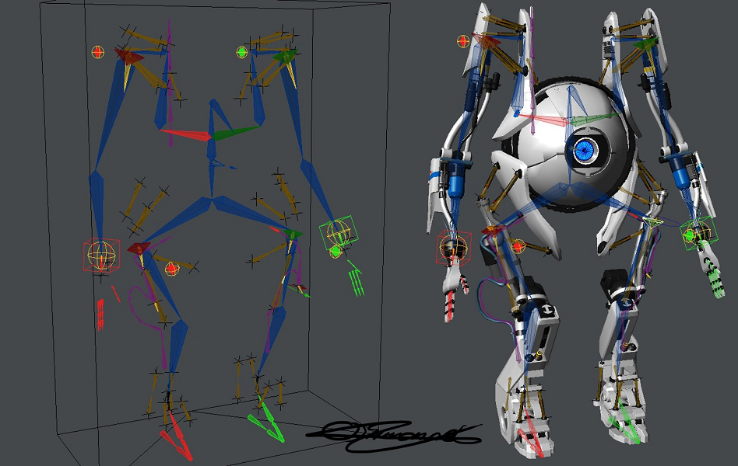
Roll
The amount that a camera is tilted to the left or right. Also known as the bank angle.

Roughness map
Greyscale texture map that describes the micro details of the surface manipulating how light reacts with it. Black means smooth and white means rough.

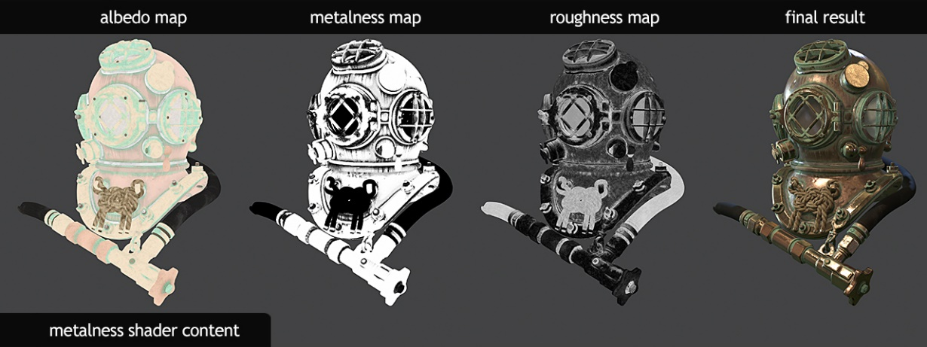

Scalar
A quantity, such as mass, length, or speed, that is completely specified by its magnitude and has no direction, a one-dimensional value.

Screen tearing
A visual artifact in video display where a display device shows information from multiple frames in a single screen draw. The artifact occurs when the video feed to the device is not in sync with the display's refresh rate.
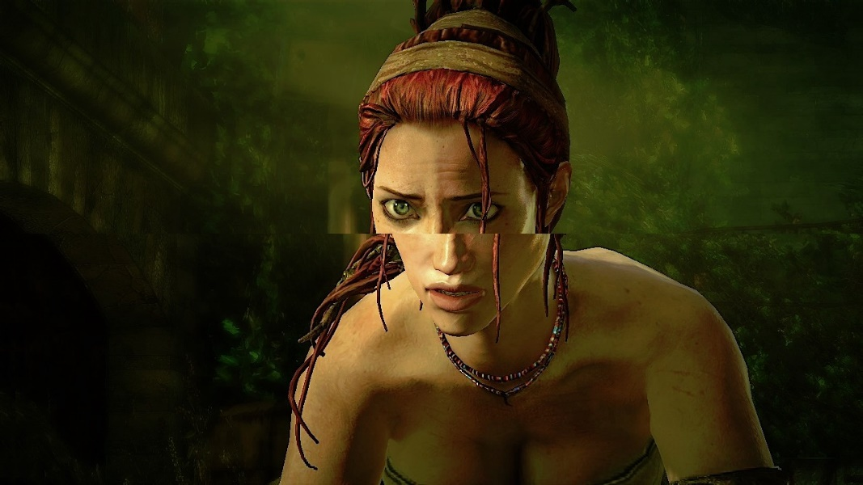

Secondary animation
Once the main movements of animation have been applied, this refers to the detail animation step. Hoses bouncing with a robot walking, flab wiggling with a heavyset character, these refer to secondary animation.

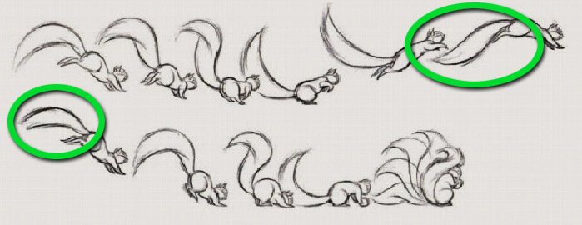

Shader
A shader is simply a program that describes how something looks. It describes the rendering steps for the GPU to create an accurate representation of the object it describes. There are two components of shaders called pixel and vertex shaders.

Shadow map
Bitmap generated by the rendering engine during a pre-render pass of the lit scene. Generally, a shadow map is less precise than a raytraced shadow, but takes less time to render. As opposed to a ray-traced shadow, a shadow map can create shadows with smooth edges. The quality of the shadows in the rendered image depends on the size of the shadow map. The bigger the map the nicer the shadows. Too small shadow map might result in aliased or stairstepped edges. For example, a 256x256 shadow map (65k)is normally sufficient for resolutions of 320x200 and less. If an object is far away from the light source, the shadow map will have to be increased in order to maintain visual quality. If the final rendering is in high-resolution, the shadow map also needs to be hi-res.

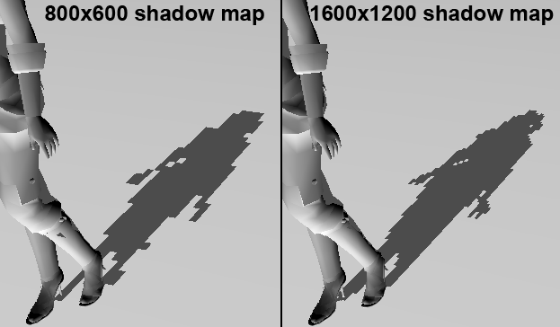

Specular
This property determines how shiny (and sometimes wet) an object appears. It represents the highlight that the light creates when shining on an object.

Spotlight
A light source emanating light in one direction only, in the shape of a cone.
Texture baking
Used to transpose characteristics of 3D geometry into 2D image textures. Many characteristics can be baked such as ambient occlusion, normals, and vertex color.
Tiling
Repeatedly placing the same texture next to itself on the same surface, creating a pattern from one image. This is achieved by increasing the texture coordinates on a polygon to a value greater than 1. Normally, the entire bitmap is tiled from 0.0 to 1.0 in u- (=x) and v (=y). Tiling textures means placing them next to one and other.
Umbra
A dark area, especially the blackest part of a shadow from which all light is cut off. The completely dark portion of the shadow cast by the earth, moon, or other body during an eclipse.
UV map
A 2D representation of a 3D mesh. The U-direction and V-direction correlate to a position on a 3d mesh (x,y,z). Used for applying textures to your 3d asset.
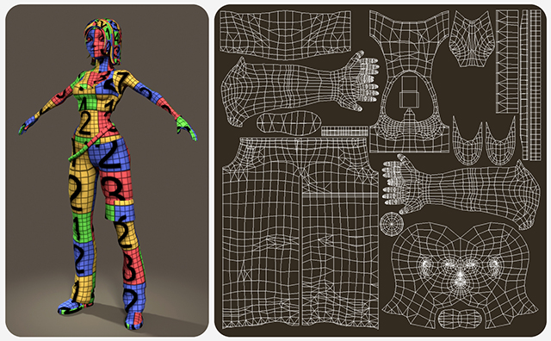
Vector
Entity with both magnitude and direction. A three-dimensional vector is written as:
V=(v1, v2, v3) where each component is a scalar.
Vertex Shader
The Vertex Shader processes vertex related data such as the position of the vertice, it’s normal direction and texture coordinate. Vertex Shaders are able to make changes to a model’s existing vertices
View frustum
Representing the field of view of the camera, the view frustum is a pyramid volume with the top sheared off. The top of the pyramid represents the viewport of the camera (usually the screen), and is often called the near (or hither) plane, while the bottom is called the far (or yon) plane.
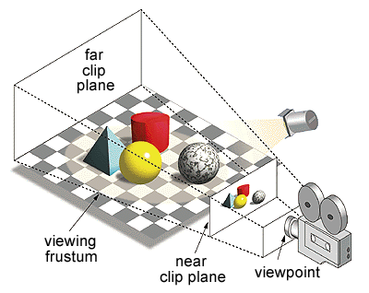
View frustum culling
Removing faces that lie outside the observer's view. Only the faces that is within the view frustum is kept for rendering - speeding up rendering time and helping to maintain a high framerate.
Viewport
Window area displaying orthogonal or perspective projection in a 3D application. The screen can either contain one big viewport or several smaller, tiled viewports.
Volumetric fog
Fog that, opposed to ordinary fog, is restricted to fit within a containing volume.
Volumetric light
Light simulating illumination of particles floating in mid-air, thereby making the light cone itself visible.
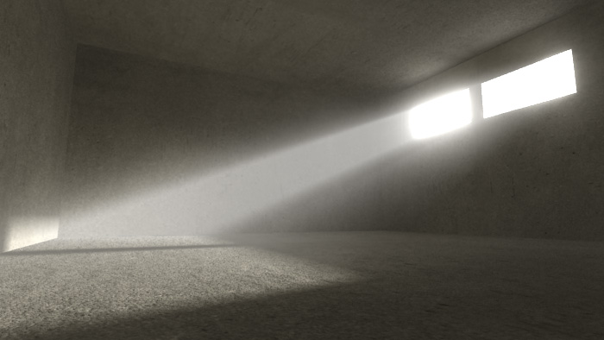
Voxel
Short for Volume Element, a voxel is a three-dimensional pixel, that is, a cube, with a specific color.
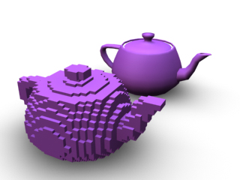
World coordinate system
The coordinate system, normally in three dimensions, used to describe the location in space of a specific point called vertex.
Z-buffer
Also called depth buffer, the z-buffer is a two-dimensional matrix of 16- or 32-bit integers with the same dimensions as the screen (or viewport). Whenever a polygon is drawn to the screen, the rasterizer checks the corresponding z-buffer value for each screen coordinate and skips drawing the current pixel if the z value is marked as being closer. This allows for some nice effects such as overlapping 3D models, and completely solves the rendering-order problem. However, this comes at the price of slower performance and greater memory usage, two factors that have become more or less moot with the proliferation of modern 3D accelerators that tend to support z-buffers in hardware.

