FK/IK Switching
FK (forward kinematics)
- Good for most motions
- Allows you to animate clean arcs, follow through and overlapping action
- Use case
  - Waving arms
  - Adding follow through on corruption’s coat tail
  - Any chain-like movement
IK (inverse kinematics)
- Good for goal based motion
- Allows you to position the hand or feet in a set location
- Hand or feet will remain in that position regardless of the body’s movement
- Use case
  - Walk cycles (keep the feet planted on the ground)
  - Pushing an object (keep the hand on the object)
Select Switch (Ctrl + Shift + a > Switch > Select Switch)
- Selects the switch anim of a certain limb
- For example
  - Selecting the left hand and selecting switch will select the left arm switch anim
Just Switch (Ctrl + Shift + a > Switch > Just Switch)
- Simply switch between FK and IK controls
- Warning: not guaranteed to match between poses. Most likely they will not match poses.
Align Switch (Ctrl + Shift + a > Switch > Align Switch)
- Switch between FK and IK controls and automatically match poses
- Warning: depending on the pose, the pose may not match completely
Align Switch and Key Before (Ctrl + Shift + a > Switch > Align Switch and Key Before)
- Switch between FK and IK controls and automatically match poses. It will key the FK/IK switch anim 1 key before the current key. This extra key will state that from this frame on, this limb will use IK or FK controls.
- Use this when you find the frame where you want to switch from one control scheme to another.
  - Examples
    - When the hand first contacts the arm rest of a chair (align switch to IK and key before)
      - This will keep the hand stationary on the arm rest
    - When the hand comes off of the arm rest (align switch to FK and key before)
      - This will allow you more control of the arm
Notes:

IK/FK switch anims
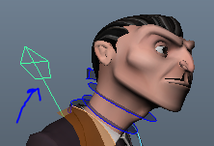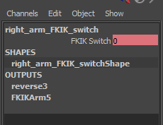
- The FKIK Switch channel can be set to either 0 or 1
  - 0 = FK
  - 1 = IK
- This makes it easy to edit when you want FK or IK in the animation via the graph editor.
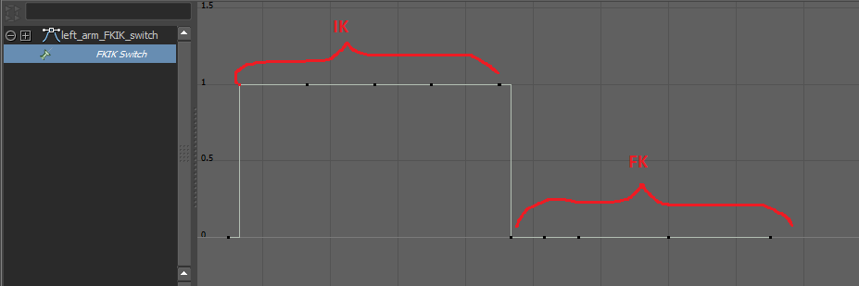
- Make sure that these curves in the graph editor are stepped. Otherwise your motion will overshoot. This is BAD.
