Beatsheet

ACTS | SEQ | BEAT DESCRIPTIONS
ACT 1 | 1 | It’s a beautiful day in the park; the fountain is on, and everybody seems bright and cheerful.
 | 1 | A mother and her daughter (Penny) walk up to the fountain.
 | 1 | Penny excitedly looks into the fountain and sees a group of dancing ducks.
 | 1 | The ducks are spinning and doing the samba.
 | 1 | Penny is delighted dancing
 | 1 | Penny tugs on her mother's arm.
 | 1 | Alice hands Penny a coin to throw into the fountain
 | 1 | Penny cradles the coin and pulls it close to her chest.
 | 1 | Penny closes her eyes and wishes for her father to return.
 | 1 | Penny comes out of her dreams closes her eyes and throws the coin
 | 1 | The coin shimmers through the air embodying the happy innocence of penny
 | 1 | Coin is snatched out of the air by a slimy hand
 | 1 | Penny is happily distracted by the dancing ducks
 | 2 | The man who caught the coin, Corruption, looks greedily at the coin he has just acquired.
 | 2 | Corruption pockets the coin.
 | 2 | Corruption, concealed behind bushes peeks over to make sure that no one is watching
 | 2 | With an evil grin Corruption begins unlocking his briefcase
 | 2 | Corruption halts and turns to find Goose looking inquisitively at the briefcase
 | 2 | Corruption angrily throws the goose over the bush
 | 2 | With a smirk and a wiggle of fingers corruption pulls a swan decoy out and affixes it upon his head, obviously pleased with himself.
 | 2 | A swan pops up above the bush
 | 2 | Corruption slithers over to the fountain
 | 2 | Corruption looks over the fountain edge greedily at the coins in the water
 | 2 | Corruption slinks into the water himself.
 | 3 | At the fountain’s edge, a couple, dreaming of a baby, toss a coin in.
 | 3 | Corruptions head pops up momentarily and swan moves toward coin in a predator like manor
 | 3 | Under water, Corruption swims over and pockets the coin.
 | 3 | Corruption continues to collect even more coins.
 | 3 | Corruption is overjoyed by how well his scheme is working.
ACT 2 | 4 | Gooses is swimming along in the fountain
 | 4 | Gooses fake swan and acting strangely and goes to investigate
 | 4 | Goose puts his head under the water suspiciously...
 | 4 | And is shocked to discover Corruption.
 | 4 | Gooses Realizes that it is Corruption and tries to signal to the crowd
 | 4 | Crowd thinks that it is one happy dance
 | 4 | Corruption, bothered by the gooses feet pull him under putting a stop to the whistle blowing
 | 4 | Corruption pushes goose away and goes in search of more coins
 | 5 | Goose recovers and launches an attack
 | 5 | Corruption Is completely absorbed with his greed
 | 5 | Goose attacks Corruptions nose
 | 5 | Corruption flees in fright/surprise
 | 5 | Case ensues, looks like it is part of the ducks dance
 | 5 | Penny is excited by the antics
 | 5 | Having enough Corruption grabs goose and tries to strangle him
 | 5 | Goose breaks free momentarily
 | 5 | In the struggle Corruption drop pennies Coin
ACT 3 ? | 6 | Coin gets jammed in Plug
 | 6 | Corruption abandons his struggle with the goose in order to save the coin
 | 6 | Corruption struggles and frees the coin unknowingly dislodging the plug because he is too engrossed in the the coin
 | 6 | Corruption is clued into the Draining fountain by a coin that is swirling past him
 | 6 | Corruption begins to panic
 | 6 | Corruption gets pulled into the vortex, with coins flying out of his pockets
 | 6 | Corruption lands at the bottom of the drained fountain
 | 6 | The crowd are in shock with the revival of Corruption
 | 6 | Still distracted by his greed Corruption snatches pennies coin of the bottom of the fountain
 | 6 | Corruption realizes that the crowd is looking at him
 | 6 | Crowd gets angry
? | 6 | Penny is doesn’t know how to comprehend something that is not innocent
 | 7 | Goose is not impressed
 | 7 | Goose chases corruption out of the fountain
 | 7 | Corruption runs away with the crowd in hot pursuit
 | 7 | Penny is struggling with the idea that everything is not a happy and innocent

Family Tree

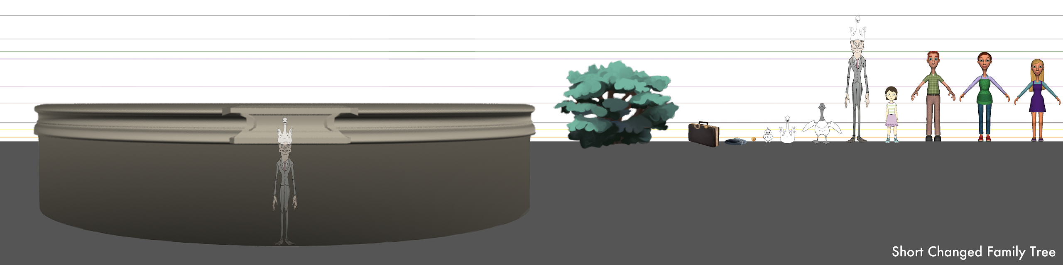

Sequence List

1. INTRO - establishes the happy fountain, ducks, and wishing people
2. BADGUY - introduces Corruption, and begins his relationship with the goose
3. GREED - shows Corruption’s scheme working wonderfully; this is his highest point
4. IMPOSTER - properly introduces the goose and his determination to reveal Corruption
5. CHASE - shows the goose temporarily stopping Corruption’s scheme, trying to expose him
6. REVEAL - finally exposes Corruption to everyone, making him his own undoing
7. END - shows Corruption pays for his actions, but the fountain isn’t the same anymore

Sequence and Shot List

Sequence | Shot # | Camera | Description
INTRO | 100 | Extreme wide | A girl and her mother walk up to a peaceful fountain.
 | 200 | Medium full | The girl looks at ducks in the fountain.
 | 300 | Wide | The ducks dance.
 | 400 | Medium full | The girl gets a coin from her mother.
 | 500 | Medium / Full inside dream | Holding the coin, the girl dreams of her father coming home from war.
 | 600 | Medium full | She throws the coin toward the fountain.
 | 700 | Close-up | The coin is suddenly snatched by a hand.
BADGUY | 100 | Close-up; tilts to medium up shot | Unnoticed, Corruption pockets the stolen coin.
 | 200 | Extreme wide; pans to full | Corruption peers over bushes, behind which he is hiding with a briefcase.
 | 300 | Close-up, down shot of briefcase | Corruption unlocks the many, many locks on the briefcase.
 | 400 | Full of Corruption; rotates to wide of both | Before opening the briefcase, Corruption notices a goose and throws it over the bushes. Then he pulls a fake swan out of the briefcase.
 | 500 | Wide downshot | Corruption slithers to the fountain with the swan on his head.
 | 600 | Medium downshot | Corruption peers at coins in the fountain.
 | 700 | Full | Corruption slithers into the fountain.
GREED | 100 | Medium | A couple with a coin dreams of a baby.
 | 200 | Wide upshot, over swan’s shoulder | They toss their coin into the fountain, toward the waiting swan.
 | 300 | Full; pans under- water to medium full of Corruption | Corruption peeks at the coin above water, then swims over below water to grab it.
 | 400 | Close-up of pocket; underwater | He pockets the couple’s coin.
 | 500 | Medium of pocket; underwater | Corruption steals more coins as they fall
 | 600 | Full of swan / close -up of Corruption | Another coin falls into the water as Corruption watches.
 | 700 | Close-up; underwater | His hand darts out to grab it underwater.
 | 800 | Close-up; underwater | He scoops up another coin.
 | 900 | Wide; underwater | Many coins fall around a delighted Corruption.
IMPOSTER | 100 | Full | The goose swims by and looks off-camera.
 | 200 | Wide, over goose’s shoulder | It looks at the swan, as Corruption peeks above water at another coin.
 | 300 | Close-up | The goose looks confused.
 | 400 | Wide | The goose swims over to examine the swan, then ducks underwater and sees Corruption.
 | 500 | Wide, over people’s shoulders | The goose motions at the swan, but the ducks make it look like a dance.
 | 600 | Close-up; underwater | The goose’s feet kick Corruption in the face.
 | 700 | Medium up shot; underwater | Corruption grabs the goose and shushes him, then swims off to get more coins.
 | 800 | Wide | The goose recovers and chases Corruption.
 | 900 | Medium up shot; underwater | Corruption catches more coins happily.
 | 1000 | Close-up; underwater | The goose bites Corruption’s nose.
 | 1100 | Medium; underwater | Corruption reacts in pain, then flees the goose.
CHASE | 100 | Wide | The goose chases the “swan” above water.
 | 200 | Extreme wide, pulling out slowly | The goose chases the swan, while the ducks dancing make it look choreographed.
 | 300 | Wide, over people’s shoulder | The people are delighted. The goose is suddenly yanked underwater.
 | 400 | Medium up shot; underwater | Corruption strangles the goose, until it breaks free.
 | 500 | Wide, over girl’s shoulder | The goose burst above water, looking beautiful, then is yanked back down.
 | 600 | Medium extreme up shot; underwater | Corruption grapples with the goose, making a coin fall out of his pocket, to his concern.
 | 700 | Moving close-up; underwater | The coin is sucked into the drain.
 | 800 | Medium extreme up shot; underwater | Corruption shoves the goose away and goes for the coin.
REVEAL | 100 | Full; underwater | Corruption tries to free the coin.
 | 200 | Close-up; underwater | He continues to struggle with it.
 | 300 | Full; underwater | Corruption frees the coin, but also accidently unplugs the drain.
 | 400 | Full; underwater | Corruption float backwards, holding his coin.
 | 500 | Close-up; underwater | A whirlpool builds out of the drain.
 | 600 | Close-up; underwater | Corruption grins at his coin, until he notices the whirlpool with shock.
 | 700 | Medium; over the shoulder; underwater | The whirlpool grows as Corruption watches.
 | 800 | Wide; underwater | Corruption is pulled into the whirlpool.
 | 900 | Wide; underwater | He is swirled around.
 | 1000 | Close-up of drain and hand | The water completely drains and Corruption lands on the bottom of the empty fountain.
END | 100 | Wide up shot | The crowd around the fountain is shocked.
 | 200 | Wide down shot | Oblivious, Corruption tries to grab more coins.
 | 300 | Wide up shot | The crowd turns angry.
 | 400 | Medium | The girl leans over the edge, shocked and sad.
 | 500 | Medium down of Corruption; pulls out and pans to wide shot of both | Corruption sneers at the crowd, gripping the coin tighter. He suddenly notices the goose standing next to him disapprovingly.
 | 600 | Wide up shot | It chases Corruption out of the fountain.
 | 700 | Extreme wide up shot | The crowd and goose chase Corruption away from the fountain.
 | 800 | Medium | The girl looks sadly at the fountain.
 | 900 | Extreme wide downshot | She lays her head against the now empty fountain.

Shot Description for INTRO_100

INTRO_100

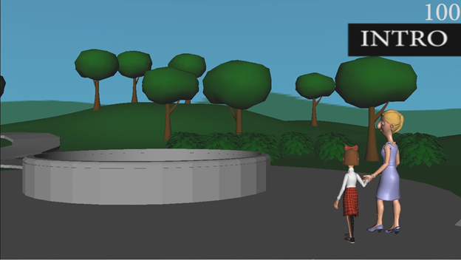

CAMERA: Static Camera. Above water. Extreme wide shot.

ACTION: A girl, Penny, and her mother walk up to the fountain.

PURPOSE: Establish the setting and bring in the characters.

ASSETS: Penny, mother, possibly other park people

TIME OF DAY: Noon

Shot Description for INTRO_200

INTRO_200

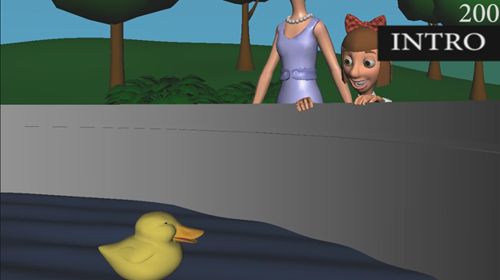

CAMERA: Static Camera. Above water. Wide up shot from inside fountain

ACTION: Penny peers over the edge at ducks.

PURPOSE: Show everyone enjoying a beautiful day by the fountain.

ASSETS: Penny, mother, ducks

Shot Description for INTRO_300

INTRO_300

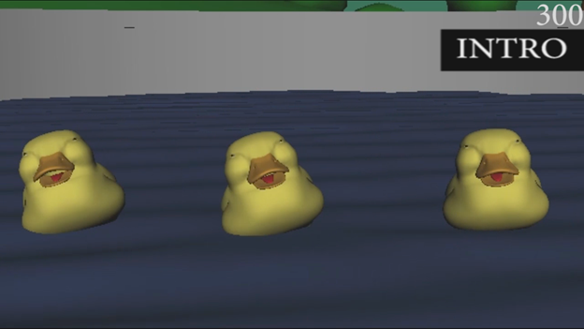

CAMERA: Static Camera. Above water. Wide, inside the fountain.

ACTION: The ducks dance the samba.

PURPOSE: Show that Penny is looking at the happy ducks dancing the samba.

ASSETS: Ducks

Shot Description for INTRO_400

INTRO_400

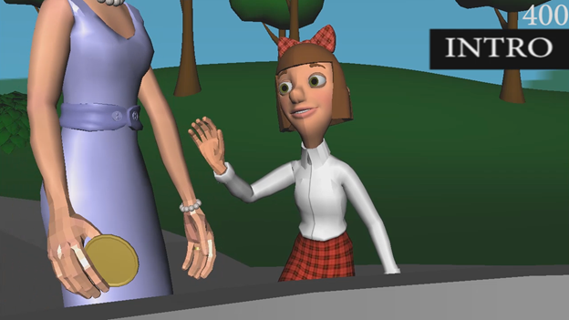

CAMERA: Static Camera. Above water. Medium full, from barely inside the fountain.

ACTION: Delighted, Penny asks for and receives a coin from her mother.

PURPOSE: Show that people make wishes in the fountain by having Penny ask her mom for a coin.

ASSETS: Penny, mother, coin

Shot Description for INTRO_500

INTRO_500

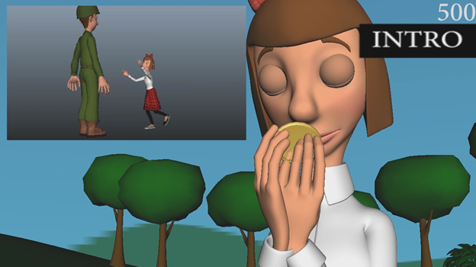

CAMERA: Static Camera. Above water. Medium of Penny; full shot inside the dream

ACTION: Holding the coin tightly, Penny wishes for her father to come home.

PURPOSE: Show Penny’s dream and link it to the coin, giving the coin significance.

ASSETS: Penny, father, coin

Shot Description for INTRO_600

INTRO_600

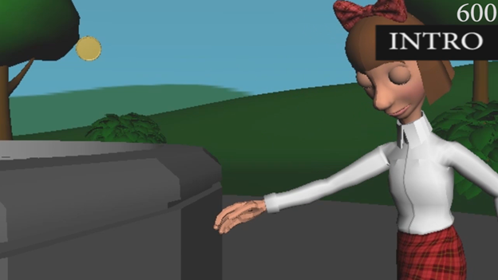

CAMERA: Static Camera. Above water. Medium wide of Penny.

ACTION: Penny throws the coin.

PURPOSE: Finish establishing that Penny is hopeful that her dream will come true.

ASSETS: Penny, possibly mother, coin

Shot Description for INTRO_700

INTRO_700

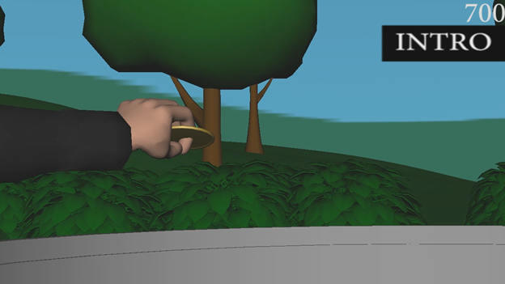

CAMERA: Static Camera. Above water. Close-up

ACTION: The coin flips through the air, until is it suddenly snatched by a hand.

PURPOSE: Introduce Corruption. Establish that he is stealing hopes/dreams.

ASSETS: Corruption, coin

Shot Description for BADGUY_100

BADGUY_100

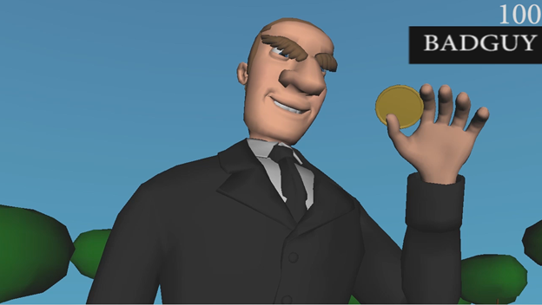

CAMERA: Moving camera. Close-up of Corruption’s hand. Camera tilts up to medium up shot, revealing Corruption’s face.

ACTION: Grinning ear to ear, Corruption pockets the coin, while Penny and her mother are looking at the fountain in the background, oblivious of Corruption’s action.

PURPOSE: Stealing Penny’s coin establishes Corruption’s greed and delight.

ASSETS: Corruption, Penny, mother, ducks

Shot Description for BADGUY_200

BADGUY_200

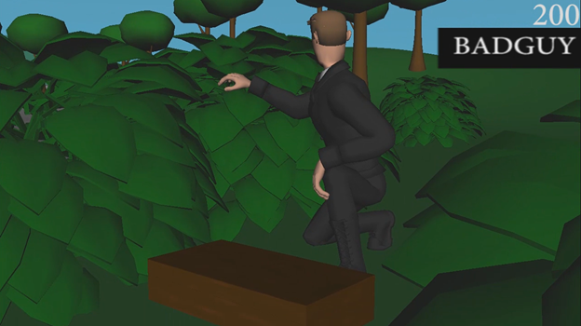

CAMERA: Moving camera. Extreme wide of the fountain, that rotates to a full shot of Corruption and the briefcase.

ACTION: Corruption peers over bushes that he is hiding behind, then pulls a briefcase toward himself

PURPOSE: Establish the secret hiding place where Corruption will set his plan in motion.

ASSETS: Corruption, park people around fountain, briefcase, bush

Shot Description for BADGUY_300

BADGUY_300

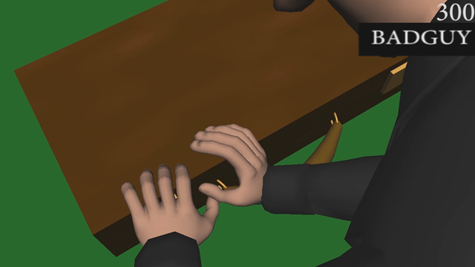

CAMERA: Static camera. Close-up of the briefcase

ACTION: Corruption unlocks a ridiculous number of locks on the briefcase

PURPOSE: Establish that the contents of the briefcase is a secret and very important. The contents are critical to his plan.

ASSETS: Corruption, briefcase, (big locks on briefcase)

Shot Description for BADGUY_400

BADGUY_400

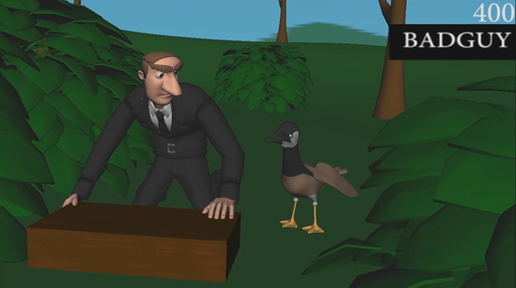

CAMERA: Moving camera. Wide of Corruption that rotates to reveal the goose

ACTION: As Corruption is about to open the briefcase, he notices a goose looking at it curiously. He grabs the goose and roughly throws it over the bushes. When the coast is clear again, Corruption pulls a fake swan out of the briefcase

PURPOSE: Introduce the goose and begin the antagonistic relationship between the goose and Corruption. Show that Corruption is not only greedy but also cruel. Introduce the swan as an important element.

ASSETS: Corruption, goose, briefcase, swan, bush

Shot Description for BADGUY_500

BADGUY_500

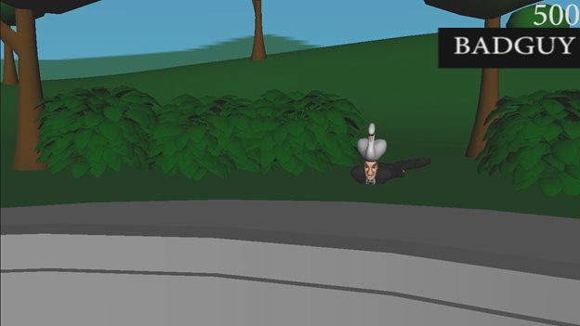

CAMERA: Static camera. Wide downshot

ACTION: The “swan” peaks over the bushes, then Corruption, with the swan on his head, slithers over to the fountain.

PURPOSE: Show that Corruption is a predator on a mission.

ASSETS: Corruption, swan, bush

Shot Description for BADGUY_600

BADGUY_600

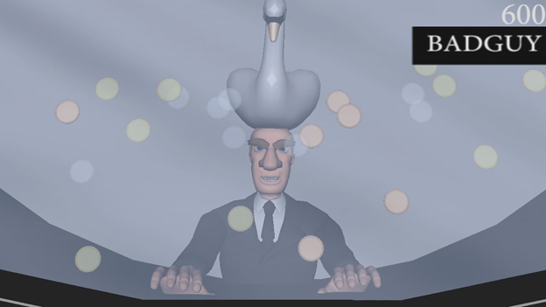

CAMERA: Static camera. Medium downshot of reflection

ACTION: With the swan on his head, Corruption peers over the fountain edge at the glittering coins below

PURPOSE: Show Corruption is motivated to steal the beautiful coins. Show that his greed is more important than everyone else’s dreams by making the coins glint and gleam in the sun.

ASSETS: Corruption, swan, coins

Shot Description for BADGUY_700

BADGUY_700

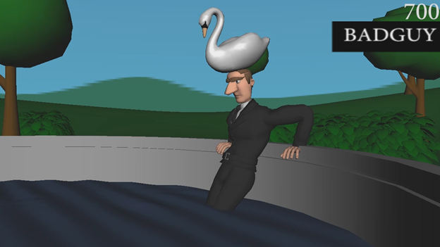

CAMERA: Static camera. Wide shot

ACTION: Corruption slithers into the fountain like a predator, making the “swan” look like it’s floating on top of the water

PURPOSE: Move Corruption into the water to show that he intends to fool everyone into thinking he’s a swan and not a threat, setting the stage for his deception.

ASSETS: Corruption, swan

Shot Description for GREED_100

GREED_100

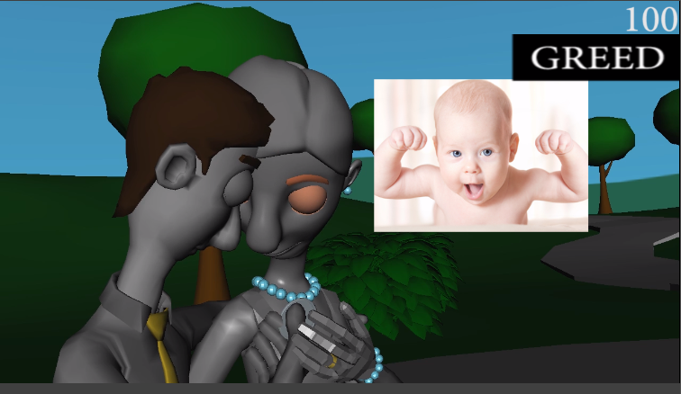

CAMERA: Static camera. Medium

ACTION: A couple holds a coin and dreams of a baby

PURPOSE: Show the couple’s dream. They think that throwing the coin into the fountain will bring them happiness and luck, emphasizing the importance of the coin to the people.

ASSETS: Wife, husband, baby, coin

Shot Description for GREED_200

GREED_200

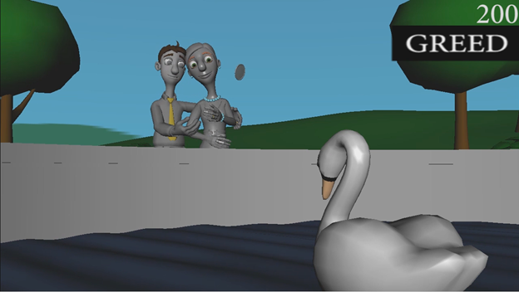

CAMERA: Static camera. Wide upshot, over the shoulder of the swan from inside the fountain so the couple is cut off at the waist

ACTION: The couple tosses their coin into the fountain, where the swan lurks in wait

PURPOSE: The swan in the foreground foreshadows the theft of the coin in the next shot.

ASSETS: Wife, husband, possibly ducks, coin, swan

Shot Description for GREED_300

GREED_300

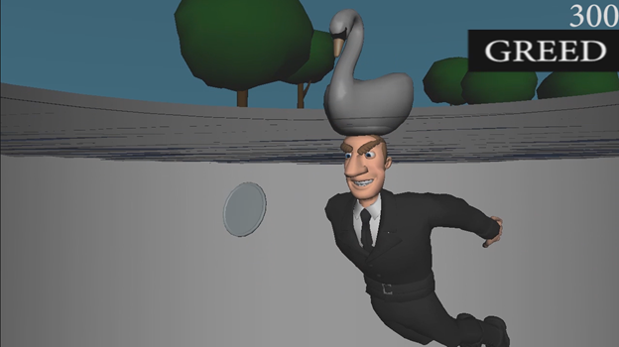

CAMERA: Moving camera. Full shot of the swan above water, tilts down underwater to a medium full shot of Corruption

ACTION: Corruption peeks above the water at the coin, then swims over to grab it

PURPOSE: Reveals the true extent of Corruption’s scheme. Introduces us to the world below the water.

ASSETS: Corruption, possibly park people, possibly ducks, swan, coin

Shot Description for GREED_400

GREED_400

CAMERA: Static camera. Close-up of Corruption’s pocket, underwater

ACTION: Corruption puts the couple’s coin in his pocket

PURPOSE: Reveals the extent of Corruption’s selfish and evil intent.

ASSETS: Corruption, coin

Shot Description for GREED_500

GREED_500

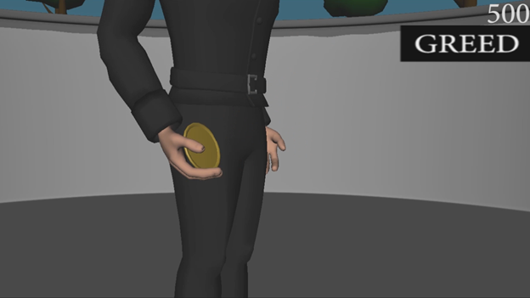

CAMERA: Static camera. Medium shot of Corruption, with his head and feet both out of the frame, underwater

ACTION: Corruptions grabs and pockets more coins as they fall

PURPOSE: Show that Corruption is steadily stealing more and more coins.

ASSETS: Corruption, coins

Shot Description for GREED_600

GREED_600

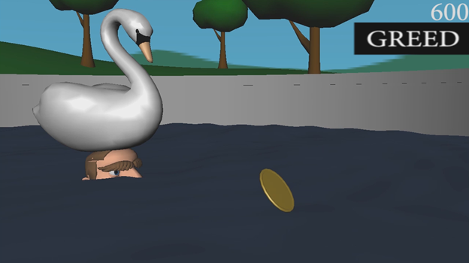

CAMERA: Static camera. Full shot of the swan / closeup of Corruption and the coin

ACTION: Another coin falls in the water as Corruption peers at it

PURPOSE: Show Corruption lying in wait for more coins.

ASSETS: Corruption, possibly ducks, swan, coin

Shot Description for GREED_700

GREED_700

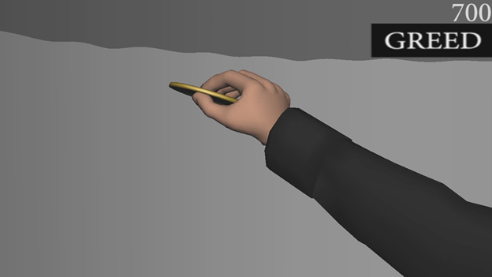

CAMERA: Static camera. Closeup of the coin and Corruption’s hand, underwater

ACTION: Corruption snatches the coin out of the air

PURPOSE: Show Corruption continuing his evil ways.

ASSETS: Corruption, coin

Shot Description for GREED_800

GREED_800

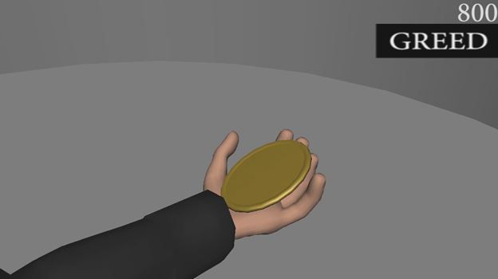

CAMERA: Static camera. Closeup of the coin and Corruption’s hand, underwater

ACTION: Corruption scoops up another coin

PURPOSE: Show Corruption progressively being happier and happier with the coins he is stealing.

ASSETS: Corruption, coin

Shot Description for GREED_900

GREED_900

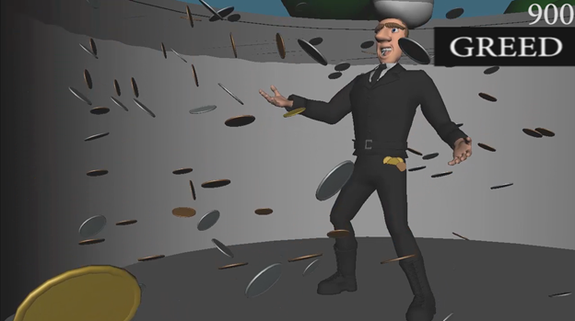

CAMERA: Static camera. Wide shot, underwater

ACTION: Dozens of coins fall around Corruption, who laughs with glee. See reference from slot machine winners and cash grab booths. His pockets are bulging with coins. EXAGGERATE!

PURPOSE: Show how wonderfully Corruption’s scheme is working and how thrilled he is that his plan is working.

ASSETS: Corruption, coins

Shot Description for IMPOSTER_100

IMPOSTER_100

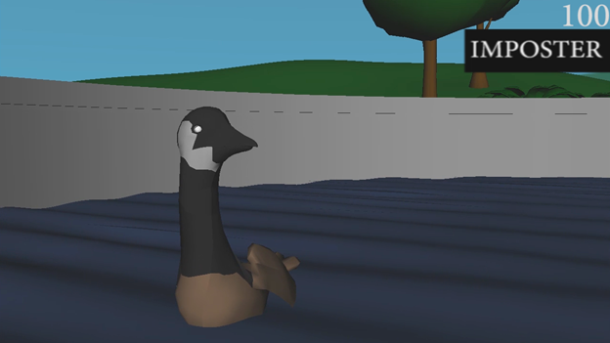

CAMERA: Static camera. Above water. Wide shot with the goose on the left ⅓ line

ACTION: Goose is floating on the water, enjoying the beautiful day, and then he looks off camera.

PURPOSE: Show the goose is minding his own business and unaware of Corruption’s plan.

ASSETS: Goose

Shot Description for IMPOSTER_200

IMPOSTER_200

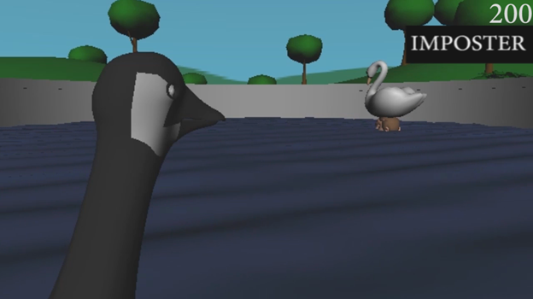

CAMERA: Static camera. Above water. Over the shoulder shot of the goose facing a full view of the swan, with the goose at ⅓ frame and Corruption at ⅔ frame

ACTION: Goose looks at the swan. After a coin is tossed into the fountain Corruption’s head pops up momentarily, only to disappear under the water.

PURPOSE: Reveals to the audience that the goose knows that something is a not quite right with this swan.

ASSETS: Corruption, Goose, coin, swan, possibly ducks, possibly park people

Shot Description for IMPOSTER_300

IMPOSTER_300

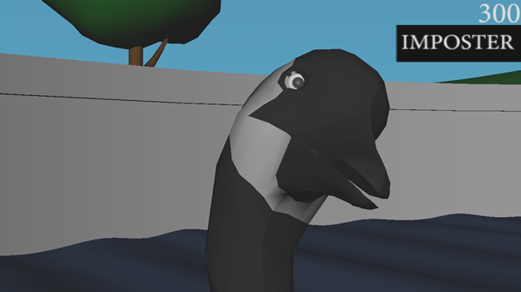

CAMERA: Static camera. Above water. Close-up on goose, centered

ACTION: The goose cocks his head to one side in confusion

PURPOSE: Show that the goose is curious about what he saw.

ASSETS: Goose

Shot Description for IMPOSTER_400

IMPOSTER_400

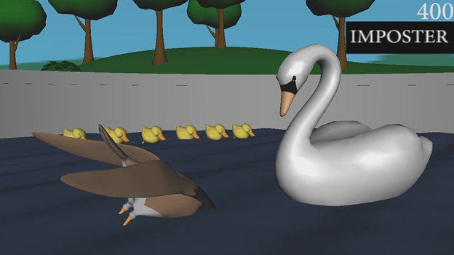

CAMERA: Static camera. Above water. Wide shot of the goose and swan.

ACTION: Goose enters from the right, examines the swan, then dunks its head underwater and discovers Corruption.

PURPOSE: Reveals to the audience that the goose has discovered Corruption.

ASSETS: Corruption, goose, ducks, swan

Shot Description for IMPOSTER_500

IMPOSTER_500

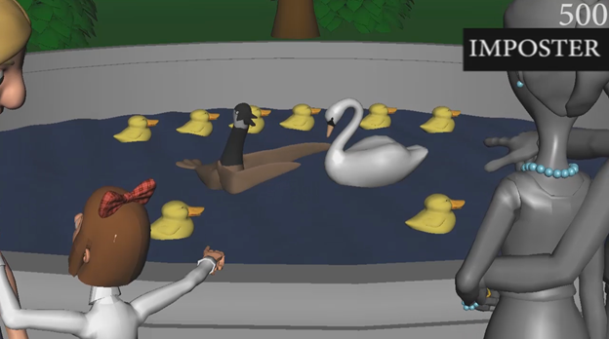

CAMERA: Static camera. Above water. Over the shoulder shot of the people, framing a wide shot of the fountain, with the goose and swan centered

ACTION: Goose motions at the fake swan, trying to draw attention, but the ducks make it look like a choreographed dance. The people are entertained by the motion of the birds.

PURPOSE: Show that the people see happy ducks dancing and don’t notice what the goose is trying to tell them. The audience can see the disconnect between what’s happening above and below the water.

ASSETS: Corruption, goose, ducks, Penny, mother, wife, husband, swan

Shot Description for IMPOSTER_600

IMPOSTER_600

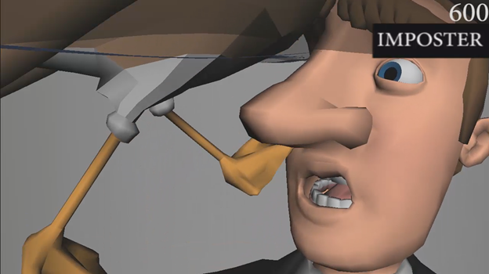

CAMERA: Static camera. Below water. Close up of Corruption’s face, right below the water’s surface

ACTION: Goose’s swimming feet get into Corruption’s face.

PURPOSE: Show the goose unintentionally interrupts Corruption’s plan while trying to reveal his deception. This enrages Corruption.

ASSETS: Corruption, goose

Shot Description for IMPOSTER_700

IMPOSTER_700

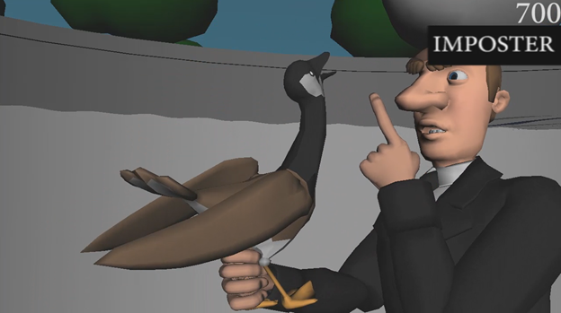

CAMERA: Static camera. Below water. Medium up shot of Corruption and the goose

ACTION: Corruption grabs the goose by his feet, shushes him, and then shoves him away. Corruption then goes off to collect more coins.

PURPOSE: Show Corruption recognizes that the goose is a threat to maintaining his cover.

ASSETS: Corruption, goose, swan

Shot Description for IMPOSTER_800

IMPOSTER_800

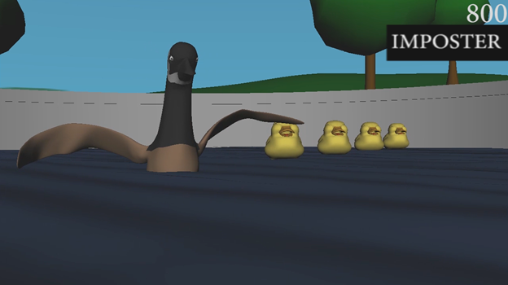

CAMERA: Static camera. Above water. Wide shot of goose.

ACTION: Goose recovers his composure and chases Corruption

PURPOSE: Show the goose’s determination to expose Corruption

ASSETS: Goose, ducks

Shot Description for IMPOSTER_900

IMPOSTER_900

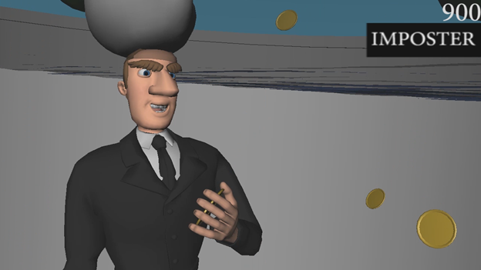

CAMERA: Static camera. Below water. Medium up shot of Corruption

ACTION: Corruption catches more coins with a big grin on his face

PURPOSE: Show Corruption has turned his attention from the goose to capturing the coins, which is his mission.

ASSETS: Corruption, coins, swan

Shot Description for IMPOSTER_1000

IMPOSTER_1000

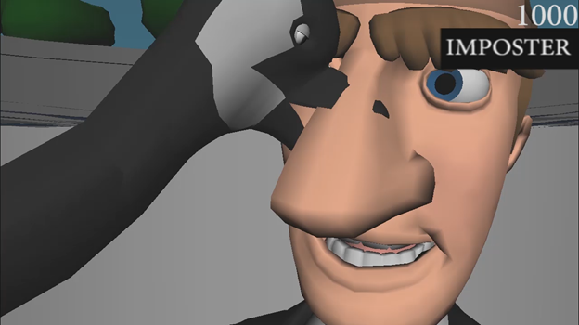

CAMERA: Static camera. Below water. Close up of Corruption face.

ACTION: Corruption’s gaze follows a coin past his face, turning to see the goose. The goose then bites his nose twice.

PURPOSE: Show the goose’s desperate attempt to rid the fountain of Corruption. Corruption is shocked and afraid of the goose, so he runs away.

ASSETS: Corruption, goose

Shot Description for IMPOSTER_1100

IMPOSTER_1100

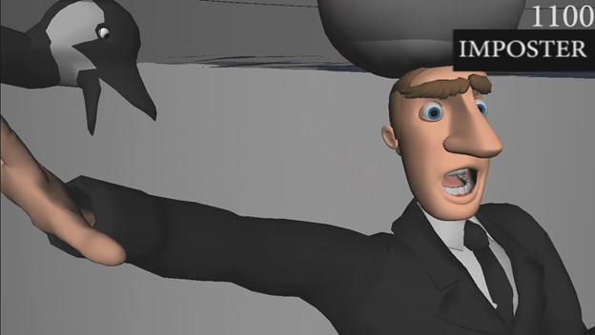

CAMERA: Static camera. Below water. Medium shot of Corruption.

ACTION: Corruption reacts to the painful bite, pushing the goose away. Then Corruption flees when the goose starts to come back.

PURPOSE: Show the goose starts to unravel Corruption’s scheme.

ASSETS: Corruption, goose, swan

Shot Description for CHASE_100

CHASE_100

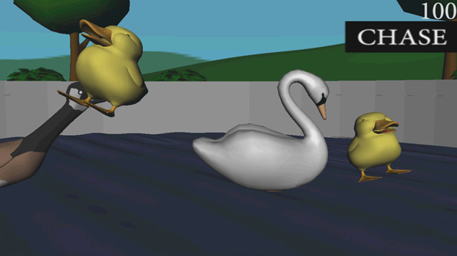

CAMERA: Static camera. Above water. Wide shot

ACTION: The swan races through the frame with the goose in hot pursuit.

PURPOSE: Show the chase beginning. Contrast the peace above with the chaos below the water.

ASSETS: Goose, ducks, swan

Shot Description for CHASE_200

CHASE_200

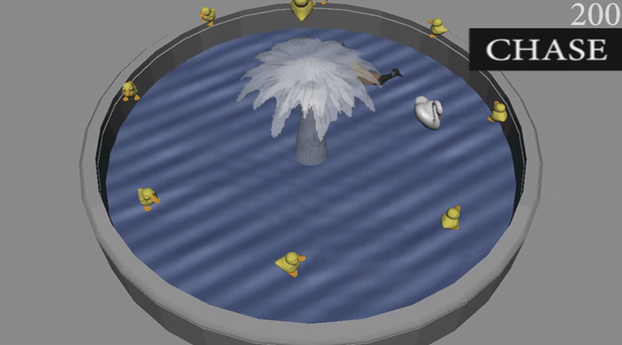

CAMERA: Moving camera. Above water. Wide birds eye view of the fountain. Camera pulls out (crane shot).

ACTION: The goose chases the swan, while the ducks dance, making the chase look choreographed

PURPOSE: Emphasize the the beauty above water.

ASSETS: Goose, ducks, park people, swan

Shot Description for CHASE_300

CHASE_300

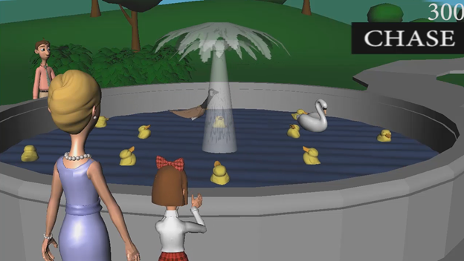

CAMERA: Static camera. Above water. Medium wide down shot over the shoulder of Penny and her mother, with the chase in the background

ACTION: All the park people are delighted; meanwhile the goose is suddenly pulled underwater, setting up for the choking in the next shot.

PURPOSE: Emphasize that the people think the chase is innocent entertainment

ASSETS: Penny, mother, park people, goose, ducks, swan

Shot Description for CHASE_400

CHASE_400

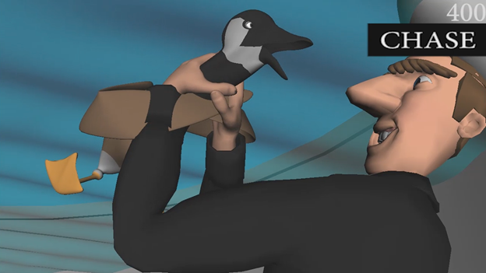

CAMERA: Static camera. Below water. Medium up shot, over Corruption’s shoulder, underwater

ACTION: Corruption tries to strangle the goose, until it breaks free

PURPOSE: Highlight the the darkness below water. Show Corruption overcoming his adversary.

ASSETS: Corruption, goose, swan

Shot Description for CHASE_500

CHASE_500

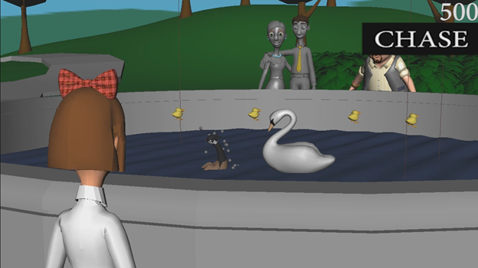

CAMERA: Static camera. Above water. Over the shoulder of Penny facing the fountain, with the goose and swan centered, and more people in the background

ACTION: The goose breaks free above water, looking beautiful, but is then pulled back down again

PURPOSE: Show that the birds are still entertaining the people at the fountain. Emphasize the goose’s motion above the water that is misread by the people at the fountain. Contrast the violence below water with the beauty above.

ASSETS: Penny, goose, ducks, park people, swan

Shot Description for CHASE_600

CHASE_600

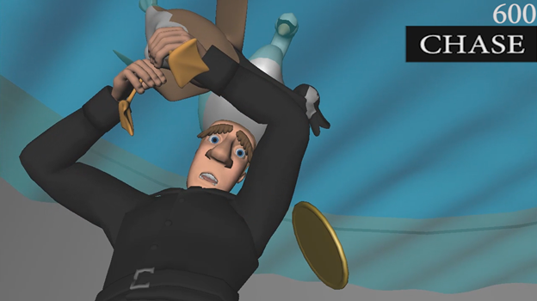

CAMERA: Static camera. Below water. Medium extreme upshot of Corruption and goose.

ACTION: Corruption grapples with the goose. He notices with concern that the special coin falls out of his pocket.

PURPOSE: Show Corruption’s panic as the coin falls out of reach.

ASSETS: Corruption, goose, coin, swan

Shot Description for CHASE_700

CHASE_700

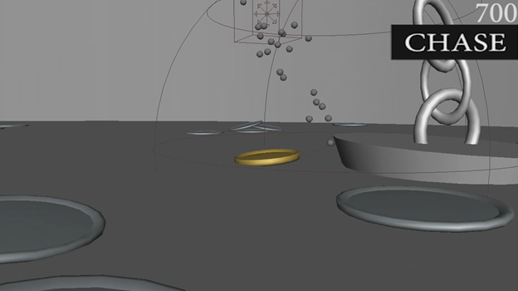

CAMERA: Moving camera, following the special coin. Below water. Close-up of the coin, following at is it pulled into the drain.

ACTION: The coin sinks to the bottom of the fountain and is sucked into the drain

PURPOSE: Set up Corruption’s ultimate downfall.

ASSETS: Plug, coins

Shot Description for CHASE_800

CHASE_800

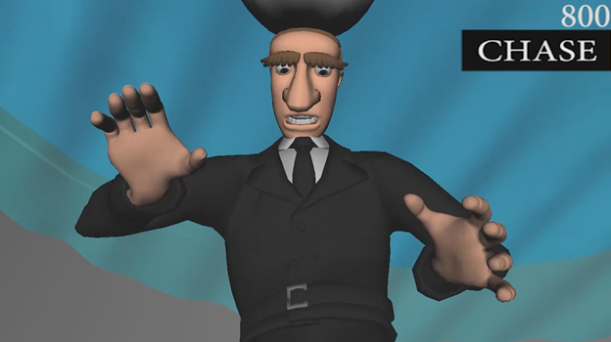

CAMERA: Static camera. Below water. Medium extreme upshot, underwater

ACTION: After brief deliberation, Corruption pushes the goose away and decides to go for the coin

PURPOSE: Show money is the only thing that matters to Corruption.

ASSETS: Corruption, goose, swan

Shot Description for REVEAL_100

REVEAL_100

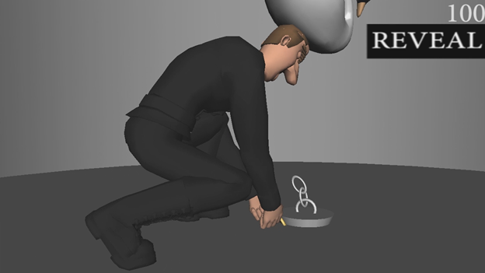

CAMERA: Moving camera. Below water. Zoom out at the beginning, then fix. Wide shot.

ACTION: Corruption struggles to free the coin.

PURPOSE: Show Corruption’s extreme effort to satisfy his endless greed.

ASSETS: Corruption, swan, plug, coins

Shot Description for REVEAL_200

REVEAL_200

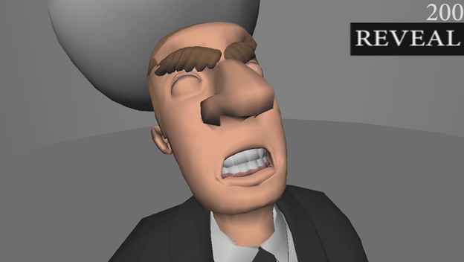

CAMERA: Static camera. Below water. Close up of Corruption.

ACTION: Corruption continues to struggle with coin.

PURPOSE: Shows how far Corruption will go to get one coin.

ASSETS: Corruption, swan

Shot Description for REVEAL_300

REVEAL_300

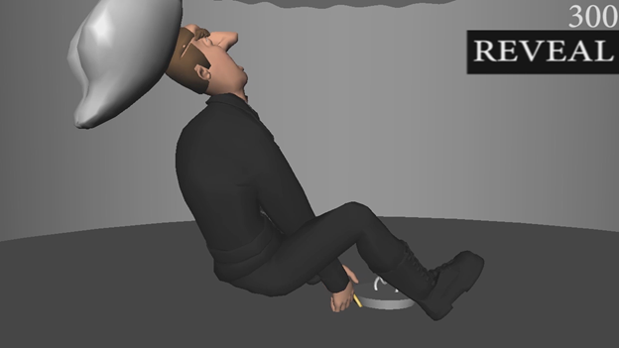

CAMERA: Static camera. Below water. Wide shot of Corruption.

ACTION: Corruption frees the coin and in doing so removing the plug.

PURPOSE: Show Corruption removing the plug. By getting what he wants, Corruption creates his own downfall.

ASSETS: Corruption,swan, plug, coins

Shot Description for REVEAL_400

REVEAL_400

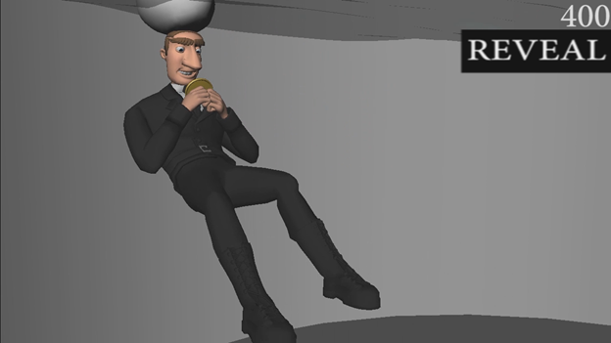

CAMERA: Static camera. Below water. Wide shot of Corruption, floating back to ⅓, underwater

ACTION: Corruption is propelled backwards, happily holding his coin.

PURPOSE: Show Corruption’s obsession with money.

ASSETS: Corruption, swan, coins

Shot Description for REVEAL_500

REVEAL_500

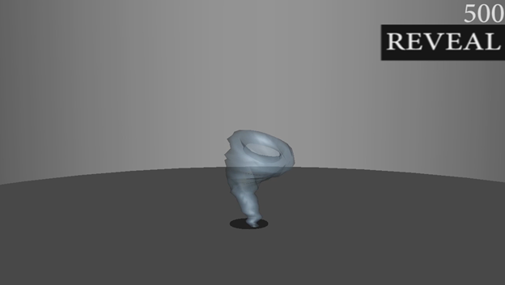

CAMERA: Static camera. Below water. Closeup of the whirlpool, underwater

ACTION: A whirlpool builds from the drain.

PURPOSE: Begin the disturbance that leads to the reveal.

ASSETS: Coins, whirlpool

Shot Description for REVEAL_600

REVEAL_600

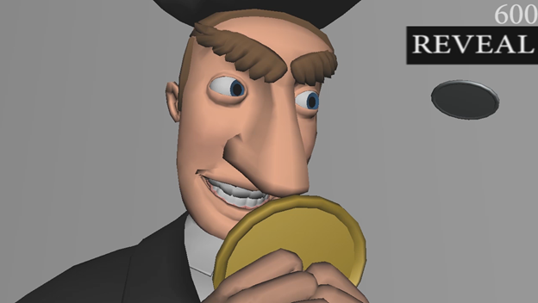

CAMERA: Static camera. Below water. Close-up of Corruption.

ACTION: Corruption grins at his coin, then is confused as several coins float by in an abnormal direction, only to discover the coins are all moving inside a whirlpool. He does a double take when he sees the whirlpool.

PURPOSE: Shows Corruption’s confusion and discovery of the whirlpool.

ASSETS: Corruption, swan, coins

Shot Description for REVEAL_700

REVEAL_700

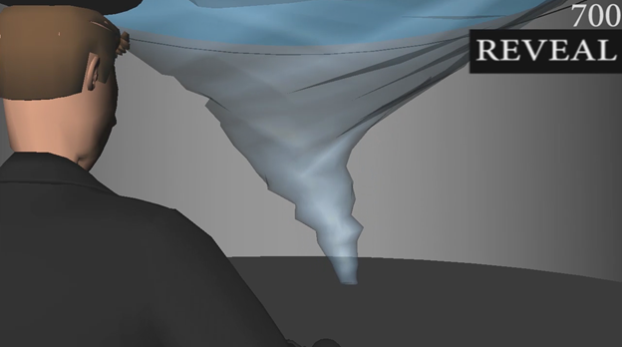

CAMERA: Static camera. Below water. Over the shoulder shot of Corruption, facing the whirlpool, underwater

ACTION: The whirlpool grows in size and power.

PURPOSE: Show what Corruption is looking at. Show the audience that the whirlpool is becoming a threat.

ASSETS: Corruption, swan, coins, whirlpool

Shot Description for REVEAL_800

REVEAL_800

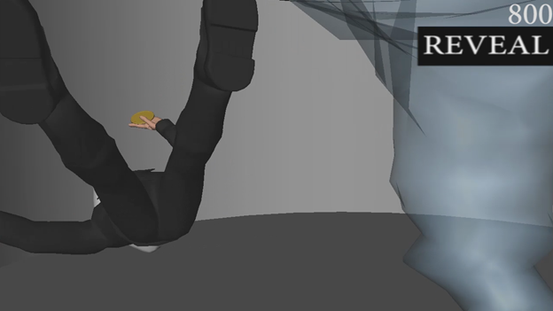

CAMERA: Static camera. Below water. Wide shot of Corruption.

ACTION: Corruption is pulled into the whirlpool.

PURPOSE: Show that Corruption has lost control over the coins and the fountain.

ASSETS: Corruption, swan, coins, whirlpool

Shot Description for REVEAL_900

REVEAL_900

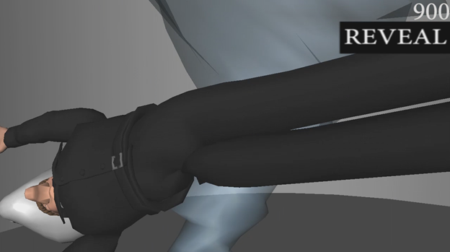

CAMERA: Static camera. Below water. Wide shot of Corruption around the centered whirlpool, underwater

ACTION: Corruption gets pulled around by the whirlpool

PURPOSE: Emphasize Corruption’s complete loss of control.

ASSETS: Corruption, swan, coins, whirlpool

Shot Description for REVEAL_1000

REVEAL_1000

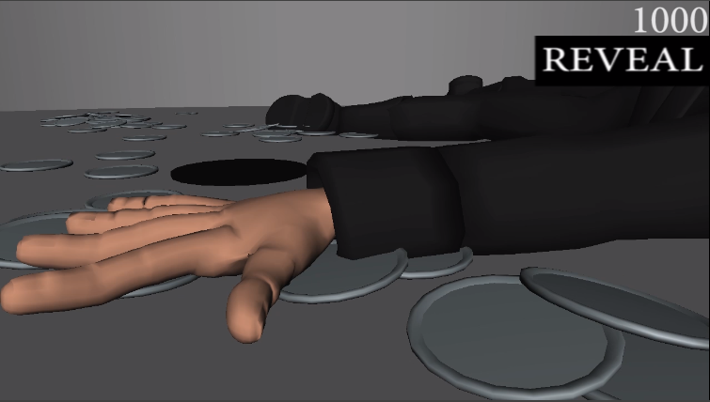

CAMERA: Static camera. Close-up of drain, hand (and body).

ACTION: Water completely drains from the fountain. Corruption lands at the bottom of the fountain.

PURPOSE: Show Corruption in a completely exposed and vulnerable state.

ASSETS: Corruption, coins, drain

Shot Description for END_100

END_100

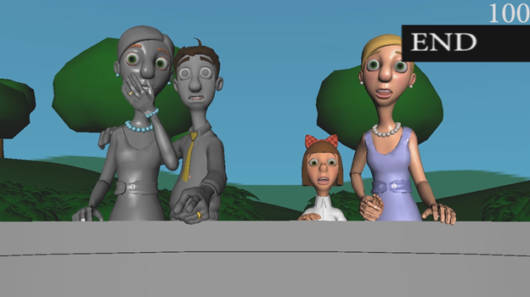

CAMERA: Static camera. Wide up shot of the people from inside the fountain.

ACTION: The crowd around the fountain is shocked.

PURPOSE: Show crowds reaction to seeing Corruption revealed.

ASSETS: Penny, mother, wife, husband

Shot Description for END_200

END_200

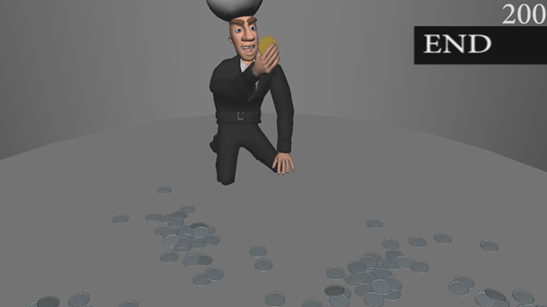

CAMERA: Static camera. Wide down shot of Corruption on the floor of the drained fountain

ACTION: Oblivious to the crowd, Corruption tries to grab all the remaining coins.

PURPOSE: Show Corruption’s singular focus on money, even after being revealed.

ASSETS: Corruption, swan, coins

Shot Description for END_300

END_300

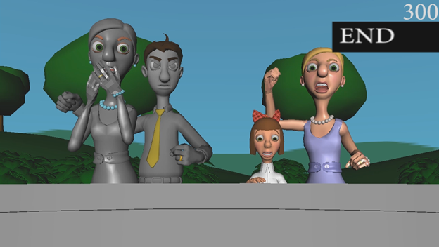

CAMERA: Static camera. Wide up shot of the people from inside the fountain.

ACTION: The crowd turns angry

PURPOSE: Show the crowd sees what Corruption has been doing; and turns from shock to rage.

ASSETS: Penny, mother, wife, husband

Shot Description for END_400

END_400

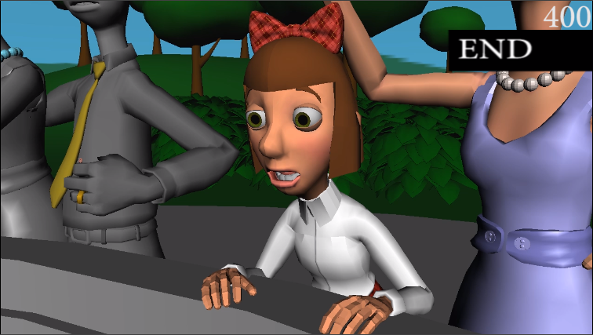

CAMERA: Static camera. Medium shot of Penny

ACTION: Penny grips the edge of the fountain and leans over with shock and sadness.

PURPOSE: Distinguish Penny from the crowd emotionally.

ASSETS: Penny, mother, wife, husband

Shot Description for END_500

END_500

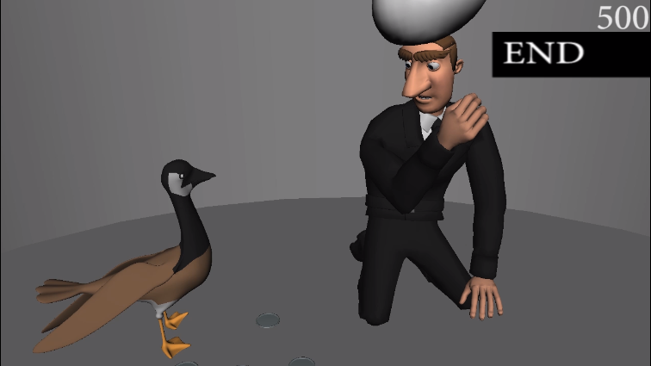

CAMERA: Moving camera. Medium down shot of Corruption, zooming out and left to a wide shot that reveals the goose.

ACTION: Corruption sneers and grips all of the coins tighter, then suddenly notices the goose next to him, who is shaking his head disapprovingly. The goose chases Corruption.

PURPOSE: Show Corruption’s stubborn commitment to his scheme. Show that he knows he’s been caught in the act and doesn’t care.

ASSETS: Corruption, goose, swan, coins

Shot Description for END_600

END_600

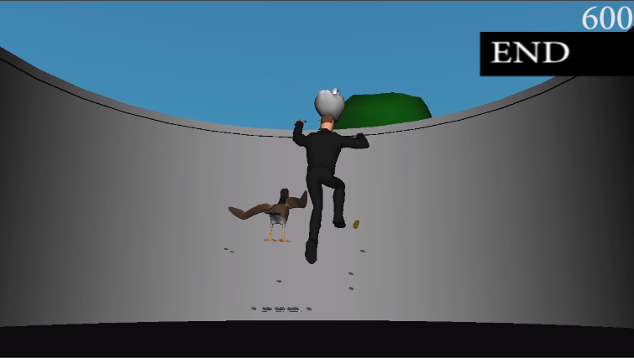

CAMERA: Static camera. Wide up shot from inside the fountain

ACTION: Corruption scrambles out of the fountain, chased by the goose.

PURPOSE: Show Corruption trying to escape. He still thinks he can get away with it.

ASSETS: Corruption, goose, swan, coins

Shot Description for END_700

END_700

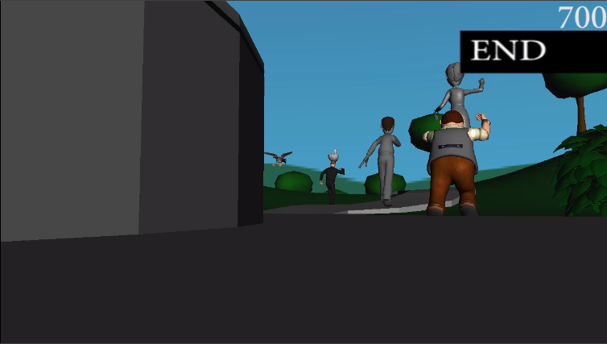

CAMERA: Static camera. Extreme wide up shot just outside the fountain

ACTION: The crowd chases Corruption away, toward the horizon.

PURPOSE: Show Corruption being chased out of the area.

ASSETS: Corruption, mother, wife, husband, park people, swan

Shot Description for END_800

END_800

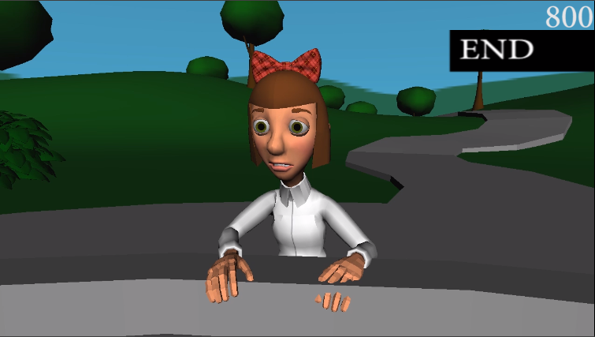

CAMERA: Static camera. Medium shot from inside the fountain

ACTION: Penny looks at the empty fountain and is sad.

PURPOSE: Show Penny has been negatively affected by Corruption and is sad.

ASSETS: Penny

Shot Description for END_900

END_900

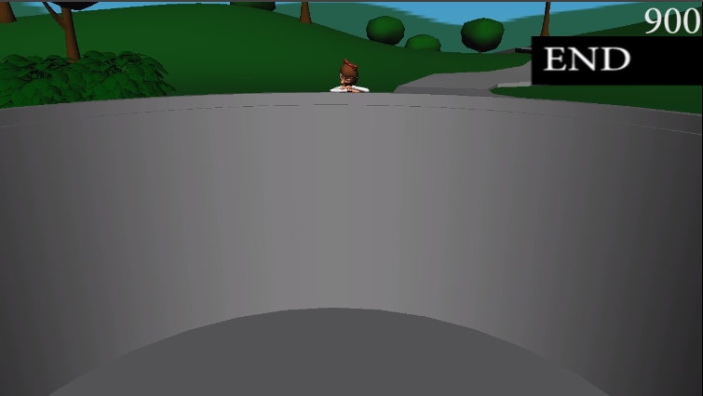

CAMERA: Static camera. Wide angled shot of the empty fountain.

ACTION: Penny lays with her head against the fountain.

PURPOSE: Show that Corruption cannot be reversed, contrasting the now empty fountain with its previously cheerful appearance.

ASSETS: Penny, coins

