Lab Exercise: Editing and Audio
Taking a sandbox clip from either one of your previous lab assignments, you will be importing it into Premiere and adding two sets of audio: A voiceover describing what is going on, and a pass at music and/or foley (foley is basically just another term for sound effects). You will then export two movie files with these tracks.

Using Premiere
1: Open Premiere
Go to Start → All Programs → Adobe Premiere Pro CS6.
Click "New Project".
2: Setting
Now, go to "Location" at the bottom, click "Browse..." and navigate to your folder on the network. If you haven’t made a folder yet be sure to create one:
O:\unix\projects\instr\production1\cse456_su15_student_files\[your student files folder].
Name your project cslab_audio_[lastname]_[firstname]. Hit “OK”. Next, to optimize your project for the Cinematic Sandbox output, click the "Setting” tab and change the following settings under General:
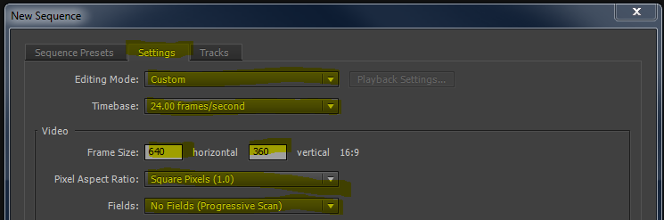
- Editing Mode - "Custom" (This will free up the resolution to be changed)
- Timebase - "24.00 frames/second"
- Frame size - "640" in horizontal, "360" in vertical
- Pixel Aspect Ratio - "Square Pixels (1.0)"
- Fields - "No Fields (Progressive Scan)"
- Sequence Name - “cslab_audio_[firstname]_[lastname]” (This can be changed later)
Once you’ve changed the settings above, click “OK”.

3: Import files into Premiere
The main interface should now have shown up.
The bottom half of the screen contains the Project Control Panel on the left and the Timeline on the right.
The Project Control Panel will show you the contents of your project, including imported media and sequences. The Timeline is where all of your editing will be done. It always shows the currently active sequence, in this case it will be the cslab_audio_[lastname]_[firstname] sequence. *Note that “sequence” in this case just means an edit of a film – a single Premiere project can contain multiple sequences.
The top half of the screen contains the viewports. The left viewport shows you individual media clips, and the right viewport shows you the Timeline, which is how your movie will appear in the end.
To get your files into Premiere go to File → Import... and again navigate to your folder on the network where you have saved your Cinematic Sandbox Project. If you rendered out individual shot files go into the “shot_renders” folder. If you rendered out the entire film, it should be the .mov file.
Select the desired shots or file (use Ctrl to select multiple files) and hit "Open." They should appear in the Project Control Panel. Alternatively you can drag and drop the video files into the Project Control Panel.
Import all files you need, including audio clips. For this lab you’ll likely only have one file to deal with.
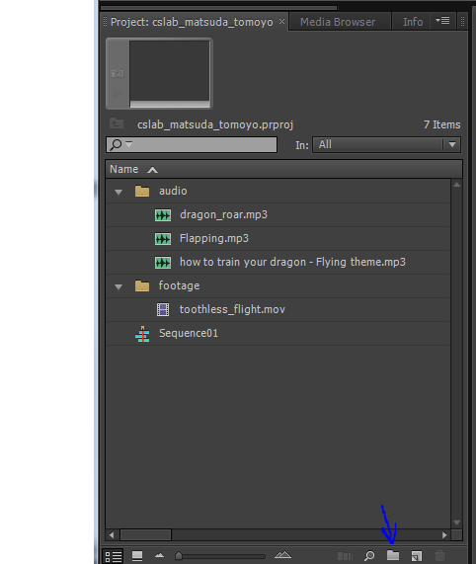
For your own sanity, you will want to create “bins” (basically folders) to organize the media in your project. Just click the folder icon to make a new bin, then drag your files into it.
4: Video
Select the video .mov clip of your animatic and left-click-drag into the Timeline.
*If your animatic is in separate shots:
Select the first shot you want in your movie in the Project Control Panel. Then left-click-drag it into the Timeline. You should see the clip appear as a rectangle at the start of the timeline.
If you hover the mouse over the right edge of the clip your cursor will turn into a red bracket with two arrows. This tool will let you adjust the length of your clip. You shouldn’t have to do this if the timing is correct in the Cinematic Sandbox.
Repeat this process with all of your clips, dragging them after the previous one in the timeline. You will notice that Premiere has a nice feature that automatically tries to snap your next clip onto the end of the previous one. If you find that that your clips aren’t snapping to nearby clips hit the s key to toggle snap back on.
Now that you have them all in the timeline, scrub through your film and make sure everything appears the way you want them to in the top right panel. To scrub, click and move the yellow marker in the timeline or alternatively hit the play button under the viewport to watch it play in real time. You can also just hit the spacebar to play and pause.
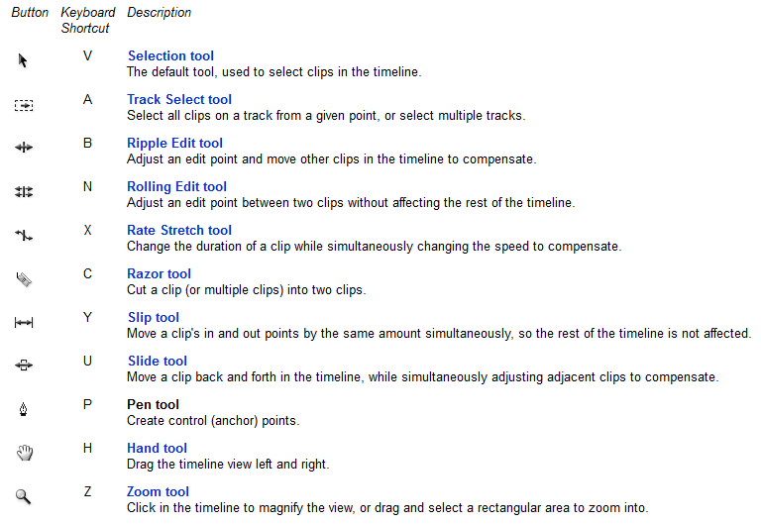
Tools to edit media tracks:

5: Audio Recording

You will soon be recording a voiceover describing the story in your animatic, but for now you will just be doing a test run by describing what’s going on in your chosen lab assignment.

Recording audio is a fairly straightforward process in Windows. Just plug in a microphone (there will be some in the lab) then open "Sound Recorder" from the Start Menu. If a settings window shows up, under the playback tab select your microphone and hit "OK".

When doing your voiceover it may help to have your movie file playing in the background as reference.

Push "Start Recording" to begin. When you hit “Stop Recording” it will prompt you to save the file. If you click cancel you have the option to resume recording. You may want to try two or three takes so you have several options to choose from. When you’re finished go ahead and import the files into Premiere.
6: Finding Music
Another task on its own is finding music that fits your piece. This is more of an optional “tips” step, but YouTube is probably your best bet to find something that works. The trick is downloading the file. There are many sites that allow you to do this. One solid option is keepvid.com.
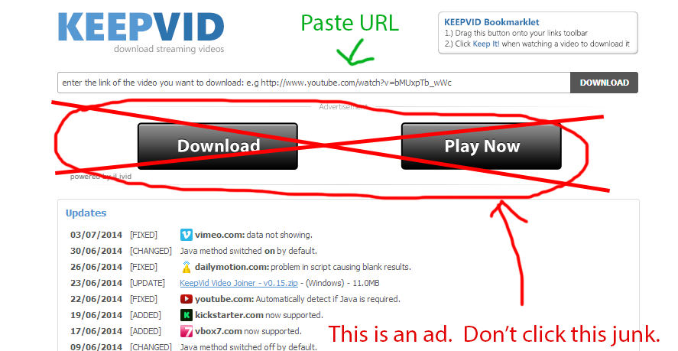
Just paste the URL in the top bar and click the small download button on the right. It will ask for permission to run a Java Applet. Click “Allow” or “Run this time” – it depends on the browser. Be sure NOT to click the ad, though. If you accidentally do and it tries to get you to download an executable file avoid it like the plague.
A list of download options will appear in the browser. The most direct option is an MP4. (Note that MP3 does show up as an option but it will just bring you to another site.) Right click the link and save the file to your student files folder. You can drag this file into Premiere. If Premiere takes issue with the MP4 a workaround is to just rename the file’s extension to “.mov”.
You can drag this file into the timeline, right click the MP4 clip and select “Unlink”. This will allow you to delete the video track while leaving the audio clip intact and free for editing.
Adding Foley/ Sound Effects:
You have an option of adding sound effects for your animatic. There is a website you could go to for free sound effects, however, you will need to register an account. The link is: www.freesound.org
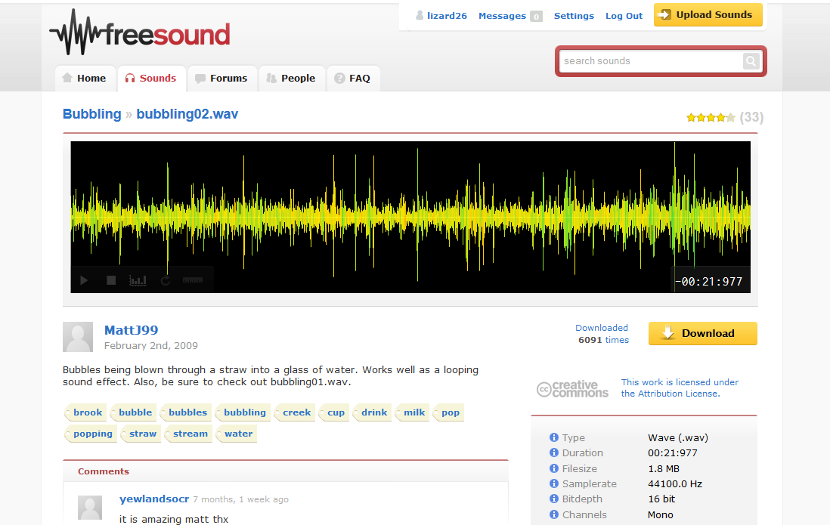
You can download the sound effect and import the file into Premiere. For organization purpose, be sure to add your sound effects to a separate media track and name it as “sfx”.
7: Audio Editing
Drag your audio files onto timeline. You’ll probably want to come up with some sort of organization. For example, voiceover on Track 1, music on Track 2, foley on Track 3 and Track 4, etc. Like video clips, you can hover the mouse cursor over the start/end edge of the clip then left click and drag to shorten or lengthen it.
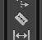
Alternatively, you can use razor tool in tool box (or hotkey c) to cut your audio into pieces. Select unnecessary part and hit “Delete” to delete.
Use multiple audio tracks to play different sound and music clips at same time. If you need more than the three audio timelines there, you can just right click the name of one of the audio tracks and choose “Add Tracks…”, then specify the number of audio (and video) tracks you want to add.
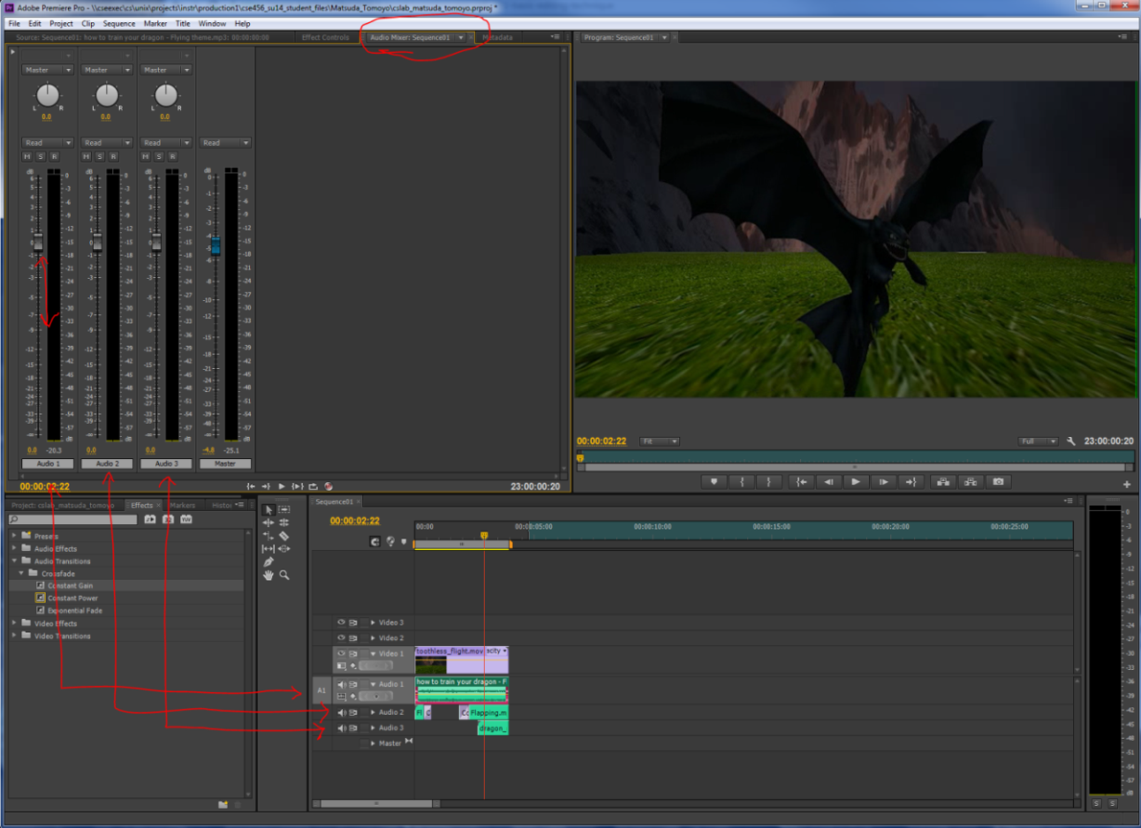
To control sound volume, go to the “Audio Mixer: [sequencename]” tab in the top left viewport. You can change the volume of each track on timeline by moving their assigned sliders up and down. The blue slider is the Master track, which allows you to control entire sound level.
You can also adjust the relative audio of individual clips by right clicking them and selecting “Audio Gain”. Select the “Set Gain to” option and just enter in a positive number for louder and a negative number for quieter. Click “Ok”.
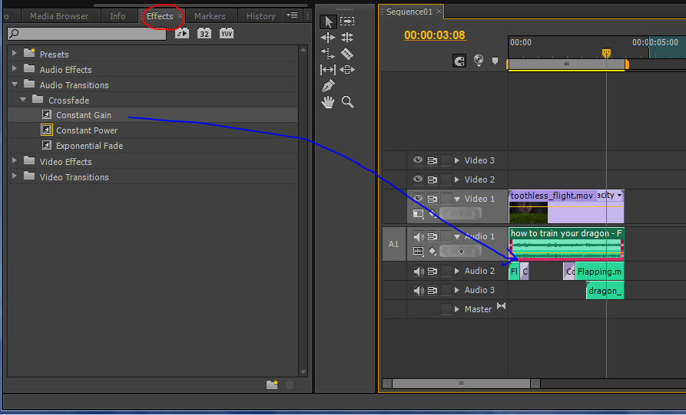
To add fade on your audio track, go to “Effects” tab in the Project Control Panel. Navigate to Audio Transitions → Crossfade→ Constant Gain. Drag Constant Gain to the timeline and drop it on the edge of and audio clip. You will see a fade effect pop in on that end of the clip. You can change the length of the effect by dragging the edge like other clips.
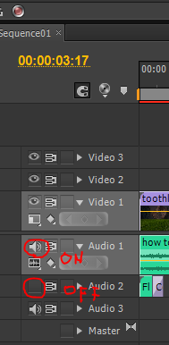
To turn on/ off the audio of a particular track just click the icon highlighted above.

8: Export the Sequences
The last step is to export your film. Select your sequence in the Project Control Panel and export it. Now go to File -> Export -> Media...
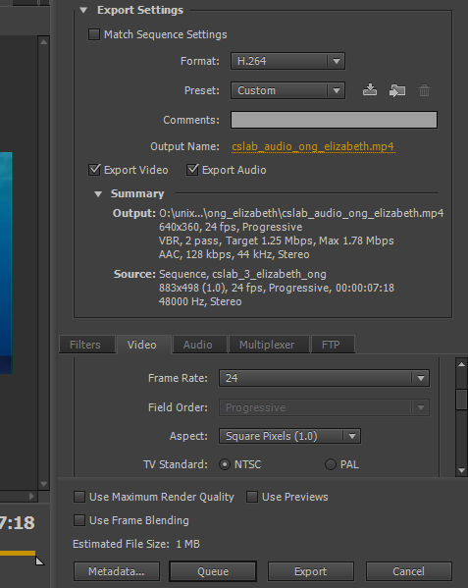
The file name should automatically be that of the sequence you are exporting.
Click cslab_audio_[lastname]_[firstname] and navigate to the place you want to export, which is your student folder.
Select "H.264" as the format. Go to the video tab, scroll down and find Basic Video Settings. Then change the Width and Height into 640*360. Make sure that Frame rate is “24” and Field order is “Progressive”.
Note that you will be exporting two files for this lab, one with voiceover and one with music/foley. Before exporting your music/foley pass be sure to temporarily disable your voiceover track as described in the audio section. Similarly, you should disable your music/foley tracks before exporting the voiceover.
When you’re ready, hit "Export". Don’t forget to save your premiere project.
In the future be sure to save your Premiere file frequently as you go and save iterations. This may not seem as relevant for this lab because it should be pretty quick, but it will become very important the more time you put into your editing later.
What to Turn-In
Turn the following two files into the class Catalyst Dropbox by the end of the lab:
- Your final video with music/foley (Turn off your voice over then export)
- Your final video with your voice over (Turn off other sounds then export)

