Red Team:
Cuijun Wu – Storyboard Lead
Fanny Halim – Audio Lead
Stephen Friedman – Editing Lead
Tania Heim – Story Lead
Ting-You Wang – Animation Lead

Visual References

Spot is based on a Jaw fish, a Rainbow Runner fish and a Goat fish.

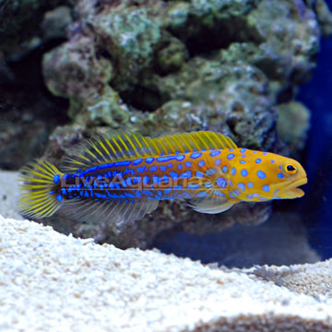
http://www.liveaquaria.com/images/categories/product/p-86343-jawfish.jpg

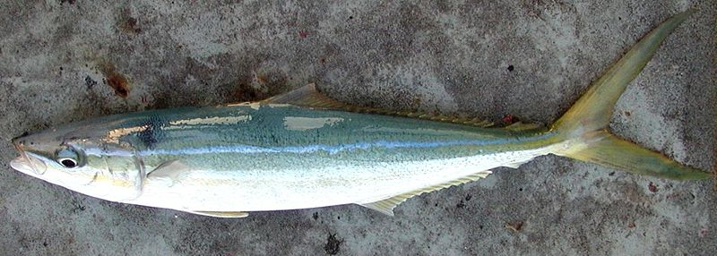
http://en.wikipedia.org/wiki/File:Rainbow_runner_3.jpg

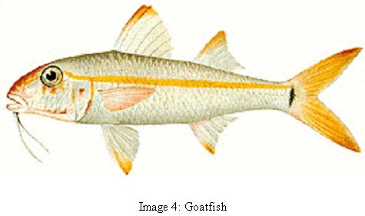http://www.atsdr.cdc.gov/HAC/PHA/viequesfish/images/goatfish.jpg

The school of fish is based on a Red Back Butterfly fish:

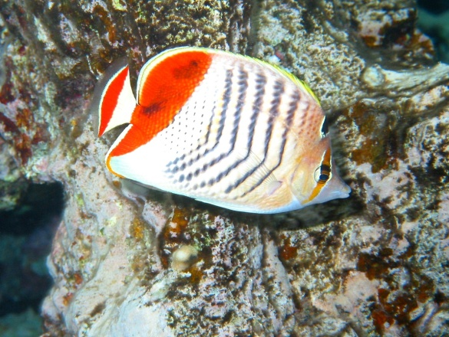
http://www.richard-seaman.com/Wallpaper/Nature/Underwater/Fish/RedBackButterflyfish1.jpg

The whale is based on the whale from Pinocchio.

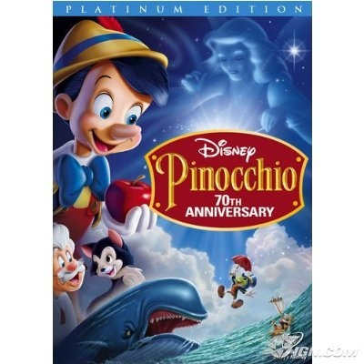
http://bluraymedia.ign.com/bluray/image/article/960/960349/pinocchio-70th-anniversary-platinum-edition-20090309034531706-000.jpg

The clam is based on various clam pictures.
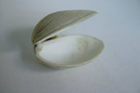
http://www.fotosearch.com/sc/CSP000/k0003137/

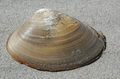
http://www.fotosearch.com/sc/CSP066/k0662975/

