University of Washington, CSE 154
Homework Assignment 5: To-Do List
CSE Majors Extra Features
CSE majors (B section) must complete both of the following two extra features to add new functionality to the program. Non-CSE majors (A section) are not required to complete any of these extra features, but if they do complete both, they can earn +1 late day for use on a future assignment (after HW5).
If you choose to do any of these extra features, in your file's comment header, indicate which one(s) you did.

Extra Feature #1. Friendly Error Messages
There are several different error cases that can occur in the site. Non-CSE majors must check for these cases but can handle them clumsily by simply aborting their pages (die). This is not a good user experience. Let's fix it by printing good error messages for several common errors.
Implement your error messages by setting session data storing an error message and redirecting the user to an appropriate page (index.php or todolist.php). The exact appearance of the error message is up to you, but it should be clearly visible and prominent on the page, such as bold red text:
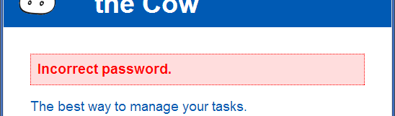
Here are all of the specific error cases you should handle gracefully:
- User types an incorrect password when trying to log in.
- User name does not match the expected pattern / regular expression when creating a new account.
- Password does not match the expected pattern / regular expression when creating a new account.
A slightly different kind of error is the case where various query parameters have not been passed (when isset returns FALSE for a given parameter value). This does not generally happen in normal usage, but the user can tweak the form to cause it not to submit various values. You do not need to handle this case.

Extra Feature #2. Additional Input Validation
The site performs some validation on various input. CSE majors should perform the following additional validation:
- Don't allow a new user account to have a password that is the same as, or contains, the username.
For example, if the user name is "smith", the password "2smithy!" would be rejected.
- Don't allow the user to submit a to-do list item that is blank or consists entirely of whitespace characters.
Display a similar error message to the screenshot shown above.

